Subject: Health
Topic: Function of Our Eyes.
Note:
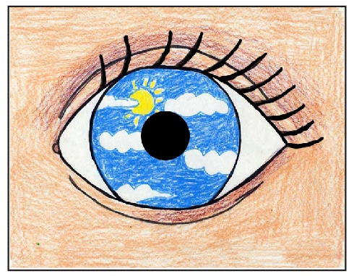
Your eyes are at work from the moment you wake up to the moment you close them to go to sleep. They take in a lot of information about the world around you — shapes, colors, movements, and more. Then they send the information to your brain and your brain tells you what you see around you.
Activity
