YEAR 5 TERM 1 WEEK 8 AND 9 General STUDIES ACTIVITIES 2022
WEEK 8
MONDAY

TOPIC: SCIENCE – PHYSICAL - SUN
Objective: At the end of the lesson the students should be able to know the facts about the Sun.
Activity 1 -
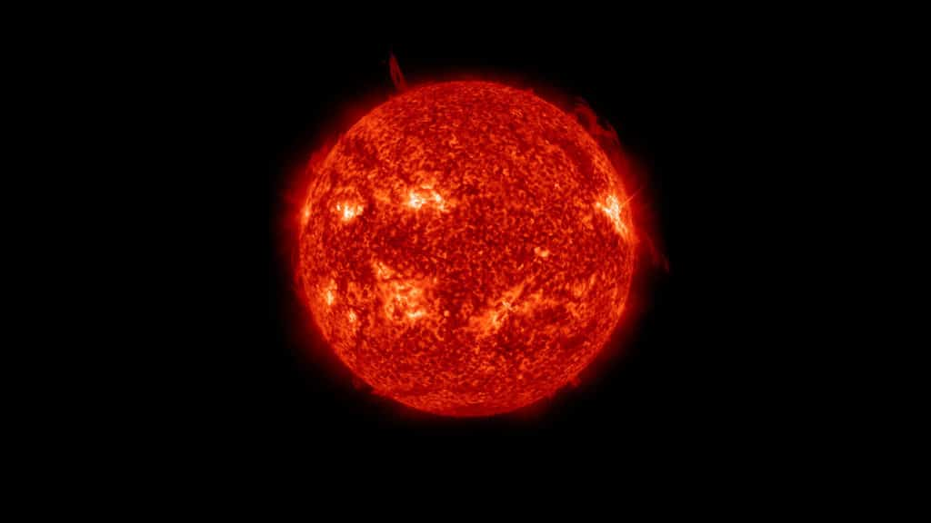
The Sun is a star, the only one we can see during the daytime. When we look in the night sky, we see endless dots of light, every one of them is a star just like our Sun.

Key Facts & Summary
- The Sun is located in the centre of the Solar System. It is a nearly perfect sphere of hot plasma, essentially, a hot ball of glowing gases.
- It is the most important source of energy for life on Earth.
- The Sun has a diameter of around 1.39 million kilometres / 864,000 miles. This is 109 times greater than the diameter of our planet.
- The Sun’s mass consists of 73% hydrogen, 25% helium, and smaller amounts of oxygen, carbon, neon, iron, and other elements.
- The Sun is so massive that it accounts for 99.86% of the total mass of the entire Solar System.
- The Sun currently fuses around 600 million tons of hydrogen into helium every second. It is converting 4 million tons of matter into energy every second as a result.
- This energy is the source of the Sun’s light and heat. It can take between 10,000 and 170,000 years for this energy to escape from the Sun’s core.

- The Sun is approximately 4.6 billion years old.
- Many cultures from around the world associated the Sun with their most important deity or a very prominent one, and for good reason! Without the Sun, we wouldn’t exist.
- The connection and interactions between the Sun and Earth drive the seasons, ocean currents, weather, climate, radiation belts, and aurorae.
- Though there are billions of stars in the galaxy, our Sun will always be the most special star.
- The Sun spins once every 25 days, but at its poles, it rotates once every 35 days.
- The Sun’s core is about 27 million degrees Fahrenheit / 15 million degrees Celsius.
The English word “sun” developed from Old English “sunne.” Many cultures throughout the world had solar deities in their religions and mythologies.

TUESDAY

TOPIC: SUN
Objective: At the end of the lesson the students should be able to know the facts about the Sun.
Activity 1 Complete facts
Complete the sentence about the sun.
- The Sun is a _________ the only one we can see during the ____________.
- The is located in the _____________ of the ________________.
- It is the most important _____________ of life on __________________
- The sun has a diameter of ____________________________________
- The Sun mass consists of 73% ______________, 25% _____________ and smaller amount of ___________, ________________, _____________, ______________ and other ______________.
- The Sun is so massive that it accounts________________ of the total mass of ___________________________________________.
- The currently fusses around ________________ tons of ______________ into ____________ every seconds.
- The Sun is approximately _______________________ old.
- The _______________ and ________________ between the Sun and the Earth drive the ___________, ______________, ______________, _______________, _______________, ___________, _____________.
- There are _______________ of stars in the _____________ but our sun will be the most ______________________________________.
- The once spins every _________________ but at its poles it rotates once every ________________.
- The sun’s ___________ is about ___________ degrees Fahrenheit / ______________ degrees Celsius.
WEDNESDAY

TOPIC: THE SEA
Objective: At the end of the lesson the students should be able to know about sea temperature.
Activity 1 - SEA TEMPERATURE
Read the notes about the Sun.
Water takes in and holds more heat than air and soil. The Sun is the closest to the earth around the equator or in the tropics so the surface temperature of the oceans is greater than in the polar regions.
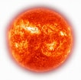

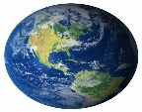

The excess heat of the tropics travel towards the poles. It is carried in the atmosphere as warm sea water. Cool air and water return to the tropics from the Poles to be heated again. This movement of heat allows the tropics to be kept cooler, and the poles to be kept warmer.

Activity 2. Answer the questions
- What holds more heat?
- In what part of the earth, the Sun is closest?
- Which part of the earth, the heat is less?
- Explain how the excess heat of the tropics travel?

THURSDAY

TOPIC: TREES
Objective: At the end of the lesson the students should be able to know how new trees grow.
Activity 1 - GROWING NEW TREES.
Read the notes about the Pollination.

There are number of ways in which a new tree can grow, but the usual way is from a seed.
The works of the flowers.
In the months from June to August, most trees have flowers. Some trees have flowers at other time of the year. Some trees have flowers all year around. The flower has an important part to play in the life of a tree, because from it develops the fruit containing the seeds from which new plants grow.

We have looked at flowers before. This time we are going to learn the names for the different parts of a flower and what their purposes are.

Look at a flower carefully. A Christmas tree flower is a good example. Under the petals are the green sepals which protect the bud. The petals are the brightly coloured part of the flower. There is sometimes a sweet juice called nectar at the bottom of the petals.

Inside the petals you will see thin stalks with powdery yellow dots on the end. These are called stamens and the yellow dots are pollen grains. This is the male part of the flower. Some flower has many stamens, but their petals are small. Do the children know what the flower of a fish poison tree or nakavika looks like? Can they think of other flowers with lots of stamens?

In the Centre of most flowers is a long stalk. This long stalk or tube has a little head on it and the tube leads down to box at the bottom. The tube is called a style. Its head is the stigma and the box at the bottom is the seed-box or ovary. This is the part of the flower in which ovules (eggs) are made and stored. The style, stigma and ovary make up the female part of the flower.

(In some flowers, some of the parts that have been described are not separate but have grown together. They are all there but they are difficult to see. For the reason it is not a good idea for the children to try and name the different parts of a bougainvillea, hibiscus or frangipani flower.)

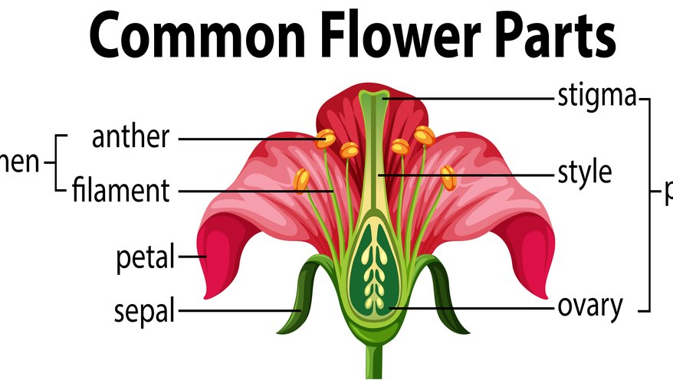
(In some flowers, some of the parts that have been described are not separated but have grown together. They are all there but they are difficult to see. In some ovaries there is only one ovule. In others there are many.

Most trees have the male and female parts together in one flower. Some trees, however like casuarina, have separate male and female flowers. Some trees have either only male flower or female flowers.
Pawpaw flowers

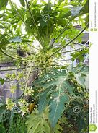
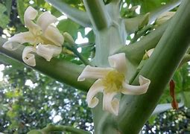
To start a new tree, the pollen from the flower must travel to the ovary, to fertilise the ovules (the developing seeds) in the ovary.
Female flower
Male flower
FRIDAY
TOPIC: TREES
Objective: At the end of the lesson the students should be able to know how new trees grow.

Activity 1 – NEW WORDS
Find the definition of these words.
- Sepal - _______________________________________________________

- Petal - ________________________________________________________

- Nectar - ______________________________________________________

- Stamen - ______________________________________________________

- Style - ________________________________________________________

- Stigma - ______________________________________________________

- Ovary - _______________________________________________________

- Ovule - ________________________________________________________

- Pollen - ______________________________________________________

- Stalk - ________________________________________________________

Activity 2
Complete these sentences.
- Most trees have flowers from the month of ___________ and ___________

- The flower has an important part to in the part of a tree because ________ _________________________________________________________

- The petals are ______________________________________________

- Some flowers have many stamens and the flowers are small and a good example is_______________________ and ____________________

- Most trees have ___________ and _________ parts together in one flower.
WEEK 9
MONDAY
TOPIC: TREES
Objective: At the end of the lesson the students should be able to know the facts about the Sun.
Activity 1 – Pollination
Read the notes about the Pollination.

Do you remember we said that flowers sometimes have a nice smell and that petals have bright colours? This is to attract insects and birds to the flower. An insect or bird lands on the flower and reaches down to the nectar inside the flower. As it does so, some of the pollen gets into its body. When it moves, the pollen is brushed from its body onto the stigma. This process is called pollination.

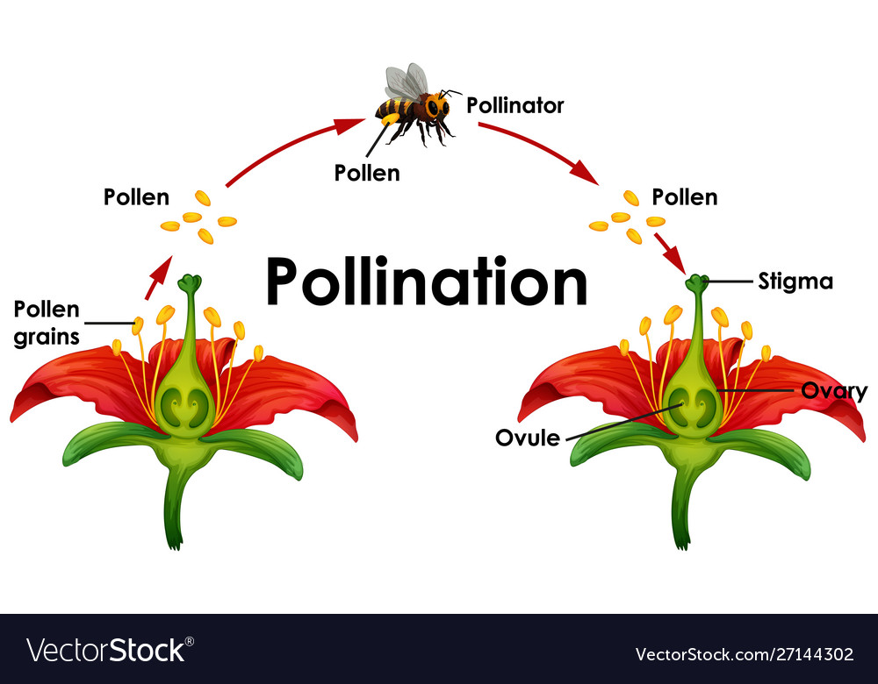

Sometimes the insects or bird takes the pollen from one flower onto the stigma of another flower of the same kind. With plants that have separate male and female flowers, it must go from male flower to a female flower.

When the male flower and the female flower are on different trees, it is more difficult. If you have a female pawpaw tree and you want it to bear fruit, you must make sure that there is a male pawpaw tree growing nearby. Explain to the children that it is not a good idea to cut down all the male pawpaw trees in their garden because they do not have any fruit. For the female tree to bear fruit, pollen must be carried from the flower of the male tree to the flower of the female tree.

Sometimes the wind helps with pollination. Some trees produce a lot of very light pollen which the wind easily shakes from the flowers and carries away. Some of it settles on the other flowers.

Trees that are pollinated by insects or birds usually have large, brightly coloured flowers to attract them. Trees that are pollinated by the wind do not need colorful petals to attract the insects; they usually have smaller flowers which are not so brightly coloured and instead are a greenish or yellowish colour.

TUESDAY
Activity 2 (Continue from Monday lesson)
Look at the trees around your home or in your garden. What are their flowers like? Watch carefully or ask your parents to find out how they are pollinated

Copy this chart in your book and fill in the information

No. | Name of the tree | Petals big or small | Colours bright or not bright | Pollinated by wind/insect/bird
1
2
3
4
5
6
7
8
9
10

WEDNESDAY

Activity 1 – Pollination (Continue from Monday lesson)
Complete the sentences.
- Flowers sometimes have a ____________ and that ___________ have ______ colours.

- This is to attract ___________ and _________ to the flowers.

- Pollination is a process in which____________________________________ ______________________________________________________________

- Sometimes the insects and birds take the ____________ from one flower onto the _________ of another flower of the same kind.

- With plants that have separate _________ and ____________ it must go from a male flower to ____________.

- It is not a good idea to cut down all the male papaws in the garden because________________________________________________________

- Wind also helps with pollination because__________________________

__________________________________________________________________

- Trees that are pollinated by insects usually have _________________________

Trees that are pollinated by wind do not need ___________________________
________________________________________________________________
THURSDAY
TOPIC: HISTORY
Objective: At the end of the lesson the students should be able to know the facts about the new age discover.
Activity 1 – The new discovery
Read the notes about the new age discovery.

Most of the famous explorers of long ago that we have read about so far came from countries that had coast along the shores of the Mediterranean Sea. As hundreds of years passed, some of their discoveries were forgotten. When people in Europe wanted to find out a new way to reach the East Indies by sea, it was explorers from the countries whose coasts were along the edge of the Atlantic Ocean, the countries of Spain, Portugal, England and the Netherlands, who made the important discoveries. Can you find the countries on the map below?

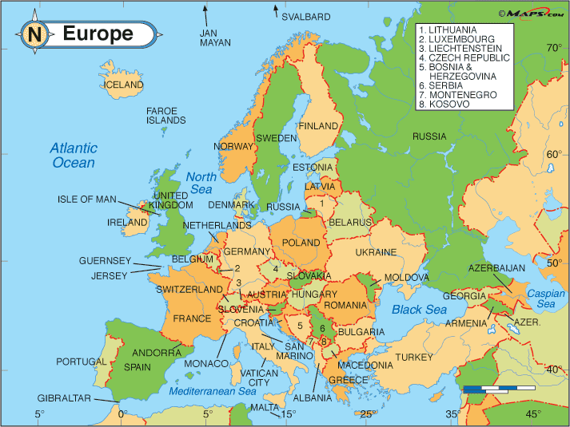
Activity 2
Answer these questions
- Where does most of the famous explorers come from?
- What happened after hundred years passed?
- Explain how people from Europe wanted to find new way to reach West Indies.
- Write the capital cities of these countries, Spain, Portugal, England and Netherlands.
- Name three other countries in the Europe continent.

FRIDAY
TOPIC: HISTORY
Objective: At the end of the lesson the students should be able to know the facts about the new age discovery.
Activity 1 – The new discovery (Continue)
Read the notes about the new age discovery.

In 1416 Prince Henry of Portugal started a school of navigation. People started calling him Henry the Navigator because of this important work. At his school he taught sailors how to use navigation instruments like the compass and the astrolabe and how to make charts of their own. After this, European sailors began to go on well prepared and well organised voyages of exploration. The time of the great discoveries was beginning.
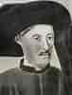

This is the picture of Prince Henry the Navigator

Between 1480 and 1500 Portuguese explorers re- discovered the sea route round the continent of Africa to Asia, this time travelling from West to East. In 1487 Bartholomew Diaz sailed round the Cape of Good Hope at the southernmost point of Africa. In 1498 Vasco da Gama sailed round the Cape of Hope again and then right across the Indian Ocean to South West India.
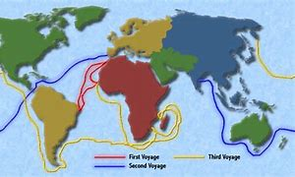

Bartholomew Diaz voyages

Activity 2 – Questions
Answer these questions
- Where Prince Henry from?

- Why did the people call him the navigator?

- What did he teach the sailors in the School?

- How does what he taught in school help the European sailors?

- What happen between 1480 and 1500?

- Explain briefly who is Bartholomew Diaz.

