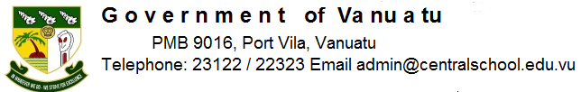

Central School
Home School Package

Year : 5

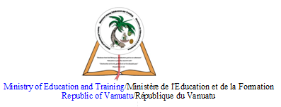

HOME SCHOOL PACKAGE CONTENT
- Lesson 1- What is water.
- Lesson 2 – Substance carried in water.
- Lesson 3 – How much of the Earth is covered with water.
- Lesson 4 – What is air.
- Lesson 5 - The human body and its system continue.
- Lesson 6 – The three food groups.
- Lesson 7 – Waves.
- Lesson 8 – Waves continue.
- Lesson 9 – Current.
- Lesson 10 – Current continue.
- Lesson 11 – Mendana and the isles of Solomon.
- Lesson 12 – Mendana and the isles of Solomon continue.
- Lesson 13 – Quiros crosses the Pacific.
- Lesson 14 - Quiros crosses the Pacific continue

LESSON PLAN

Teacher | Name : Mr Nombong and Mr Bule  Subject : Water

Date
Topic :Whatis water
Lessonnumber : 1

Learning Outcomes | The students will be able to know the:  - The forms of water  - The colour of water  - Water cycle.
Introduction | The studentsdiscuss the forms of water and what water cycle mean to them.
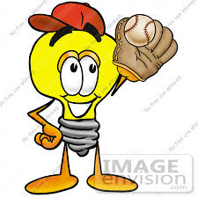 | No water, no life, sacred gift, thank you water.
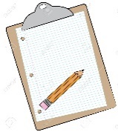  Learners notes | Summary  - Water iseverywhere. Water canbe a liquid , a solid or a gas.  - When water issolid, we call itice. When water isa gaswe call itwater vapour.  - Whatcolouris water ? If water is pure, thenwater vapour, liquid water and solidice are all mostclear and transparent. If they are not, thenthey are impure and containothermaterials.  - Has water got a taste ? Pure water istasteless, but water containingothermaterialswill have some taste.  The water cycle  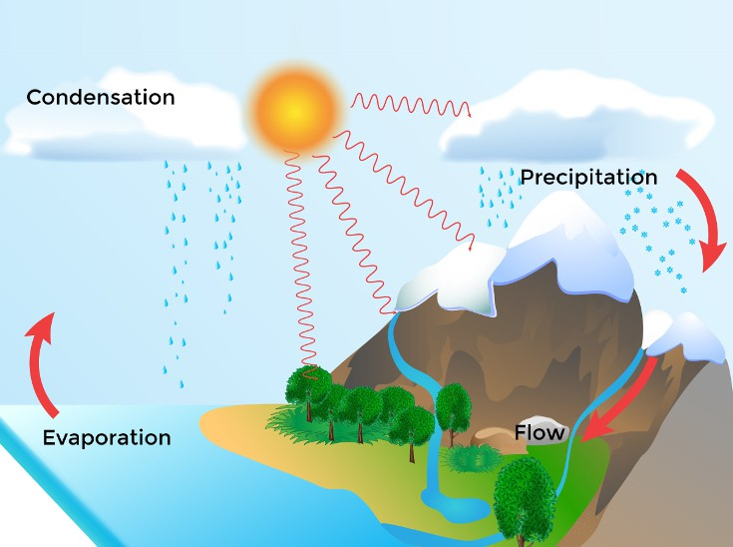  - Water goes round in a cycle and thisiscalled the water cycle.  - Evaporation – the sea water isheated by the sun and changes into water vapour.  - The water vapourrisesinto the atmosphere and cools down.  - Condensation – the water vapour cools and changes back intosmalldroplets of water heldtogether in the form of clouds .  - The windblows the clouds over the land.  - The cloudsrise high into the cold air in the sky and soitrains.  - The rainfallsinto the land and the rivers and streams.  - The rivers flow into the sea. The cycle startsagain.
Questions
1 . Name the 3 forms of water.
2. Describewhen the water is pure.
3.Describe the water cycle.

Assignment
Assessment | test
References

Teacher | Name : Mr Nombong and Mr Bule  Subject : water

Date
Topic : Substance carried in water
Lesson number: 2

Learning Outcomes | The student will be able to understand:  - Materials are carried by water  - Some can dissolve and some can not dissolve in water
Introduction | The students fill glasses with clean and dirty water and look atthe differences.
 | You live without love but not without water.
Learners notes | Summary  - Minerals – As the rainwater and water from the rivers and steams flow over and through the rocks, tiny parts of the rocks are washed off and dissolved in the water. Whenthings dissolve in waterwe are not able to see them. These dissolved materials are called minerals and are washed down to the sea.  - Air – Air also dissolve in water. Fishes and other living things that live in water are able to take in air from the water  - Other Particles – These are other materials which will not dissolve. These make the water cloudy and dark in colour.
 | 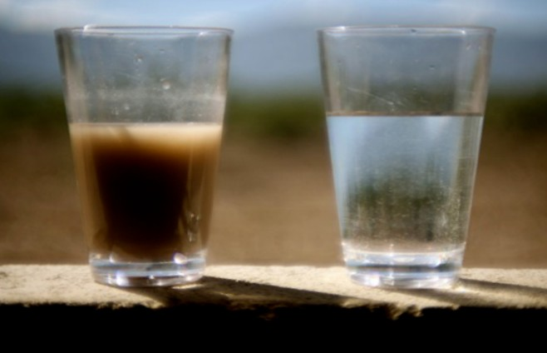
 | Students discuss the differences of the two glasses and write their findings
Assignment | A visit to the river will help the students to see the actual activties.
Assessment | Test
References

Teacher | Name : Mr Nombong and Mr Bule  Subject : Water

Date
Topic : How much of the earth is covered with water?
Lesson number : 3

Learning Outcomes | The students should be able to know that:  - Most of the earth surface is covered by sea water  - The importance of the water.
Introduction | The students watch a video of the land and water and the locations of water.
 | Water is more precious than gold.
Learners notes | Summary  Why is water special?  Water covers more than 70% of the Earth’s surface. The most common locations are in oceans, rivers, lakes and glaciers.  It has special properties:  - It exists in the solid, liquid and gas states at normal temperatures on Earth.  - At 4°C water is at its most dense. Below this temperature, ice is able to float on liquid water.  - Water dissolves many substances, including salts in the sea and proteins in living things.  - Water has a high surface tension , allowing some small insects to walk on its surface.  Water can exist in solid, liquid and gas states at normal temperatures on Earth.  Why is water important?  Water is essential to all animal and plant life on Earth. Plants, for example, use water in photosynthesis to make their food.  Roughly 60% of the adult human body is water and it performs many functions, including:  - Dissolving vital nutrients in the bloodstream and delivering them to cells.  - Regulating our body temperature.  - Dissolving waste substances and carrying them out of the body in urine, faeces and sweat.  - Protecting tissues ,joints and the spinal cord .  Humans need to drink plenty of water to replenish what we lose though sweat, urine, and faeces.
 | 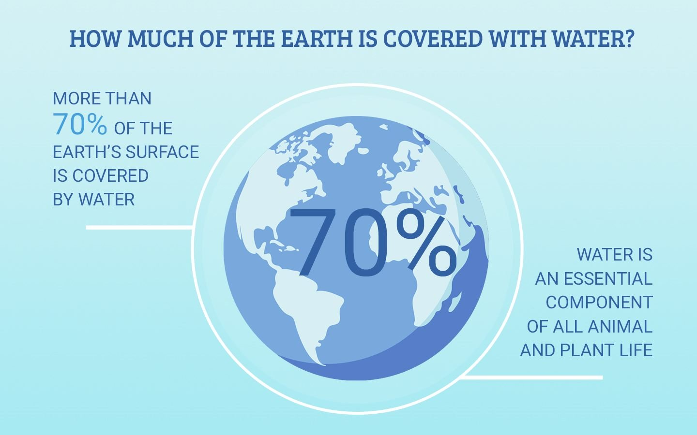
Questions
- How many percent of earth surface iscovered by water ?
- Name the different water locations.
- Describe the importance of water.

Assignment
Assessment | Test
References

Teacher | Name : Mr Nombong and Mr Bule  Subject : Air

Date
Topic :What is air ?
Lesson number : 4

Learning Outcomes | The students will be able to understand what is waterand the importance of water.
Introduction | The students to go out and feel the air blowing against their body, taking deep breaths in and out. Telling the direction of the wind blowing.
 | Breathing is the greatest pleasure in life.
Learners notes | Summary  WHAT IS AIR?  - Air is all around us  - You feel it hitting your face, hands and legs on windy days.  - You see it blowing leaves, twisting fire smoke and flapping clothes on line.  - But you cannot see it or smell it.  - Because air is a mixture of gases which have no colour and no smell.  - Air contains 78% nitrogen, 21% oxygen and 0.03% carbon dioxide. The reminder consists of a group of gases known as the rare gases.  - We need oxygen from the air to keep alive.
 | 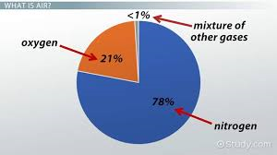
Questions
- What is air ?
- What are the gases contains in the air ?
- What gas do we breathe ?

Assignment
Assessment | Test
References

LESSON PLAN
Teacher | Name :Mr Nombong and Mr Bule  Subject :Health science

Date
Topic :The human body & it’s system
Lessonnumber : 5

Learning Outcomes | The students should be able to:  - Know the parts of the body  - Understand how body works
Introduction | Students name the parts of the body and thier functions to access their prior knowledge regarding the human body systems and allows them to build on that knowledge through group discussion and the creation and analysis of their combined understanding of the topic.
 | The human body is the instrument of our hold on the World.
Learners notes | Summary  The human brain is the command center for the human nervous system. It receives signals from the body's sensory organs and out puts .Each eye constantly adjusts the amount of light itlets in, focuses on objects near and far, and produces continuous images that are instantly transmitted to the brain.The ear's function is to transmit and transduce sound to the brain through the parts of the ear: the outer ear, the middle ear and the inner ear.The human heart is an organ that pumps blood throughout the body via the circulatory system, supplying oxygen and nutrients to the tissues and removing carbondioxide and other wastes.The main function of the lungs is the process of gas exchange called respiration (or breathing). In respiration, oxygen from incoming air enters the blood, and carbondioxide, a waste gas from the metabolism, leaves the blood.The liver's main job is to filter the blood coming from the digestive tract, before passing it to the rest of the body. The liver also detoxifies chemicals and metabolizes drugs. As it does so, the liver secretes bile that ends up back in the intestines. The kidneys perform many crucial functions, including: maintaining overall fluid balance. regulating and filtering minerals from blood. Filtering waste materials from food, medications, and toxic substances.The stomach secretes acid and enzymes that digest food. Ridges of muscle tissue called rugae line the stomach. The stomach muscles contract periodically, churning food to enhance digestion. The pyloric sphincter is a muscular valve that opens to allow food to pass from the stomach to the small intestine. The 4 major functions of the large intestine are recovery of water and electrolytes, formation and storage of faeces and fermentation of some of the indigestible food matter by bacteria. The ileocaecal valve controls the entry of material from the last part of the small intestine called the ileum. The small intestine is the part of the intestines where 90% of the digestion and absorption of food occurs, the other 10% taking place in the stomach and large intestine. The main function of the small intestine is absorption of nutrients and minerals from food.
 | 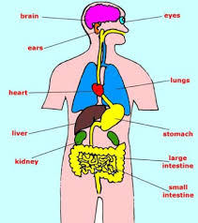
 | Names the parts of the human bodies and their functions.
Assignment
Assessment | Test
References

LESSON PLAN

Teacher | Name : Mr Nombong and Mr Bule  Subject : NUTRITION

Date
Topic : The three food groups
Lesson number : 6

Learning Outcomes | The students will be able to review:  - The three food groups, balanced meals and good and poor choices.
Introduction | The student are ask to bring the three kinds of food for and they will share with each other.
 | Real food real local.
Learners notes | Summary  The three food groups are :  - Body building or growth foods to help grow strong.  - Energy food or power food to help us move, work and play  - Protective food or health foods to help us prevent sicknesses and stay healthy.
 | 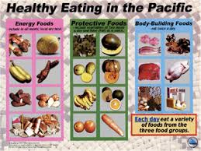
Question.
- Manioc is in what food group ?
- Orange is in what food group ?
- Beef is in what food group ?

Assignment
Assessment | Test
References

LESSON PLAN

Teacher | Name : Mr Nombong and Mr Bule  Subject :TheSea

Date
Topic :Waves
Lesson number :7

Learning Outcomes | The students will be able to know how the waves are form and wave – length and wave-period.
Introduction | The students will brain storm how waves are form and the heights and lengths.
 | The breaking of a wave cannot explain a whole sea.
Learners notes | Summary  - Made by the wind blowing on the surface of the sea.  - Distance between each wave( wave-lenght) and the time between each wave ( wave-period) are controlled by the speed of the wind. Winds often change directions and so make waves which come from different directions have different wave -lengths, wave-periods and speed  - At high tide the waves are high. The sea wind can make them even higher. One after another they crush against the cliffs or break upon the reef or rocks. But they smash some of the rocksalso. Very big rocks fall under the waves. The waves roll them over and over and break them into smaller pieces.The waves grind the pieces together until they are tiny grains of sand. To change big rocks into sand takes thousands and thousands of high tides and hundreds and hundreds of years.  - The size of the waves depends on the strength of the wind and on the distance from which the wave has come. The height of the waveis the vertical distance between the crest( highest point) and the trough ( lowest point)
 | 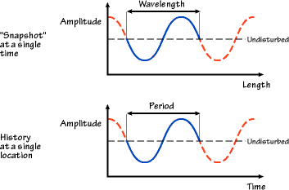
Questions
- What is a wave-length ?
- What is a wave- period ?
- Describe how the sand is made by the waves.
- What is a crest and trough ?

Assignment
Assessment | Test
References

LESSON PLAN

Teacher | Name : Mr Nombong and Mr Bule  Subject : The sea

Date
Topic :Current
Lessonnumber : 8 & 9

Learning Outcomes | The students will be able to understand:  - how the current is form  - what is coriolis effect  - trade winds.
Introduction | The students brainstorm a. trade winds b. coriolis effect c. hemisphere
 | Life is like the sea. Its tides and currents sometimes take a man to distant shores that he never dreamed existed.
Learners notes | Summary  - Sun shines on Earth and it makes the land and sea hot and they both get a little bit bigger. We say they expand  - Where the sun is hottest, around the equator, the heat makes the sea water expand and get lighter and so it moves away from the equator  - The great ocean currents are caused by the wind that always blow from the east between the equator and the tropics. We call them the Trade winds.  - The warm water in the area of the equator crosses the pacific from the east.When it reaches Australia it turns to it left because of the ratational movement of the earth. The current goes on in a southerly direction and carries the warm water into the antarctic region.Here the water iscooled. The current the American continent, it turns to its left and leaves in a northerly direction towards the equator where the water is warmed and begins its circuit again. This why the se ais warm a long the coast of Australia.  - This turning is called the Coriolis effect. The movements of the winds and the marine currents turn to the left in the southern hemisphere( the southern half of the world) and to the right in the northern hemisphere  - Currents are caused by the daily raise and falls of the tides, winds and shifting warm and cool water.They are like rivers in the ocean. The water of a particular current flows constantly in the same direction.
 | 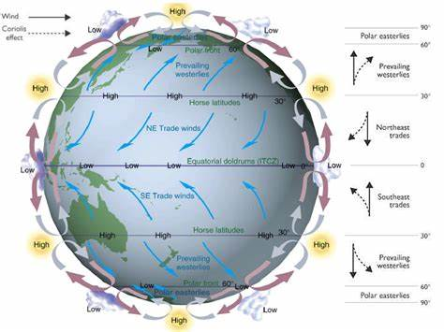
Questions
- How are currents form ?
- What are trade winds ?
- Explain the term ‘coriolis effect’
- What is hemisphere ?

Assignment
Assessment | Test
References
LESSON PLAN

Teacher | Name : Mr Nombong and Mr Bule  Subject :History

Date
Topic :Mendana and the Isles of Solomon
Lesson number : 10 &11

Learning Outcomes | The students will be able to study and know the voyage of Mendana and what was his mission to the Isles of Solomon.
Introduction | The students will recall the previous explorers they have learned and their missions to prepare them for the new lesson.
 | To explore is to come out from comfort zone.
Learners notes | Summary  - Nearly fifty years after magellan’s voyage across the Pacific a young man from Spain called Avero de Mandana led another voyage of discovey for Spain. The king send him to find the southern continent and the rich islands of the Pacific. He told him to to make the native people there Christians.  - For a long time the people of Spain had known the story of King Solomon and his temple in the bible. They thought that the gold that he used to build the temple come from some islands in the Pacific near Spice Islands. It was these islands that the king of spain wanted Mendana to find.  - Eighty days after his ship as left Peru a country on the west coast of South America, Mendana saw land in the distance. The seemed very high. The explorers thought they had at last found the great South Continent. Large number of people armed with bows and arrows and spears came out in very fast canoes to the ships to greet them. The sailors were guided through the reefs a ‘star’ that shone brightly even though it was 10 o’clock in the morning. This was the planetVenus.They named the place that they landed the bay of the star and the land itself Santa Ysabel. The island is still called by thisnametoday. The day Mendana and his men land was February 7th 1568.
 | 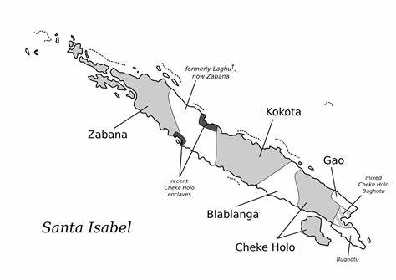
Questions
- Where Mendana from ?
- What was his mission to the Pacific ?
- Who came to meet Mendana’s men after eighty days he left Peru.
- When did Mendana and his men landed in Santa Ysabel ?

Assignment
Assessment | Test
References

LESSON PLAN

Teacher | Name :Mr Nombong and Mr Bule  Subject :History

Date
Topic :Quiros crosses the Pacific.
Lessonnumber :12 & 13

Learning Outcomes | The students will be able to study and know the voyage of Quiros and what was his mission to the Pacific.
Introduction | The students will recall the previous explorers they have learned and their missions to prepare them for the new lesson.
 | You are an explorer and you represent our spieces and the greatest thing you can do is to bring back a good idea.
Learners notes | Summary  - A man called Pedro Fernandez de Quiros had been with Mendana on his last voyage. He thought that Santa Cruz, the Solomon islands and Papua New Guinea, which had been found earlier explorers, must all be fairly close together. He was also sure that the great southern continent could not bevery far away from them. He was a very religious man. He decided that he must find this land. He thought that they were many heathen people there. He wanted to convert them all to Christianity. He planned to build a settlement there so that they could carry out thiswork.  - After years of preparation, heat last set sail from Peru on December 21st 1605. He had with him two small ships and a launch, which between them carried nearly three hundred soldiers and several religious leaders. They took biscuits and other dry food, enough for a voyagé lasting a year, many hundreds of jars of water, and farmtools, fruits and animals to start their new settlement. The pilot of one of the ships said ‘ We sail with good will to serve GOD and spread our Holy Cathlolic faith and to bring credit to our King our Lord’  - The ships spent three and a half months crossing the Pacific Ocean, travelling west as far as Taumaco, an island in the Duff group of the Solomon islands. In all that time they discovered only 14 islands. Most of them were low atolls.They did not dicover any fresh water on any of them. Taumaco was a very different kind of island. There the sailors were glad to be able to get the three things they needed most, drinking water, firewood and food. They stayed on the island for nearly two weeks and the people living there told them about the islands to the south  - They decided to sail in the direction and come first to the island of Tikopia, the most southerly of SolomonIslands. Then they went on further south for three days.  - Just before sunrise on April 25th 1606 they discovered a very high island ahead, which they called San Marcos (Saint Mark) because they first saw it on that day. Saint Mark’s day. The same day they saw another island to the north-west, which they called Los Porttales de Belen.
 | 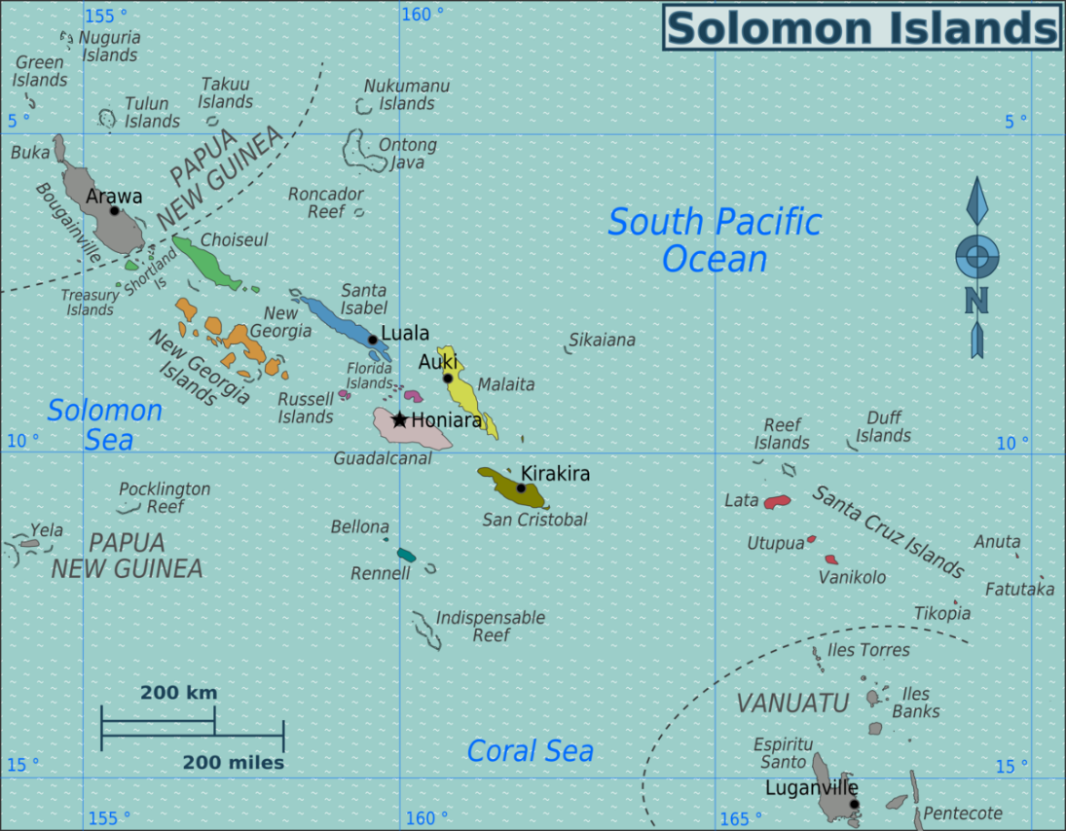
Questions
- Who is Quiros ?
- How many soliders did he take with him on his voyage ?
- How long did the ships cross the Pacific ocean ?
- What happen on April 25th 1606 ?

Assignment
Assessment | Test
References

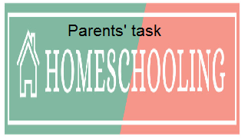

WEEKLY CHECKLIST For Parents:

Term: 2 Week number 1 Date…… to…… Month: …………

Subject | Number of lessons | Days | Tickwhenactivityiscomplete | Parents comment | Signature
 | 1
 | 2
 | 3
 | 4
 | 5
 | 6

Term: 2 Week number 2 Date…… to…… Month: …………

Subject | Number of lessons | Days | Tickwhenactivityiscomplete | Parents comment | Signature
 | 1
 | 2
 | 3
 | 4
 | 5
 | 6

Term: 2 Week number 3 Date…… to…… Month: …………

Subject | Number of lessons | Days | Tickwhenactivityiscomplete | Parents comment | Signature
 | 1
 | 2
 | 3
 | 4
 | 5
 | 6

Term 2 Week number 6 Date …….. to ……. Month………..

Subject | Number of lessons | Days | Tickwhenactivityiscomplete | Parents comment | Signature
 | 1
 | 2
 | 3
 | 4
 | 5
 | 6

Term: 2 Week number 5 Date…… to…… Month: …………

Subject | Number of lessons | Days | Tickwhenactivityiscomplete | Parents comment | Signature
 | 1
 | 2
 | 3
 | 4
 | 5
 | 6

Term: 2 Week number 6 Date…… to…… Month: …………

Subject | Number of lessons | Days | Tickwhenactivityiscomplete | Parents comment | Signature
 | 1
 | 2
 | 3
 | 4
 | 5
 | 6

Term: 2 Week number 7 Date…… to…… Month: …………

Subject | Number of lessons | Days | Tickwhenactivityiscomplete | Parents comment | Signature
 | 1
 | 2
 | 3
 | 4
 | 5
 | 6

Term: 2 Week number 8 Date…… to…… Month: …………

Subject | Number of lessons | Days | Tickwhenactivityiscomplete | Parents comment | Signature
 | 1
 | 2
 | 3
 | 4
 | 5
 | 6

Term: 2 Week number 9 Date…… to…… Month: …………

Subject | Number of lessons | Days | Tickwhenactivityiscomplete | Parents comment | Signature
 | 1
 | 2
 | 3
 | 4
 | 5
 | 6

Term: 2 Week number 10 Date…… to…… Month: …………

Subject | Number of lessons | Days | Tickwhenactivityiscomplete | Parents comment | Signature
 | 1
 | 2
 | 3
 | 4
 | 5
 | 6

Term: 2 Week number 11 Date…… to…… Month: …………

Subject | Number of lessons | Days | Tickwhenactivityiscomplete | Parents comment | Signature
 | 1
 | 2
 | 3
 | 4
 | 5
 | 6

Term: 2 Week number 12 Date…… to…… Month: …………

Subject | Number of lessons | Days | Tickwhenactivityiscomplete | Parents comment | Signature
 | 1
 | 2
 | 3
 | 4
 | 5
 | 6

Term: 2 Week number 13 Date…… to…… Month: …………

Subject | Number of lessons | Days | Tickwhenactivityiscomplete | Parents comment | Signature
 | 1
 | 2
 | 3
 | 4
 | 5
 | 6

