Central School
Home School Package

Year :2
Subject : GENERAL
STUDIES

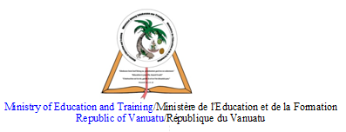

HOME SCHOOL PACKAGE CONTENT

Lesson Number | Subjects | Lesson Topics
L1 | Our Environment | Parts of a plant
L2 | Our Environment | Animals of the sea
L3 | Our Communities | Places around the school
L4 | Our Communities | People at school
L5 | Agriculture | Classifying plants
L6 | Nutrition | Food Classification: Local food
L7 | Health | Functions of our teeth
L8 | Health | Functions of our teeth in nutrition
L9 | Health | The growth of our teeth
L10 | Agriculture | Garden needs
L11 | Our Environment | Animals of the sea
L12 | Our Environment | Fish
L13 | Our Communities | People around the school
L14 | Our Communities | Teachers at school
L15 | Revision Exercise

LESSON Plan

Teacher | Name :Mrs Kalpat & Mrs Rarao  Subject :OurEnvironment

Date
Topic :Parts of a plant
Lesson number :1

Learning outcomes | The stdsshould be able to  - label the parts of a plant  - identify the plants which grow from seeds, bulb and cuttings
Introduction | Discuss the parts of the plant.  Explain that some parts of the plant are used for growing new plants such as seeds.  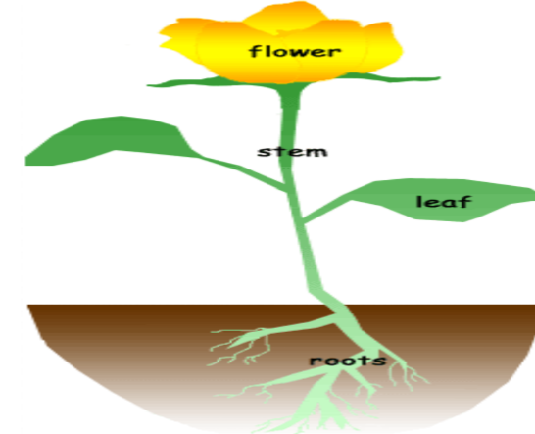
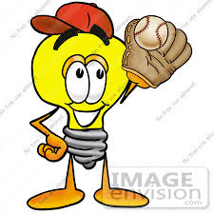 | Catch phrase for the lesson  Some plants grow from seeds, some from bulb and some from cuttings.
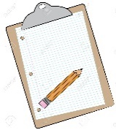  Learners notes | Summary  Takeyourchild outside to visit the plants. Identify the stem, flower and seeds of the plants.  Find out which of the plants grows from seeds, bulb and cuttings.
Activity 1- Parts of the plant. Match
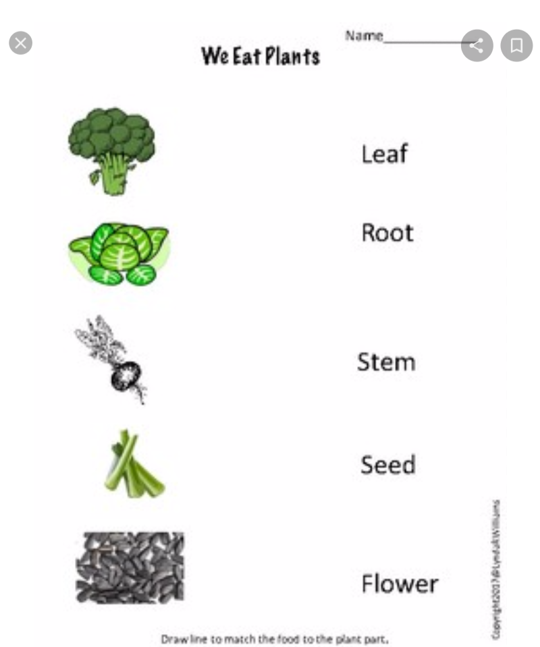

Activity 2
What part of the plant do we plant?
(Seed, Bulb, Cuttings)

a. Mango ____________

b. Lettuce ____________

c. Yam ______________

d. Manioc __________

e. Hibiscus flower __________

f. Coconut _____________

g. Potato ________________.

h. Sun flower ____________

Assignment
Assessment
References | Pg 31(TG)
LESSON Plan

Teacher | Name :Mrs Kalpat & Mrs Rarao  Subject :GeneralStudies

Date
Topic :Animals of the sea
Lesson number :2

Learning outcomes | The stds should be able to  - classify the animals into their correct groupings
Introduction | What is your favourite animal in the sea ?  Give three sentences about your favourite animal.
Catch phrase for the lesson
Sea animals
Learners notes | Summary  Name the different animals of the sea.  The identify the animals  - with shells/without shells  - those that are edible/ non edible  - those that are dangerous/not dangerous  -mammals and reptiles
Activity 1- Match
Edible or Non- Edible

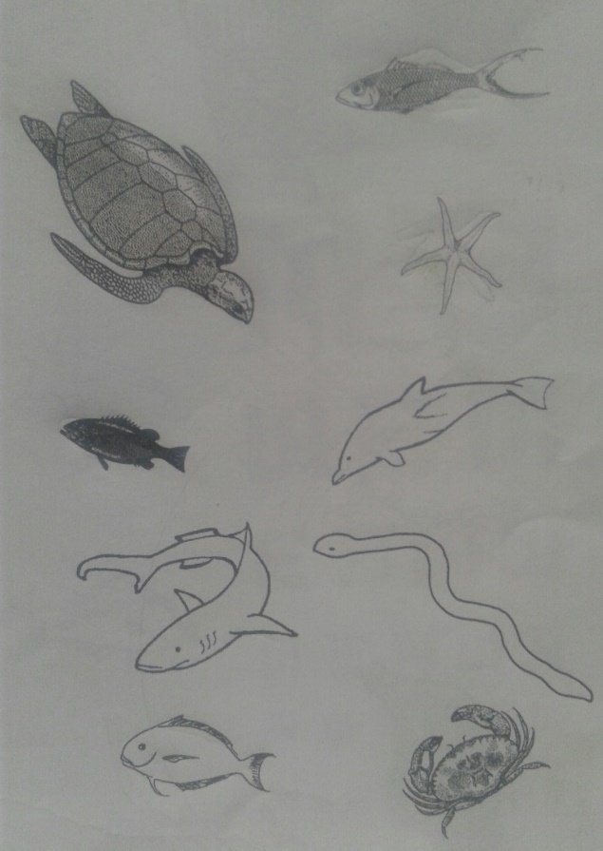
Edible
Non- Edible

Activity 2. Write the names.

a. Name 2 sea animals with shell.
i ____________ ii_______________

b. Name 2 sea mammals.
i ____________ ii _______________

c. Name 2 reptiles in the sea.
i _____________ ii _____________

d.Name 2 dangerous animals in the sea.
i_____________ ii _______________

Assignment
Assessment
References | Pg 35 (TG)

LESSON Plan

Teacher | Name :Mrs Kalpat & Mrs Rarao  Subject :Our Communities

Date
Topic :Places at School
Lesson number :3

Learning outcomes | The stds should be able to identify places around the school and explain their uses.
Introduction | What is the name of this place ?  Do you have this place at your school ?  Do you like this place ? Why ?  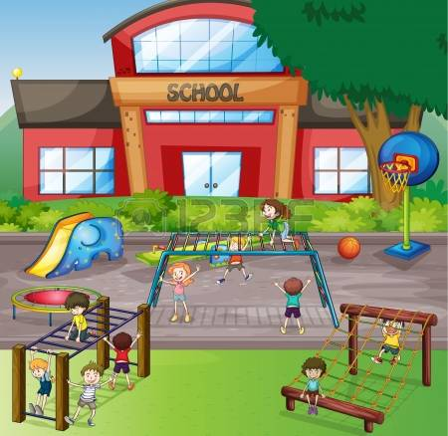
Catch phrase for the lesson
Beware of all areas around the school
Learners notes | Summary  Discuss and explain what these places are used for or why they are important at school.  Library  Clinic  Stage  classroom  canteen  staffroom
Activity
Write the number for each name in the circle.
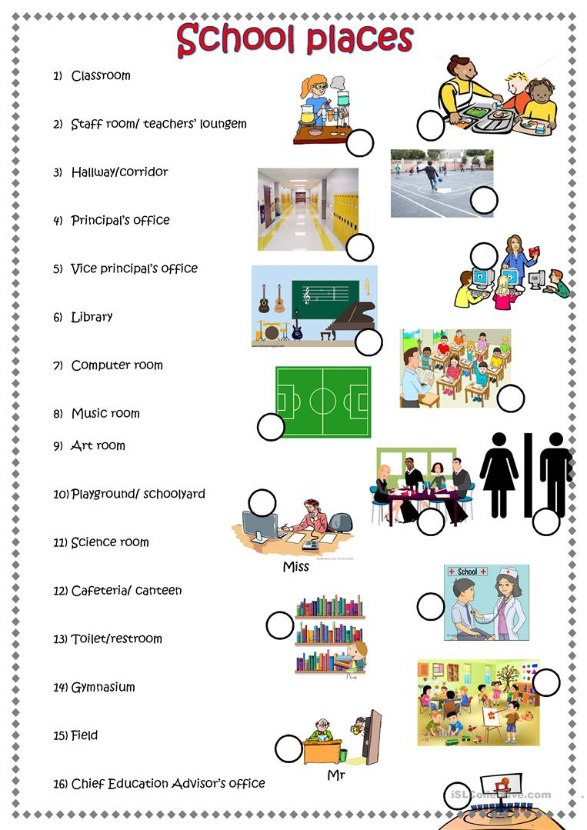

Assignment
Assessment
References | Pg 35(TG)

LESSON Plan

Teacher | Name :Mrs Kalpat & Mrs Rarao  Subject :Our Communities

Date
Topic :People At School
Lesson number :4

Learning outcomes | Be able to  -identify different workers at school  -explain their job.
Introduction | Who is this person in the picture ?  What is his job at school ?  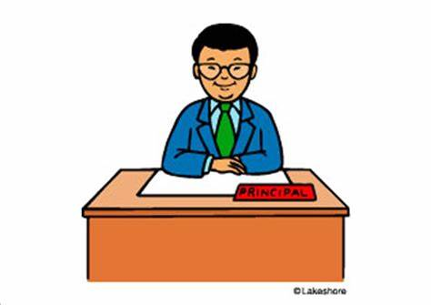
Catch phrase for the lesson
There are many people in my school who work everyday.
Learners notes | Summary  Identify 5 different workers at Central school.  Discuss what job do they do at school.
Label the pictures.
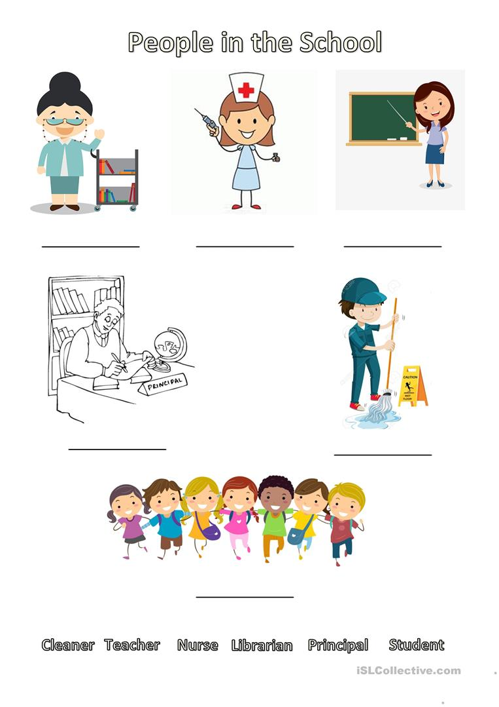
Assignment
Assessment
References | Pg 38(TG)

LESSON Plan

Teacher | Name :Mrs Kalpat & Mrs Rarao  Subject :Agriculture

Date
Topic :Classifying Plants
Lesson number :5

Learning outcomes | Be able to  -classify plants under the two groups,Fruits and Vegetables.  - identify the differences between fruits and vegetables.
Introduction | Introduce the lesson by singing the song ‘Jesus Gave us Pawpaw’  List the fruits and vegetables mentioned in the song.  Sort into groups of fruits and vegetables.
Catch phrase for the lesson
Fruits and Vegetables
Learners notes | Summary  A fruit develops from the flower of a plant.  Fruits contain seeds, while vegetables consist of roots, stems and leaves  Vegetables can be cooked.
Activity 1
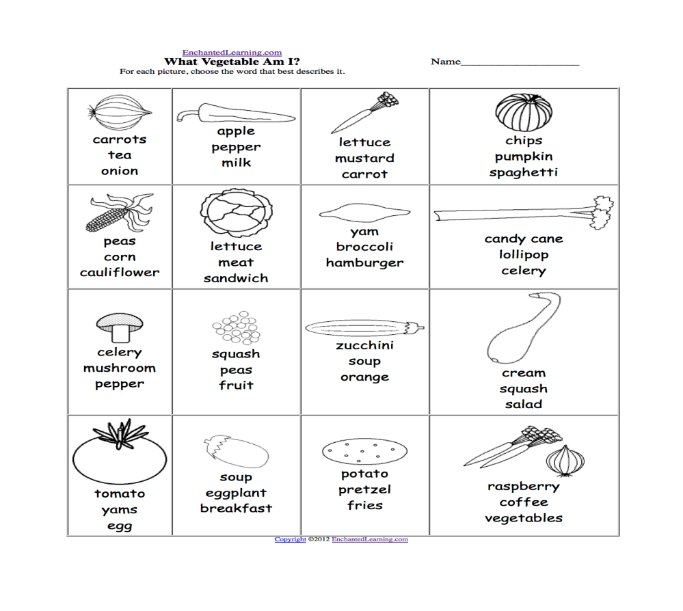

Activity 2
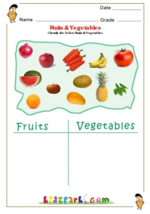

Assignment
Assessment
References

Term: 2 Week number 6 Date…… to…… Month: …………

Subject | Number of lessons | Days | Tick when activity is complete | Parents comment | Signature
 | 1
 | 2
 | 3
 | 4
 | 5
 | 6

LESSON Plan

Teacher | Name :Mrs Kalpat & Mrs Rarao  Subject :Nutrition

Date
Topic : Local Food Classification
Lesson number :6

Learning outcomes | Be able to appreciate and value local food
Introduction | Discuss the food in this picture.  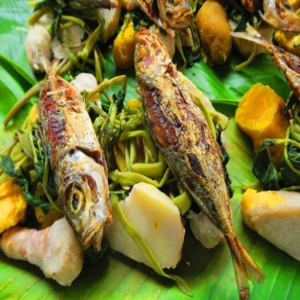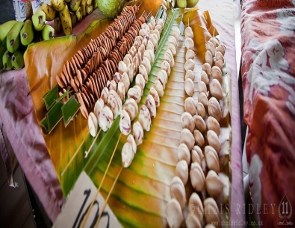  Is this meal nutritious ? Why ?  This meal is consist of different food. List them.  Where can you do you get these food from ?
Catch phrase for the lesson
Local food is nutritious
Learners notes | Summary  Local food is consists of fruits and vegetables farm locally, sea food and nuts. By eating this foods everyday will provide you with more of the nutrients needed to provide you with energy and to keep you healthy.  So you choose — which would you prefer? Fresh fruit and vegetables? Or canned? Or juice?
Activity 1
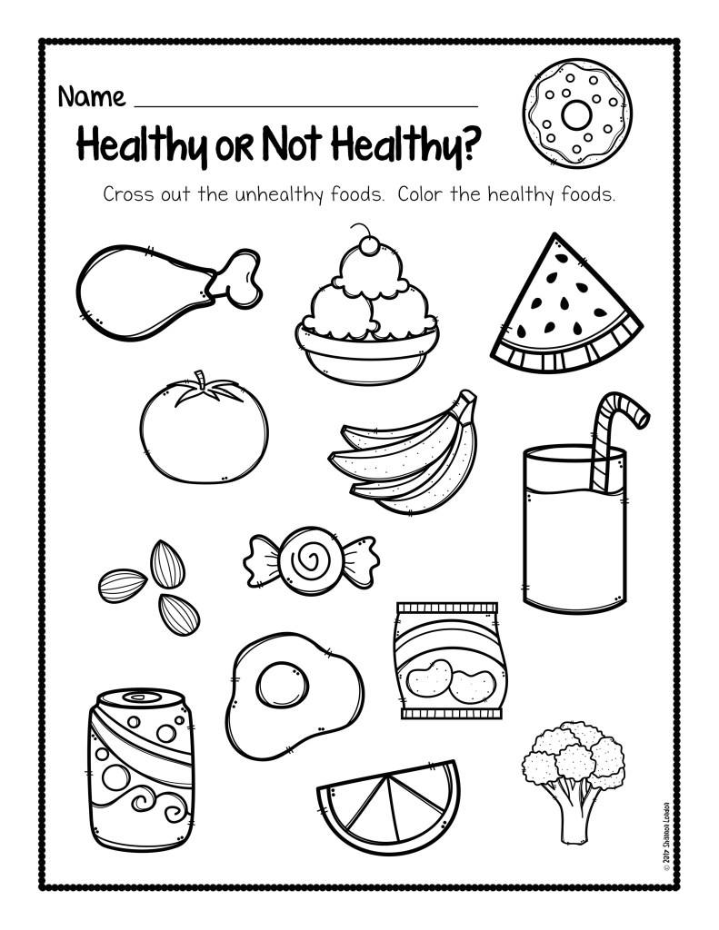

Activity 2
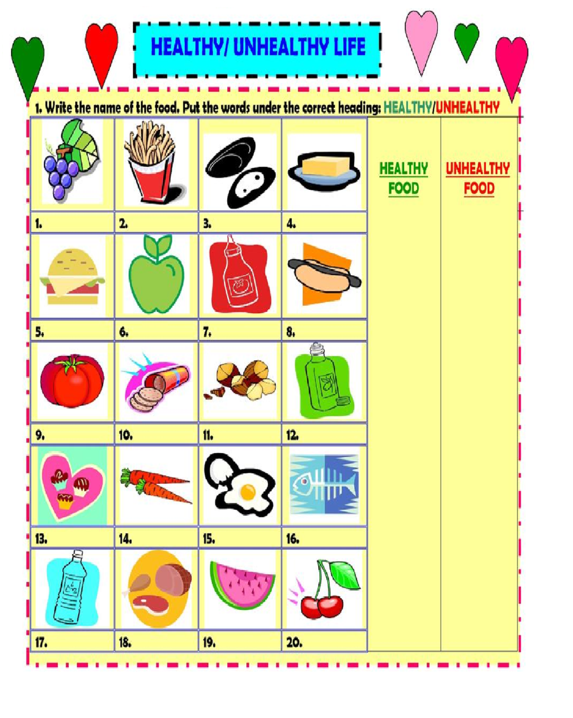
Assignment
Assessment
References

LESSON Plan

Teacher | Name :Mrs Kalpat &Mrs Rarao  Subject : Health

Date
Topic :The functions of our teeth
Lesson number :7

Learning outcomes | Be able to appreciate the functions of our teeth.
Introduction | 1.Ask the stds to look at their teeth in the mirror to know if their teeth are ;  -clean and healthy(no decay)  - same size  -same shape  2. Count how many teeth do they have altogether.  3. Discuss the functions of their teeth.
Catch phrase for the lesson
How good it looks and feels to have clean and healthy teeth.
Learners notes | Summary  Functions of our teeth  Good looks-Our teeth help us to have good looks and  a nice smile  Good eating- Our teeth break food into smaller  pieces so that we can swallow it.  Good speech- Our tongues and lips touch our teeth  so we can make different sounds.
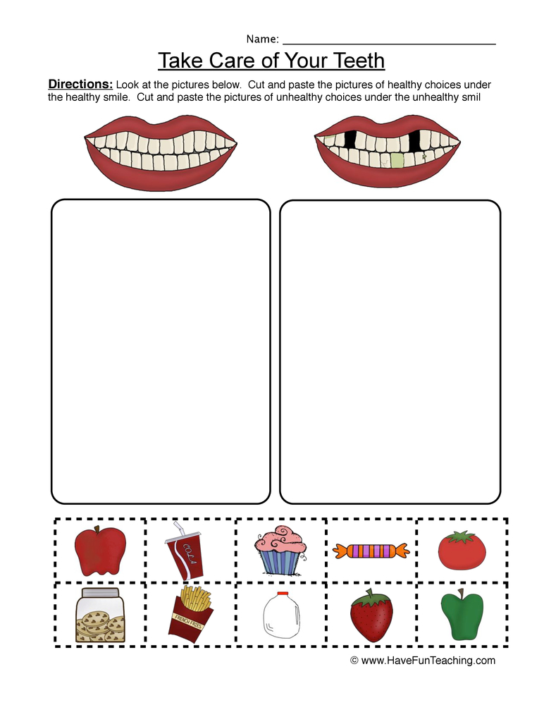
Activity 2
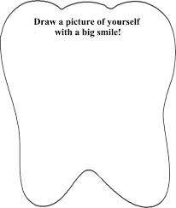
Assignment
Assessment
References | TG- Pg 86 & 87

LESSON Plan

Teacher | Name :Mrs Kalpat & Mrs Rarao  Subject : Health

Date
Topic : Functions of our teeth in nutrition
Lesson number 8:

Learning outcomes | Be able to explain the functions of our front and back teeth
Introduction | 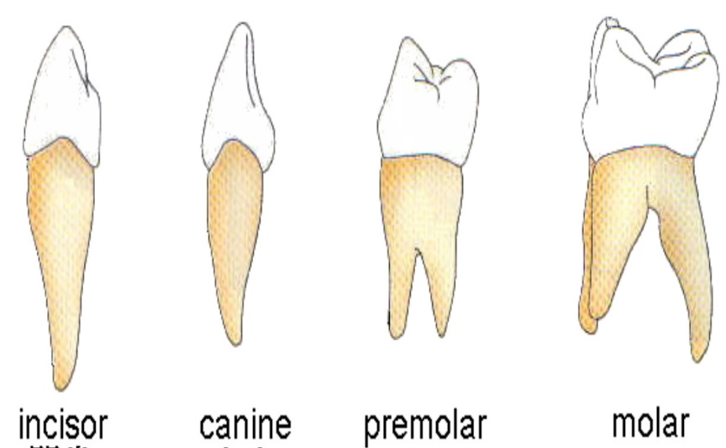  Discuss the differences and functions of the following teeth.
 | Catch phrase for the lesson
Learners notes | Summary  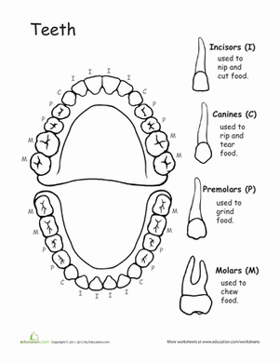
 | 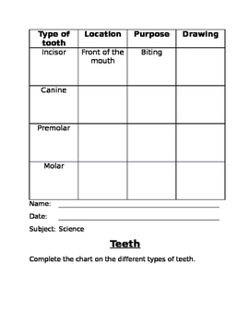
Assignment
Assessment
References | TG - Pg 88 &89

LESSON Plan

Teacher | Name :Mrs Kalpat &Mrs Rarao  Subject :Health

Date
Topic : The growth of our teeth
Lesson number :9

Learning outcomes | Be able to learn how teeth grow.
Introduction | Ask the stds ;  - Did you ever have a tooth come out ?  - Did a new tooth grow back in place of the tooth  that come out ?  - Count how many new teeth have had grown back in place of the fallen teeth.
Catch phrase for the lesson
It is normal to loose all your baby teeth.
Learners notes | Summary  Susan’s Story  Use this story to introduce ‘baby tooth’ and ‘adult tooth’  When Susan was a baby, no one could see any teeth in her mouth. She had gums, but no teeth. When Susan was seven months old, a tooth started to grow out of her gums. Then more teeth grew from her gums. The teeth were growing inside her gums when she was born, then they grew out where they could be seen. These teeth we call ‘baby teeth’ because we get them when we are babies.  Susan is now almost three years old. She has twenty teeth now. She can eat all kinds of food.  Now Susan is six years old.One of her baby teeth has come out. Soon a new teeth will grow in place of the tooth that comes out. The second tooth first grow inside her gum, even though she couldn’t see it. The second tooth will grow out of her gum to take it’s place. This will happen to Susan’s other baby teeth, too. The second tooth is called ‘permanant tooth or adult tooth’. We will have it in our mouth for the rest of our lives.  Susan is twelve years old now. All of her baby teeth have come out, and adult teeth have grown in their place. These teeth first grew inside Susan’s gums. Then they took the place of her baby teeth when the baby teeth came out.
The adult teeth will last our whole lives if we take good care of them.
Write down three simple ways of how to care for our teeth.

- _____________________________________

ii. _____________________________________

iii. _____________________________________

Assignment
Assessment
References | TG- Pg 90 - 99

LESSON Plan

Teacher | Name :Mrs Kalpat & Mrs Rarao  Subject :Agriculture

Date
Topic :Garden Needs
Lesson number :10

Learning outcomes | Be able to know that a healthy garden requires care and attention and identify ways to maintain it to produce good vegetables and plants.
Introduction | Ask these oral questions to start the lesson.  - What is a garden ?  - What do you find in the garden ?  - What do you have to do to get these plants ?  - Do these plants grow all on their own ?
Catch phrase for the lesson
A garden requires care and attention.

Learners notes | Summary  Spend time discussing the introductory question.  What do plants need to grow?  Needs  Good soil (Nutrients)  Water  Air  Light  Space.  Care
Activity 1
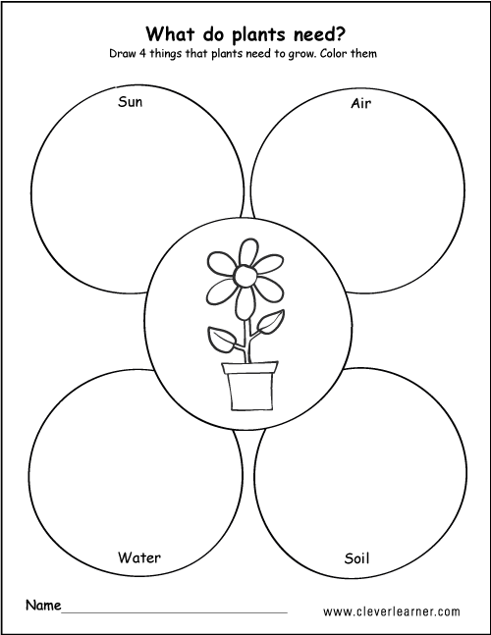
Activity 2
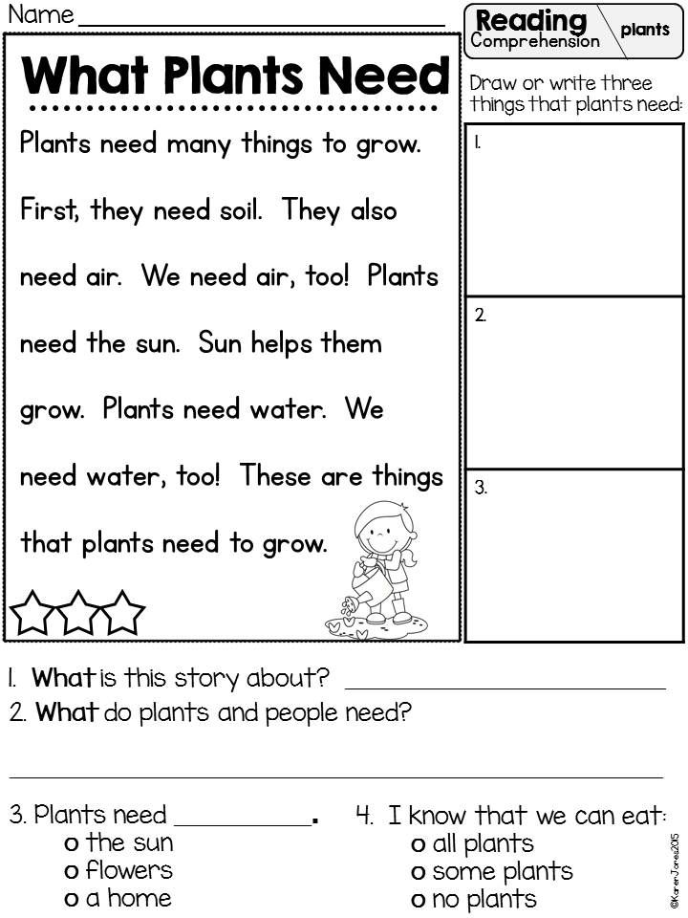

Assignment
Assessment
References | TG- Pg 58

Term: 2 Week number 7 Date…… to…… Month: …………

Subject | Number of lessons | Days | Tick when activity is complete | Parents comment | Signature
 | 1
 | 2
 | 3
 | 4
 | 5
 | 6

LESSON Plan

Teacher | Name :Mrs Kalpat & Mrs Rarao  Subject :Our Environment

Date
Topic : Animals of the sea
Lesson number : 11

Learning outcomes | The stds should be able to  - identify different groups of sea animals  - classify the animals into their correct groupings
Introduction | Name the animals in the picture.  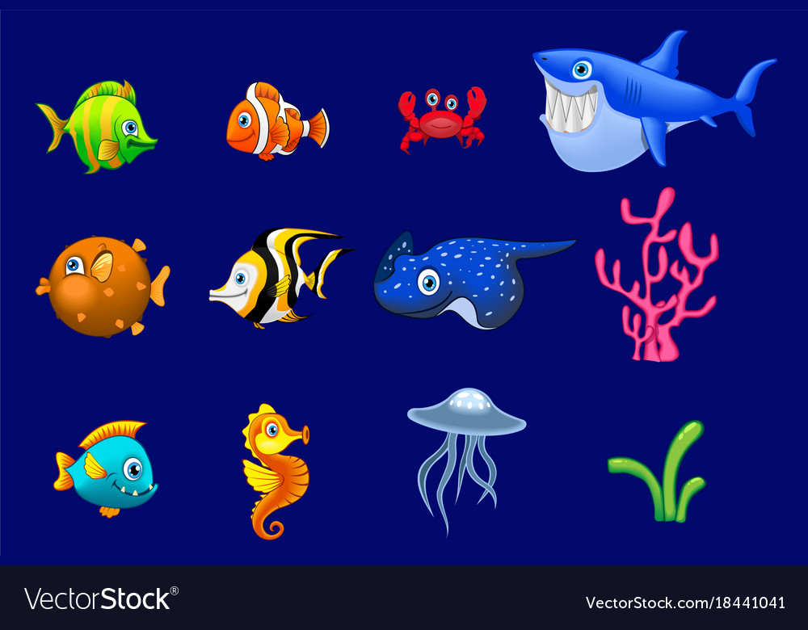
Catch phrase for the lesson
There is a large variety of types of animals in the seas around Vanuatu.
Learners notes | Summary  The children can group the animals according to these groups  - Those with shells  - Those without shells  - Those that are edible  - Those that are non edible  - Those that are dangerous  - Those that are not dangerous  - Those that are mammals
Colour the pictures
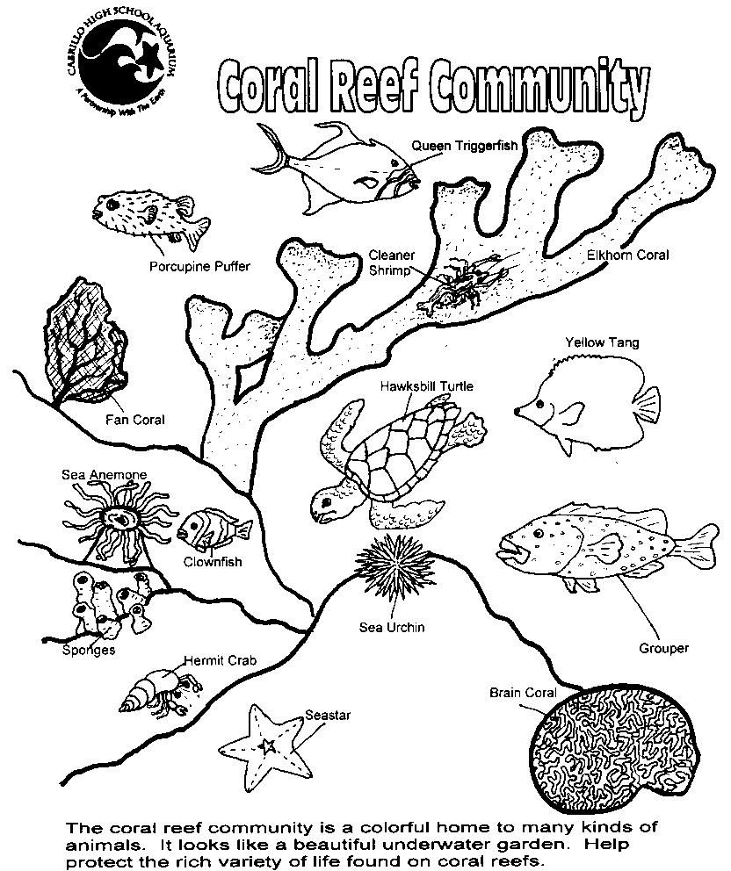

Assignment
Assessment
References | TG- Pg 35

LESSON Plan

Teacher | Name :Mrs Kalpat & Mrs Rarao  Subject :Our Environment

Date
Topic :Fish
Lesson number :12

Learning outcomes | The stds should be able to  - name different fish  - identify reef fish and deep sea fish
Introduction
Catch phrase for the lesson

Reef fish and deep sea fish
Learners notes | Summary  A fish is an animal which lives and breathes in water. All fish are vertebrates (have a backbone) and most breathe through gills and have fins and scales.  The largest fish is the great whale shark.  Fish eat other fish, fish eggs, mollusks, aquatic plants, algae, insects, water birds and turtles.
Match the fish to the correct group.
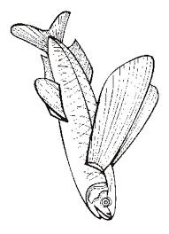
Reef Fish
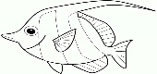
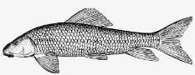

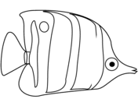
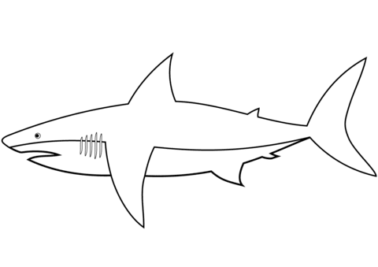
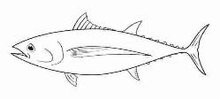
Deep Sea Fish
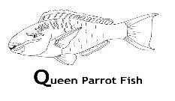

Assignment
Assessment
References | TG- Page 36

LESSON Plan

Teacher | Name :Mrs Kalpat & Mrs Rarao  Subject :Our Communities

Date
Topic : People around the school.
Lesson number : 13

Learning outcomes | Be able to learn which people make up their school community.
Introduction | Identify different people at school and discuss what job they do.
Catch phrase for the lesson
Our school community.

Learners notes | Summary  The class brainstorm ideas to draw up a list of people that make up a school community. This can involve people who visit the school as well as those who work in the school. The people on the list would include children, teachers, principal, parents, teacher assisstants, office workers, cleaners etc.
Choose the words from the list to complete the sentences.
security, teacher, nurse, principal, cleaner, students, librarian

1. 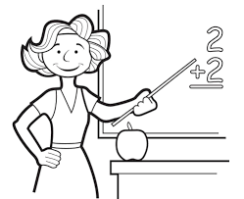 She is the ___________.
2. 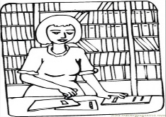 She is the ____________.
3. 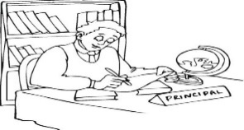 He is the ______________.
4. 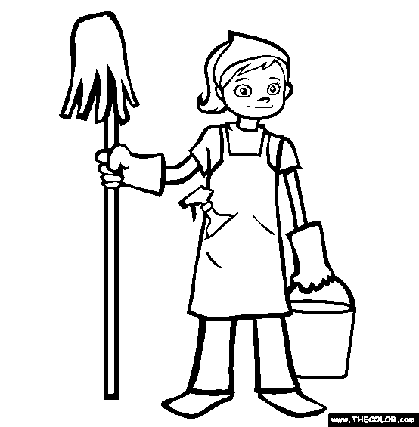 She is the __________________.
5. She is the ______________.

6. 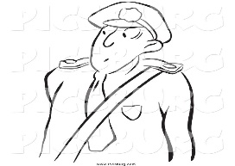 He is the __________________.
7. 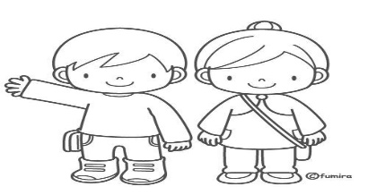 They are the ________________.

Assignment
Assessment
References | TG- Page 39

LESSON Plan

Teacher | Name :Mrs Kalpat & Mrs Rarao  Subject :Our Communities

Date
Topic :Teachers at school.
Lesson number :14

Learning outcomes | Be able to  -learn which people make up their school community.  - identify teachers of their school and the classes they teach.
Introduction | Who is a Teacher  What is the Teachers job ?  Discuss other jobs the teacher does at school apart from teaching.
Catch phrase for the lesson
Teachers are members of the school community.
Learners notes | Summary  Teachers at Central Primary School  Grade Teacher Grade Teacher  1A Mrs Tatangis 4A Mr Daniel  1B Mrs Lui 4B Mrs Nampas  2A Mrs Kalpat 5A Mr Bule  2B Mrs Rarao 5B Mr Nombong  3A Ms Barth 6A Mrs Edmond  3B Ms Willie 6B Mr Tambe
Complete the chart
Year 3 Teachers
Ms _________& Ms __________

Year 6 Teachers
Mrs ________ & Mr ________
Year 1 Teachers
Mrs _____________&
Mrs _______________

Mrs ________________
Headteacher (Primary)

Year 4 Teachers
Mr _______________&
Mrs ______________

Year 2 Teachers
Mrs ___________&
Mrs ____________

Year 5 Teachers
Mr ___________ & Mr ______________

Assignment
Assessment
References

LESSON Plan

Teacher | Name :Mrs Kalpat & Mrs Rarao  Subject : Genera Studies

Date
Topic :Revision
Lesson number :15

Learning outcomes | To revise the contents learned in the lessons taught.
Introduction
 | Catch phrase for the lesson
Learners notes | Summary
Revision Exercise

- Label the parts of the tree below.
roots, stem, fruits, flower

2. Match the animals to the correct group.
Edible
Non- Edible NNNnNNNNNon- edible

3.Who does this job at school? Choose the name from the box below. (5mks)
Nurse, Cleaner, Teacher, Principal, Driver,

- Sweep the classrooms. _________________.
- Drives the school truck. _________________
- Teachers the children. __________________
- Ensure daily activities are carried out. _______________.
- Treats a sick student. ____________________

4. Plant needs. Match.

5. Draw the food to match the set of tooth of a person.(4mks)

Assignment
Assessment
References

Term: 2 Week number 8 Date…… to…… Month: …………

Subject | Number of lessons | Days | Tick when activity is complete | Parents comment | Signature
 | 1
 | 2
 | 3
 | 4
 | 5
 | 6

Term: 2 Week number 9 Date…… to…… Month: …………

Subject | Number of lessons | Days | Tick when activity is complete | Parents comment | Signature
 | 1
 | 2
 | 3
 | 4
 | 5
 | 6

Term: 2 Week number 10 Date…… to…… Month: …………

Subject | Number of lessons | Days | Tick when activity is complete | Parents comment | Signature
 | 1
 | 2
 | 3
 | 4
 | 5
 | 6

Term: 2 Week number 11 Date…… to…… Month: …………

Subject | Number of lessons | Days | Tick when activity is complete | Parents comment | Signature
 | 1
 | 2
 | 3
 | 4
 | 5
 | 6

Term: 2 Week number 12 Date…… to…… Month: …………

Subject | Number of lessons | Days | Tick when activity is complete | Parents comment | Signature
 | 1
 | 2
 | 3
 | 4
 | 5
 | 6

Term: 2 Week number 13 Date…… to…… Month: …………

Subject | Number of lessons | Days | Tick when activity is complete | Parents comment | Signature
 | 1
 | 2
 | 3
 | 4
 | 5
 | 6

