Central School
Home School Package

Year :2

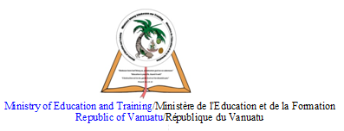

HOME SCHOOL PACKAGE CONTENT

Lesson Number | Page Number
1 | 3 - 6
2 - 5 | 7 - 8
Parent’s Checklist | 9
6 | 10 - 14
7 - 10 | 15 - 16
Parent’s Checklist | 17
11- 12 | 18 - 19
13 - 15 | 20 - 21
Parent’s Checklist | 22

LESSON Plan

Teacher | Name : Mrs Rarao/ Mrs Kalpat  Subject : Language
Date | 22/06/20
Topic : Verbs
Lesson number :1

Learning outcomes | To know the verbs ‘is, am,are’.  To know when to use the verbs in sentences
Introduction | Explains the words- is- it is a verb  Am- it is a verb  Are- it is a verb  These words are used in sentences  Also has, have,had are verbs used in sentences.  We have, they have… she has, he has, it has…  Past tense we use ‘had’. Eg.We had our louvres broken last night
Catch phrase for the lesson
I am writing
They are writing
She is writing
Learners notes | Summary- The students need to know the words and be able to use them in the sentences. They need to understand the meanings and soc an use them in sentences correctly.
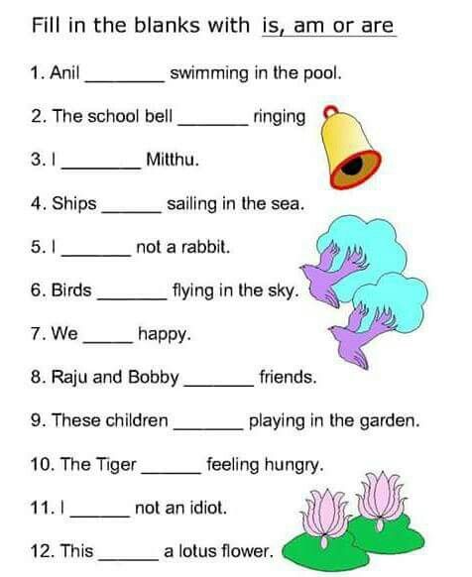
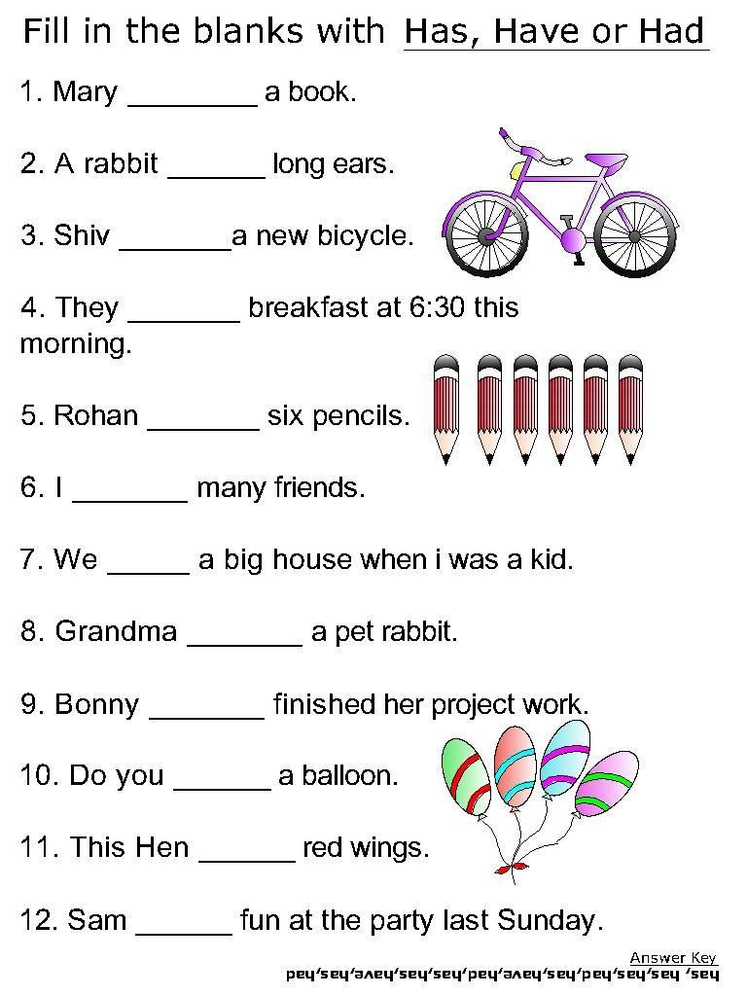

Assignment
Assessment
References

LESSON Plan

Teacher | Name : Mrs Rarao/ Mrs Kalpat  Subject : Language
Date | 23/06/20 -26/06/20
Topic : Sounds (Unit 18)
Lesson number : 2 - 5

Learning outcomes | To know the sound ‘oa’ as in boat.. ‘o--e’ as in rose… ‘o’ as in comb..
Introduction | To introduce the sound, explain the difference between ‘o’ as in orange are short ‘o’ sound.  The ‘oa’, ‘o—e’, ‘o’ are long sound
Catch phrase for the lesson
Chant – ‘Row the boat, oa,oa,oa
Row the boat, oa, oa,oa
Row the boat, oa, oa,oa
That is the sound that o a makes’
Learners notes | Summary- Students will mix up sounds like this especially when there is ‘o’ and ‘oa’. So it is important to go slowly explaining the activities so they can understand better and be able to do the work well.  Point to the word as he/she says the word  Make sounds and say the word. Eg. g o ----go  g o es -------goes , s o l d ---- sold  Start doing the activity
Act 1 and 2 – Tue,
Act 3 and 4- Wed
Act 5 and 6- Thurs
Act 7 - Fri
Assignment
Assessment
References | Sound Waves 2. Unit 18. Pages 42-43

Term: 2 Week number 6 Date…… to…… Month: …………

Subject | Number of lessons | Days | Tick when activity is complete | Parents comment | Signature
 | 1
 | 2
 | 3
 | 4
 | 5
 | 6

LESSON Plan

Teacher | Name : Mrs Rarao/ Mrs Kalpat  Subject : Language
Date | 29/06/20
Topic : Nouns
Lesson number : 6

Learning outcomes | To know what nouns are  when to use them in sentences
Introduction | What are nouns ? Nouns are naming words .  Names of people- Tom, Kim, Tina  Names of Places- Pango, Santo, Australia  Names of animals or things- Dog, table, tree
Catch phrase for the lesson
Nouns are ‘Naming Words’
Learners notes | Summary- Nouns are naming words and students need to know the words so can be able to use them correctly in sentences.  This can be names of animals, people, places, or objects.  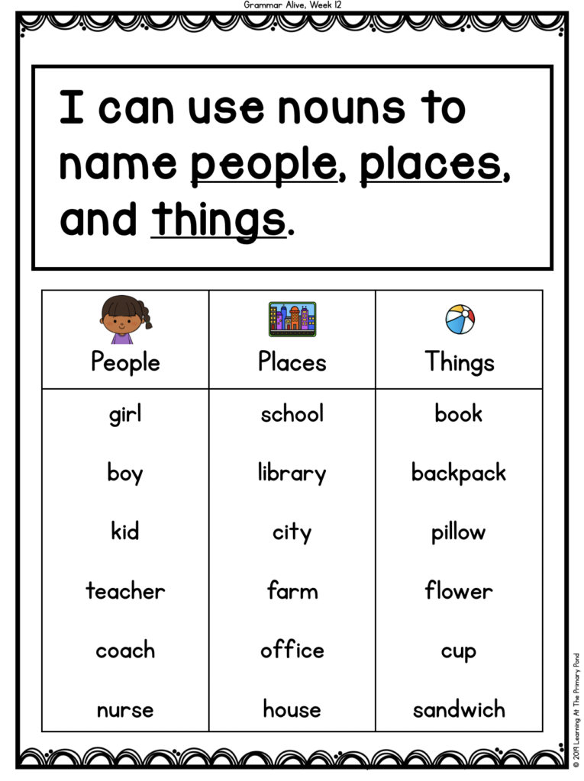
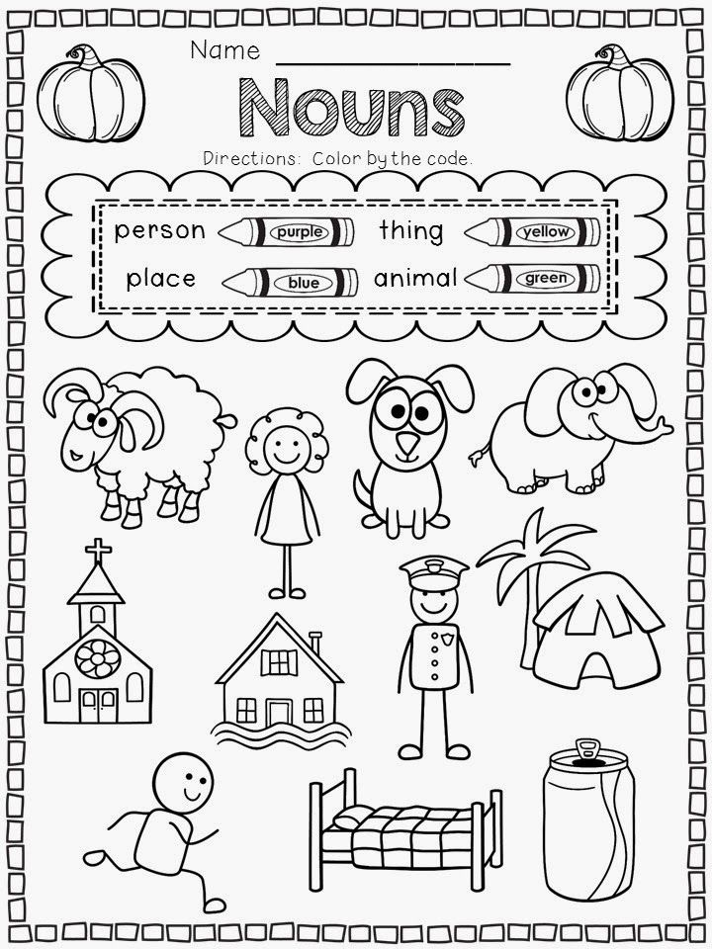
- 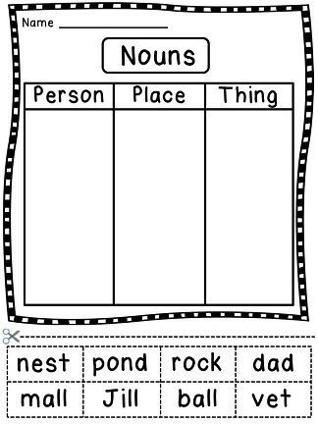
Assignment
Assessment
References

LESSON Plan

Teacher | Name : Mrs Rarao/Mrs Kalpat  Subject : Language
Date | 30/06/20- 3/07/20
Topic : Sounds (Unit 19)
Lesson number : 7- 10

Learning outcomes | To know the sound n, nn, ng and when to use the in sentences
Introduction | Introduce the sound  Students say words with the sound or names with the sound
Catch phrase for the lesson
Chant ‘Nanny has a net n, n, n
Nanny has a net n, n, n
Nanny has a net n, n, n
That is the sound that n makes’
Learners notes | Summary - The students need to know the sounds well before they carry out the activities. It is important that they go through the list words everday before carrying out the activities.
Act 1 and 2 – Tues(pg 44)
Act 3 – Wed(Pg 44)
Act 1and 2 – Thurs (pg 45)
Act 3 – Fri (pg 45)

Assignment
Assessment
References | Sound Wave 2- Unit 19. Pages 44-45

Term: 2 Week number 7 Date…… to…… Month: …………

Subject | Number of lessons | Days | Tick when activity is complete | Parents comment | Signature
 | 1
 | 2
 | 3
 | 4
 | 5
 | 6

LESSON Plan

Teacher | Name : Mrs Rarao/Mrs Kalpat  Subject :Language
Date | 6/07-7/07
Topic : Reading Comprehension
Lesson number : 11-12

Learning outcomes | To be able to read a story  Be able to comprehend to the activities allocated
Introduction | Talk about Hens  Why hens lay eggs  Students can talk about their own hens(if any)
 | Catch phrase for the lesson
Learners notes | Summary- Students need to read with understanding . They need to express themselves and talk about the story in their own words to show that they understand readings.
 | 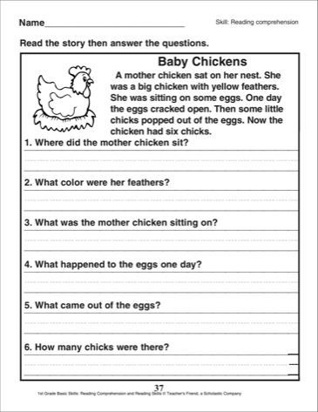
Assignment
Assessment
References

LESSON Plan

Teacher | Name : Mrs Rarao/Mrs Kalpat  Subject : Language
Date | 8/07 – 10/07
Topic :Sound
Lesson number :13 - 15

Learning outcomes | To know the sound ‘ar, a’and when to use the words in sentences
Introduction | Introduce the sound, ‘ar’ as in star  ‘a’ as in ask  Explain the difference between ‘a’ as in ‘bad’as it is a short ‘a’ and ‘ar’ as in star is a long ‘ar’
 | Catch phrase for the lesson
Learners notes | Summary - The students need to know the sounds well before they carry out the activities. It is important that they go through the list words everday before carrying out the activities.
Act 1 and 2 - Wed
Act 3 and 4 – Thurs
Act 5 and 6 - Fri

Assignment
Assessment
References | Sound Wave 2 – Unit 20 Pages 46-47

Term: 2 Week number 8 Date…… to…… Month: …………

Subject | Number of lessons | Days | Tick when activity is complete | Parents comment | Signature
 | 1
 | 2
 | 3
 | 4
 | 5
 | 6

