Central School
Home School Package

Year : 1

HOME SCHOOL PACKAGE CONTENT
CONTENT | PAGE NUMBER
Lesson Plan WEEK 6 | 3 - 16
Lesson Plan WEEK 7 | 17 - 31
Lesson Plan WEEK 8 | 32 - 47
Parent’s Home Schooling Checklist | 48 - 54

LESSON PLAN FOR WEEK 6 SIX
Teacher | Name :Diana Maranda Lui/Rita Tatangis  Subject :Language (Grammar / Sounds Waves)
Date | Monday 29th June 2020
Topic : Nouns / Sound s/ss/x(ks)
Lesson number :1

Learning Outcomes | .The students to identify the different nouns in a sentence and tell if a noun is a place , person or thing.  .Students to identify the different words that sound with s, ss and ks
Introduction | . Review the activity using picture cards to identify the nouns and tell if a noun name is a place , person or thing.  . Students to identify the different words and sounds with letter s, ss and ks by reading and spell correctly.  .Introduce the activity with specific examples using sound waves.
Catch phrase for the lesson
. Twenty Hats
Learners notes | Summary  . Look at the sentence  Twenty Hats (It describes a noun)  . Encourage the students to name all nouns they see around them either the name of a person , thing or a place.  .Students to know to spell and write the words with the sound of s , ss and ks .
Parts Of Speech : Nouns
Instructions : Look for the underlined noun in each sentence. Tell if the noun is a person, place or thing.

For example : The store is open on Sunday place
1.The car was in front of the house __________
2.She was going to catch the ball __________
3.I could not see the boy __________
4.Chips are my favorite snack __________
5.I got two books from the library __________
6. My teacher is very nice to the class ___________
7.We saw the last leaf fall. ____________
8. He left his bag at the school. ____________

Sound Wave Activity
. Do activity 1 (Page 21)

Assignment
Assessment | . Review the activity by doing a labelling activity to identify the different nouns
References | . Sound Wave Book

LESSON PLAN
Teacher | Name :Diana Maranda Lui & Rita Tatangis  Subject :Language
Date | Tuesday 30th June 2020
Topic : Grammer / Sound Waves
Lesson number : Two (2)

Learning Outcomes | .The children should understand when to use nouns and why it’s important to use.  . The sound of letter s, ss , x (ks) in different words
Introduction | .Briefly review to create sentences using nouns by looking at the different pictures  . Introduce the activity by making an illustration using two children and describe .  . Review the sound s of letter s, ss, x(ks)
.Catch Phrase For The Lesson

The very old shoe

Learners Notes | Summary  .Look at the sentence and identify the noun phrase in this sentence  For example :  The very old shoe  Head word( it is a noun )  Information about the shoe
Examples Of Noun
Underline the nouns in a sentence
1.The cat jump over the moon.
2. The girls cooked the taro and fish

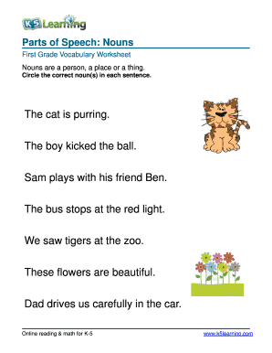

. Sound Wave Activity
-Activity 2 (Sound Wave page 21)

Assignment | -
Assessment | -
References | .Sound Wave Booklet

LESSON PLAN
Teacher | Name :Diana Maranda Lui/Rita Tatangis  Subject :Language (Grammar / Sounds Waves)
Date | Wednesday 1st July 2020
Topic : Nouns / Sound s/ss/x(ks)
Lesson number :3

Learning Outcomes | .The students to identify the different nouns in a sentence and tell if a noun is a place , person or thing.  .Students to identify the different words that sound with s, ss and ks
Introduction | . Review the activity using picture cards to identify the nouns and tell if a noun name is a place , person or thing.  . Students to identify the different words and sounds with letter s, ss and ks by reading and spell correctly.  .Introduce the activity with specific examples using sound waves.
Catch phrase for the lesson
Mobile Phone
Learners notes | Summary  . Look at the sentence  Mobile Phone (It describes a noun,name of an object)  . Encourage the students to name all nouns they see around them either the name of a person , thing or a place  .Students to know to spell and write the words with the sound of s and S
Parts Of Speech : Nouns
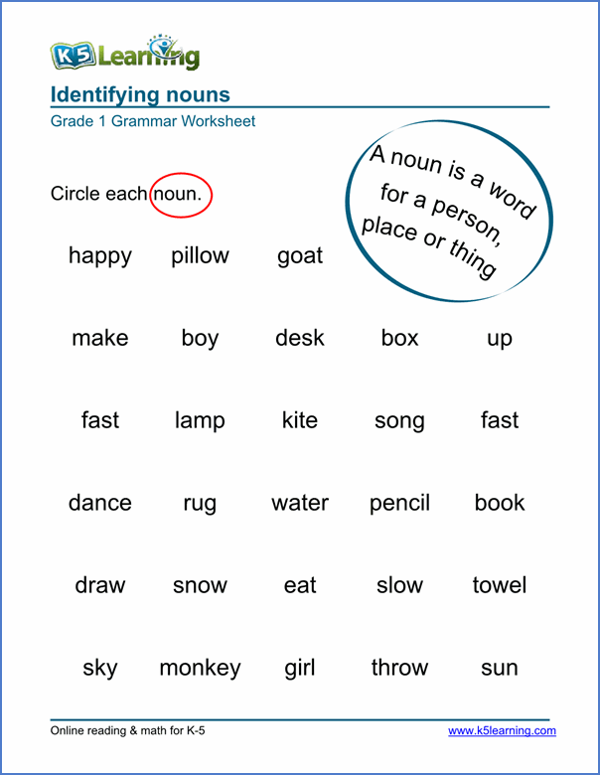

Sound Wave Activity
. Do activity 3 (Page 21)

Assignment
Assessment | . Review the activity by doing a labelling activity to identify the different nouns
References | . Sound Wave Book

LESSON PLAN
Teacher | Name :Diana Maranda Lui/Rita Tatangis  Subject :Language (Grammar / Sounds Waves)
Date | Thursday 2nd July 2020
Topic : Nouns / Sound s/ss/x(ks)
Lesson number :4

Learning Outcomes | .The students to identify the different nouns in a sentence and tell if a noun is a place , person or thing.  .Students to identify the different words that sound with s, ss and ks
Introduction | . Review the activity using picture cards to identify the nouns and tell if a noun name is a place , person or thing.  . Students to identify the different words and sounds by reading and spell correctly.  .Introduce the activity with specific examples using sound waves.
Catch phrase for the lesson
The Thick Textbook
Learners notes | Summary  . Look at the sentence  The Thick Textbook (it describes a noun )  . Encourage the students to name all nouns they see around them either the name of a person , thing or a place  . Students to know to spell and write the words with the correct spelling also creating own sentences using these words.
Parts Of Speech : Nouns

Activity 1
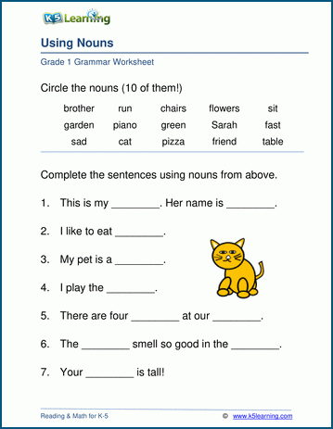

Activity 2: Sight Words

Instructions: Create your own sentence using these words

- With
- I
- He
- Her
- The

_____________________________________________________

_____________________________________________________

_____________________________________________________

_____________________________________________________

Assignment
Assessment | . Review the activity by doing a labelling activity to identify the different nouns  .Spell and write the sight words correctly
References

LESSON PLAN
Teacher | Name :Diana Maranda Lui/Rita Tatangis  Subject :Language (Grammar / Sounds Waves)
Date | Friday 3rd July 2020
Topic : Nouns / Sound s/ss/x(ks)/ Sight Words
Lesson number :5

Learning Outcomes | .The students to identify the different nouns in a sentence and tell if a noun is a place , person or thing.  .Students to identify the different sight words by spell and write the words correctly.
Introduction | . Review the activity using picture cards to identify the nouns and tell if a noun name is a place , person or thing.  . Students to identify the different words and sounds by reading and spell correctly.
Catch phrase for the lesson
The new car
Learners notes | Summary  . Look at the sentence  The new car (it describes a noun )  . Encourage the students to name all nouns they see around them either the name of a person , thing or a place  . Students to know to spell and write the words with the correct spelling also creating own sentences using these words.
Parts Of Speech : Nouns

Activity 1

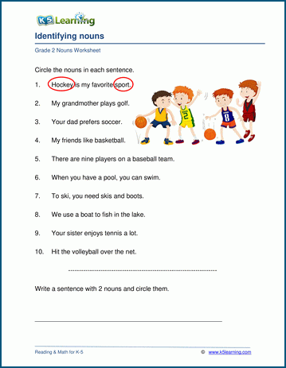

Activity 2: Sight Words

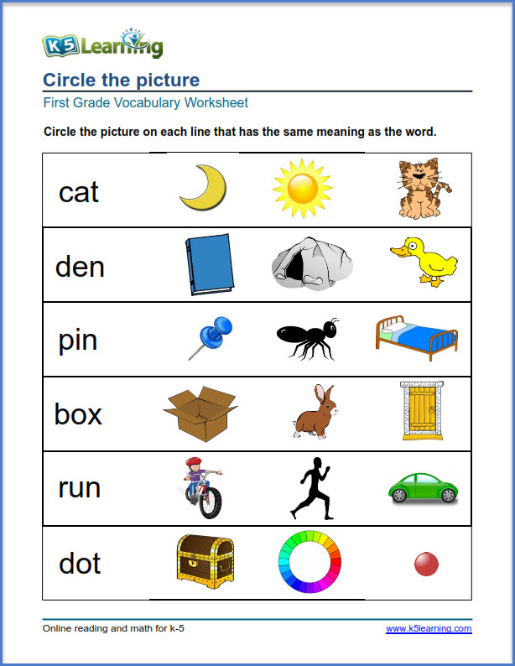

Assignment

Assessment | . Review the activity by doing a labelling activity to identify the different nouns  .Spell and write the sight words correctly
References

LESSON PLAN FOR WEEK SEVEN (7)
Teacher | Name :Diana Maranda Lui/Rita Tatangis  Subject :Language (Grammar / Sounds Waves)
Date | Monday 6th July 2020
Topic : Prepositions/ Sound tt / t/Sight Words
Lesson number :1

Learning Outcomes | .The students to identify the different ways of using different prepositions .  .Students to identify the different words that sound with t/tt  .Students read and spell the sight words correctly
Introduction | . Review the activity using picture cards to identify the nouns and tell if a noun name is a place , person or thing.  . Introduce simple preposition by illustrate and do orally  . Students to identify the different words and sounds by reading and spell correctly.  .Introduce the activity with specific examples using sound waves.
Catch phrase for the lesson
The box is up on the shelf.
Learners notes | Summary  . Encourage the students to read the following sentences using simple prepositions  . Students to know to spell and read the sight words  .Students to say the sound when it starts with t / tt and listen to the sound carefully
Prepositions

Activity 1
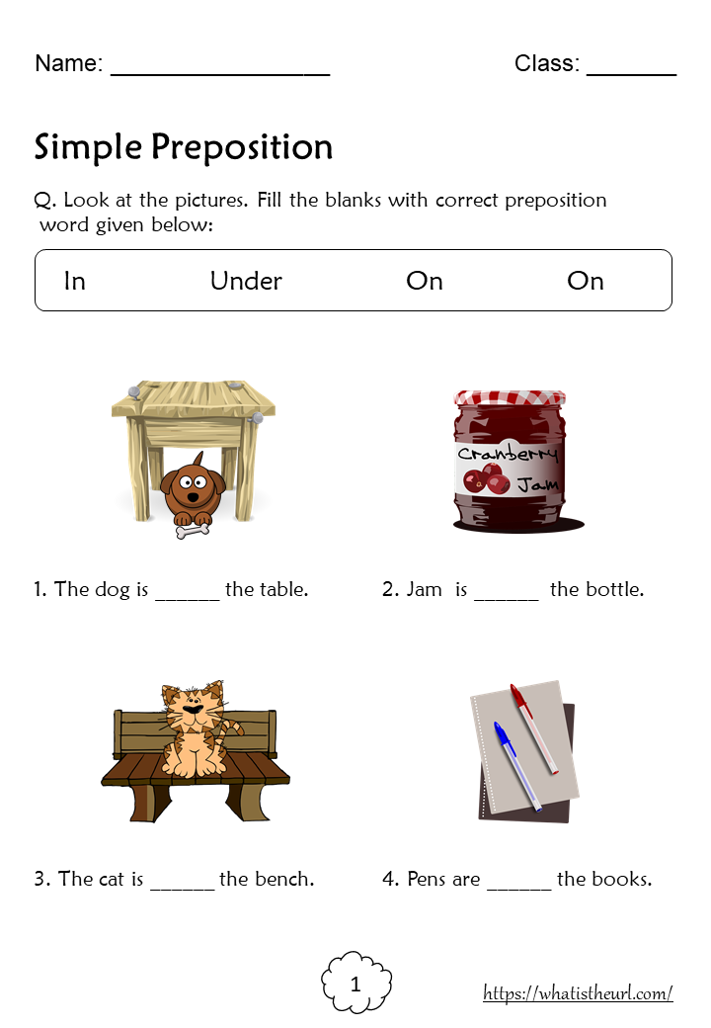

Activity 2: Sight Words

Instructions: Read and spell these words correctly

- Of
- He
- To
- Be
- On
Activity 3: Sound Wave Activity
Do activity 1 page 22

Assignment
Assessment | . Review the activity by creating sentences with prepositions orally  .Spell and write the sight words correctly
References | . Sound Wave Book

LESSON PLAN
Teacher | Name :Diana Maranda Lui/Rita Tatangis  Subject :Language (Grammar / Sounds Waves)
Date | Tuesday 7th July 2020
Topic : Prepositions/ Sound tt / t/Sight Words
Lesson number :2

Learning Outcomes | .The students to identify the different ways of using different prepositions .  .Students to identify the different words that sound with t/tt  .Students read and spell the sight words correctly
Introduction | . Review the activity using real objects and create sentences using simple prepositions orally  . Students to identify the different words and sounds by reading and spell correctly.  .Introduce the activity with specific examples using sound waves.
Catch phrase for the lesson
The clock is above the bed.
Learners notes | Summary  . Encourage the students to read the following sentences using prepositions  . Students to know to spell and read the sight words  .Students to say the sound when it starts with t / tt and listen to the sound carefully
Prepositions

Activity 1

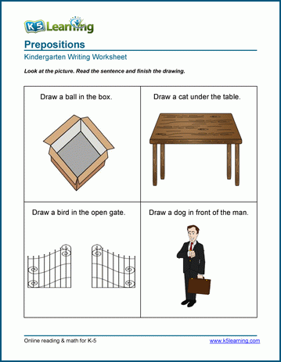

Activity 2: Sight Words

Instructions: Read and spell these words correctly

- Of
- He
- To
- Be
- On
Activity 3: Sound Wave Activity

Do activity 2 page 22

Assignment
Assessment | . Review the activity by creating sentences with prepositions orally  .Spell and write the sight words correctly
References | . Sound Wave Book

LESSON PLAN
Teacher | Name :Diana Maranda Lui/Rita Tatangis  Subject :Language (Grammar / Sounds Waves)
Date | Wednesday 8th July 2020
Topic : Prepositions/ Sound tt / t/Sight Words
Lesson number :3

Learning Outcomes | .The students to identify the different ways of using different prepositions .  .Students to identify the different words that sound with t/tt  .Students read and spell the sight words correctly
Introduction | . Review the activity using real objects and create sentences using simple prepositions orally  . Students to identify the different words and sounds by reading and spell correctly.  .Introduce the activity with specific examples using sound waves.
Catch phrase for the lesson
The cat is under the table.
Learners notes | Summary  . Encourage the students to read the following sentences using prepositions  . Students to know to spell and read the sight words  .Students to say the sound when it starts with t / tt and listen to the sound carefully
Prepositions

Activity 1

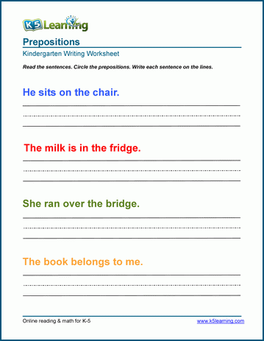

Activity 2: Sight Words

Instructions: Read and spell these words correctly

- Of
- He
- To
- Be
- On
Activity 3: Sound Wave Activity

Do activity 3 page 22

Assignment
Assessment | . Review the activity by creating sentences with prepositions orally  .Spell and write the sight words correctly
References | . Sound Wave Book

LESSON PLAN
Teacher | Name :Diana Maranda Lui/Rita Tatangis  Subject :Language (Grammar / Sounds Waves)
Date | Thursday 9th July 2020
Topic : Punctuations/ Sound tt / t/Sight Words
Lesson number :4

Learning Outcomes | .The students to identify the different punctuation marks to use in a sentence or phrase .  .Students read and spell the sight words correctly
Introduction | . Review the activity using real objects and create sentences using simple prepositions orally  .Introduce the different punctuation marks to use in a sentence.  . Students to identify the different words and sounds by reading and spell correctly.  .Introduce the unjumble activity with example.
Catch phrase for the lesson
Where are you from ?....
Learners notes | Summary  .Encourage students to look at the different punctuation marks (samples)  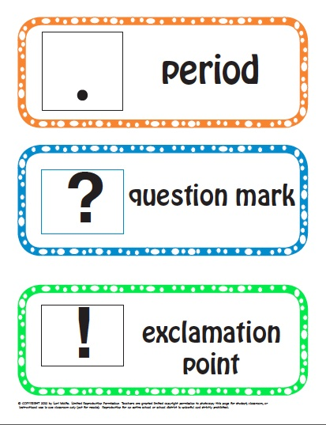  . Encourage the students to read the following sentences using puctuation marks.  . Students to know to spell and read the sight words  .Students to write the sight words correctly
Punctuations

Activity 1

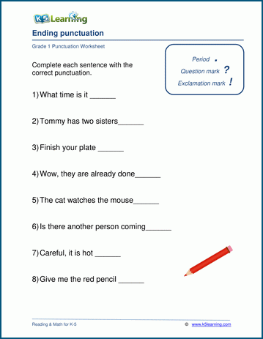

Activity 2: Sight Words

Instructions: Read and spell these words correctly

- Of
- He
- To
- Be
- On

Activity 3: Unjumble Activity

For example: no - on

1.eb-__________________
2.fo-___________________
3.ot-___________________
4.eh-___________________

Assignment
Assessment | . Review the activity by creating sentences with puntuctions orally  .Spell and write the sight words correctly
References

LESSON PLAN
Teacher | Name :Diana Maranda Lui/Rita Tatangis  Subject :Language (Grammar / Sounds Waves)
Date | Friday 10th July 2020
Topic : Punctuations/Sight Words
Lesson number :5

Learning Outcomes | .The students to identify the different punctuation marks to use in a sentence or phrase .  .Students read and spell the sight words correctly
Introduction | . Review the activity using real objects and create sentences using simple prepositions orally  .Introduce the different punctuation marks to use in a sentence.  . Students to identify the different words and sounds by reading and spell correctly.  .Students do spelling test
Catch phrase for the lesson
The ball is under the chair.
Learners notes | Summary  .Review with the students to look at the different punctuation marks (samples)  . Encourage the students to read the following sentences using puctuation marks.  . Students to know to spell and read the sight words  .Students to write the sight words correctly
Punctuations

Activity 1

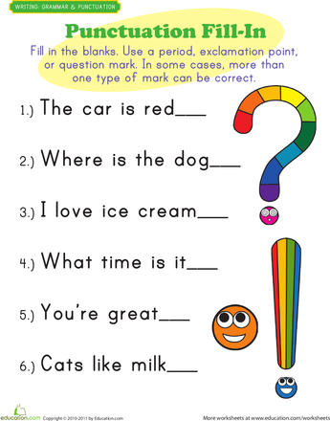

Activity 2: Sight Words

Instructions: Read and spell these words correctly

- Of
- He
- To
- Be
- On

Assignment
Assessment | . Review the activity by creating sentences with puntuctions orally  .Spell and write the sight words correctly
References

LESSON PLAN FOR WEEK EIGHT(8)
Teacher | Name :Diana Maranda Lui/Rita Tatangis  Subject :Language (Grammar / Sounds Waves)
Date | Monday 13th July 2020
Topic : Plural Of Nouns & Singular /Sound u
Lesson number :1

Learning Outcomes | .The students to identify the singular and plural of nouns.  .Students to identify the different words that sound with u  .Students read and spell the sight words correctly
Introduction | . Review the activity using picture cards to identify the different punctuation marks .  . Introduce simple singular & plural of nouns by illustrating the words that use orally.  . Students to identify the different words and sounds by reading and spell correctly.  .Introduce the activity with specific examples using sound waves.
Catch phrase for the lesson
More than one…….apple – 2 apples
Learners notes | Summary  . Encourage the students to read the following sentences using singular and plural of nouns by using objects around you.  .Briefly explain how to use plural nouns by adding s  . Students to know to spell and read the sight words  .Students to say the sound when it starts with u and listen to the sound carefully
Plural/ Singular Nouns

Activity 1
Instructions : Write the plural nouns of the following words

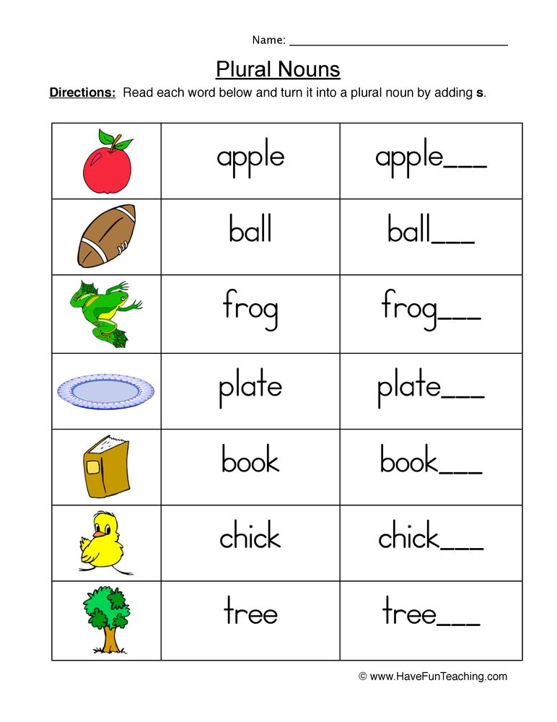

Activity 2: Sight Words

Instructions: Read and spell these words correctly

- I
- By
- Or
- No
- Up

Activity 3: Sound Wave Activity
Do activity 1 page 23

Assignment
Assessment | . Review the activity by creating opposites orally  .Spell and write the sight words correctly
References | . Sound Wave Book

LESSON PLAN
Teacher | Name :Diana Maranda Lui/Rita Tatangis  Subject :Language (Grammar / Sounds Waves)
Date | Tuesday 14th July 2020
Topic : Singular& Plural Nouns /Sound u
Lesson number :2

Learning Outcomes | .The students to identify the plural/ singular nouns .  .Students to identify the different words that sound with u  .Students read and spell the sight words correctly
Introduction | . Review the activity using picture cards to identify the plural/ singular nouns  . Students to identify the different words and sounds by reading and spell correctly.
Catch phrase for the lesson
More than one ……-1pear-2pears
Learners notes | Summary  . Review with the students to read the following sentences on plural of nouns.  . Students to know to spell and read the sight words  .Students to say the sound when it starts with u and listen to the sound carefully
Plural/ Singular Nouns

Activity 1
Instructions : Write the plural nouns of the following words

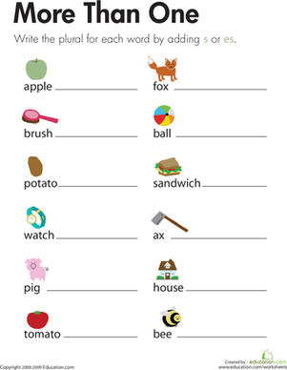

Activity 2: Sight Words

Instructions: Read and spell these words correctly

- I
- By
- Or
- No
- Up

Activity 3: Sound Wave Activity
Do activity 2 page 23

Assignment
Assessment | . Review the activity by doing an oral assesment on plurals of nouns  .Spell and write the sight words correctly
References | . Sound Wave Book

LESSON PLAN
Teacher | Name :Diana Maranda Lui/Rita Tatangis  Subject :Language (Grammar / Sounds Waves)
Date | Wednesday 14th July 2020
Topic : Plurals & Singular Nouns /Sound u
Lesson number :3

Learning Outcomes | .The students to identify the plural/singular nouns  .Students to identify the different words that sound with u  .Students read and spell the sight words correctly
Introduction | . Review the activity using plural and singular nouns  . Students to identify the different words and sounds by reading and spell correctly.
Catch phrase for the lesson
More than one……….
Learners notes | Summary  . Briefly explain the plural and singular nouns to the students with specific examples by creativity.  . Students to know to spell and read the sight words  .Students to say the sound when it starts with u and listen to the sound carefully
Plural and Singular Nouns

Activity 1
Instructions : Write the plurals of the following words

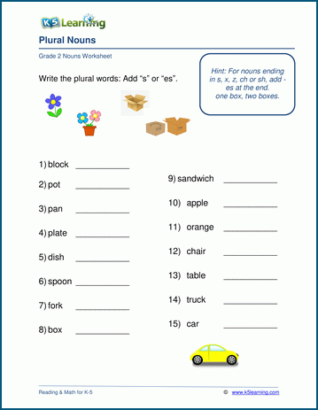

Activity 2: Sight Words

Instructions: Read and spell these words correctly

- I
- By
- Or
- No
- Up

Activity 3: Sound Wave Activity
Do activity 3 page 23

Assignment
Assessment | . Review the activity by creating plural nouns orally  .Spell and write the sight words correctly
References | . Sound Wave Book

LESSON PLAN
Teacher | Name :Diana Maranda Lui/Rita Tatangis  Subject :Language (Grammar / Sounds Waves)
Date | Thursday 15th July 2020
Topic : Plurals & Singular Nouns /Sound u
Lesson number :4

Learning Outcomes | .The students to identify the plural/singular nouns  .Students read and spell the sight words correctly
Introduction | . Review the activity using plural and singular nouns  . Students to identify the different words and sounds by reading and spell correctly.
Catch phrase for the lesson
More than one……….
Learners notes | Summary  . Briefly explain the plural and singular nouns to the students with specific examples by creativity.  . Students to know to spell and read the sight words
Plural and Singular Nouns

Activity 1
Instructions : Write the plurals of the following words

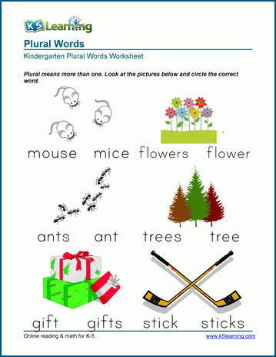

Activity 2: Sight Words

Instructions: Read and spell these words correctly

- I
- By
- Or
- No
- Up

Activity 3: Sound Activity

Assignment
Assessment | . Review the activity by creating plural nouns orally  .Spell and write the sight words correctly
References

LESSON PLAN
Teacher | Name :Diana Maranda Lui/Rita Tatangis  Subject :Language (Grammar / Sounds Waves)
Date | Friday 16th July 2020
Topic : Plurals & Singular Nouns /Sound u
Lesson number :5

Learning Outcomes | .The students to identify the plural/singular nouns  .Students to identify the different words that sound with u  .Students read and spell the sight words correctly
Introduction | . Review the activity using plural and singular nouns  . Students to identify the different words and sounds by reading and spell correctly.
Catch phrase for the lesson
More than one……….
Learners notes | Summary  . Briefly explain the plural and singular nouns to the students with specific examples by creativity.  . Students to know to spell and read the sight words  .Students to say the sound when it starts with u and listen to the sound carefully
Plural and Singular Nouns

Activity 1
Instructions : Write the plurals of the following words

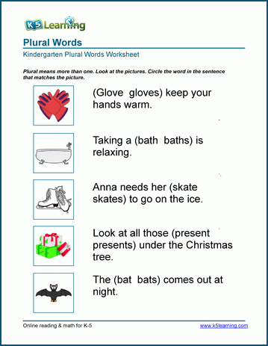

Activity 2
Instructions: Write in the plural and singular nouns

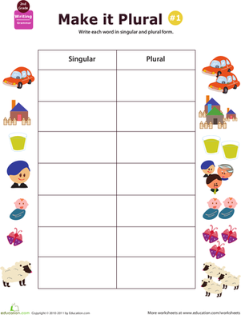

Activity 3: Sight Words

Instructions: Read and spell these words correctly

- I
- By
- Or
- No
- Up

Activity 4: Sound Activity

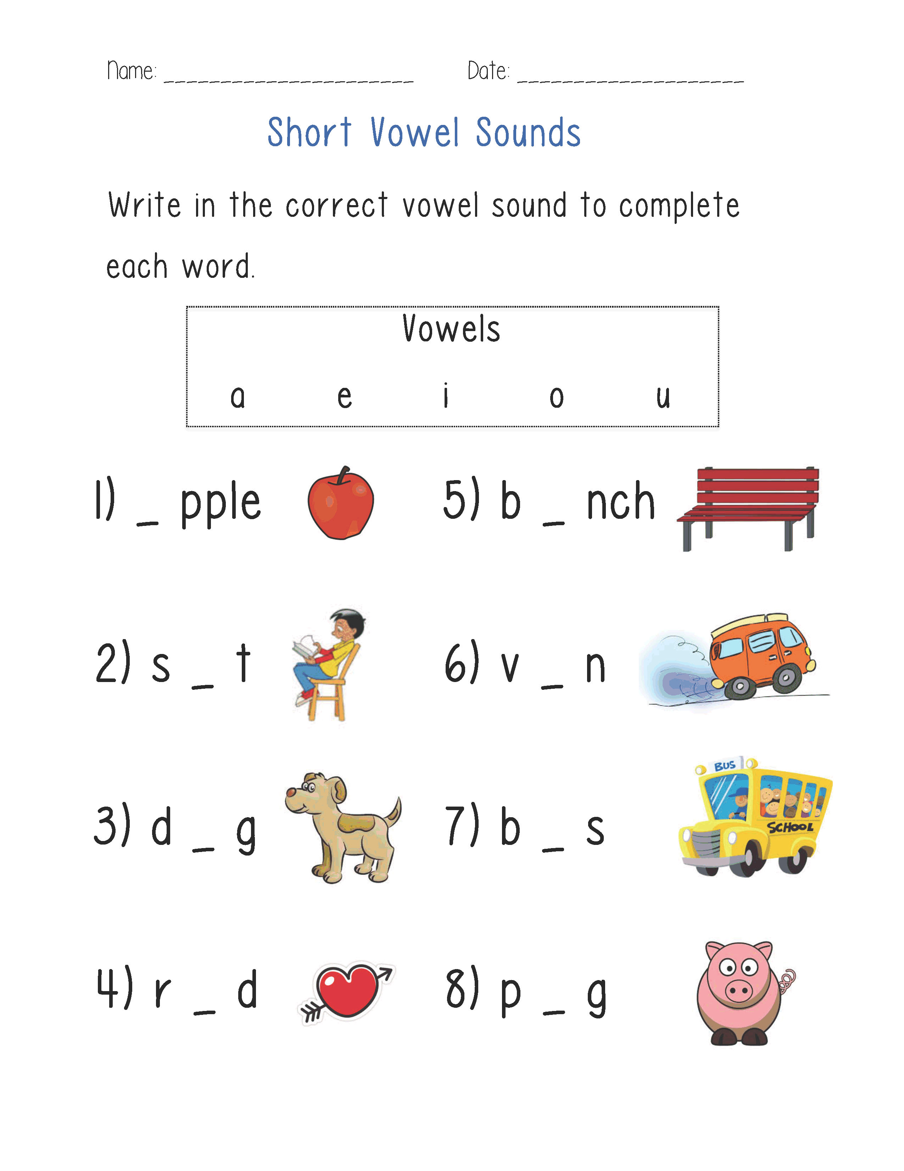

Assignment
Assessment | . Review the activity by creating plural nouns orally  .Spell and write the sight words correctly  . English Test
References

WEEKLY CHECKLIST For Parents:

Term: 2 Week number 1 Date…… to…… Month: …………

Subject | Number of lessons | Days | Tick when activity is complete | Parents comment | Signature
 | 1
 | 2
 | 3
 | 4
 | 5
 | 6

Term: 2 Week number 2 Date…… to…… Month: …………

Subject | Number of lessons | Days | Tick when activity is complete | Parents comment | Signature
 | 1
 | 2
 | 3
 | 4
 | 5
 | 6

Term: 2 Week number 3 Date…… to…… Month: …………

Subject | Number of lessons | Days | Tick when activity is complete | Parents comment | Signature
 | 1
 | 2
 | 3
 | 4
 | 5
 | 6

Term 2 Week number 6 Date …….. to ……. Month………..

Subject | Number of lessons | Days | Tick when activity is complete | Parents comment | Signature
 | 1
 | 2
 | 3
 | 4
 | 5
 | 6

Term: 2 Week number 5 Date…… to…… Month: …………

Subject | Number of lessons | Days | Tick when activity is complete | Parents comment | Signature
 | 1
 | 2
 | 3
 | 4
 | 5
 | 6

Term: 2 Week number 6 Date…… to…… Month: …………

Subject | Number of lessons | Days | Tick when activity is complete | Parents comment | Signature
 | 1
 | 2
 | 3
 | 4
 | 5
 | 6

Term: 2 Week number 7 Date…… to…… Month: …………

Subject | Number of lessons | Days | Tick when activity is complete | Parents comment | Signature
 | 1
 | 2
 | 3
 | 4
 | 5
 | 6

Term: 2 Week number 8 Date…… to…… Month: …………

Subject | Number of lessons | Days | Tick when activity is complete | Parents comment | Signature
 | 1
 | 2
 | 3
 | 4
 | 5
 | 6

Term: 2 Week number 9 Date…… to…… Month: …………

Subject | Number of lessons | Days | Tick when activity is complete | Parents comment | Signature
 | 1
 | 2
 | 3
 | 4
 | 5
 | 6

Term: 2 Week number 10 Date…… to…… Month: …………

Subject | Number of lessons | Days | Tick when activity is complete | Parents comment | Signature
 | 1
 | 2
 | 3
 | 4
 | 5
 | 6

Term: 2 Week number 11 Date…… to…… Month: …………

Subject | Number of lessons | Days | Tick when activity is complete | Parents comment | Signature
 | 1
 | 2
 | 3
 | 4
 | 5
 | 6

Term: 2 Week number 12 Date…… to…… Month: …………

Subject | Number of lessons | Days | Tick when activity is complete | Parents comment | Signature
 | 1
 | 2
 | 3
 | 4
 | 5
 | 6

Term: 2 Week number 13 Date…… to…… Month: …………

Subject | Number of lessons | Days | Tick when activity is complete | Parents comment | Signature
 | 1
 | 2
 | 3
 | 4
 | 5
 | 6

