Central School
Home School Package

Year : 13 Statistics

HOME SCHOOL PACKAGE CONTEN
LESSON Plan WEEK 1 – WEEK 3

Teacher | Name : Felix Fatdal  Subject : Statistics

Date

Topic :
Lesson number :

Learning outcomes | Specific Learning Outcomes (SLO): Students are able to Skill level SLO code  define an event in statistics. 1 Sta1.1.1.1  identify an example of an event. 1 Sta1.1.1.2  definetrial. 1 Sta1.1.1.3  defineoutcome. 1 Sta1.1.1.4  define sample space. 1 Sta1.1.1.5  define mutually exclusive events. 1 Sta1.1.1.6  identify an example of mutually exclusive events. 1 Sta1.1.1.7  define independent events. 1 Sta1.1.1.8  identify an example of independent events. 1 Sta1.1.1.9  definecomplementary events. 1 Sta1.1.1.10  identify an example of complementary events. 1 Sta1.1.1.11  define conditional events. 1 Sta1.1.1.12  identify an example of conditional events. 1 Sta1.1.1.13  define inclusive events. 1 Sta1.1.1.14  identify an example of inclusive events. 1 Sta1.1.1.15  define combined events. 1 Sta1.1.1.16  identify an example of combined events. 1 Sta1.1.1.17  compute probability of an event. 2 Sta1.1.2.1  solve standard mutually exclusive event problems. 2 Sta1.1.2.2  solve standard independent event problems. 2 Sta1.1.2.3  solve standard complementary event problems. 2 Sta1.1.2.4  solve standard conditional event problems. 2 Sta1.1.2.5  solve standard problems using tree diagrams techniques. 2 Sta1.1.2.6  solve standard problems using Venn diagrams techniques. 2 Sta1.1.2.7  solve standard problems using tables of counts and relative frequencies techniques. 2 Sta1.1.2.8  solve standard problems using theoretical and experimental probability techniques. 2 Sta1.1.2.9  solve standard problems using theoretical and experimental probability techniques on exclusive events. 2 Sta1.1.2.10  solve standard problems using permutations techniques. 2 Sta1.1.2.11  solve standard problems using combinations techniques. 2 Sta1.1.2.12  solve standard problems using theoretical and experimental probability techniques on either/or events. 2 Sta1.1.2.13  solve standard problems using theoretical and experimental probability techniques on at least one event. 2 Sta1.1.2.14  solve standard probability of inclusive events (both conditions are true). 2 Sta1.1.2.15  determine the probability of complements of events. 2 Sta1.1.2.16  solve standard combined events problems. 2 Sta1.1.2.17  solvecomplex mutually exclusive events problems. 3 Sta1.1.3.1  solve complex independent events problems. 3 Sta1.1.3.2  solve complex complementary events problems. 3 Sta1.1.3.3  solve complex conditional events problems. 3 Sta1.1.3.4  solve complex combined events problems. 3 Sta1.1.3.5  solve complex problems using tree diagrams techniques. 3 Sta1.1.3.6  solve complex problems using Venn diagrams techniques. 3 Sta1.1.3.7  solve complex problems using tables of counts and relative frequencies techniques. 3 Sta1.1.3.8  solve complex problems using theoretical and experimental probability techniques. 3 Sta1.1.3.9  solve complex problems using permutations techniques. 3 Sta1.1.3.10  solve complex problems using combinations techniques. 3 Sta1.1.3.11  solve more complex mutually exclusive events problems. 4 Sta1.1.4.1  solve more complex independent events problems. 4 Sta1.1.4.2  Solvemore complex complementary events problems. 4 Sta1.1.4.3  solve more complex conditional event problems. 4 Sta1.1.4.4  solve more complex combined event problems. 4 Sta1.1.4.5  solve more complex problems using tree diagrams techniques. 4 Sta1.1.4.6  solve more complex problems using Venn diagrams techniques. 4 Sta1.1.4.7  solve more complex problems using tables of counts and relative frequencies techniques. 4 Sta1.1.4.8  solve more complex problems using theoretical and experimental probability techniques. 4 Sta1.1.4.9  solve more complex problems using permutations techniques. 4 Sta1.1.4.10  solve more complex problems using combinations techniques. 4 Sta1.1.4.11
Introduction | Probability theory, a branch of mathematics concerned with the analysis of random phenomena. The outcome of a random event cannot be determined before it occurs, but it may be any one of several possible outcomes. The actual outcome is considered to be determined by chance.
 | 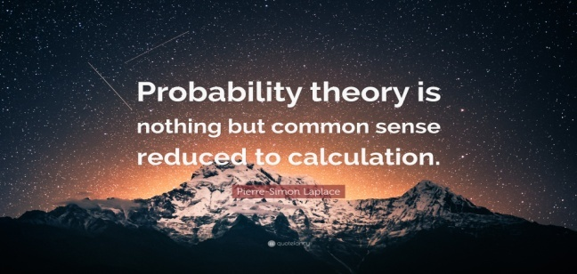
Learners notes | Sample Spaces and Events  Rolling an ordinary six-sided die is a familiar example of a random experiment, an action for which all possible outcomes can be listed, but for which the actual outcome on any given trial of the experiment cannot be predicted with certainty. In such a situation we wish to assign to each outcome, such as rolling a two, a number, called the probability of the outcome that indicates how likely it is that the outcome will occur. Similarly, we would like to assign a probability to any event, or collection of outcomes, such as rolling an even number, which indicates how likely it is that the event will occur if the experiment is performed. This section provides a framework for discussing probability problems, using the terms just mentioned.  Definition  A random experiment is a mechanism that produces a definite outcome that cannot be predicted with certainty. The sample space associated with a random experiment is the set of all possible outcomes. An event is a subset of the sample space.  Definition  An event E is said to occur on a particular trial of the experiment if the outcome observed is an element of the set E.  EXAMPLE 1  Construct a sample space for the experiment that consists of tossing a single coin.  Solution:  The outcomes could be labeled h for heads and t for tails. Then the sample space is the set S={h,t}.S={h,t}.  EXAMPLE 2  Construct a sample space for the experiment that consists of rolling a single die. Find the events that correspond to the phrases “an even number is rolled” and “a number greater than two is rolled.”  Solution:  The outcomes could be labeled according to the number of dots on the top face of the die. Then the sample space is the set S={1,2,3,4,5,6}.S={1,2,3,4,5,6}.  The outcomes that are even are 2, 4, and 6, so the event that corresponds to the phrase “an even number is rolled” is the set {2,4,6}, which it is natural to denote by the letter E. We write E={2,4,6}.E={2,4,6}.  Similarly the event that corresponds to the phrase “a number greater than two is rolled” is the set T={3,4,5,6}T={3,4,5,6}, which we have denoted T.  A graphical representation of a sample space and events is a Venn diagram, as shown in Figure 3.1 "Venn Diagrams for Two Sample Spaces" for Note 3.6 "Example 1" and Note 3.7 "Example 2". In general the sample space S is represented by a rectangle, outcomes by points within the rectangle, and events by ovals that enclose the outcomes that compose them.  Figure 3.1 Venn Diagrams for Two Sample Spaces  EXAMPLE 3  A random experiment consists of tossing two coins.  - Construct a sample space for the situation that the coins are indistinguishable, such as two brand new pennies.  - Construct a sample space for the situation that the coins are distinguishable, such as one a penny and the other a nickel.  Solution:  - After the coins are tossed one sees either two heads, which could be labeled 2h2h, two tails, which could be labeled 2t2t, or coins that differ, which could be labeled d. Thus a sample space is S={2h,2t,d}.S={2h,2t,d}.  - Since we can tell the coins apart, there are now two ways for the coins to differ: the penny heads and the nickel tails, or the penny tails and the nickel heads. We can label each outcome as a pair of letters, the first of which indicates how the penny landed and the second of which indicates how the nickel landed. A sample space is then S′={hh,ht,th,tt}.S′={hh,ht,th,tt}.  A device that can be helpful in identifying all possible outcomes of a random experiment, particularly one that can be viewed as proceeding in stages, is what is called a tree diagram. It is described in the following example.  EXAMPLE 4  Construct a sample space that describes all three-child families according to the genders of the children with respect to birth order.  Solution:  Two of the outcomes are “two boys then a girl,” which we might denote bbgbbg, and “a girl then two boys,” which we would denote gbb.gbb. Clearly there are many outcomes, and when we try to list all of them it could be difficult to be sure that we have found them all unless we proceed systematically. The tree diagram shown in Figure 3.2 "Tree Diagram For Three-Child Families", gives a systematic approach.  Figure 3.2Tree Diagram For Three-Child Families  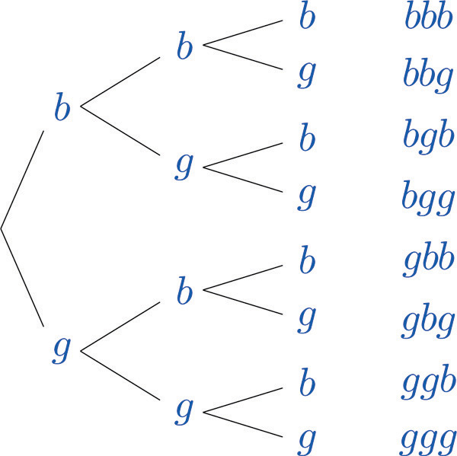  The diagram was constructed as follows. There are two possibilities for the first child, boy or girl, so we draw two line segments coming out of a starting point, one ending in a b for “boy” and the other ending in a g for “girl.” For each of these two possibilities for the first child there are two possibilities for the second child, “boy” or “girl,” so from each of the b and g we draw two line segments, one segment ending in a b and one in a g. For each of the four ending points now in the diagram there are two possibilities for the third child, so we repeat the process once more.  The line segments are called branches of the tree. The right ending point of each branch is called a node. The nodes on the extreme right are the final nodes; to each one there corresponds an outcome, as shown in the figure.  From the tree it is easy to read off the eight outcomes of the experiment, so the sample space is, reading from the top to the bottom of the final nodes in the tree,  S={bbb,bbg,bgb,bgg,gbb,gbg,ggb,ggg}S={bbb,bbg,bgb,bgg,gbb,gbg,ggb,ggg}  Probability  Definition  The probability of an outcome e in a sample space S is a number p between 0 and 1 that measures the likelihood that e will occur on a single trial of the corresponding random experiment. The value p = 0 corresponds to the outcome e being impossible and the value p = 1 corresponds to the outcome e being certain.  Definition  The probability of an event A is the sum of the probabilities of the individual outcomes of which it is composed. It is denoted P(A).P(A).  The following formula expresses the content of the definition of the probability of an event:  If an event E is E={e1,e2,…,ek}E={e1,e2,…,ek}, then  P(E)=P(e1)+P(e2)+ ⋅ ⋅ ⋅ +P(ek)P(E)=P(e1)+P(e2)+ · · · +P(ek)  Figure 3.3 "Sample Spaces and Probability" graphically illustrates the definitions.  Figure 3.3 Sample Spaces and Probability  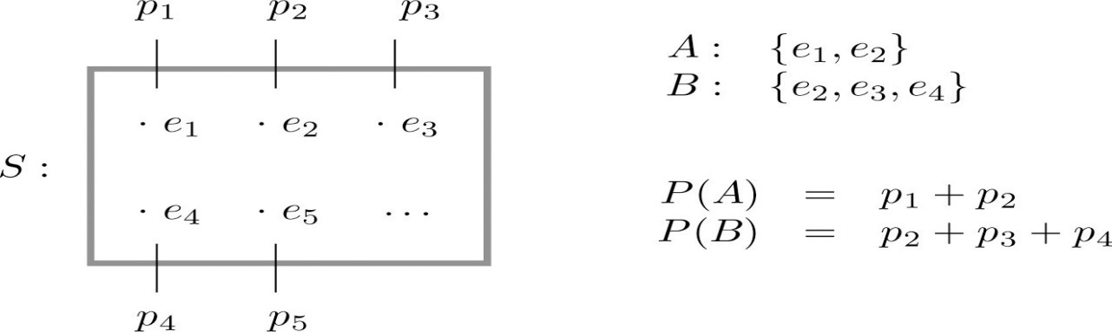  Since the whole sample space S is an event that is certain to occur, the sum of the probabilities of all the outcomes must be the number 1.  In ordinary language probabilities are frequently expressed as percentages. For example, we would say that there is a 70% chance of rain tomorrow, meaning that the probability of rain is 0.70. We will use this practice here, but in all the computational formulas that follow we will use the form 0.70 and not 70%.  EXAMPLE 5  A coin is called “balanced” or “fair” if each side is equally likely to land up. Assign a probability to each outcome in the sample space for the experiment that consists of tossing a single fair coin.  Solution:  With the outcomes labeled h for heads and t for tails, the sample space is the set S={h,t}.S={h,t}. Since the outcomes have the same probabilities, which must add up to 1, each outcome is assigned probability 1/2.  EXAMPLE 6  A die is called “balanced” or “fair” if each side is equally likely to land on top. Assign a probability to each outcome in the sample space for the experiment that consists of tossing a single fair die. Find the probabilities of the events E: “an even number is rolled” and T: “a number greater than two is rolled.”  Solution:  With outcomes labeled according to the number of dots on the top face of the die, the sample space is the set S={1,2,3,4,5,6}.S={1,2,3,4,5,6}. Since there are six equally likely outcomes, which must add up to 1, each is assigned probability 1/6.  Since E={2,4,6}E={2,4,6}, P(E)=1∕6+1∕6+1∕6=3∕6=1∕2.P(E)=1∕6+1∕6+1∕6=3∕6=1∕2.  Since T={3,4,5,6}T={3,4,5,6}, P(T)=4∕6=2∕3.P(T)=4∕6=2∕3.  EXAMPLE 7  Two fair coins are tossed. Find the probability that the coins match, i.e., either both land heads or both land tails.  Solution:  In Note 3.8 "Example 3" we constructed the sample space S={2h,2t,d}S={2h,2t,d} for the situation in which the coins are identical and the sample space S′={hh,ht,th,tt}S′={hh,ht,th,tt} for the situation in which the two coins can be told apart.  The theory of probability does not tell us how to assign probabilities to the outcomes, only what to do with them once they are assigned. Specifically, using sample space S, matching coins is the event M={2h,2t}M={2h,2t}, which has probability P(2h)+P(2t).P(2h)+P(2t). Using sample space S′S′, matching coins is the event M′={hh,tt}M′={hh,tt}, which has probability P(hh)+P(tt).P(hh)+P(tt). In the physical world it should make no difference whether the coins are identical or not, and so we would like to assign probabilities to the outcomes so that the numbers P(M)P(M) and P(M′)P(M′) are the same and best match what we observe when actual physical experiments are performed with coins that seem to be fair. Actual experience suggests that the outcomes in S′S′ are equally likely, so we assign to each probability 1∕4, and then  P(M′)=P(hh)+P(tt)=14+14=12P(M′)=P(hh)+P(tt)=14+14=12  Similarly, from experience appropriate choices for the outcomes in S are:  P(2h)=14 P(2t)=14 P(d)=12P(2h)=14 P(2t)=14 P(d)=12  which give the same final answer  P(M)=P(2h)+P(2t)=14+14=12P(M)=P(2h)+P(2t)=14+14=12  The previous three examples illustrate how probabilities can be computed simply by counting when the sample space consists of a finite number of equally likely outcomes. In some situations the individual outcomes of any sample space that represents the experiment are unavoidably unequally likely, in which case probabilities cannot be computed merely by counting, but the computational formula given in the definition of the probability of an event must be used.  EXAMPLE 8  The breakdown of the student body in a local high school according to race and ethnicity is 51% white, 27% black, 11% Hispanic, 6% Asian, and 5% for all others. A student is randomly selected from this high school. (To select “randomly” means that every student has the same chance of being selected.) Find the probabilities of the following events:  - B: the student is black,  - M: the student is minority (that is, not white),  - N: the student is not black.  Solution:  The experiment is the action of randomly selecting a student from the student population of the high school. An obvious sample space is S={w,b,h,a,o}.S={w,b,h,a,o}. Since 51% of the students are white and all students have the same chance of being selected, P(w)=0.51P(w)=0.51, and similarly for the other outcomes. This information is summarized in the following table:  OutcomeProbabilityw0.51b0.27h0.11a0.06o0.05OutcomewbhaoProbability0.510.270.110.060.05  - Since B={b}B={b}, P(B)=P(b)=0.27.P(B)=P(b)=0.27.  - Since M={b,h,a,o}M={b,h,a,o}, P(M)=P(b)+P(h)+P(a)+P(o)=0.27+0.11+0.06+0.05=0.49P(M)=P(b)+P(h)+P(a)+P(o)=0.27+0.11+0.06+0.05=0.49  - Since N={w,h,a,o}N={w,h,a,o}, P(N)=P(w)+P(h)+P(a)+P(o)=0.51+0.11+0.06+0.05=0.73P(N)=P(w)+P(h)+P(a)+P(o)=0.51+0.11+0.06+0.05=0.73  EXAMPLE 9  The student body in the high school considered in Note 3.18 "Example 8" may be broken down into ten categories as follows: 25% white male, 26% white female, 12% black male, 15% black female, 6% Hispanic male, 5% Hispanic female, 3% Asian male, 3% Asian female, 1% male of other minorities combined, and 4% female of other minorities combined. A student is randomly selected from this high school. Find the probabilities of the following events:  - B: the student is black,  - MFMF: the student is minority female,  - FNFN: the student is female and is not black.  Solution:  Now the sample space is S={wm,bm,hm,am,om,wf,bf,hf,af,of}.S={wm,bm,hm,am,om,wf,bf,hf,af,of}. The information given in the example can be summarized in the following table, called a two-way contingency table:  Gender Race / Ethnicity  White Black Hispanic Asian Others  Male 0.25 0.12 0.06 0.03 0.01  Female 0.26 0.15 0.05 0.03 0.04  - Since B={bm,bf}B={bm,bf}, P(B)=P(bm)+P(bf)=0.12+0.15=0.27.P(B)=P(bm)+P(bf)=0.12+0.15=0.27.  - Since MF={bf,hf,af,of}MF={bf,hf,af,of}, P(M)=P(bf)+P(hf)+P(af)+P(of)=0.15+0.05+0.03+0.04=0.27P(M)=P(bf)+P(hf)+P(af)+P(of)=0.15+0.05+0.03+0.04=0.27  - Since FN={wf,hf,af,of}FN={wf,hf,af,of}, P(FN)=P(wf)+P(hf)+P(af)+P(of)=0.26+0.05+0.03+0.04=0.38P(FN)=P(wf)+P(hf)+P(af)+P(of)=0.26+0.05+0.03+0.04=0.38  KEY TAKEAWAYS  - The sample space of a random experiment is the collection of all possible outcomes.  - An event associated with a random experiment is a subset of the sample space.  - The probability of any outcome is a number between 0 and 1. The probabilities of all the outcomes add up to 1.  - The probability of any event A is the sum of the probabilities of the outcomes in A.
 | 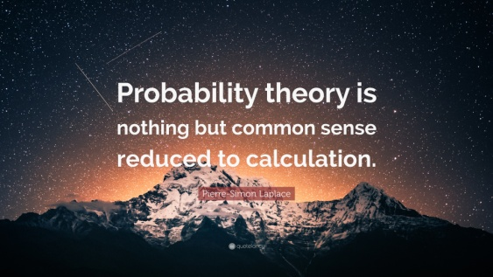
Study the Example above and attemp the activities in the following order.
Week 1 : Q1 and Q2
Week 2 : Q3 and Q4
Week 3 : Q4 and Q5
Use your exercice book to do the activity. Do not copy the Question only write your feed back. If you can do online and submit that will be fine.

EXERCISES

BASIC
- A box contains 10 white and 10 black marbles. Construct a sample space for the experiment of randomly drawing out, with replacement, two marbles in succession and noting the color each time. (To draw “with replacement” means that the first marble is put back before the second marble is drawn.)
- A box contains 16 white and 16 black marbles. Construct a sample space for the experiment of randomly drawing out, with replacement, three marbles in succession and noting the color each time. (To draw “with replacement” means that each marble is put back before the next marble is drawn.)
- A box contains 8 red, 8 yellow, and 8 green marbles. Construct a sample space for the experiment of randomly drawing out, with replacement, two marbles in succession and noting the color each time.
- A box contains 6 red, 6 yellow, and 6 green marbles. Construct a sample space for the experiment of randomly drawing out, with replacement, three marbles in succession and noting the color each time.
- In the situation of Exercise 1, list the outcomes that comprise each of the following events.
  - At least one marble of each color is drawn.
  - No white marble is drawn.
- In the situation of Exercise 2, list the outcomes that comprise each of the following events.
  - At least one marble of each color is drawn.
  - No white marble is drawn.
  - More black than white marbles are drawn.
- In the situation of Exercise 3, list the outcomes that comprise each of the following events.
  - No yellow marble is drawn.
  - The two marbles drawn have the same color.
  - At least one marble of each color is drawn.
- In the situation of Exercise 4, list the outcomes that comprise each of the following events.
  - No yellow marble is drawn.
  - The three marbles drawn have the same color.
  - At least one marble of each color is drawn.
- Assuming that each outcome is equally likely, find the probability of each event in Exercise 5.
- Assuming that each outcome is equally likely, find the probability of each event in Exercise 6.
- Assuming that each outcome is equally likely, find the probability of each event in Exercise 7.
- Assuming that each outcome is equally likely, find the probability of each event in Exercise 8.
- A sample space is S={a,b,c,d,e}.S={a,b,c,d,e}. Identify two events as U={a,b,d}U={a,b,d} and V={b,c,d}.V={b,c,d}. Suppose P(a)P(a) and P(b)P(b) are each 0.2 and P(c)P(c) and P(d)P(d) are each 0.1.
  - Determine what P(e)P(e) must be.
  - Find P(U).P(U).
  - Find P(V).P(V).
- A sample space is S={u,v,w,x}.S={u,v,w,x}. Identify two events as A={v,w}A={v,w} and B={u,w,x}.B={u,w,x}. Suppose P(u)=0.22P(u)=0.22, P(w)=0.36P(w)=0.36, and P(x)=0.27.P(x)=0.27.
  - Determine what P(v)P(v) must be.
  - Find P(A).P(A).
  - Find P(B).P(B).
- A sample space is S={m,n,q,r,s}.S={m,n,q,r,s}. Identify two events as U={m,q,s}U={m,q,s} and V={n,q,r}.V={n,q,r}. The probabilities of some of the outcomes are given by the following table:
OutcomeProbablitym0.18n0.16qr0.24s0.21OutcomemnqrsProbablity0.180.160.240.21
  - Determine what P(q)P(q) must be.
  - Find P(U).P(U).
  - Find P(V).P(V).
- A sample space is S={d,e,f,g,h}.S={d,e,f,g,h}. Identify two events as M={e,f,g,h}M={e,f,g,h} and N={d,g}.N={d,g}. The probabilities of some of the outcomes are given by the following table:
OutcomeProbablityd0.22e0.13f0.27gh0.19OutcomedefghProbablity0.220.130.270.19
  - Determine what P(g)P(g) must be.
  - Find P(M).P(M).
  - Find P(N).P(N).

APPLICATIONS
- The sample space that describes all three-child families according to the genders of the children with respect to birth order was constructed in Note 3.9 "Example 4". Identify the outcomes that comprise each of the following events in the experiment of selecting a three-child family at random.
  - At least one child is a girl.
  - At most one child is a girl.
  - All of the children are girls.
  - Exactly two of the children are girls.
  - The first born is a girl.
- The sample space that describes three tosses of a coin is the same as the one constructed in Note 3.9 "Example 4" with “boy” replaced by “heads” and “girl” replaced by “tails.” Identify the outcomes that comprise each of the following events in the experiment of tossing a coin three times.
  - The coin lands heads more often than tails.
  - The coin lands heads the same number of times as it lands tails.
  - The coin lands heads at least twice.
  - The coin lands heads on the last toss.
- Assuming that the outcomes are equally likely, find the probability of each event in Exercise 17.
- Assuming that the outcomes are equally likely, find the probability of each event in Exercise 18.

ADDITIONAL EXERCISES
- The following two-way contingency table gives the breakdown of the population in a particular locale according to age and tobacco usage:
Age | Tobacco Use
 | Smoker | Non-smoker
Under 30 | 0.05 | 0.20
Over 30 | 0.20 | 0.55
- A person is selected at random. Find the probability of each of the following events.
  - The person is a smoker.
  - The person is under 30.
  - The person is a smoker who is under 30.
- The following two-way contingency table gives the breakdown of the population in a particular locale according to party affiliation (A, B, C, or None) and opinion on a bond issue:
Affiliation | Opinion
 | Favors | Opposes | Undecided
A | 0.12 | 0.09 | 0.07
B | 0.16 | 0.12 | 0.14
C | 0.04 | 0.03 | 0.06
None | 0.08 | 0.06 | 0.03
- A person is selected at random. Find the probability of each of the following events.
  - The person is affiliated with party B.
  - The person is affiliated with some party.
  - The person is in favor of the bond issue.
  - The person has no party affiliation and is undecided about the bond issue.
- The following two-way contingency table gives the breakdown of the population of married or previously married women beyond child-bearing age in a particular locale according to age at first marriage and number of children:
Age | Number of Children
 | 0 | 1 or 2 | 3 or More
Under 20 | 0.02 | 0.14 | 0.08
20–29 | 0.07 | 0.37 | 0.11
30 and above | 0.10 | 0.10 | 0.01
- A woman is selected at random. Find the probability of each of the following events.
  - The woman was in her twenties at her first marriage.
  - The woman was 20 or older at her first marriage.
  - The woman had no children.
  - The woman was in her twenties at her first marriage and had at least three children.
- The following two-way contingency table gives the breakdown of the population of adults in a particular locale according to highest level of education and whether or not the individual regularly takes dietary supplements:
Education | Use of Supplements
 | Takes | Does Not Take
No High School Diploma | 0.04 | 0.06
High School Diploma | 0.06 | 0.44
Undergraduate Degree | 0.09 | 0.28
Graduate Degree | 0.01 | 0.02
- An adult is selected at random. Find the probability of each of the following events.
  - The person has a high school diploma and takes dietary supplements regularly.
  - The person has an undergraduate degree and takes dietary supplements regularly.
  - The person takes dietary supplements regularly.
  - The person does not take dietary supplements regularly.

LARGE DATA SET EXERCISES
Note: These data sets are missing, but the questions are provided here for reference.
- Large Data Sets 4 and 4A record the results of 500 tosses of a coin. Find the relative frequency of each outcome 1, 2, 3, 4, 5, and 6. Does the coin appear to be “balanced” or “fair”?
- Large Data Sets 6, 6A, and 6B record results of a random survey of 200 voters in each of two regions, in which they were asked to express whether they prefer Candidate A for a U.S. Senate seat or prefer some other candidate.
  - Find the probability that a randomly selected voter among these 400 prefers Candidate A.
  - Find the probability that a randomly selected voter among the 200 who live in Region 1 prefers Candidate A (separately recorded in Large Data Set 6A).
  - Find the probability that a randomly selected voter among the 200 who live in Region 2 prefers Candidate A (separately recorded in Large Data Set 6B).

ANSWERS
- S={bb,bw,wb,ww}S={bb,bw,wb,ww}

- S={rr,ry,rg,yr,yy,yg,gr,gy,gg}S={rr,ry,rg,yr,yy,yg,gr,gy,gg}

  - {bw,wb}{bw,wb}
  - {bb}{bb}

  - {rr,rg,gr,gg}{rr,rg,gr,gg}
  - {rr,yy,gg}{rr,yy,gg}
  - ∅

  - 2/4
  - 1/4

  - 4/9
  - 3/9
  - 0

  - 0.4
  - 0.5
  - 0.4

  - 0.21
  - 0.6
  - 0.61

  - {bbg,bgb,bgg,gbb,gbg,ggb,ggg}{bbg,bgb,bgg,gbb,gbg,ggb,ggg}
  - {bbb,bbg,bgb,gbb}{bbb,bbg,bgb,gbb}
  - {ggg}{ggg}
  - {bgg,gbg,ggb}{bgg,gbg,ggb}
  - {gbb,gbg,ggb,ggg}{gbb,gbg,ggb,ggg}

  - 7/8
  - 4/8
  - 1/8
  - 3/8
  - 4/8

  - 0.25
  - 0.25
  - 0.05

  - 0.55
  - 0.76
  - 0.19
  - 0.11

- The relative frequencies for 1 through 6 are 0.16, 0.194, 0.162, 0.164, 0.154 and 0.166. It would appear that the die is not balanced.

3.2 Complements, Intersections, and Unions

LEARNING OBJECTIVES
- To learn how some events are naturally expressible in terms of other events.
- To learn how to use special formulas for the probability of an event that is expressed in terms of one or more other events.
Some events can be naturally expressed in terms of other, sometimes simpler, events.

Complements

Definition
The complement of an event A in a sample space S, denoted A^{c}, is the collection of all outcomes in S that are not elements of the set A. It corresponds to negating any description in words of the event A.

EXAMPLE 10
Two events connected with the experiment of rolling a single die are E: “the number rolled is even” and T: “the number rolled is greater than two.” Find the complement of each.
Solution:
In the sample space S={1,2,3,4,5,6}S={1,2,3,4,5,6} the corresponding sets of outcomes are E={2,4,6}E={2,4,6} and T={3,4,5,6}.T={3,4,5,6}. The complements are Ec={1,3,5}Ec={1,3,5} and Tc={1,2}.Tc={1,2}.
In words the complements are described by “the number rolled is not even” and “the number rolled is not greater than two.” Of course easier descriptions would be “the number rolled is odd” and “the number rolled is less than three.”
If there is a 60% chance of rain tomorrow, what is the probability of fair weather? The obvious answer, 40%, is an instance of the following general rule.

Probability Rule for Complements
P(Ac)=1−P(A)P(Ac)=1−P(A)
This formula is particularly useful when finding the probability of an event directly is difficult.

EXAMPLE 11
Find the probability that at least one heads will appear in five tosses of a fair coin.
Solution:
Identify outcomes by lists of five hs and ts, such as tthtttthtt and hhttt.hhttt. Although it is tedious to list them all, it is not difficult to count them. Think of using a tree diagram to do so. There are two choices for the first toss. For each of these there are two choices for the second toss, hence 2×2=42×2=4 outcomes for two tosses. For each of these four outcomes, there are two possibilities for the third toss, hence 4×2=84×2=8 outcomes for three tosses. Similarly, there are 8×2=168×2=16 outcomes for four tosses and finally 16×2=3216×2=32 outcomes for five tosses.
Let O denote the event “at least one heads.” There are many ways to obtain at least one heads, but only one way to fail to do so: all tails. Thus although it is difficult to list all the outcomes that form O, it is easy to write Oc={ttttt}.Oc={ttttt}. Since there are 32 equally likely outcomes, each has probability 1/32, so P(Oc)=1∕32P(Oc)=1∕32, hence P(O)=1−1∕32≈0.97P(O)=1−1∕32≈0.97 or about a 97% chance.

Intersection of Events

Definition
The intersection of events A and B, denoted A ∩ B, is the collection of all outcomes that are elements of both of the sets A and B. It corresponds to combining descriptions of the two events using the word “and.”
To say that the event A ∩ B occurred means that on a particular trial of the experiment both A and B occurred. A visual representation of the intersection of events A and B in a sample space S is given in Figure 3.4 "The Intersection of Events ". The intersection corresponds to the shaded lens-shaped region that lies within both ovals.

Figure 3.4 The Intersection of Events A and B
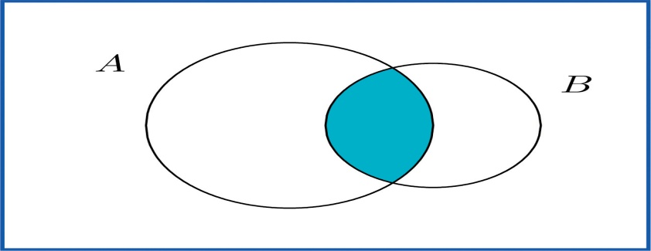

EXAMPLE 12
In the experiment of rolling a single die, find the intersection E ∩ T of the events E: “the number rolled is even” and T: “the number rolled is greater than two.”
Solution:
The sample space is S={1,2,3,4,5,6}.S={1,2,3,4,5,6}. Since the outcomes that are common to E={2,4,6}E={2,4,6} and T={3,4,5,6}T={3,4,5,6} are 4 and 6, E∩T={4,6}.E∩T={4,6}.
In words the intersection is described by “the number rolled is even and is greater than two.” The only numbers between one and six that are both even and greater than two are four and six, corresponding to E ∩ T given above.

EXAMPLE 13
A single die is rolled.
- Suppose the die is fair. Find the probability that the number rolled is both even and greater than two.
- Suppose the die has been “loaded” so that P(1)=1∕12P(1)=1∕12, P(6)=3∕12P(6)=3∕12, and the remaining four outcomes are equally likely with one another. Now find the probability that the number rolled is both even and greater than two.
Solution:
In both cases the sample space is S={1,2,3,4,5,6}S={1,2,3,4,5,6} and the event in question is the intersection E∩T={4,6}E∩T={4,6} of the previous example.
- Since the die is fair, all outcomes are equally likely, so by counting we have P(E∩T)=2∕6.P(E∩T)=2∕6.
- The information on the probabilities of the six outcomes that we have so far is
OutcomeProbablity11122p3p4p5p6312Outcome123456Probablity112pppp312
Since P(1)+P(6)=4∕12=1∕3P(1)+P(6)=4∕12=1∕3 and the probabilities of all six outcomes add up to 1,
P(2)+P(3)+P(4)+P(5)=1−13=23P(2)+P(3)+P(4)+P(5)=1−13=23
Thus 4p=2∕34p=2∕3, so p=1∕6.p=1∕6. In particular P(4)=1∕6.P(4)=1∕6. Therefore
P(E∩T)=P(4)+P(6)=16+312=512P(E∩T)=P(4)+P(6)=16+312=512

Definition
Events A and B are mutually exclusive if they have no elements in common.
For A and B to have no outcomes in common means precisely that it is impossible for both A and B to occur on a single trial of the random experiment. This gives the following rule.

Probability Rule for Mutually Exclusive Events
Events A and B are mutually exclusive if and only if
P(A∩B)=0P(A∩B)=0
Any event A and its complement A^{c} are mutually exclusive, but A and B can be mutually exclusive without being complements.

EXAMPLE 14
In the experiment of rolling a single die, find three choices for an event A so that the events A and E: “the number rolled is even” are mutually exclusive.
Solution:
Since E={2,4,6}E={2,4,6} and we want A to have no elements in common with E, any event that does not contain any even number will do. Three choices are {1,3,5} (the complement E^{c}, the odds), {1,3}, and {5}.

Union of Events

Definition
The union of events A and B, denoted A ∪ B, is the collection of all outcomes that are elements of one or the other of the sets A and B, or of both of them. It corresponds to combining descriptions of the two events using the word “or.”
To say that the event A ∪ B occurred means that on a particular trial of the experiment either A or B occurred (or both did). A visual representation of the union of events A and B in a sample space S is given in Figure 3.5 "The Union of Events ". The union corresponds to the shaded region.

Figure 3.5 The Union of Events A and B
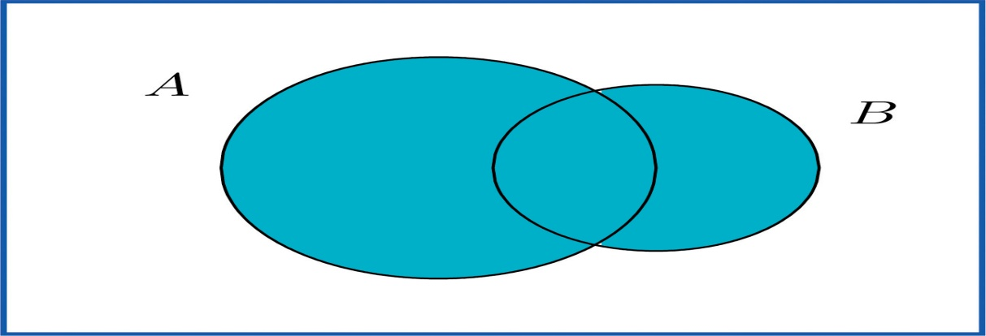

EXAMPLE 15
In the experiment of rolling a single die, find the union of the events E: “the number rolled is even” and T: “the number rolled is greater than two.”
Solution:
Since the outcomes that are in either E={2,4,6}E={2,4,6} or T={3,4,5,6}T={3,4,5,6} (or both) are 2, 3, 4, 5, and 6, E∪T={2,3,4,5,6}.E∪T={2,3,4,5,6}. Note that an outcome such as 4 that is in both sets is still listed only once (although strictly speaking it is not incorrect to list it twice).
In words the union is described by “the number rolled is even or is greater than two.” Every number between one and six except the number one is either even or is greater than two, corresponding to E ∪ T given above.

EXAMPLE 16
A two-child family is selected at random. Let B denote the event that at least one child is a boy, let D denote the event that the genders of the two children differ, and let M denote the event that the genders of the two children match. Find B ∪ D and B∪M.B∪M.
Solution:
A sample space for this experiment is S={bb,bg,gb,gg}S={bb,bg,gb,gg}, where the first letter denotes the gender of the firstborn child and the second letter denotes the gender of the second child. The events B, D, and M are
B={bb,bg,gb} D={bg,gb} M={bb,gg}B={bb,bg,gb} D={bg,gb} M={bb,gg}
Each outcome in D is already in B, so the outcomes that are in at least one or the other of the sets B and D is just the set B itself: B∪D={bb,bg,gb}=B.B∪D={bb,bg,gb}=B.
Every outcome in the whole sample space S is in at least one or the other of the sets B and M, so B∪M={bb,bg,gb,gg}=S.B∪M={bb,bg,gb,gg}=S.
The following Additive Rule of Probability is a useful formula for calculating the probability of A∪B.A∪B.

Additive Rule of Probability
P(A∪B)=P(A)+P(B)−P(A∩B)P(A∪B)=P(A)+P(B)−P(A∩B)
The next example, in which we compute the probability of a union both by counting and by using the formula, shows why the last term in the formula is needed.

EXAMPLE 17
Two fair dice are thrown. Find the probabilities of the following events:
- both dice show a four
- at least one die shows a four
Solution:
As was the case with tossing two identical coins, actual experience dictates that for the sample space to have equally likely outcomes we should list outcomes as if we could distinguish the two dice. We could imagine that one of them is red and the other is green. Then any outcome can be labeled as a pair of numbers as in the following display, where the first number in the pair is the number of dots on the top face of the green die and the second number in the pair is the number of dots on the top face of the red die.
112131415161122232425262132333435363142434445464152535455565162636465666111213141516212223242526313233343536414243444546515253545556616263646566
- There are 36 equally likely outcomes, of which exactly one corresponds to two fours, so the probability of a pair of fours is 1/36.
- From the table we can see that there are 11 pairs that correspond to the event in question: the six pairs in the fourth row (the green die shows a four) plus the additional five pairs other than the pair 44, already counted, in the fourth column (the red die is four), so the answer is 11/36. To see how the formula gives the same number, let A_{G} denote the event that the green die is a four and let A_{R} denote the event that the red die is a four. Then clearly by counting we get P(AG)=6∕36P(AG)=6∕36 and P(AR)=6∕36.P(AR)=6∕36. Since AG∩AR={44}AG∩AR={44}, P(AG∩AR)=1∕36P(AG∩AR)=1∕36; this is the computation in part (a), of course. Thus by the Additive Rule of Probability,
P(AG∪AR)=P(AG)+P(AR)−P(AG−AR)=636+636−136=1136P(AG∪AR)=P(AG)+P(AR)−P(AG−AR)=636+636−136=1136

EXAMPLE 18
A tutoring service specializes in preparing adults for high school equivalence tests. Among all the students seeking help from the service, 63% need help in mathematics, 34% need help in English, and 27% need help in both mathematics and English. What is the percentage of students who need help in either mathematics or English?
Solution:
Imagine selecting a student at random, that is, in such a way that every student has the same chance of being selected. Let M denote the event “the student needs help in mathematics” and let E denote the event “the student needs help in English.” The information given is that P(M)=0.63P(M)=0.63, P(E)=0.34P(E)=0.34, and P(M∩E)=0.27.P(M∩E)=0.27. The Additive Rule of Probability gives
P(M∪E)=P(M)+P(E)−P(M∩E)=0.63+0.34−0.27=0.70P(M∪E)=P(M)+P(E)−P(M∩E)=0.63+0.34−0.27=0.70
Note how the naïve reasoning that if 63% need help in mathematics and 34% need help in English then 63 plus 34 or 97% need help in one or the other gives a number that is too large. The percentage that need help in both subjects must be subtracted off, else the people needing help in both are counted twice, once for needing help in mathematics and once again for needing help in English. The simple sum of the probabilities would work if the events in question were mutually exclusive, for then P(A∩B)P(A∩B) is zero, and makes no difference.

EXAMPLE 19
Volunteers for a disaster relief effort were classified according to both specialty (C: construction, E: education, M: medicine) and language ability (S: speaks a single language fluently, T: speaks two or more languages fluently). The results are shown in the following two-way classification table:
Specialty | Language Ability
 | S | T
C | 12 | 1
E | 4 | 3
M | 6 | 2
The first row of numbers means that 12 volunteers whose specialty is construction speak a single language fluently, and 1 volunteer whose specialty is construction speaks at least two languages fluently. Similarly for the other two rows.
A volunteer is selected at random, meaning that each one has an equal chance of being chosen. Find the probability that:
- his specialty is medicine and he speaks two or more languages;
- either his specialty is medicine or he speaks two or more languages;
- his specialty is something other than medicine.
Solution:
When information is presented in a two-way classification table it is typically convenient to adjoin to the table the row and column totals, to produce a new table like this:
Specialty | Language Ability |  | Total
 | S | T
C | 12 | 1 | 13
E | 4 | 3 | 7
M | 6 | 2 | 8
Total | 22 | 6 | 28
- The probability sought is P(M∩T).P(M∩T). The table shows that there are 2 such people, out of 28 in all, hence P(M∩T)=2∕28≈0.07P(M∩T)=2∕28≈0.07 or about a 7% chance.
- The probability sought is P(M∪T).P(M∪T). The third row total and the grand total in the sample give P(M)=8∕28.P(M)=8∕28. The second column total and the grand total give P(T)=6∕28.P(T)=6∕28. Thus using the result from part (a),
P(M∪T)=P(M)+P(T)−P(M∩T)=828+628−228=1228≈0.43P(M∪T)=P(M)+P(T)−P(M∩T)=828+628−228=1228≈0.43
or about a 43% chance.
- This probability can be computed in two ways. Since the event of interest can be viewed as the event C ∪ E and the events C and E are mutually exclusive, the answer is, using the first two row totals,
P(C∪E)=P(C)+P(E)−P(C∩E)=1328+728−028=2028≈0.71P(C∪E)=P(C)+P(E)−P(C∩E)=1328+728−028=2028≈0.71
On the other hand, the event of interest can be thought of as the complement M^{c} of M, hence using the value of P(M)P(M) computed in part (b),
P(Mc)=1−P(M)=1−828=2028≈0.71P(Mc)=1−P(M)=1−828=2028≈0.71
as before.

KEY TAKEAWAY
- The probability of an event that is a complement or union of events of known probability can be computed using formulas.

EXERCISES

BASIC
- For the sample space S={a,b,c,d,e}S={a,b,c,d,e} identify the complement of each event given.
  - A={a,d,e}A={a,d,e}
  - B={b,c,d,e}B={b,c,d,e}
  - S
- For the sample space S={r,s,t,u,v}S={r,s,t,u,v} identify the complement of each event given.
  - R={t,u}R={t,u}
  - T={r}T={r}
  - ∅ (the “empty” set that has no elements)
- The sample space for three tosses of a coin is
S={hhh,hht,hth,htt,thh,tht,tth,ttt}S={hhh,hht,hth,htt,thh,tht,tth,ttt}
Define events
H:at least one head is observedM:more heads than tails are observedH:at least one head is observedM:more heads than tails are observed
  - List the outcomes that comprise H and M.
  - List the outcomes that comprise H ∩ M, H ∪ M, and H^{c}.
  - Assuming all outcomes are equally likely, find P(H∩M)P(H∩M), P(H∪M)P(H∪M), and P(Hc).P(Hc).
  - Determine whether or not H^{c} and M are mutually exclusive. Explain why or why not.
- For the experiment of rolling a single six-sided die once, define events
T:the number rolled is threeG:the number rolled is four or greaterT:the number rolled is threeG:the number rolled is four or greater
  - List the outcomes that comprise T and G.
  - List the outcomes that comprise T ∩ G, T ∪ G, T^{c}, and (T∪G)c.(T∪G)c.
  - Assuming all outcomes are equally likely, find P(T∩G)P(T∩G), P(T∪G)P(T∪G), and P(Tc).P(Tc).
  - Determine whether or not T and G are mutually exclusive. Explain why or why not.
- A special deck of 16 cards has 4 that are blue, 4 yellow, 4 green, and 4 red. The four cards of each color are numbered from one to four. A single card is drawn at random. Define events
B:the card is blueR:the card is redN:the number on the card is at most twoB:the card is blueR:the card is redN:the number on the card is at most two
  - List the outcomes that comprise B, R, and N.
  - List the outcomes that comprise B ∩ R, B ∪ R, B ∩ N, R ∪ N, B^{c}, and (B∪R)c.(B∪R)c.
  - Assuming all outcomes are equally likely, find the probabilities of the events in the previous part.
  - Determine whether or not B and N are mutually exclusive. Explain why or why not.
- In the context of the previous problem, define events
Y:the card is yellowI:the number on the card is not a oneJ:the number on the card is a two or a fourY:the card is yellowI:the number on the card is not a oneJ:the number on the card is a two or a four
  - List the outcomes that comprise Y, I, and J.
  - List the outcomes that comprise Y ∩ I, Y ∪ J, I ∩ J, I^{c}, and (Y∪J)c.(Y∪J)c.
  - Assuming all outcomes are equally likely, find the probabilities of the events in the previous part.
  - Determine whether or not I^{c} and J are mutually exclusive. Explain why or why not.
- The Venn diagram provided shows a sample space and two events A and B. Suppose P(a)=0.13P(a)=0.13, P(b)=0.09P(b)=0.09, P(c)=0.27P(c)=0.27, P(d)=0.20P(d)=0.20, and P(e)=0.31.P(e)=0.31. Confirm that the probabilities of the outcomes add up to 1, then compute the following probabilities.
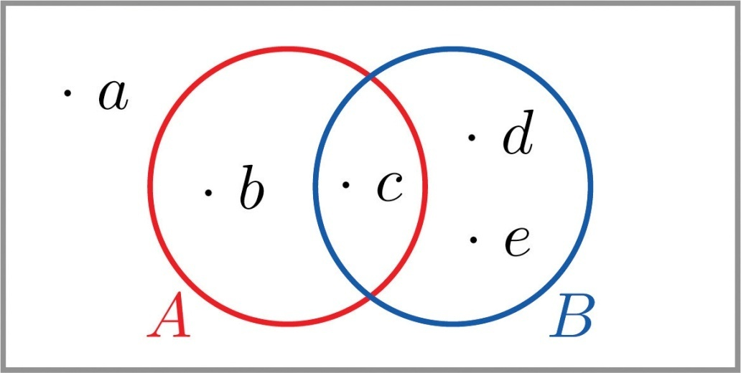

  - P(A).P(A).
  - P(B).P(B).
  - P(Ac)P(Ac) two ways: (i) by finding the outcomes in A^{c} and adding their probabilities, and (ii) using the Probability Rule for Complements.
  - P(A∩B).P(A∩B).
  - P(A∪B)P(A∪B) two ways: (i) by finding the outcomes in A ∪ B and adding their probabilities, and (ii) using the Additive Rule of Probability.
- The Venn diagram provided shows a sample space and two events A and B. Suppose P(a)=0.32P(a)=0.32, P(b)=0.17P(b)=0.17, P(c)=0.28P(c)=0.28, and P(d)=0.23.P(d)=0.23. Confirm that the probabilities of the outcomes add up to 1, then compute the following probabilities.
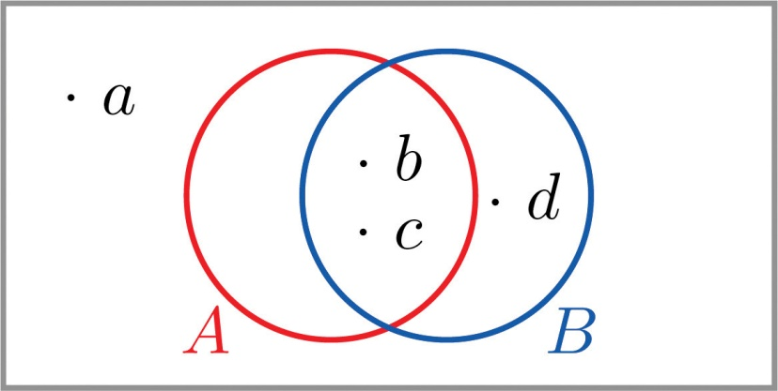

  - P(A).P(A).
  - P(B).P(B).
  - P(Ac)P(Ac) two ways: (i) by finding the outcomes in A^{c} and adding their probabilities, and (ii) using the Probability Rule for Complements.
  - P(A∩B).P(A∩B).
  - P(A∪B)P(A∪B) two ways: (i) by finding the outcomes in A ∪ B and adding their probabilities, and (ii) using the Additive Rule of Probability.
- Confirm that the probabilities in the two-way contingency table add up to 1, then use it to find the probabilities of the events indicated.
 | U | V | W
A | 0.15 | 0.00 | 0.23
B | 0.22 | 0.30 | 0.10
  - P(A)P(A), P(B)P(B), P(A∩B).P(A∩B).
  - P(U)P(U), P(W)P(W), P(U∩W).P(U∩W).
  - P(U∪W).P(U∪W).
  - P(Vc).P(Vc).
  - Determine whether or not the events A and U are mutually exclusive; the events A and V.
- Confirm that the probabilities in the two-way contingency table add up to 1, then use it to find the probabilities of the events indicated.
 | R | S | T
M | 0.09 | 0.25 | 0.19
N | 0.31 | 0.16 | 0.00
  - P(R)P(R), P(S)P(S), P(R∩S).P(R∩S).
  - P(M)P(M), P(N)P(N), P(M∩N).P(M∩N).
  - P(R∪S).P(R∪S).
  - P(Rc).P(Rc).
  - Determine whether or not the events N and S are mutually exclusive; the events N and T.

APPLICATIONS
- Make a statement in ordinary English that describes the complement of each event (do not simply insert the word “not”).
  - In the roll of a die: “five or more.”
  - In a roll of a die: “an even number.”
  - In two tosses of a coin: “at least one heads.”
  - In the random selection of a college student: “Not a freshman.”
- Make a statement in ordinary English that describes the complement of each event (do not simply insert the word “not”).
  - In the roll of a die: “two or less.”
  - In the roll of a die: “one, three, or four.”
  - In two tosses of a coin: “at most one heads.”
  - In the random selection of a college student: “Neither a freshman nor a senior.”
- The sample space that describes all three-child families according to the genders of the children with respect to birth order is
S={bbb,bbg,bgb,bgg,gbb,gbg,ggb,ggg}.S={bbb,bbg,bgb,bgg,gbb,gbg,ggb,ggg}.
For each of the following events in the experiment of selecting a three-child family at random, state the complement of the event in the simplest possible terms, then find the outcomes that comprise the event and its complement.
  - At least one child is a girl.
  - At most one child is a girl.
  - All of the children are girls.
  - Exactly two of the children are girls.
  - The first born is a girl.
- The sample space that describes the two-way classification of citizens according to gender and opinion on a political issue is
S={mf,ma,mn,ff,fa,fn},S={mf,ma,mn,ff,fa,fn},
where the first letter denotes gender (m: male, f: female) and the second opinion (f: for, a: against, n: neutral). For each of the following events in the experiment of selecting a citizen at random, state the complement of the event in the simplest possible terms, then find the outcomes that comprise the event and its complement.
  - The person is male.
  - The person is not in favor.
  - The person is either male or in favor.
  - The person is female and neutral.
- A tourist who speaks English and German but no other language visits a region of Slovenia. If 35% of the residents speak English, 15% speak German, and 3% speak both English and German, what is the probability that the tourist will be able to talk with a randomly encountered resident of the region?
- In a certain country 43% of all automobiles have airbags, 27% have anti-lock brakes, and 13% have both. What is the probability that a randomly selected vehicle will have both airbags and anti-lock brakes?
- A manufacturer examines its records over the last year on a component part received from outside suppliers. The breakdown on source (supplier A, supplier B) and quality (H: high, U: usable, D: defective) is shown in the two-way contingency table.
 | H | U | D
A | 0.6937 | 0.0049 | 0.0014
B | 0.2982 | 0.0009 | 0.0009
- The record of a part is selected at random. Find the probability of each of the following events.
  - The part was defective.
  - The part was either of high quality or was at least usable, in two ways: (i) by adding numbers in the table, and (ii) using the answer to (a) and the Probability Rule for Complements.
  - The part was defective and came from supplier B.
  - The part was defective or came from supplier B, in two ways: by finding the cells in the table that correspond to this event and adding their probabilities, and (ii) using the Additive Rule of Probability.
- Individuals with a particular medical condition were classified according to the presence (T) or absence (N) of a potential toxin in their blood and the onset of the condition (E: early, M: midrange, L: late). The breakdown according to this classification is shown in the two-way contingency table.
 | E | M | L
T | 0.012 | 0.124 | 0.013
N | 0.170 | 0.638 | 0.043
- One of these individuals is selected at random. Find the probability of each of the following events.
  - The person experienced early onset of the condition.
  - The onset of the condition was either midrange or late, in two ways: (i) by adding numbers in the table, and (ii) using the answer to (a) and the Probability Rule for Complements.
  - The toxin is present in the person’s blood.
  - The person experienced early onset of the condition and the toxin is present in the person’s blood.
  - The person experienced early onset of the condition or the toxin is present in the person’s blood, in two ways: (i) by finding the cells in the table that correspond to this event and adding their probabilities, and (ii) using the Additive Rule of Probability.
- The breakdown of the students enrolled in a university course by class (F: freshman, SoSo: sophomore, J: junior, SeSe: senior) and academic major (S: science, mathematics, or engineering, L: liberal arts, O: other) is shown in the two-way classification table.
Major | Class
 | F | So | J | Se
S | 92 | 42 | 20 | 13
L | 368 | 167 | 80 | 53
O | 460 | 209 | 100 | 67
- A student enrolled in the course is selected at random. Adjoin the row and column totals to the table and use the expanded table to find the probability of each of the following events.
  - The student is a freshman.
  - The student is a liberal arts major.
  - The student is a freshman liberal arts major.
  - The student is either a freshman or a liberal arts major.
  - The student is not a liberal arts major.
- The table relates the response to a fund-raising appeal by a college to its alumni to the number of years since graduation.
Response | Years Since Graduation
 | 0–5 | 6–20 | 21–35 | Over 35
Positive | 120 | 440 | 210 | 90
None | 1380 | 3560 | 3290 | 910
- An alumnus is selected at random. Adjoin the row and column totals to the table and use the expanded table to find the probability of each of the following events.
  - The alumnus responded.
  - The alumnus did not respond.
  - The alumnus graduated at least 21 years ago.
  - The alumnus graduated at least 21 years ago and responded.

ADDITIONAL EXERCISES
- The sample space for tossing three coins is
S={hhh,hht,hth,htt,thh,tht,tth,ttt}S={hhh,hht,hth,htt,thh,tht,tth,ttt}
  - List the outcomes that correspond to the statement “All the coins are heads.”
  - List the outcomes that correspond to the statement “Not all the coins are heads.”
  - List the outcomes that correspond to the statement “All the coins are not heads.”

ANSWERS

  - {b,c}{b,c}
  - {a}{a}
  - ∅

  - H={hhh,hht,hth,htt,thh,tht,tth}H={hhh,hht,hth,htt,thh,tht,tth}, M={hhh,hht,hth,thh}M={hhh,hht,hth,thh}
  - H∩M={hhh,hht,hth,thh}H∩M={hhh,hht,hth,thh}, H∪M=HH∪M=H, Hc={ttt}Hc={ttt}
  - P(H∩M)=4∕8P(H∩M)=4∕8, P(H∪M)=7∕8P(H∪M)=7∕8, P(Hc)=1∕8P(Hc)=1∕8
  - Mutually exclusive because they have no elements in common.

  - B={b1,b2,b3,b4}B={b1,b2,b3,b4}, R={r1,r2,r3,r4}R={r1,r2,r3,r4}, N={b1,b2,y1,y2,g1,g2,r1,r2}N={b1,b2,y1,y2,g1,g2,r1,r2}
  - B∩R=∅B∩R=∅, B∪R={b1,b2,b3,b4,r1,r2,r3,r4},B∪R={b1,b2,b3,b4,r1,r2,r3,r4}, B∩N={b1,b2}B∩N={b1,b2}, R∪N={b1,b2,y1,y2,g1,g2,r1,r2,r3,r4},R∪N={b1,b2,y1,y2,g1,g2,r1,r2,r3,r4}, Bc={y1,y2,y3,y4,g1,g2,g3,g4,r1,r2,r3,r4},Bc={y1,y2,y3,y4,g1,g2,g3,g4,r1,r2,r3,r4}, (B∪R)c={y1,y2,y3,y4,g1,g2,g3,g4}(B∪R)c={y1,y2,y3,y4,g1,g2,g3,g4}
  - P(B∩R)=0P(B∩R)=0, P(B∪R)=8∕16P(B∪R)=8∕16, P(B∩N)=2∕16P(B∩N)=2∕16, P(R∪N)=10∕16P(R∪N)=10∕16, P(Bc)=12∕16P(Bc)=12∕16, P((B∪R)c)=8/16P((B∪R)c)=8∕16
  - Not mutually exclusive because they have an element in common.

  - 0.36
  - 0.78
  - 0.64
  - 0.27
  - 0.87

  - P(A)=0.38P(A)=0.38, P(B)=0.62P(B)=0.62, P(A∩B)=0P(A∩B)=0
  - P(U)=0.37P(U)=0.37, P(W)=0.33P(W)=0.33, P(U∩W)=0P(U∩W)=0
  - 0.7
  - 0.7
  - A and U are not mutually exclusive because P(A∩U)P(A∩U) is the nonzero number 0.15. A and V are mutually exclusive because P(A∩V)=0.P(A∩V)=0.

  - “four or less”
  - “an odd number”
  - “no heads” or “all tails”
  - “a freshman”

  - “All the children are boys.”
Event: {bbg,bgb,bgg,gbb,gbg,ggb,ggg}{bbg,bgb,bgg,gbb,gbg,ggb,ggg},
Complement: {bbb}{bbb}
  - “At least two of the children are girls” or “There are two or three girls.”
Event: {bbb,bbg,bgb,gbb}{bbb,bbg,bgb,gbb},
Complement: {bgg,gbg,ggb,ggg}{bgg,gbg,ggb,ggg}
  - “At least one child is a boy.”
Event: {ggg}{ggg},
Complement: {bbb,bbg,bgb,bgg,gbb,gbg,ggb}{bbb,bbg,bgb,bgg,gbb,gbg,ggb}
  - “There are either no girls, exactly one girl, or three girls.”
Event: {bgg,gbg,ggb}{bgg,gbg,ggb},
Complement: {bbb,bbg,bgb,gbb,ggg}{bbb,bbg,bgb,gbb,ggg}
  - “The first born is a boy.”
Event: {gbb,gbg,ggb,ggg}{gbb,gbg,ggb,ggg},
Complement: {bbb,bbg,bgb,bgg}{bbb,bbg,bgb,bgg}

- 0.47

  - 0.0023
  - 0.9977
  - 0.0009
  - 0.3014

  - 920/1671
  - 668/1671
  - 368/1671
  - 1220/1671
  - 1003/1671

  - {hhh}{hhh}
  - {hht,hth,htt,thh,tht,tth,ttt}{hht,hth,htt,thh,tht,tth,ttt}
  - {ttt}

Assignment
Assessment
References

LESSON Plan WEEK 2 AND Week 3
Work on the Internal Assessment. Part A.

