Year 13 Biology Home Test 2 – 2020 (Time allowed: 1 hour)

Name:_________________________________________________________________

 |  | Assessor’s use only
1 | Define niche differentiation.  ______________________________________________________________ |  | Skill Level 1  1  0  NR
2 | Define out-competition.  ______________________________________________________________  ______________________________________________________________ |  | Skill Level 1  1  0  NR
3 | Define interspecific competition.  ______________________________________________________________  ______________________________________________________________ |  | Skill Level 1  1  0  NR
4 | State the competitive exclusion principle.  ______________________________________________________________  ______________________________________________________________ |  | Skill Level 1  1  0  NR
5 | The sea star, Pisaster ochraceous, and the mussel, Mytilus califomicus, are two commonly found species that co-exist on the rocky shoreline of coastal Catalina Island. The sea star Pisaster ochraceous is an important predator.  The numbers of sea star were reduced by removal from experimental areas of the shoreline over a ten-year period, which allowed the mussel populations in the experimental areas to expand into new habitats.  The effects on species diversity over the ten-year period are shown in the graph below. (SPFSC 2016, A9 p6)  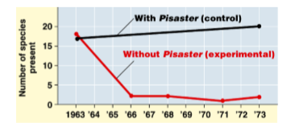  Explain how interspecific competition limit the numbers of population in the intertidal community.  ______________________________________________________________  ______________________________________________________________  ______________________________________________________________  ______________________________________________________________  ______________________________________________________________  ______________________________________________________________  ______________________________________________________________  ______________________________________________________________  ______________________________________________________________ |  | Skill Level 3  3  2  1  0  NR
6 | The graph below shows the relationship between prey and predator populations. (SPFSC 2019, 1.4 p3)  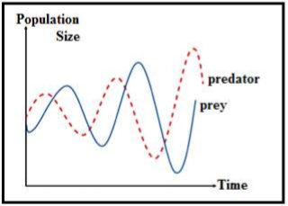  With reference to the graph, describe the features of the prey and predator relationships.  ______________________________________________________________  ______________________________________________________________  ______________________________________________________________  ______________________________________________________________  ______________________________________________________________  ______________________________________________________________  ______________________________________________________________ |  | Skill Level 2  2  1  0  NR

