Year 13 Biology Home Test 1 – 2020 (Time allowed: 1 hour)

Name:_________________________________________________________________

 |  | Assessor’s use only
1a | The actogram below shows the periods of activity of a hermit crab.  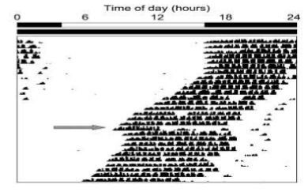  When the animal is placed into constant darkness, its endogenous clock runs at its natural speed (free-running period) in the absence of the zeitgebers of sunrise/sunset. (SPFSC 2018, 1.3 p3)  Define actogram.  ______________________________________________________________ |  | Skill Level 1  1  0  NR
1b | Define zeitgebers.  ______________________________________________________________  ______________________________________________________________ |  | Skill Level 1  1  0  NR
1c | Define free-running period. (SPFSC 2016)  ______________________________________________________________  ______________________________________________________________ |  | Skill Level 1  1  0  NR
1d | State whether the hermit crab is crepuscular, diurnal or nocturnal.  ______________________________________________________________ |  | Skill Level 1  1  0  NR
1e | Define the term endogenous.  ______________________________________________________________  ______________________________________________________________  ______________________________________________________________ |  | Skill Level 1  1  0  NR
1d | Explain the adaptive advantages of the tidal timing on the life of the hermit crab. Support your answer using the actogram above.  ______________________________________________________________  ______________________________________________________________  ______________________________________________________________  ______________________________________________________________  ______________________________________________________________  ______________________________________________________________  ______________________________________________________________ |  | Skill Level 3  3  2  1  0  NR
2a | Environmental change has negatively affected most biological systems on our planet and is becoming of increasing concern for the well-being and survival of many species. (SPFSC 2019, 1.5 p4)  Define biological clock.  ______________________________________________________________  ______________________________________________________________  ______________________________________________________________ |  | Skill Level 1  1  0  NR
2b | Using an example of a named organism, discuss the implications of environmental (destructive) change on the organism’s biological clock and its survival.  In your answer, you may:  - name and describe an example of environmental destruction;  - explain the implication of the destruction on the biological clock of the named organism; and  - discuss the effect of the affected biological cycle on the survival of the named organism.  ______________________________________________________________  ______________________________________________________________  ______________________________________________________________  ______________________________________________________________  ______________________________________________________________  ______________________________________________________________  ______________________________________________________________  ______________________________________________________________  ______________________________________________________________  ______________________________________________________________  ______________________________________________________________  ______________________________________________________________  ______________________________________________________________  ______________________________________________________________  ______________________________________________________________  ______________________________________________________________  ______________________________________________________________  ______________________________________________________________  ______________________________________________________________  ______________________________________________________________  ______________________________________________________________  ______________________________________________________________  ______________________________________________________________  ______________________________________________________________  ______________________________________________________________ |  | Skill Level 4  4  3  2  1  0  NR
3 | Research on the mussel Mytilus califomianus revealed the following rhythm when pumping seawater through its gill filaments. (SPFSC 2016, A6 p4)  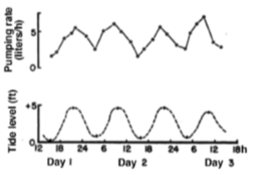  The rhythm was found to be independent of temperature and was shown to continue in the laboratory in both constant darkness and continuous light for a 4 week period.  Discuss this rhythm of the Mytilus califomianus mussels. In your answer you must;  - identify the type of cycle (biological rhythm) shown by the mussel: circadian, circatidal, circalunar, or circannual;  - explain from the information given, why the pumping cycle shown by the mussel is endogenous; and  - discuss the adaptive advantages of this rhythm for the mussels.  ______________________________________________________________  ______________________________________________________________  ______________________________________________________________  ______________________________________________________________  ______________________________________________________________  ______________________________________________________________  ______________________________________________________________  ______________________________________________________________  ______________________________________________________________  ______________________________________________________________  ______________________________________________________________  ______________________________________________________________  ______________________________________________________________  ______________________________________________________________  ______________________________________________________________  ______________________________________________________________  ______________________________________________________________  ______________________________________________________________  ______________________________________________________________  ______________________________________________________________  ______________________________________________________________  ______________________________________________________________  ______________________________________________________________  ______________________________________________________________ |  | Skill Level 4  3  2  1  0  NR

