What is History?
“is knowing about the past to give meaning to the present and hope for the Future”.
“ is an investigation and interpretation of the past”.
Why is History Important?
“if you know your history you’ll know where you’re coming from”
“We cannot know the village where we were going, unless we know the village from where we came.
How do Historians work?
Historians try to understand what happened in the past.....what people did.....why they did it and how their lives changed. They began by looking for sources (Primary and Secondary) and Evidence about the past. They tell the story accurately before they can write. Historians are like Detectives who look for clues that will help them to write a story
- Using Clues( Gathering Clues, example a person’s history)
- Understanding Time( BC –Before Christ, AD –Anno Domini – in the years of Christ)

Exercise 1:
A): Name the Century in which the following dates occur:
- 350BC
- 75BC
- 350AD
- 1606AD
- 1814AD
- 1939AD
B): Write down any year in each of the following centuries:
- 2nd Century BC
- 18th Century AD
- 6th Century AD
Historians interpret evidence; clues then came up with their judgements, conclusions about what happen in the past. The process is of investigation is called an ‘’ENQUIRY”. An enquiry involves asking and try to find answers, Six questions: What, when, why, where, how, who.
Working with Sources
We look at various sources of information to find evidence.
1: Primary Source – sources which come from the actual time of the people and event you are investigating( First hand information) example. Grave, stone axe, talking with old people, Personal daries etc....
2: Secondary Sources – when historians often write about people and events after they have happened. Example: History textbook, newspaper.

Exercise 2: Decide which of the following are Primary or Secondary Sources
- A fish hook made about 2000 years ago?
- Rock painting
- Letters written by a missionary between 1870 and 1924 to a bishop in Paris.
- The stories of an old man about life during the Second World War.
- A lecture on Blackbirding in the South Pacific by Professor Tor at USP.
- A copy of “the Journal of the Pacific History”
- The last Census
- A play about 50 years ago by theatre group.
- The private diary of a plantation owner from 1948 -1979.
- A photograph of Abu John in 1925.
Written Sources
Sources that include newspaper, books, plantation records, private letters, diaries and government report.
Physical sources
Sources includes places where events happened as well as artefacts from the past. Example, old type of fan, Reef sandals.
Interviews
Photographs
DEFINITION OF TERMS
Oral traditions – is a form of human communication where knowledge, arts, ideas and cultural material is received or transmitted orally.
Imperialism – Extension of a nation’s power by territorial, acquisition or economic and political dominance of other nation.
Colonialism – A policy of acquiring full political control over another country.
Aristocracy - The Highest class in certain societies typically comprising people of noble birth hereditary titles.
Democracy - A system of government by the whole population through elected representatives.
Condominium - The joint control of a states affairs by other states.

National Consciousness - is a shared sense of national identity which a share understanding that a group of people share.
Dual System - is a system combines apprenticeships in a company –government.
Colonial power – powerful nations maintaining control over other countries.
Colony – A country or area under full partial control of another country and occupied by settlers from that country.
Colonial administration - a system of governance used by British and France to control parts of their colonial empire.
Protectorate - A state that is controlled and protected by another
Political party split – A group of people with similar political goals and opinion.
Non –Verbal Text – refers to the use of Photograph, pictures, films and cartoons that portrayed a message related to a historical event.
Different sources where historians can obtained information from:
- Written Source
- Oral Source
- Visual Source
- Examining Artefacts
- Historical Site.

The History of Vanuatu

The Early Explorers
Many of the islands of Vanuatu have been inhabited for thousands of years, the oldest archaeological evidence dates back to 2000 BC. Vanuatu is one of the most culturally diverse countries on earth, with a population of approximately 217,750, 113 distinct languages and innumerable dialects. This amazing diversity is a result of 4,000 years of sporadic immigration from many Pacific countries. Although most settlers arrived from Melanesia, the larger built, lighter skinned Polynesians also settled in the islands.
In 1605, the Portuguese explorer Pedro Fernández de Quirós became the first European to reach the islands, believing it to be part of Terra Australis. Europeans began settling the islands in the late 18th century, after British explorer James Cook visited the islands on his second voyage, and gave them the name New Hebrides.
In 1887, the islands began to be administered by a French-British naval commission, with the French and British agreeing to an Anglo-French Condominium on the New Hebrides in 1906.

Missionaries
The first two missionaries set foot in Vanuatu, on Erromango in 1839. An inauspicious beginning, with the death of one of their most famous members (John Williams of the London Missionary Society), prompted the mission societies to proceed cautiously.
For the following nine years, they used converted Polynesian missionaries. Polynesians were regarded as a form of cannon fodder and if they survived, Europeans could safely follow.
In 1845, Samoan teachers landed on Efate, but most had been killed within a few years. The following years saw Catholic, Presbyterian and Anglican missionaries from England, Noumea and France making various short lived (through death) or aborted (rapid retreat) attempts to convert the ni-Vanuatu. However, through perseverance, by the 1860's various denominational mission stations existed throughout the islands.
The effect on the local populations varied. For those who converted to Christianity in one form or another, many died, due to the exposure of an entire range of introduced diseases. By then these included not only measles and dysentery, but smallpox, influenza, pneumonia, scarlet fever, mumps, whooping cough and the simple, but often quite deadly, common cold.
Traditional medicines when combined with a degree of genetic immunity, proved effective against endemic diseases, but had no impact on these new medical conditions. Consequently some considered that the new religion and its God were impotent in the face of disease.
Others took a more pragmatic view; as all illnesses stemmed from sorcery anyway, Christianity must be a particularly malevolent religion to attack its converts in such a violent manner. This attitude resulted in the death of several missionaries following epidemics.
However, the missionaries kept coming and eventually had profound impact on the Melanesian society, by destroying rich cultural heritage centuries old. Catholicism in particular was more readily embraced as Catholic missionaries did not take a dim view of converts merging elements of their own beliefs with Catholicism. In the end, the success of the Catholics had an extraordinary effect on the way the country was to be eventually governed.

World War 2
With the fall of France to Germany in World War 2, the French side of the condominium technically became at war with the other half - Britain.
However in 1940, the French population of the New Hebrides immediately declared their support for General De Gaul's Free French Forces – the first of France's Pacific colonies to do so. This would be on of the only times of the Condominium that the French and British were not at odds with each other.
With France under German rule, the French Ambassador was placed in a difficult position as there was no support structure of a functioning French government. However, these concerns were overshadowed by the fast approaching Japanese forces.
In early 1942, the Japanese reached the nearby Solomon Islands and the New Hebridean's lived in fear that they would be next. The Americans, however, arrived first, totally unannounced, in May 1942 filling Mele Bay with warships.
Due to this unannounced arrival, a large number of the Vila population fled into the hills believing the Japanese had arrived. It took time to convince them otherwise, but the stealthy nature of the American arrival was key in its defensive strategy against the seemingly unbeatable Japanese.
Being at war, the Americans simply took over and built an entire infrastructure to support their introduced military population and the necessary equipment to wage a counter offensive. They brought in tens of thousands of tons of machinery, built barracks and hospitals, a road around the entire island, airstrips and wharves in a desperate attempt to push back the Japanese, leaving France and Britain in shame for all they had not done for the islands.
In Espiritu Santo, 100,000 troops arrived in short order, doubling the population of the country almost overnight.
Throughout the islands, an interesting social phenomena took place. New Hebrideans were astounded at the equality with which black and white military personnel were treated, so when they went to work for the Americans, they received respect and wages far in excess to anything they had ever experienced before. The typically generous Americans would also look at New Hebridean living conditions and provided clothes and beds, ice boxes and furniture where needed.
The early 1940's were calm years for the native New Hebrideans. Vanuatu was attacked only once by a Japanese plane (that was shot down), resulting in one casualty on Santo - Besse the cow.
Thus they never experienced the horrors of Japanese occupied New Guinea or Solomon Islands. Instead, they saw fair treatment, better living conditions, modern medical aid, economic growth and a vast expansion of facilities, many of which are still in use years later.

End of the War
Three years later, the Americans left as swiftly as they arrived. As the policy that had funded the war effort meant the American economy could not sustain the influx of returning goods, the Americans suggested to the Condominium Government they might like to purchase plant equipment, bulldozers, modern workshop machinery, cranes, trucks and office equipment for a price of only seven cents in the dollar on the real value of the goods.
However, since the Americans were going to leave it behind anyway, the Condominium questioned the need to pay for it. So, the decision was made to bulldoze every movable object into the ocean. This reckless discard contributed to the already proliferating Cargo Cults throughout the islands, and the growing resentment of native New Hebridean's to Condominium rule. There are places around Efate Island where divers can discover much of this discarded war material; the most famous spot being Million Dollar Point in Espiritu Santo.
Perhaps the most well-known remnants of war and one of the most famous dive spots in the world is that of the SS Coolidge.
On February 21 1931, the widow of the 30th President of the United States, Calvin Coolidge, christened the bow of the largest and finest merchant ship ever built by an American shipyard, before it set sail and ended its journey on Santo. The 654 foot, 21,936 ton "President Coolidge" was the one of the last truly opulent vessel s to be built anywhere.
In 1941 the Coolidge went into service with the American Army as a transport ship for reinforcing Pacific garrisons. Once fully converted in 1942 she was able to carry 5,000 troops.
The Coolidge made several South Pacific runs in 1942. In October, she departed San Francisco for New Caledonia and Espiritu Santo laden with the 5,092 officers and troops of the 172nd Regiment, 43rd Infantry division. They were to be much needed reinforcements for the American assault on Guadalcanal.
On the morning of 26th October 1942, the Coolidge approached Espiritu Santo by the Eastern side of the Segond Channel. Due to security, the navy were unable to radio the Captain special instructions on how to enter the channel.
As the ship began to enter the channel, and the failure of a patrol boat to stop her, radio officers had no choice but to break silence and issue a warning, but it came too late.

An explosion struck the aft fire room - an explosion from a mine, one of many scattered in a deadly mine field across the channel. Thirty seconds later a second explosion hit the engine room - the ship was mortally wounded. Captain Nelson ordered the now listing ship to be turned to the shore and run aground. Immediately, abandon ship order issued.
Everyone aboard was told to leave their possessions and equipment, they could return for them later. Men abandoned hard hats, guns and personal equipment as they scrambled to leave the dying vessel.
Many suffered chemical burns as they landed in the oily waters and Santo had few facilities to accommodate such large numbers of injured. However, the ship was fully laden with the supplies need to treat the injured. But the Coolidge would never let her troops return for their possessions. Fifty five minutes after the she was beached, the great vessel gave a shuddering lurch and slid backwards into the oily water, disappearing to her grave at the edge of the Segond Channel.
As she sank, she rolled onto her Port side, taking with her two men who were never found.
The loss of millions of dollars’ worth of equipment and the setback to the war effort were not large in the overall scheme of the War, but it was nevertheless a costly mistake.
Still, such a costly mistake has turned Espiritu Santo into a Mecca for divers worldwide, as the Coolidge is the largest, most intact and accessible wreck of World War 2.
Located only a few kilometres from Luganville, the second largest town in Vanuatu on the island of Espiritu Santo, the wreck lies only a few paces from the relatively calm shore. Divers can reach it by boat or by foot, through one of several dive operations based in Santo.

With visibility normally around 15-25 meters, such a wreck dive offers exceptional underwater clarity. The outer parts of the ship can be safely seen by novice divers. For penetration diving, most areas of interest, allow divers to see outside the vessel at all times. However it is strongly recommended that divers take it easy at first, exploring the outside on the first few dives and making gradual penetrations of the wreck.
Following the war, Condominium authorities were left with a legacy of, from their perspective, overpaid and over ambitious New Hebridean natives. Today, many ni-Vanuatu recall how the authorities came into their homes and took what the Americans had given their fathers. Britain and France were left in tatters at the end of the War. They were left with little enough to rebuild their own nation and thus the New Hebridean economy staggered along under its hopelessly inadequate dual political system. But a spark had been lit and it would not die. By the 1960's it was ready to ignite.

Father of Independence
Land, from the perspective of Ni-Vanuatu before Independence, was not something that could be owned. And therefore it could not be sold. It is held in trust by families, from one generation to the next, as has been the tradition for many since before Christ was born. One might give away, or sell the use of land, but not the land itself.
Europeans, however, took an entirely different viewpoint. By the mid 1960's European settlers claimed ownership of almost 30% of the county's land mass. These settlers had, for the most part, cleared land to grow coconuts - copra being the mainstay of the economy for some time.
But as the price of copra fell, planters began to look at alternatives. With the idea of expanding into cattle production, planters began clearing jungle adjoining their properties. This led to immediate protests in Santo and Malekula from local villagers who objected strongly to yet more of their 'custom' land being pilfered.
The objections grew and natural resentment that started at the end of the war sparked the formation of political parties.
On the one hand were French backed parties such as the supposedly custom-oriented Nagriamel movement. Led by the colourful and charismatic Jimmy Stevens, it claimed to protect Melanesian's claim to traditional lands.

On the other hand, in 1971 when Stevens petitioned the United Nations for early Independence, the Anglican Minister Father Walter Lini formed the Anglophone backed Vanua'aku Party.
As the country became more politicised, the (minority) Anglicans joined the Vanua'aku Party, but the (majority) French fragmentised. Many mixed race and educated Melanesian considered themselves more French than Melanesian and were adamantly opposed to the British declared aim of early Independence.
Some wanted the Condominium to remain, whilst others wanted the British out and France to annex the country entirely. This division, and the added confusion the push for Santo autonomy, set the stage upon which the first general election was held.
After enough wrangling and accusations to fill several books, in November 1979, Lini's Vanua'aku Party emerged victorious. But being the winner did not mean everyone agreed. As Vanuatu is one of the most culturally diverse countries on earth, trying to govern it gave the Condominium more grief than it could have imagined. With virtually no preparation for Independence under the British/French rule, Lini was not going to have an easy time of it.
The French are notoriously possessive about their colonies, but despite their objections, Independence was set for mid-1980. However in May of that year, a few weeks prior to the end of Condominium rule, an insurrection on Tanna split the island in two. One faction supported the new government while the other supported the French.
In Santo, Stevens seized the opportunity to blockade the airport, run the police from their small station and declare Santo independent of Vanuatu, and raised the flag of the independent country of Venerama.
Pandemonium took hold for the next few weeks. France would not agree to British troops intervening and French troops did nothing. Steven's men were armed with only bows and arrows yet they managed to hold Santo to ransom. Lini was given virtually no support from the exiting colonial powers, except verbal sympathy and assurances that all would be taken care of.
With Independence Day fast approaching, Lini was clearly at a political impasse. Officially he could do nothing because Vanuatu was not yet his to govern. However, he asked the neutral Papua New Guinea troops to step into what the world farcically began to call, the ‘Coconut War’.
It was a strange war, of words and diplomatic double talk, bows and arrows and Francophone shrugs. It ended suddenly when Steven's son was shot and killed as he sat in the rear of a utility that ran through a PNG troop roadblock. Following Steven's statement that he had meant no-one to be harmed, he surrendered and was arrested.
Documents also came to light that indicated the French administration had been deceitful; they officially backed Lini as the duly elected representative of the people of Vanuatu, but they had secretly supported the secessionist citizens and Stevens.
On midnight June 1980, the French and British flags were lowered for the last time, amidst tears and brave salutes and the flag of the Republic of Vanuatu was raised in celebration at the birth of a new nation. The vast majority of French nationals left Vanuatu and land ownership reverted entirely to the indigenous ni-Vanuatu with leases of land set at 60 years.

Chief Roimata - Ancient King of Vanuatu

In July 2008, Chief Roi Mata’s Domain was formally registered as a World Heritage site – the first in Vanuatu. At just half an hour’s drive north of Port Vila, the site features a string of perfect beaches, a breathtaking harbour, spectacular views of the hat-shaped island of Artok and so much more.
Throughout the middle and southern islands of Vanuatu there existed the story of a great and powerful chief, who united the warring and cannibalistic tribes of the area into a unified, and peaceful group of tribes, a first in ancient Vanuatu.
In a cultures where language is unwritten, oral traditions are faithfully passed down from generation to generation. The accuracy of such history is frequently disputed by Western cultures, for what is heard can be changed in the retelling. And in any case, how does one separate fact from legend?
As the story goes, a paramount chief beyond paramount chiefs, Chief Roi Mata took on the title of King. Through sheer personal magnetism, Roymata, managed to unite the warring and cannibalistic tribes of the area into a unified, peaceful group in what are fondly 'remembered' as halcyon years.
But sibling jealousy ended the life of this much revered man, when his brother shot a poison dart into his throat. He did not die quickly, but suffered a lingering malaise.
His grieving family and clan carried the dying King around the island of Efate, to say farewell to those whom he had unified.
Finally, he was taken to the famous Feles Cave on Lelepa Island where he died. It is then told how he was carried to Devil's Point, the entry to the underworld, and through the underwater caverns of Tukutuku to the nearby Island or Retoka (Hat Island) where he was interred. And, say the legends, following the custom of the era, men and women were interred with him. But perhaps most spine chilling was that many of these people were entombed alive.
How true could the legend be? One version tells of how the waters between Tukutuku and Retoka Island parted to allow the funeral party across. Certainly that could not be fact.
As to the caverns of Tukutuku, they are very real. Lava tunnels and coral encrusted lava flows create an underwater labyrinth that could easily be thought to lead to a mythical underworld. But the caves have been explored extensively by scuba divers and do not lead to Retoka Island.
But how long ago did this happen? By matrilineal decent, the people of Tongoa (who retain an extensive oral history going back to their first settlement in Vanuatu over 5,000 years ago) narrowed it down to 1265 A.D. Following the interment, a seven hundred year-long tabu, on pain of death had been placed on Retoka. As such, no-one lived there and few plucked up the courage to sleep, or even go there, despite its wealth of turtle eggs and abundant fish life. Retoka became known as the Island of the Dead and a ghost island.
In 1967 a French archaeologist, Jose Garanger, offered to search for the grave of Roymata to determine if he was a real, or mythological figure. The chiefs of Lelepa, equally curious, gave their go-ahead on condition that the grave be returned to its original state after investigation.
Once on Retoka, the site was surprisingly easy to find. Two rock slabs, like tombstones, at the base of a large white wood tree were located in a natural 'clearing' only 100m from the beach, on the North West side of the small island. Oral tradition stated that no tree or bush would ever grow over the site of Roymata's grave.
In an area 20m x 10m, the archaeological team dug down a metre; carefully uncovering skeletons as they went. According to oral history, they were to discover 47 skeletons. As bones were uncovered it quickly became evident that a mass burial had taken place.
Finally, with the entire grave site exposed, the evidence was carefully documented, photographed and reburied intact, complete with rich adornments. Forty seven skeletons were unearthed with radio-carbon dating placing their time of death between 1250 and 1300 AD.
These facts verified the oral histories was true. And from such history was revealed what the discoveries at the site really meant. Hundreds of mourners had accompanied Roymata to his final resting place and forty six were never to leave.
Traditionally, when a prominent Chief died, he required the company of his family and supporters to join him in his journey to the subterranean netherworld. At least one of his wives must go - Roymata was reputed to have had ten.
Those also to accompany Roymata were the very old, incurably sick or incapacitated, children whose mothers had died in childbirth, lesser chief's wives where a daughter had died, sick witch doctors and wives of dead sorcerer's.
Practically, this was a general clearing out of economically unproductive people, and those who may have caused the deaths of others. For the men, being buried alive followed the ritual kava ceremony where the kava would have been laced with a soporific poison. But women were not allowed to drink kava, so they were either buried alive or strangled with a cord, then laid out beside their husband. All were orientated towards the southwest, so their spirits entered the dry 'country of the dead' out from Devil's Point. Those buried closest to Roymata were richly adorned with bracelets, shells and carved bones.
These were most likely immediate family or honoured volunteers. Roymata's arms were ringed with valuable full circle pig's tusks, and white 'magic' shells placed strategically around his body. His head was supported on a slab of dressed limestone. Many skulls appear elongated, following the fashion of some northern islands to stretch the skull by biding after birth.
Retoka Island is now no longer tabu. The customary owners of the island offer tours to explore the island and Roymata's grave.

James cook (3)voyage into the Pacific.
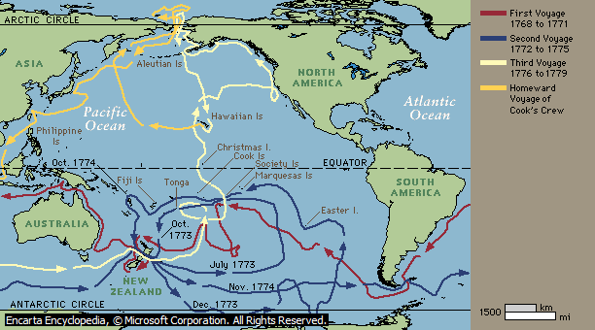
The Motives of Intervention by the early Europeans:
- To spread Christianity
- Imperialism
- Economic( Raw material)
- Vulnerability
- Penal Colonies and Naval base
The Europeans involved in many activities that help upgrade the indigenous ways of living and on the other hand bring negativity to their lives.

Advantage
- Help spread Gospel and Civilisation
- Introduce new sports
- Centralised administration
- Monetary

Disadvantage
- Introduced new disease: eg, TB, whooping cough and leprosy(Depopulation)
- Political Transformation
- Western cultures

Example of Goods and materials that changed indigenous people’s lives

In Vanuatu the foreigners leased land and owned large hectares of land. Therefore, Ni – vans were adapted to western lifestyle and forget their traditional ways of life. For example, in Vila, 90% of the population consumed western(imported) food rather than our stable food which result in many diseases affecting local indigenous such Sugar, Diabetes, obesity and so ford which result in death.

Labour Trade – simply means the period in which European trade European Goods/materials to recruit workers to work as labours in commercial plantations. For example, in 1878 the owner of the Queensland trade ammunition for islanders(Solomon) to be recruited.
Robert Towns –Queensland
Sir Arthur Gordon - Fiji
Governor George Guyou – New Caledonia (Built wharf and roads)
Hubbert Murray (Governor) – PNG (gold)
Dr. Wilhlem Solf(Governor)DHPG - Samoa
Labour trade is the same thing as slavery. Where they perform services without pay, provide minimal food, shelter and clothing. The owners can sell the labourers in any way possible.

In 1887 the British and French established a joint naval commission to administer the islands. In 1906 they became a territory jointly administered by the British and French, with each power retaining jurisdiction over its own citizens.

Exercise 3: Complete the table by entering the date of independence respective to each country.

Partitioning of the Pacific
Year | Country | Annexed or controlled by | Independence
1842 | Marquises | France
1874 | Fiji | Britain | 1970
1881 | Tahiti | France
1902 | New Hebrides | Britain/ France | 1980
1885 | Marshall islands | Germany
1886 | Gilbert/Ellice –Tuvalu | Britain
1886 | Northern Solomons | Germany
1886 | Nauru | Germany
1892 | Gilbert/Ellice –Tuvalu | British’s Protectorate
1893 | Solomon Islands | British’s Protectorate
1900 | Cook islands | Britain
1899 | Western Samoa | Germany | 1962
1899 | American Samoa | USA
1899 | Tonga | Temporary Protectorate to Britain | 1970
1899 | Niue | Britain

Germany, the new comer or expansion into the Pacific was linked with large trading plantations. Believing that they would make great fortunes and profit in extracting copra in Samoa. Germany had a tradition of a constitution monarchy with a powerful aristocracy – highest social class. They share power by creating separate administration for indigenous people ‘’Native administration”. Expatriates officials replaced indigenous leaders, institutions and collected taxes.

Imperialism is when imperial powers taking control over weaker states. For example, Britain over Fiji, France taking over New Caledonia and Germany over the Western Samoa. The imperial powers colonised the Pacific islanders for quite long periods of time (For example Britain over Fiji for 96years, British over Vanuatu for 78 years), even before WWI(1914 -18) and WWII(1941 -45). Meaning that they have influenced us with their cultures and administration. Imperialism has its negative and positive effects on the lives of the Pacific people.

Indirect Rule – It is a rule used by Great Britain and Germany. This rule allows the imperial powers to confront the authorities before taking over. They did share power with the indigenous and is much concern in safeguarding indigenous cultures.
Direct Rule – This rule was used by France and USA. No confrontation with the indigenous where the administration was totally administered by them. Meaning that all the domestic affairs were controlled by them.

France colonised the Pacific islands since 1842 and she is still in the Pacific colonising New Caledonia and Tahiti without any proper plan for her colonies to gain independence.
- Negative impacts of French Rule
- 90% of the land were owned by them
- Controlled all domestic affairs
- Indigenous rights were replaced by foreigners.
- No sense of Identity
- Positive Impacts of French Rule
- Improve standard of living for the Pacific people
- Build schools and Hospitals/roads
- Aid
- Awarded scholarships

Sketch Map of the Pacific during the Period of WWII
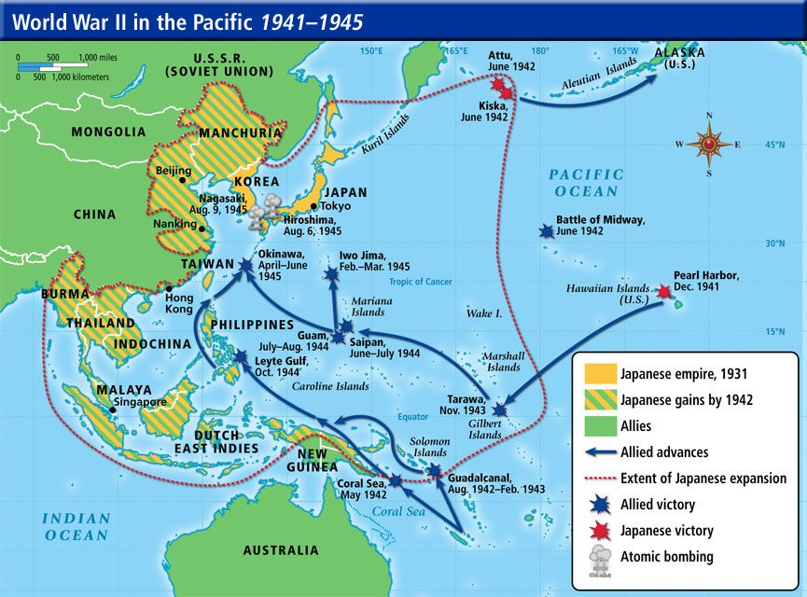
The two(2)Pacific island countries impacted by WWII were, the Solomon islands and Hawaii. These are the two countries in which most of the battle took place against the Japanese and USA. The Japanese quickly took over much of Southeast Asia and were well on their way to dominance by 1942. However, the US won a critical battle called the Battle of Midway on June 4, 1942. Badly outnumbered, the US Navy sunk four Japanese aircraft carriers and forced the Japanese to retreat. Winning this battle gave the Americans cause for hope and was a turning point in the war in the Pacific.
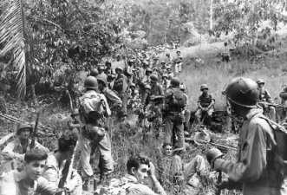
Marines rest in the field on Guadalcanal
Photo by John L. Zimmerman
After the Battle of Midway the United States began to fight back against the Japanese. They fought to take over strategic islands in the Pacific. One of the first major battles was over the island of Guadalcanal. After fierce fighting the US was able to take the island, but they learned that fighting the Japanese was not going to be easy. There were many battles over islands in the South Pacific, these included Tarawa, Saipan, and Iwo Jima. Iwo Jima took 36 days of fighting to take the island. Today a statue of marines raising a flag on the island of Iwo Jima serves as the Marine Corps Memorial in Washington DC.
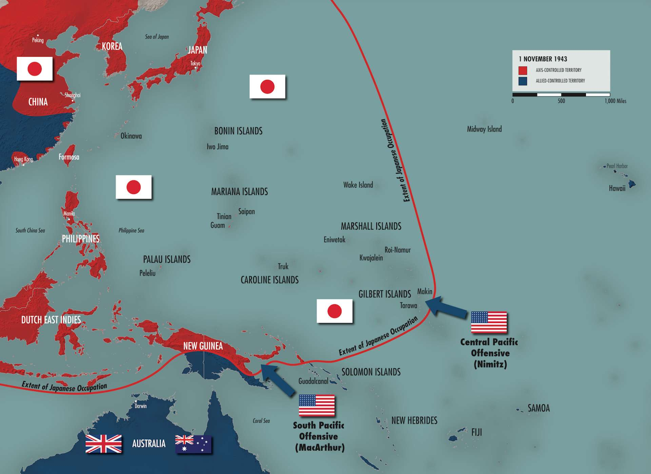
(International Relation 1900)

The motives behind islander’s participation in WWII are as follow:
- Some hope that war service might help them campaigned for citizenship and equality.
- Some believe war was an adventure with good pay
- Loyal to the allies
Cold war - was a long period of tension between the democracies of the Western World and the communist countries of Eastern Europe. The west was led by the United States and Eastern Europe was led by the Soviet Union. These two countries became known as superpowers.

Decolonisation

Country | Colonial Name | Colonial Power | Independence Date | First Head of State | Independence won through
New Zealand | Dominion of New Zealand | United Kingdom | 20th century | - | gradual process
Australia | Australia |  | 20th century | - | gradual process
Indonesia | Dutch East Indies | Netherlands | 17 August 1945^{[5]} | Sukarno | Indonesian National Revolution
Samoa | Western Samoa Trust Territory | New Zealand | 1 January 1962 | Malietoa Tanumafili II and Tui Atua Tupua Tamasese Mea'ole^{[6]} | peaceful campaign by the Mau movement
Nauru | Nauru Trust Territory | Australia^{[7]} | 31 January 1968 | Hammer DeRoburt | peaceful campaign
Tonga | Kingdom of Tonga | United Kingdom | 4 June 1970 | Taufaʻahau Tupou IV | request
Fiji | Fiji |  | 10 October 1970^{[9]} | Kamisese Mara^{[10]}  (Prime Minister: head of gov.) | British initiative, and negotiation
Papua New Guinea | German New Guinea  Territory of New Guinea  Trust Territory of Papua and New Guinea | German Empire United Kingdom^{[11]}  Australia | 16 September 1975 | Michael Somare  (Prime Minister: head of gov.) | Australian initiative
Solomon Islands | British Solomon Islands | United Kingdom | 7 July 1978 | Peter Kenilorea  (Prime Minister: head of gov.) | British initiative
Tuvalu | Gilbert and Ellice Islands | United Kingdom | 1 October 1978 | Toaripi Lauti  (Prime Minister: head of gov.) | British initiative
Kiribati | Gilbert and Ellice Islands | United Kingdom | 12 July 1979 | Ieremia Tabai | British initiative
Vanuatu | New Hebrides | United Kingdom France^{[12]} | 30 July 1980 | George Kalkoa | peaceful campaign by the New Hebrides National Party
Marshall Islands | Trust Territory of the Pacific Islands | United States | 21 October 1986 | Amata Kabua | –^{[13]}
Federate states of Micronesia | Trust Territory of the Pacific Islands | United Kingdom | 3 November 1986 | Tosiwo Nakayama | –^{[14]}
Cook islands | Cook Islands | New Zealand | 4 August 1965/1992/current^{[15]} | Albert Henry  (Prime Minister: head of gov.) | –
Palau | Trust Territory of the Pacific Islands | United States | 1 October 1994 | Kuniwo Nakamura | –
Niue | Niue | New Zealand | 19 October 1974/1994/current^{[16]} | Robert Rex  (Prime Minister: head of gov.)

Political Parties
- Vanua’aku Pati
- Vanuatu National United Party
- Union of Moderate Party
- Vanuatu Republican Party
- Green Confederation
- Peoples progressive party
- Melanesian progressive party
- National Community Association
- People’s Action Party
- Reunification movement for change
- Land and Justice Party
- Leaders Party
The Vanua'aku Pati (rough translation: Our Land Party)^{[1]} is a democratic socialist political party in Vanuatu. At the last general election, held on 22 January 2016, they received 11.91% of the vote and 6 seats. They supported the election of Charlot Salwai as Prime Minister.^{[2]} The party was founded on 17 August 1971 by Walter Lini as the New Hebridean Cultural Association, renamed later that same year as the New Hebrides National Party, and was one of two parties formed during the country's move towards independence. While the NHNP was supported by British interests, the Union of New Hebrides Communities was supported by French interests. The NHNP went on to win the 1975 elections and in 1977 it was renamed the Vanua'aku Pati.^{[3]} The party won the pre-independence 1979 elections and Lini became chief minister. The country gained independence in 1980 and Lini became the first Prime Minister of Vanuatu, remaining in the post until 1991. In 1991 the party split, and Lini was among those who left the party.
After the 1991 elections, the party lost its dominance over the government. Despite this, the party remained strong. During the next decade, as party members Donald Kalpokas and Edward Natapei served as prime ministers of Vanuatu. The party began steadily losing seats in the early 2000s; it took 18 in the 1998 elections, 14 in the 2002 elections, and 8 in the 2004 elections, a setback which forced Prime Minister Natapei to resign. The party suffered another split after the elections, as the leadership refused to support the national coalition government of Serge Vohor while two Vanua'aku Party representatives supported this government, allowing it to take office. However, after a controversy over the diplomatic recognition of Taiwan and China, the Vanua'aku Party reunited in December 2004 and was involved in the effort to oust Vohor. It remained influential, and was a key supporter of the National United Party government of Walter Lini's brother Ham Lini which lasted from December 2004 through the September 2008 elections. After a short break from participation in the coalition government, the party returned in July 2007 when its leader, former Prime Minister Edward Natapei, became deputy prime minister. The party had a strong result in the September 2008 elections, gaining 11 of the 52 results, making this party the largest one in Parliament and allowing Natapei to return as prime minister.
After multiple attempts to remove Natapei, he was forced out by a vote of no confidence on 2 December 2010, replaced by opposition leader Sato Kilman.^{[4]} Natapei was temporarily reinstated on 16 June 2011 when the Supreme Court of Vanuatu ruled Kilman's election as prime minister violated the Vanuatu constitution. A new election was held on 26 June of that year, in which Kilman was reinstated.
The party lost three seats in the parliamentary elections of 30 October 2012; however, it remained the largest single party in parliament.^{[5]}
The name of the Vanua'aku Party means "Party of Our land" in English (from the word vanua). It supports socialist economic policies and is mostly supported by English speakers.
The Vanuatu National United Party (NUP, generally pronounced noop) is a political party in Vanuatu. It was founded by Vanuatu's independence leader Walter Lini when he broke away from the Vanua'aku Pati. It is a social democratic party which traditionally received most of its support from English speakers.
In 1991, Walter Lini who had served as prime minister of Vanuatu for 12 years as a member of the Vanua'aku Pati and lost his position after a split in the Vanua'aku Pati, joined the National United Party, soon becoming its leader. Following Walter's death in 1999, his brother Ham Lini became party leader. The party became one of the largest political parties in Vanuatu along with the Vanua'aku Party and the Union of Moderate Parties, and participated in coalitions with both at various times. In the July 2004 elections, the party won 10 of the 52 seats, and because of losses by the other major parties, it became the largest single party in Parliament. In December 2004, Ham Lini became prime minister, the first member of NUP to take this position while a member of the party. At the 2008 elections, the NUP lost 2 seats, and received a total of 8 seats in Parliament, becoming the second largest party. Ham Lini was not able to form another government, but the National United Party became an important coalition partner in the new government formed by the Vanua'aku Party.
After the 2012 elections NUP remained in coalition with the People's Progress Party in the Kilman government. The party went into opposition upon the election of Moana Carcasses as Prime Minister in 2013. It returned to government in 2014 when a motion of no confidence brought the government of Joe Natuman to power, with Ham Lini as Deputy Prime Minister, then returned to opposition in 2015 during the Sato Kilman government.
Although untarnished by the bribery scandal that brought down Kilman's government, NUP won only 4 seats in the subsequent general election, 3 of them on Pentecost Island. As of 2016, the party is once again in government, as part of a broad coalition, and Ham Lini is Minister for Climate Change.
The Union of Moderate Parties (Union des Partis Moderés) is a liberal political party in Vanuatu founded in 1981.^{[1]} At the last general election, held on 22 January 2016, they won 9.73% of the vote and 6 seats. It is currently headed by Ishmael Kalsakau.^{[2]}
The party's influence grew after internal difficulties caused the Vanua'aku Pati government to fall in 1991. The UMP was the governing party in Vanuatu from 1991 to 1998. Former prime ministers Maxime Carlot Korman and Serge Vohor came from this party. However, the UMP suffered internal struggles of its own, and in the late 1990s, Corman left to form the Vanuatu Republican Party. Serge Vohor who hails from the Island Of Santo remains the president of UMP. It won 12 seats in the 1998 elections, 15 seats in the 2002 elections and 9 seats in the 2004 elections. Despite the obvious setback, Vohor was able to form a coalition government in August 2004, but lost a confidence vote four months later. From then until the 2008 elections, Vohor and the UMP sometimes were coalition partners in the Lini government, and at other times were in the opposition, serving as the largest opposition force. After the 2008 elections, the party remains an important political grouping, but is not expected to form the next government.
Serge Vohor has led the party since 1988. In February 2012, he was re-elected leader of the party, prior to the general election in October. This marks a longevity record for the leadership of any political party in Vanuatu.^{[3]}
The Vanuatu Republican Party (Parti Républicain de Vanuatu) is a centrist political party in Vanuatu. At the last general elections, held on 22 January 2016, they won no seats and 1.75% of the vote. Its leader is Maxime Carlot Korman, who was previously a member of the Union of Moderate Parties and had served as Prime Minister of Vanuatu while a member of the UMP. Korman and the Republican Party were part of the coalition government led by Ham Lini's National United Party from 2004 to 2008, and Korman served in the cabinet as minister of lands.
Korman left the UMP in the late 1990s after his rival Serge Vohor won a leadership struggle. At the July 6, 2004 elections, the party won 4 of the 52 seats. At the 2008 elections, the Republicans gained 3 seats and became as strong as the UMP, which had been the dominant party in the French-speaking community. In the 2012 elections the Republican Party lost 2 seats, including Korman's. Nonetheless the party participated in the government, with the party's only MP, Marcellino Pipite, serving as Tourism and Commerce Minister.
The Greens Confederation is a green political party in Vanuatu. At the legislative election of 2008 the party won 2 out of 52 seats, increasing to 3 seats at the election of 2012 with 3.5% of the votes. Its most prominent member is Moana Carcasses Kalosil, former deputy leader of the opposition, former cabinet minister and former Prime Minister of Vanuatu. It was soon joined by two other MPs, increasing its numbers to five.
The People's Progressive Party is a reformist political party in Vanuatu.
At the 6 July 2004 legislative elections, the party won 3 out of 52 seats. The following election saw its seat count increased to 4. Its leader, Sato Kilman served as Deputy Prime Minister and foreign minister of Vanuatu from December 2004 to July 2007. He had made the party an important member of the National United Party-led coalition of Prime Minister Ham Lini but in July 2007, apparently due to corruption charges put against Kilman's secretary^{[citation needed]}, Lini expelled the People's Progress Party from the cabinet. Kilman formed his first legal cabinet in June 2011 and his government was reflected in 2012, with PPP winning six seats. The party was forced into opposition in 2013 when Kilman resigned and Moana Carcasses became Prime Minister.
The Melanesian Progressive Party is a political party in Vanuatu. At the election held on 30 October 2012, the party won 2 out of 52 seats; it lost one of these in the 2016 election. Despite its small number of seats it has been important in setting up coalition governments since the 1990s. Its most prominent member is former prime minister Barak Sopé
The National Community Association (Association de la communauté nationale) is a social-liberal and nationalist political party in Vanuatu. At the elections held on 6 July 2004, the party won 2 out of 52 seats
The People's Action Party (Parti de l'Action Populaire) is a political party in Vanuatu. At the elections held on 6 July 2004, the party won 1 out of 52 seats. It lost this seat at the 2012 election.
The Reunification Movement for Change (Namangi Aute) is a Malekulan regionalist political party in Vanuatu. At the most recent general election, held on 22 January 2016, they won 3.44% of the vote and 3 seats.

Land and Justice Party
From Wikipedia, the free encyclopedia
The Land and Justice Party (in Bislama, Graon mo Jastis Pati (GJP)^{[1]}) is a traditionalist, conservative political party in Vanuatu. The party was launched on 11 November 2010 and is led by MP Ralph Regenvanu.^{[2]}
The party aims to produce a generational change in Vanuatu's leadership and is concerned about foreign ownership of businesses.^{[3]} Upon launching the party, Regenvanu -a popular, young and independent Member of Parliament- reportedly described chiefs, churches, women and youth as the four solid legs of the party. He also stated that prospective GJP candidates for parliamentary election would be "severely tested on their record of community service", to ensure that all GJP MPs were committed to defending the public interest.^{[1]}
Subsequently, Regenvanu said his party advocated against people selling their land to investors and thereby depriving their children and descendants of that asset. It also supported a greater use of the customary judicial system, where chiefs act as mediators, rather than the "Western" system, which Regenvanu said often implied significant financial costs for litigants. (See the article on the law of Vanuatu.)^{[4]}
A month after launching the party, Regenvanu was appointed Minister of Cooperatives and ni-Vanuatu Business Development in the Cabinet of new Prime Minister Sato Kilman.^{[5][6]}
The party obtained four seats in Parliament in the October 2012 general election, the first national election it contested.^{[7]} Regenvanu was subsequently appointed Minister for Lands in the government headed by his ally Prime Minister Moana Carcasses Kalosil (of the Green Confederation). As Minister for Lands, Regenvanu -who described himself as a “notorious critic” of free trade and foreign ownership of lands^{[8]}- introduced a proposal whereby land leases would necessarily be examined by a committee, thus depriving the ministry itself of the power to lease lands without any external controls. This was a response to alleged acts of corruption carried out by previous ministers. This unprecedented reform was described as part of Regenvanu's ongoing measures against corruption. More generally, his proposals sought to "untangle a whole series of obscure rules on customary landownership", and provide clarity to landowners.^{[9]}
In the February 2013 provincial election, the party's Willie Fred Tasso won the presidency of the Malampa Province Provincial Government Council.^{[10]} The party currently participates in the government of Moana Carcasses.
The party was reportedly the first ever to field a candidate with a disability in any election in Vanuatu, when wheelchair user Arthur Simrai stood in the municipal election in Port Vila in November 2013.^{[11]} Regenvanu indicated that the party wished to push, in particular, for buildings to be better equipped for wheelchair access.^{[12]}

Vanuatu Labour Party
From Wikipedia, the free encyclopedia
Jump to navigationJump to search
The Vanuatu Labour Party (Bislama: Leba Pati) is a political party in Vanuatu. The party was established on June 3, 1987. It was founded on the initiative of various trade union organizations in order to contest the 1987 parliamentary election. The proposal to found the party was first presented by Ephraim Kalsakau, a leader of the Vanuatu Municipal Workers Union.^{[1]}
In the 1987 polls, it presented four candidates; George Kalsakau in Port Vila, Willy Romain in Tanna, Thomas Reynold in Luganville and Kenneth Satungia of Efate.^{[1]} All four candidates were trade union leaders.^{[2]} Ephraim Kalsakau later claimed that the electoral participation was mainly intended as an awareness-raising effort, and that the party hadn't expected to win any of the seats.^{[3]}
The party did not present candidates in the 1991 parliamentary election.^{[2]}
The party gained parliamentary representation in 2005 as Joshua Kalsakau, then the Minister for Ni-Vanuatu Business and a MP from Efate representing the National Community Association Party, joined the party.^{[1]}
Joshua Kalsakau is the president of the party whilst Lui Kaltonga is its general secretary.^{[4]}
The party is connected to the Vanuatu Council of Trade Unions and the Vanuatu National Workers Union. The main stronghold of the party in the capital Port Vila.^{[1]}
Joshua Kalsakau was reelected from his seat in the 2008 parliamentary election.^{[5][6]} In Luganville, the party had launched Pierre Malamlaen as its candidate. Malamlaen was however not elected.^{[5]} After the elections, Joshua Kalsakau was named as the new Minister of Justice in the cabinet of Edward Natapei.^{[7]} In the 2012 general election, Kalsakau narrowly lost his seat, by a margin of just twelve votes (out of more than 15,000), leaving Labour without representation in Parliament.
The Leaders Party of Vanuatu (LPV) is a political party in Vanuatu.

Political ideologies in Vanuatu
Vanuatu has a multi-party system /Democracy of government. In the decades after independence, the English-oriented Vanua'aku Party and the French-oriented Union of Moderate Parties fragmented into numerous smaller parties, defined increasingly by personality politics rather than ideology. These have been joined by newly formed parties such as the Land and Justice Party with a strong indigenous identity.
The political culture is based around clientelism, with MPs having 'allocations' of money to spend on their constituents, and voters judging candidates primarily on their ability to bring resources into their communities rather than on national policy positions.

Therefore, the types of government in Vanuatu are as follow:
- Republic
- Parliamentary Republic
- Unitary State (characterised by Unity)
The politics of Vanuatu take place within the framework of a constitutional democracy. The constitution provides for a representative parliamentary system. The head of the Republic is an elected President. The Prime Minister of Vanuatu is the head of government.
The Split Party is non-ideological and that it accepts members from all sides of the political spectrum.

