YEAR 12 MATHEMATICS
Central School- Port Vila

MARCH - JUNE
TEACHER: MRS SUZANNE SANTHY

Table of Contents

Introduction 2
Instructions for students 2
Time management 2
Instructions for parents 3
Teachers contact 3
Scheme of work – YEAR 12 MATHEMATICS 4

Introduction

This package contains:
- The Scheme of work (or Overview)
- Photocopied handouts/activities.
- Answer sheets
Please note:
- The scheme of work covers topics from week 9 (Term 1) to week 5(Term 2).
- The Scheme of work is made easy for students and parents to read and understand.

Instructions for students
What you need to do every day:

- Set 1 hour to do your work
- Check the scheme of work before you start (week number, dates and day of the week)
- Identity what needs to be done (activity column on the scheme of work)
- Redo examples for better understanding
- Answer questions in your book and NOT on the handout.
- Write your answers neatly and show all the working out.
- Use the answer sheet to check your work
- Complete daily activities before moving to the following day’s activities.

Time management
- Spend 1 hour per day to work on the assigned questions and activities
- Use your time wisely
- Organize yourself

Instructions for parents
As a parent or guardian, you will be the “teacher”. Here are some of the things that we ask you to do, to help your child.

- Set a time (at least 1 hour) for the student to do math activities during the day
- Read and understand the scheme of work.
- Help the student to identify daily or weekly activities.
- Assist the student in understanding the concept if you can.
- Check and make sure that the daily activities are completed.
- Be supportive and encouraging.

Note:
- The scheme of work is our guide.

Thankyou for your help.

Teacher’s contact
For any queries, please contact us:

Mrs. Suzanne SANTHY
Math Teacher for 12
Contact: 7774394
Email: suzannesanthy@gmail.com

Scheme of work – YEAR 12 MATHEMATICS
Week | Day | Topic and subtopic | Learning outcome: Students should be able to: |  | Activities
9  (30/03 – 3/04) | Monday | Topic 1:  Algebraic Expressions  Indices  Exponential  Logarithms | - State/Identify a rational algebraic expression. |  | - Read notes and study examples1&2  - Redo examples  - Do Exercise 1.
 | Tuesday | Algebraic Expressions | - Apply laws of indices and operations to simplify or expand a rational algebraic expression |  | - Study the examples  - Redo examples  - Do exercise 2
 | Wednesday | Algebraic Expressions | - Simplify algebraic expressions to decode a message |  | - Do exercise 3
 | Thursday | Algebraic Expressions | - Simplify algebraic expressions to decode a message |  | - Finish off exercise 3
 | Friday | Algebraic Expressions | - Complete all the exercises given |  | - Complete all exercises given
10  (6/04- 10/04) | Monday | Asymptotes of a rational algebraic function | - Calculate the x and y asymptote of a rational algebraic function |  | - Read notes and study examples1&2  - Redo examples  - Do Exercise 4.
 | Tuesday | $x$ and y intercept of a rational function | -. Calculate the x and y  asymptote of a rational  algebraic function |  | - Read notes and study examples1&2  - Redo examples  - Do Exercise 5.
 | Wednesday | Sketch the graph of a rational function | - Sketch the graph of a rational function showing the asymptotes and intercepts |  | - Read notes and study examples1&2  - Redo examples  - Do Exercise 6.
 | Thursday | Sketch the graph of a rational function | - Sketch the graph of a rational function showing the asymptotes and intercepts |  | - Do exercise 7
 | Friday | Good Friday (Public Holiday)
11  (13/04 – 17/04) | Monday | Easter Monday (Public Holiday)
 | Tuesday | Sketching the Rational function | - Finding x and y intercepts, asymptotes and sketch the rational functions |  | - Do exercise 8  on the worksheet
 | Wednesday | Changing the subject of a formula | - Manipulate an algebraic equation to change the subject of the formula |  | - Read notes and study examples  - Redo examples  - Do Exercise 9.
 | Thursday | Changing the subject of a formula | - Manipulate an algebraic equation to change the subject of the formula |  | - Study examples 2,3,4  - Redo examples  - Do exercise 10
 | Friday | Changing the subject of a formula | - Manipulate an algebraic equation to change the subject of the formula |  | - Complete the exercises for this week
12  (20/04 – 24/04) | Monday | Changing the subject of a formula | - Manipulate an algebraic equation to change the subject of the formula |  | - Worded Problem  - Do Exercise 11
 | Tuesday | Add/Subtract and simplify rational algebraic expressions | - -Simplifying the algebraic expressions |  | - Read and study the examples  - Redo the examples  - Do Exercise 12
 | Wednesday | Add/Subtract and simplify rational algebraic expressions | -Simplifying the algebraic expressions |  | - Read and study the examples  - Redo the examples  -Do Exercise 13
 | Thursday | Add/Subtract and simplify rational algebraic expressions | - -Simplifying the algebraic expressions |  | Finish off Exercise 13
 | Friday |  |  |  | - Finish all Exercises
13  (27/04 – 1/05) | Monday | Divide and simplify algebraic expressions | -Simplify the rational expressions |  | - Read and study the examples  - Redo the examples  -Do Exercise 14
 | Tuesday | Multiply and simplify algebraic expressions | -Simplify the rational expressions |  | - Read and study the examples  - Redo the examples  -Do Exercise 15
 | Wednesday | Laws of Indices | - Evaluate the indices  Calculate the Indices |  | - Read and study the examples  - Redo the examples  -Do Exercise 16 Qs 1-3
 | Thursday | Laws of Indices | -Simplify the indices |  | - Do Q4
 | Friday | Labour Day (Public Holiday)
TERM 2
1  (18/05 – 22/05) | Monday | Laws of Logarithms |  | Simplify the logarithms | - Read and study the examples  - Redo the examples  -Do Exercise 17
 | Tuesday | Exponential graphs |  | -Sketch the exponential graphs | - Read and study the examples  - Redo the examples  -Do Exercise 18
 | Wednesday | Exponential graphs |  | -Sketch the exponential graphs | - Do Exercise 19
 | Thursday | Logarithm graphs |  | -Sketch the logarithm graphs | - Read and study the examples  - Redo the examples  -Do Exercise 20
 | Friday | Logarithm graphs |  | -Sketch the logarithm graphs | -Finish of Exercise 20
2  (25/05 – 29/05) | Monday | Internal Assessment |  |  | Revision
 | Tuesday | Internal Assessment |  |  | Revision
 | Wednesday | Internal Assessment |  |  | Revision
 | Thursday | Internal Assessment |  |  | Revision
 | Friday | Internal Assessment |  |  | Revision
3  (1/06 – 5/06) | Monday | Mid-year Exam |  |  | Revision
 | Tuesday | Mid-year Exam |  |  | Revision
 | Wednesday | Mid-year Exam |  |  | Revision
 | Thursday | Mid-year Exam |  |  | Revision
 | Friday | Mid-year Exam |  |  | Revision

STRAND 1.0 ALGEBRA
SUB-STRAND 2.1: Rational Algebraic Expressions
SUB-STRAND | SLO NO. | SPECIFIC LEARNING OUTCOMES | SKILL LEVEL | SLO CODE | ACHIEVED
1.4 | 1.1 | State/Identify a rational algebraic expression. | 1 | 12MAT1.4.1.1
1.4 | 1.2 | State/Identify a rational algebraic function. | 1 | 12MAT1.4.1.2
1.4 | 2.1 | Apply laws of indices and operations to simplify or expand a rational algebraic expression | 2 | 12MAT1.1.2.1
1.4 | 2.2 | Calculate the x asymptote of a rational algebraic function. | 2 | 12MAT1.4.2.2
1.4 | 2.3 | Calculate the y asymptote of a rational algebraic expression. | 2 | 12MAT1.4.2.3
1.4 | 2.4 | Calculate the x intercept of a rational algebraic expression. | 2 | 12MAT1.4.2.4
1.4 | 2.5 | Calculate the y intercept of a rational algebraic expression. | 2 | 12MAT1.4.2.5
1.4 | 2.6 | Generate a table of values based on a rational algebraic expression. | 2 | 12MAT1.4.2.6
1.4 | 4.1 | Sketch the graph of a rational function showing the asymptotes and intercepts | 4 | 12MAT1.4.4.1
1.4 | 3.1 | Manipulate an algebraic equation to change the subject of the formula | 3 | 12MAT1.4.3.1
1.4 | 3.2 | Solve a rational algebraic equation. | 3 | 12MAT1.4.3.2
1.4 | 3.3 | Add/Subtract and simplify rational algebraic expressions. | 3 | 12MAT1.4.3.3
1.4 | 3.4 | Divide and simplify algebraic expressions. | 3 | 12MAT1.4.3.4
1.4 | 3.5 | Multiply and simplify algebraic expressions. | 3 | 12MAT1.4.3.5
1.4 | 4.2 | Solve a word problem involving a rational algebraic equation. | 4 | 12MAT1.4.4.2

RATIONAL EXPRESSION
Rational expression is a ratio of two polynomial expressions in the form of $R\left(x\right)=\frac{P\left(x\right)}{Q\left(x\right)}$ where P(x) and Q(x) are polynomials and Q(x) cannot be zero.

Examples:
$\frac{x^{2}+2x+3}{x+2}$, $\frac{5}{2x-1}$, $\frac{\left(x+2\right)\left(x-2\right)}{x}$ are some of the rational expressions.
A rational expression is a fractional expression where both numerator and denominator is a
polynomial expressions.

Example 1:
Simplify the expression $\frac{{5x}^{2}+3x}{x^{2}+x}$
Solution:
i) Take the common terms out by factorising the numerator and the denominator first if possible:
$\frac{{5x}^{2}+3x}{x^{2}+x}$ = $\frac{x\left(5x+3\right)}{x\left(x+1\right)}$
ii) Cancel the common terms.
$\frac{x\left(5x+3\right)}{x\left(x+1\right)}$ = $\frac{\left(5x+3\right)}{\left(x+1\right)}$
=$\frac{5x+3}{x+1}$
Example 2:
Simplify the expression $\frac{x+3}{x+2}-\frac{x+3}{4}$
Solution:
Simplify the expression the further.
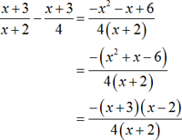

Exercise 1:
Simplify these rational algebraic expressions:
Solutions:
1. $\frac{3}{2}$
2. 4
3. $\frac{-1}{ 2}$
4. $x-5$
5. $\frac{2}{x-5}$
6. $x+3$
7. $\frac{x-4}{x-3}$
8. $\frac{x+5}{x-1}$
9. $\frac{x+2}{x-2}$
10. $\frac{1}{{\left(x-1\right)}^{2}}$

1. $\frac{3x+3}{2x+2}$
2. $\frac{12x-8}{3x-2}$
3. $\frac{4-x}{2x-8}$
4. $\frac{x^{2}-5}{x+5}$
5. $\frac{2x+4}{x^{2}-3x-10}$
6. $\frac{x^{2}+2x-3}{x-1}$
7. $\frac{x^{2}-16}{x^{2}+x-12}$
8. $\frac{x^{2}+9x+20}{x^{2}+3x-4}$
9. $\frac{x+3}{x^{2}+2x-8} × \frac{x^{2}+6x+8}{x+3}$
10. $\frac{x}{x^{2}+x-2} ÷ \frac{x^{2}-x}{x+2}$

Apply laws of indices and operations to simplify or expand a rational algebraic expression
Example:
Simplify this algebraic expression with positive indices:
a) ${3x}^{-2}×$ $4x^{-3}$ b) ${\left(xy^{2}\right)}^{-4}$
Solution:
a) ${3x}^{-2}×$ $4x^{-3}$ b) ${\left(xy^{2}\right)}^{-4}$
=${ 12x}^{-5}$ = $x^{-4}y^{-8}$
= $\frac{12}{x^{5}}$ = $\frac{1}{x^{4}y^{8}}$
Exercise 2:
Simplify these algebraic expressions. Write all answers with positive indices.
1. ${\left(\frac{1}{x}\right)}^{-2}$ 2. ${\left(2x^{-1}\right)}^{3}$ 3. ${\left(\frac{2y}{x^{2}}\right)}^{-2}$ 4. ${\left(\frac{5x^{3}}{y^{2}}\right)}^{-2}$
5. ${\left(\frac{4x^{-2}}{3y^{5}}\right)}^{-1}$ 6. ${\left(\frac{2a^{2}b^{-3}}{3a^{-1}b^{5}}\right)}^{-4}$ 7. ${\left(27a^{\frac{3}{4}}\right)}^{\frac{1}{3}}$ $×$ ${\left({9a}^{\frac{-3}{2}}\right)}^{\frac{-1}{2}}$
Solutions:
1. $x^{2}$ 2. $\frac{8}{x^{3}}$ 3. $\frac{x^{4}}{{4y}^{2}}$ 4. $\frac{y^{4}}{{25x}^{6}}$ 5. $\frac{{3x}^{2}y^{5}}{4}$ 6. $\frac{{81b}^{32}}{{16a}^{12}}$ 7. $a$

Exercise 3: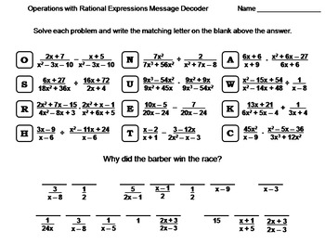
Asymptotes of a rational algebraic functions
Vertical Asymptote
To find the vertical asymptotes, set the denominator of the function to zero and solve for $x.$
Example 1: Find the vertical asymptote of the rational function :
$y=\frac{3}{x^{2}-1} = \frac{3}{\left(x-1\right)\left(x+1\right)}$
Vertical Asymptotes: $x=-1$ and $x=1$
Horizontal Asymptote
To find the horizontal asymptote, we compare the degree of the numerator with the degree of the denominator. If they have the same degree, the coefficient of the $x$ term of the highest degree will be the y value of the horizontal asymptote.
Example 2: Find the horizontal asymptote of the rational functions:
i) $y=\frac{2x-4}{3x+2}$ horizontal asymptote at $y=\frac{2}{3}$
ii) $y=\frac{2x}{{3x}^{2}+1}$ horizontal asymptote at $y=0$.
iii) $y=\frac{{2x}^{3}}{{3x}^{2}+1}$ No horizontal asymptote, degree in the numerator is smaller than in the denominator.

Exercise 4:
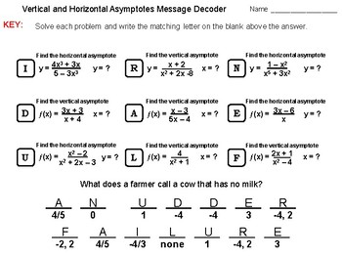

Calculate the x and y intercept of a rational algebraic expression
- To find the $y-intercept$ let $x=0$.
- To find the $x-intercept$ let $y=0.$
Example:
Find the $x-intercept$ and the $y-intercept$ of $y=\frac{x-4}{x+2}$
Solution:
$y-intercept:$ $y=\frac{0-4}{0+2}=-2$
$x-intercept:$ $0=\frac{x-4}{x=2}→x-4=0→x=4$

Exercise 5:
Find the x and y intercepts of these rational functions:
1.$y=\frac{x+3}{x-1}$
2. $y=\frac{x+4}{x+2}$
3. $y=\frac{2x}{x-4}$
4. $y=\frac{3x+2}{x+1}$
5. $y=\frac{3-x}{1+x}$
6. $y=\frac{2-3x}{1-x}$
Solutions:
1. $x=1, y=1$ 2. $x=-2, y=1$ 3. $x=4, y=2$
4. $x=-1, y=3$ 5. $x=-1, y=-1$ 6. $x=1, y=3$

Sketch the graph of a rational function showing the asymptotes and intercepts.
A Rational function is a function whose rule can be written as a ratio of two polynomials. The basic rational function is$y=\frac{1}{x}$ and has a graph called a hyperbola, which has two separate branches.
Rational functions may have asymptotes(boundary lines). The $y=\frac{1}{x}$ has a vertical asymptote at $x=0$ and a horizontal asymptote at $y=0$.
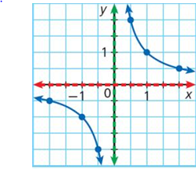

Basic graph of $y=\frac{1}{x}$ Basic graph of $y=-\frac{1}{x}$
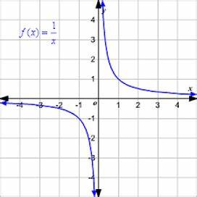
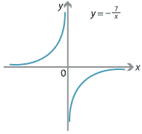

Examples 1: Sketch the graph of: a) $xy=6$
Answer:
- $xy=6$ or same as $y=\frac{6}{x}$ Plot some points with coordinates
when substituting an x value to the equation, $\left(1,6\right) ,\left(2,3\right),\left(3,2\right) \left(6,1\right)$
$and \left(-1,-6\right) \left(-2, -3\right)$,$\left(-3,-2\right),\left(-6,-1\right)$ etc, and join with a smooth curve.

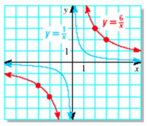
- Translations of the hyperbola

- Vertical translations
When adding or subtracting a number after the function the graph will be translated along the $y-axis,$ eg: $y=\frac{8}{x} ±2$ In this function, the graph will be translated 2 times up along the $y-axis$ (if the number added is 2) and also the horizontal asymptote will be moving up 2 times along the y-axis. The equation of the asymptote will $y=2.$

- Horizontal translations
When adding or subtracting a number in the denominator after the $x$ term, the hyperbola graph will be translated along the $x-axis.$eg: $y=\frac{8}{x-1}$ In this function the basic hyperbola graph will be shifting 1 time to the right and also the vertical asymptote will be shifting 1 time to the right, so the asymptote line will have the equation $x=1.$

Example 2: Sketch the graph of $y=\frac{1}{x-2}+4$
Solution:
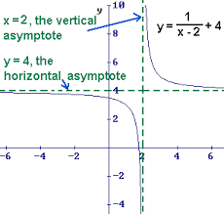
The graph has been translated 2 units RIGHT and 4 UP.
Vertical Asymptote: $x=2$
Horizontal Asymptote: $y=4$

Exercise 6:
1. Sketch graphs for these hyperbolas. Give the equations of both asymptotes:
a) $y=\frac{4}{x}+3$
b) $y=\frac{-6}{x}-2$
c) $y=\frac{2}{x+3}$
d) $y=\frac{-4}{x-5}$

2. Draw the graphs of these hyperbolas. State the equations of both the vertical and horizontal asymptotes.
a) $y=\frac{3}{x-1}+2$
b) $y=\frac{-8}{x+4}-2$
c) $y+2=\frac{2}{3-x}$
Exercise 7:
Sketch these hyperbolas by first finding the intercepts and asymptotes.
1. $y=\frac{x+3}{x-1}$ 2. $y=\frac{x+1}{x-2}$ 3. $y=\frac{x+4}{x+2}$ 4. $y=\frac{x-1}{x-3}$ 5. $y=\frac{x-1}{x-3}$

6. $y=\frac{2x}{x-4}$ 7. $y=\frac{3x+2}{x+1}$ 8. $y=\frac{2x-4}{x+2}$ 9. $y=\frac{3-x}{1+x}$ 10. $y=\frac{2-3x}{1-x}$

11. What are the coordinates of the points the graph of the function $y=\frac{2x+3}{x-1}$ intersects the $y- axis?$
12. What is the equation of the horizontal asymptote of the graph of $=\frac{7x-2}{2x+1}$ ?
13. State the equations of the two asymptotes to the curve $y=\frac{3x-2}{x+1}.$
14. State the equations of the two asymptotes to the curve $y=\frac{3x}{1-x}.$

Solutions:
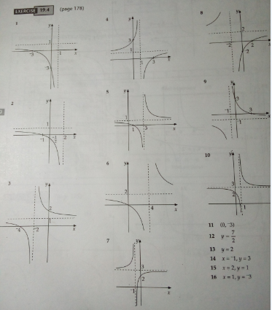

Exercise 8:
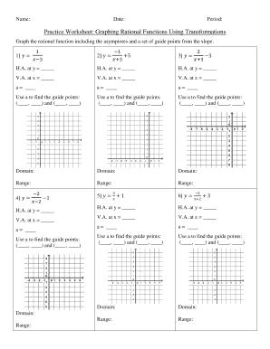

Manipulate an algebraic equation to change the subject of the formula

Changing the subject of a formula
The subject of a formula is the variable that is being worked out. It can be recognised as the letter on its own on one side of the equals sign.
For example, in the formula for the area of a rectangle $=bh$ $\left(area=base×height\right)$, the subject of the formula is $A.$.

Rearranging formulae
In order to change the subject of a formula, or rearrange a formula, items in the formula need to be rearranged so a different variable is the subject. Knowledge of solving equations and inverse operations is very useful.
In the formula $A=bh$, the area $\left(A\right)$is the subject of the formula which means it is the area that is being worked out.
Example 1:
Rearrange the formula to make the subject of the formula.
Solution:
To make the subject of the formula means to rearrange the formula so it begins with .
Answer this question by finding the letter in the formula.
$v-at=u$
Solutions:
- $x=\frac{y+1}{3}$
- $x=\frac{6-2y}{3}$
- $x=\frac{y-3}{3}$ or $x=\frac{y}{3}-1$
- $x=\frac{4y-12}{3}$
- $x=\frac{2-y}{10}$
- $x=\frac{17-4y}{15}$
- $x=2y-1$
- $x=\frac{y-2}{4}$
- $x=\frac{3}{2q-p}$
- $x=\frac{6y+17}{5}$

$u=v-at$
Exercise 9:
Make $x$ the subject of these expressions:
- $y=3x-1$
- $3x+2y=6$
- $y=3\left(x+1\right)$
- $4y-3x=12$
- $2y=4\left(1-5x\right)$
- $4\left(y-3\right)=5\left(1-3x\right)$
- $y=\frac{x+1}{2}$
- $\frac{y+2}{4}=x+1$
- $\frac{3}{x}+p=2q$
- $\frac{x+1}{2}-\frac{3y-4}{5}=3$

Example 2:
Make $x$ the subject of the relation $5y=\frac{2}{x-3}$.
Solution:
$5y=\frac{2}{x-3}$.
$5y\left(x-3\right)=2$ $\left(cross-multiplying\right)$
$5xy-15y=2$ $\left(expanding\right)$
$5xy=15y+2$ $\left(rearranging\right)$
$x=\frac{15y+2}{5y}$

Example 3 :
Make $x$ the subject of the relation $y=\frac{3x-1}{x+2}$.
Solution:
$y=\frac{3x-1}{x+2}$.
$xy+2y=3x-1$ $\left(cross-multiplying\right)$
$xy-3x=-2y-1$ $\left(rearranging\right)$
$x\left(y-3\right)=-2y-1$ $\left(Factorising\right)$
$x=\frac{-2y-1}{y-3}$

Example 4 :
Make $x$ the subject of the formula $y=\sqrt{2x+5}$
Solution:
$$y=\sqrt{2x+5}$$
$y^{2}={\left(\sqrt{2x+5}\right)}^{2}$. $\left(squaring both sides\right)$
$y^{2}=2x+5$
$2x=y^{2}-5$ $\left(rearranging\right)$
$x=\frac{y^{2}-5}{2}$

Exercise 10:
Make $x$ the subject of these algebraic expressions:
Solutions:
- $x=\frac{3-2y}{y}$
- $x=\frac{5y}{1-y}$
- $x=\frac{2-3y}{y-1}$
- $x=\frac{2+y}{3-2y}$
- $x=\frac{2-y}{y-1}$
- $x=y^{2}-2$
- $x=$ $\frac{y^{2}+1}{2}$
- $x={\left(y-3\right)}^{2}-3$
= $y^{2}-6y+6$
- $x={\left(y-4\right)}^{2}+1$
= $y^{2}-8y+17$
- $x=\frac{{3y}^{2}+5}{1-y^{2}}$

- $y=\frac{3}{x+2}$
2. $y=\frac{x}{x+5}$
3. $y=\frac{x+2}{x+3}$
4.$y=\frac{3x-2}{2x+1}$
5. $\frac{y}{2+x}=\frac{2y-1}{x+3}$
6. $y=\sqrt{x+2}$
7. $y=\sqrt{2x-1}$
8. $y-3=\sqrt{x+3}$
9. $y=\sqrt{x-1}$ + 4
10. $y=\sqrt{\frac{x-5}{x+3}}$

Worded Problem
Exercise 11:
1. The curved surface area of a cylinder is given by the equation $A=2πrl$. Make r the subject of this formula.

2. The area of a triangle is given by the formula $A=\frac{1}{2}bh$. What is the formula for the height of a triangle given the area and base?

3. V= $\frac{ 4}{ 3}πr^{3}$ is the formula for the volume of a sphere with radius $r.$ What is the formula for the radius $r$ of a sphere with volume V?

4. The volume of a cone with base radius r and vertical height height h is given by
$V=\frac{1}{3}πr^{3}h.$
a) Make h the subject of this formula
b) Make r the subject of this formula.
Solutions:
1. r =$\frac{A}{2πl}$ 2. $h=\frac{2A}{b}$ 3. $r=\sqrt[3]{\frac{3V}{4π}}$ 4. a) $h=\frac{3V}{πr^{2}}$
b) $r= \sqrt{\frac{3V}{πh}}$

Add/Subtract and simplify rational algebraic expressions
Rational algebraic expressions are fractions . Fractions can be only added/subtracted when the denominators are the same. When the denominators are different, obtain the common denominator by multiplying. Then the numerators have to be adjusted by ‘cross-multiplying’ diagonally.
Examples1:
Simplify $\frac{2x+1}{6x}+ \frac{5}{4x}$
Solution:
12x will be the Lowest Common Denominator (LCD).
$\frac{2x+1}{6x}+ \frac{5}{4x}$
=$\frac{2\left(2x+1\right)+3\left(5\right)}{12x}$
= $\frac{4x+2+15}{12x}$
= $\frac{4x+17}{12x}$

Exercise 12:
Simplify the following algebraic expression:
- $\frac{2c}{7}+\frac{3c}{7}$
Solutions:
1.$\frac{5c}{7}$ 2. $\frac{4}{q}$ 3.$\frac{16x}{6}$ 4.$\frac{x}{14}$ 5. $\frac{2y+3x}{xy}$
6. $\frac{2y-x}{xy}$ 7. $\frac{2-4x}{xy}$ 8. $\frac{ay+bx}{x^{2}y}$ 9. $\frac{9+4y}{6x}$
10. $\frac{7x-63}{30}$ 11.$\frac{5x-3}{6}$

- $\frac{13}{q}-\frac{9}{q}$
- $\frac{5x}{3}+\frac{2x}{2}$
- $\frac{4x}{7}-\frac{x}{2}$
- $\frac{2}{x}+\frac{3}{y}$
- $\frac{2}{x}-\frac{1}{y}$
- $\frac{2}{xy}-\frac{4}{y}$
- $\frac{a}{x^{2}}+\frac{b}{xy}$
- $\frac{3}{2x}+\frac{2y}{3x}$
- $\frac{2x-3}{5}-\frac{x+9}{6}$
- $\frac{x-2}{2}+\frac{2x+3}{6}$

Example 2:
Simplify $\frac{4}{x-3}- \frac{3}{x+1}$
Solution:
Since the denominators are not the same, multiply the two denominators together. Now the denominator is $\left(x-3\right)\left(x+1\right)$.
$$\frac{4}{ x-3}- \frac{3}{x+1}$$
= $\frac{4\left(x+1\right)- 3\left(x-3\right)}{\left(x-3\right)\left(x+1\right)}$
= $\frac{4x+4-3x+9}{\left(x-3\right)\left(x+1\right)}$
= $\frac{x+13}{\left(x-3\right)\left(x+1\right)}$

Exercise 13:
Simplify the following algebraic fractions:
- $\frac{1}{x+2}+\frac{1}{x+3}$ 2. $\frac{3}{x-1}+\frac{2}{x+5}$ 3. $\frac{2}{2x+3}+\frac{3}{3x-1}$

4. $\frac{x}{x-4}-\frac{3}{x+5}$ 5. $\frac{4}{5x-2}-\frac{x}{x+3}$ 6. $\frac{5}{x}+\frac{2}{x-1}+\frac{3}{x+3}$

7. $\frac{2}{x-1}-\frac{3}{x+2}+\frac{5}{x-3}$ 8. $\frac{5x}{x^{2}+5x+6}-\frac{2}{x+3}+\frac{4}{x+2}$
Solutions:
- $\frac{2x+5}{\left(x+2\right)\left(x+3\right)}$ 2. $\frac{5x+13}{\left(x-1\right)\left(x+5\right)}$ 3. $\frac{12+7}{\left(2x+3\right)\left(3x-1\right)}$ 4. $\frac{x^{2}+2x+12}{\left(x-4\right)\left(x+5\right)}$
5. $\frac{12+6x-x^{2}}{\left(x-2\right)\left(x+3\right)}$ 6.$\frac{{10x}^{}+13x-15}{x\left(x-1\right)\left(x+3\right)}$ 7. $\frac{{4x}^{2}+15x-31}{\left(x-1\right)\left(x+2\right)\left(x-3\right)}$ 8.$\frac{7x+8}{x^{2}5x+6}$

Divide and simplify algebraic expressions
When dividing rational expression, First you have to factorise the expression if possible then change the division sign to multiplication sign. Write the reciprocal (or flip) of the second fraction and multiply the rational expression.
Example1:
Simplify $\frac{x^{2}-1}{x^{2}+x} ÷ \frac{x^{2}+1}{x^{2}-x}$
Solution:
$\frac{x^{2}-1}{x^{2}+x} ÷ \frac{x^{2}+1}{x^{2}-x}$ = $\frac{x^{2}-1}{x^{2}+x}×\frac{x^{2}-x}{x^{2}+1}$
= $\frac{\left(x+1\right)\left(x-1\right)}{x\left(x+1\right)}×\frac{x\left(x-1\right)}{x^{2}+1}$
= $\frac{\left(x-1\right)\left(x-1\right)}{x^{2}+1}$
=$\frac{{\left(x-1\right)}^{2}}{x^{2}+1}$
Exercise 14:
Simplify these rational expressions:
Solutions:
- $\frac{2}{3}$
- Cannot be simplified
- $\frac{x-2}{{\left(x+2\right)}^{2}}$
- $\frac{y^{3}}{\left(y+3\right)\left(y-9\right)\left(y+1\right)}$

- $\frac{m+4}{m+9}$

- $\frac{x+8}{3}÷\frac{2x+16}{4}$

- $\frac{x+2}{x^{2}-2x}÷\frac{x-2}{x^{2}+2x}$

- $\frac{x}{x^{2}+5x+6}÷\frac{x^{2}+2x}{x^{2}+x-6}$

- $\frac{y^{2}-3y}{y^{2}-9}÷\frac{y^{2}-8y-9}{y^{2}}$

- $\frac{m^{2}+7m+12}{m^{2}+11m+18}÷\frac{m^{2}+9m+18}{m^{2}+8m+12}$

Multiply and simplify algebraic expressions
- Factorise all numerators and denominators.
- Cancel common factors
- Multiply across
- Simplify if possible
Example:
Simplify $\frac{x^{2}-16}{x^{2}-4x+3}×\frac{3x-9}{x^{2}+4x}$

Solution:
$$\frac{x^{2}-16}{x^{2}-4x+3}×\frac{3x-9}{x^{2}+4x}$$

=$\frac{\left(x+4\right)\left(x-4\right)}{\left(x-3\right)\left(x-1\right)}×\frac{3\left(x-3\right)}{x\left(x+4\right)}$

= $\frac{3\left(x-4\right)}{x\left(x-1\right)}$

Exercise 15:
Simplify these rational (algebraic) expressions:
Solutions:
- $\frac{2}{x-2}$
- 1
- $\frac{1}{\left(x+1\right)\left(x-7\right)}$
- 5
- $\frac{\left(x-3\right)\left(x+7\right)}{\left(x+5\right)\left(x+1\right)}$

- $\frac{m\left(m-8\right)}{\left(m+4\right)\left(m-2\right)}$
- $\frac{4}{x^{2}-4}× \frac{x+2}{2}$

- $\frac{x^{2}-36}{x+6}×\frac{3}{3x-18}$

- $\frac{x+3}{x^{2}+5x+4}×\frac{x+4}{x^{2}-4x-21}$

- $\frac{y^{2}-25}{y^{2}-5y}×\frac{5y}{y+5}$

- $\frac{x^{2}+x-12}{x^{2}+3x-10}×\frac{x^{2}+5x-14}{x^{2}+5x+4}$

- $\frac{m^{2}-6m-16}{m^{2}-16}×\frac{m^{2}-4m}{m^{2}-4}$
Exponential and Logarithmic Equations

- State a law of indices.
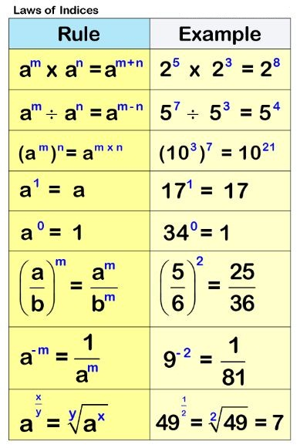

Example 1:

Evaluate :
a) $2^{-4}$ b) ${\left(\frac{2}{3}\right)}^{-2}$

Solutions:

a)${ 2}^{-4}$ = $\frac{1}{2^{4}}$ = $\frac{1}{16}$

b) Note that the power is a negative therefore write the reciprocal of the base and the power becomes a positive.

${\left(\frac{2}{3}\right)}^{-2}$= ${\left(\frac{3}{2}\right)}^{2}$ = $\frac{9}{4}$

Exercise 16:

1. Evaluate these powers:
a) $7^{3}$ b) ${\left(-5\right)}^{4}$ c) $6^{-1}$ d) ${16}^{0}$ e) ${\left(0.9\right)}^{0}$

2. Calculate the following:
a) ${64}^{\frac{1}{2}}$ b) ${112}^{\frac{1}{2}}$ c) ${\left(5^{2}\right)}^{3}$ d) ${\left(3^{2}\right)}^{0.5}$ e) ${\left(4^{5}\right)}^{\frac{1}{2}}$

3. Evaluate the following. Write all answers as fractions or whole numbers:
a) ${\left(\frac{3}{4}\right)}^{-2}$ b) ${\left(\frac{2}{3}\right)}^{-3}$ c) ${\left(1\frac{4}{5}\right)}^{-2}$ d) ${\left(2\frac{3}{4}\right)}^{-1}$

Solutions:

1. a) 343 b) 625 c) $\frac{1}{6}$ d) 1 e) 1

2. a) 8 b) 10.58 c) 15 625 d) 3 e) 32

3. a) $\frac{16}{9}$ b) $\frac{27}{8}$ c) $\frac{25}{81}$ d) $\frac{4}{11}$

4.
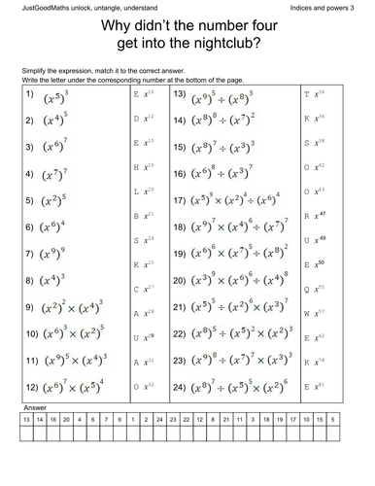

- State a law of logarithms.

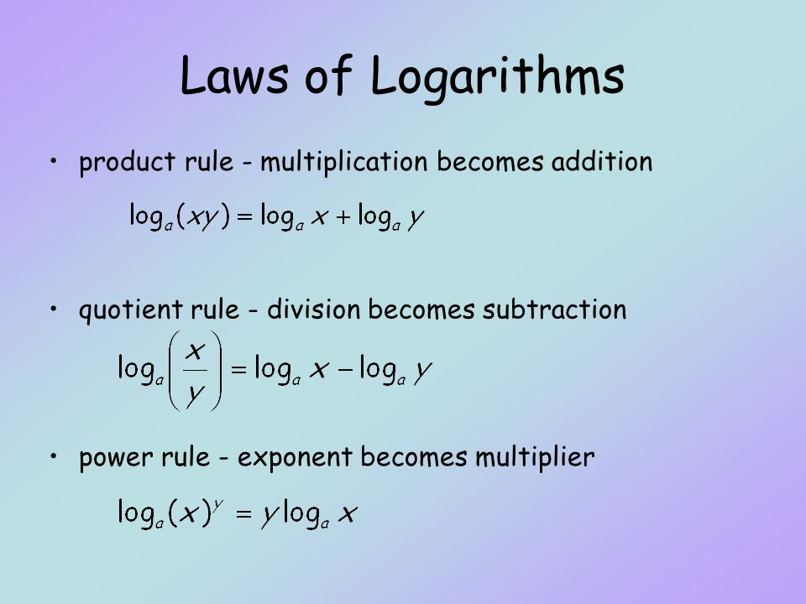

Example 1:
Simplify log(3) + log(5)

Solution:
From rule 1 above:

log(3) + log(5)
= log(3x5)
= log(15)

Example 2:
Simplify log(12) – log(2)

Solution:
From rule 2 above:

log(12) –log(2)
= log$\left(\frac{12}{2}\right)$
= log(6)

Exercise 17:

- Write as the log of a single number:
- log(2) + log(3)
- log(4) + log(5)
- log(x) – log(y)
- log(2) + log(5) + log(3)
- log(18) - log(9) - log(2)

2.
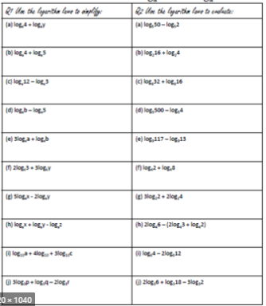

- Sketch the general exponential and Logarithm graphs

Exponential Functions

Any function of the form $y=a^{x}$ is said to be an exponential function.

Properties of Exponential functions
i) If the base is greater than 1, we get a growth curve: $\left(a>1\right).$
ii) If the base is less than 1, we get a decay curve: $\left(0<a>1\right).$
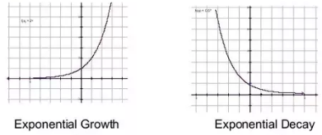
-The $x-axis$ is an asymptote.
-The graph of an function passes through the point (0, 1). This is the$y-intercept.$
-The domain of the function $y=a^{x}$ is all real numbers.
-The range of the function $y=a^{x}$ is $\left\{y>0,y∈R\right\}$

Note: If a number is added or subtracted to the exponential function ($y=2^{x}±c)$ the graph will be translated along the $y-axis.$ If a number is added or subtracted in the power(or index) the graph will be translated along the $x-axis.$

Examples:
i)Sketch the graphs of :
a) $y=3^{x}$ b) $y={\left(\frac{1}{2}\right)}^{x}$

Solutions:
You can fill up table of values by putting some $x$values to find the $y$ values.
a) $y=3^{x}$
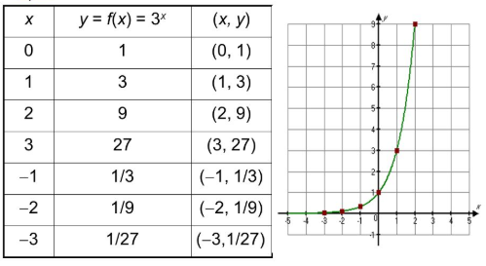

b) $y={\left(\frac{1}{3}\right)}^{x}$
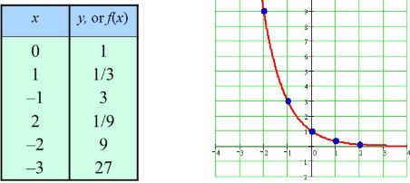

Exercise 18:
Draw the exponential graphs by plotting points, or otherwise, For each one, give the:
- equation of the asymptote
- domain
- range

- $y=2^{x}+3$
- $y=2^{x}-4$
- $y=2^{x+1}$
- $y=2^{x-2}$

Exercise 19:
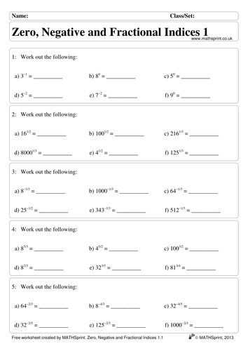

Logarithm Functions
The function $y=\log_{a}\left(x\right)$ is the inverse of the exponential function $=a^{x}$ . This means that the graph is obtained by swapping $x$ and y values from the $y=a^{x}$ graph.
We reflect the exponential graph in the line $y=x$ to get the inverse graph (or the logarithm
Example:
Sketch the graph of $y=\log_{10}(x)$
Solution:
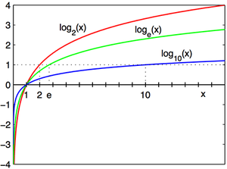

Exercise 20:
Sketch these logarithm graphs
- $y=\log_{2}\left(x\right)+4$
- $y=\log_{2}\left(x+4\right)$
- $y=\log_{2}\left(x\right)-4$
- $y=\log_{2}\left(x+3\right)$
- $y=\log_{2}\left(x+3\right)-2$
- $y={-log}_{2}\left(x\right)$
- $y={-log}_{2}\left(x\right)$
- $y={-log}_{2}\left(x\right)$ +2

