Central School
Home School Package

Year 12 : Biology

LESSON Plan

Date | Term 2 Week 8  Tuesday – 7th July, 2020
Strand 4 : Environmental Biology
Sub-strand 4.1 : Communities
Lesson number : 2

Learning outcomes | - List the features of zonation and stratification. (BIO4.1.2.2 – Skill Level 2)  - Differentiate the pattern of zonation and stratification in an ecosystem. (BIO4.1.3.1 – Skill Level 3)  - Explain how competition for living space, food and nutrients affects relationships in a community. (BIO4.1.3.3 – Skill Level 3)
Learners notes | Stratification :  - Within many plant communities, especially forests, stratification occurs. This is the distinct vertical layering (strata) of plants that occurs as a response to light intensity.  - Layers in a community may be identified and named but this can vary from community to community :  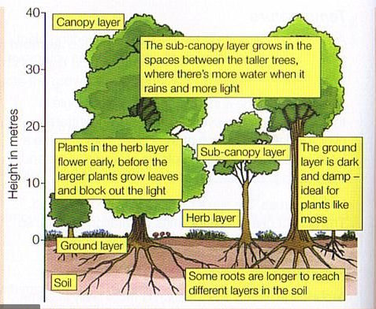  (layers in a forest community)  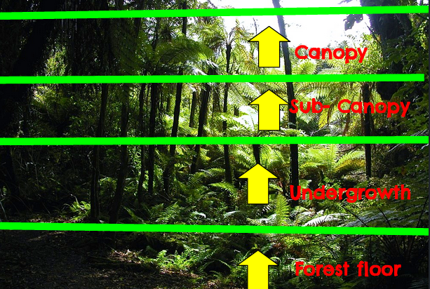  (layers in a forest community)  - Canopy : these are the tallest trees, which must be adapted to / tolerant to high light intensities, high temperatures, high wind speeds, low humidity.  - Sub-canopy : these are shorter trees which must be adapted to / tolerant of reduced light intensities, reduced temperatures, reduced wind speeds, increased humidity.  - Shrub layer : bushy branching plants that must be adapted to low light intensities, low temperatures, low wind speeds, higher humidity.  - Ground layer : a diverse layer that includes juvenile forms of the upper layers. Species that live here permanently must be adapted to the lowest light intensities, temperatures, air movement ; highest humidity. Damp conditions can be common. Examples : ground ferns, mosses, liverworts  - Leaf litter : covers the forest floor and is the fallen leaves / fronds / branches / seeds from all plants. Fungi live here and decompose dead material ; seeds germinate in the soil and seedlings grow in the sheltered conditions. A rich collection of invertebrates makes its home here. Invertebrates include arthropods (centipedes, millipedes, insects, spiders), molluscs (snails, slugs), and annelids (earthworms).  Zonation :  - Zonation is shown by the distinct horizontal bands of life forms that occur across a particular habitat or area.  - Zonation results from the constant change of some environmental factor across the community, eg tidal movement and temperature.  - Example of zonation can be seen on mountains. The main environmental factor that causes zonation on a mountain is temperature change. Competition between plants for light, space and nutrients increases down the mountain.  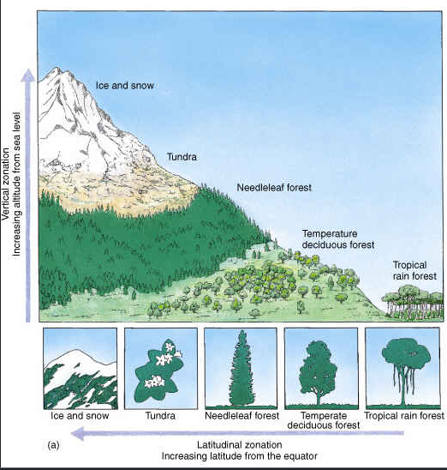  (zonation on a mountain results from temperature change)  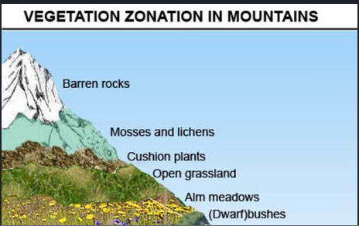  (zonation on a mountain results from temperature change)  - Another example of zonation can be seen on rocky shore. The main environmental factor that causes zonation on the rocky shore is tidal movement (exposure to sea water and air). Competition for space and food increases down the shore from high to low tide.  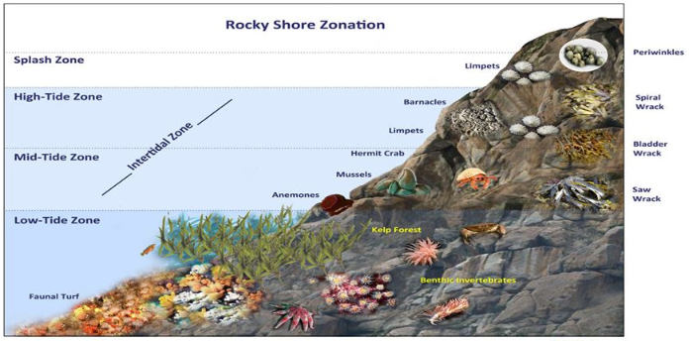  (zonation on rocky shore results from tidal change)  - As environmental conditions exceed the tolerance limits of a species, the zone of distribution for a species finishes. Another species, adapted to the new environmental conditions, forms another zone until it, too, can no longer cope with conditions.  - Competition between species where they meet means zones are usually quite distinct.  - Zones are often named for the dominant / characteristic species found there.  - When environmental conditions in a zone are harsh / extreme (eg. high up a mountain, high tide area of the rocky shore), the biodiversity of the zone is typically less than that of a zone where conditions are more moderate / not so extreme (eg. lower parts of a mountain or low-tide area of the shore).  - Organisms that live in harsh conditions must have high physiological tolerances. However, the greater the biodiversity, the greater is the interspecific competition for resources such as space and food that is likely to occur.  Competition  - Competition occurs when resources are in short supply.  - Intraspecific competition occurs between members of the same species and is the more fierce of the two types of competition, as the individuals have the same resource requirements.  - Interspecific competition occurs between members of different species. It can be important in determining an organisms’s actual niche as well as actual zone in the community (an organism’s tolerance and adaptations will give it a potential niche and set the absolute boundaries for its life zone, but competition with other species may reduce these boundaries.  - Competition is harmful to both individuals/species involved, and can induce physiological stress resulting in increased mortality (death rate) and reduced natality (birth rate).  - Plants are more likely to compete for light, space, water, nutrients.  - Animals are most likely to compete for space, food, water, shelter, nest sites.  - Interspecific competition can be detected by removing one species. It is highly likely that two species were in competition for a resource if :  - the population of the remaining species increases (over a short time frame).  - the actual niche of the remaining species expands (over a long time frame).  - the zone boundaries of the remaining species increase (over a long time frame).
https://www.youtube.com/watch?v=Tk_c5dT9OV8

https://www.youtube.com/watch?v=NQotcekgeM0

https://www.youtube.com/watch?v=ePsjdKoSA9g

https://www.youtube.com/watch?v=DwR2zDR0-gQ

ACTIVITY
1. List the features of zonation and stratification.
__________________________________________________________________
__________________________________________________________________
__________________________________________________________________
__________________________________________________________________
__________________________________________________________________
__________________________________________________________________

2. Differentiate the pattern of zonation and stratification in an ecosystem.
__________________________________________________________________
__________________________________________________________________
__________________________________________________________________
__________________________________________________________________
__________________________________________________________________
__________________________________________________________________
__________________________________________________________________
__________________________________________________________________
__________________________________________________________________
__________________________________________________________________
__________________________________________________________________
__________________________________________________________________

- Explain how competition for living space, food and nutrients affects relationships in a rocky shore community.
__________________________________________________________________
__________________________________________________________________
__________________________________________________________________
__________________________________________________________________
__________________________________________________________________
__________________________________________________________________
__________________________________________________________________
__________________________________________________________________
__________________________________________________________________
__________________________________________________________________
__________________________________________________________________
__________________________________________________________________

- Explain how competition for living space and nutrients affects relationships in a forest community.
__________________________________________________________________
__________________________________________________________________
__________________________________________________________________
__________________________________________________________________
__________________________________________________________________
__________________________________________________________________
__________________________________________________________________
__________________________________________________________________
__________________________________________________________________
__________________________________________________________________
__________________________________________________________________
__________________________________________________________________
__________________________________________________________________
__________________________________________________________________

References | Bunn, T. & Roberts, A. (2008). NCEA Level 2 Biology. New Zealand : ESA Publications, pp 115 – 122, 123  Roberts, A. (2011). ESA Study Guide Level 2 Biology. New Zealand : ESA Publications, pp 143 – 150, 152 – 153  https://www.pinterest.co.uk/pin/48061920998817652/  http://pestalitav.blogspot.com/2014/03/new-zealand-bush-layers.html  https://edu.glogster.com/glog/vertical-zonation/h94gple3ol  https://slideplayer.com/slide/8798384/

