Central School
Home School Package

Year 12 : Biology

HOME SCHOOL PACKAGE CONTENT

This home school package contains the activities for Week 8 of Term 2, 2020 in the following order :

- Monday : 6th July, 2020 – Lesson 1
- Tuesday : 7th July, 2020 – Lesson 2
- Wednesday : 8th July, 2020 – Lesson 3
- Thursday : 9th July, 2020 – Lesson 4
- Friday : 10th July, 2020 – Lesson 5 (Home Test 4.1)

Note to Parents :
- Kindly monitor your child’s learning at home.
- Fill in the weekly checklist on page 8 of this lesson activity (Lesson 1) after your child completes the activity for each day (Monday 6th July – Friday 10th July).

LESSON Plan

Date | Term 2 Week 8  Monday – 6th July, 2020
Strand 4 : Environmental Biology
Sub-strand 4.1 : Communities
Lesson number : 1

Learning outcomes | - Define community. (BIO4.1.1.1 - Skill Level 1)  - Describe the characteristics of a community. (BIO4.1.2.1 - Skill Level 2)  - Define pioneer species (BIO4.1.1.2 – Skill Level 1)  - Describe the role of a pioneer species in a community. (BIO4.1.2.3 – Skill Level 2)  - Explain how community succession and climax impacts the stability of a community. (BIO401.3.2 – Skill Level 3)
Learners notes | Biological community :  - A biological community is all the organisms that live within a defined area (eg lake, forest, beach, grassland) and their interrelationships.  - Communities may be large and long lived (eg the community of Lake Letas on Gaua island) or they may be small and short lived (eg the community of a cow pat or of a shallow pond).  - A community is named after :  - the dominant species that live there (largest biomass) such as a tussock grassland community  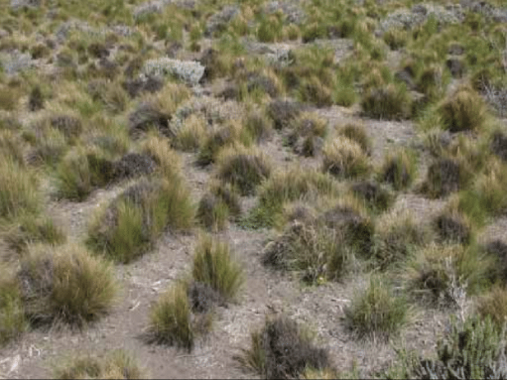  (tussock grassland community)  - the most important physical feature of the community – such as a rocky shore community  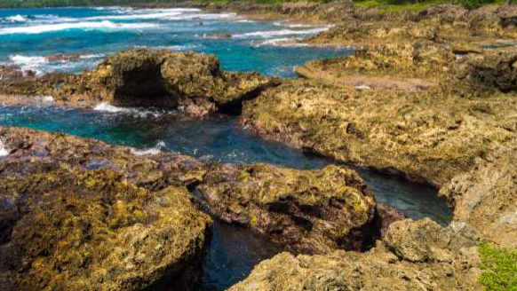  (rocky shore community)  - Communities may have well-defined boundaries such as a lake, or they blend into each other across a transition zone (eg. a sand-dune community may blend into a coastal forest community)  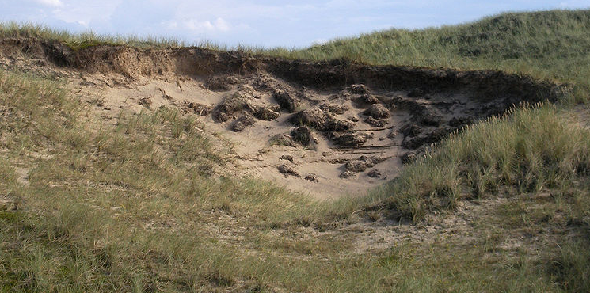  (sand-dune community)  Succession :  - The development of a mature community from bare land is ecological succession. This is usually a long slow process.  - The development of mature community from bare land that has not been inhabited before is called primary succession. Examples : cooled lava from a volcanic eruption ; new sand dunes on seashore  - The development of mature community from previously inhabited land is called secondary succession. This process is faster because the ground is already fertile.  - The first organisms to colonise the new habitat are pioneer plant species. These hardy plant species are tolerant of exposure, high temperatures, dehydration (loss of moisture), and low soil fertility. Pioneer plant species trap nutrients, utilise inorganic compounds, and form habitats for the first consumers by providing shelter and food. As the pioneer plant species and their associated organisms die and decompose, they increase soil fertility. The changed environmental conditions allow other species to grow up and above the pioneer species, killing the pioneer species by shading them out. The succession of establishment, competition and replacement continues, providing a variety of distinct successional communities.  - The final community is a climax community.  - Climax communities are stable. No further succession occurs because climax species provide the conditions necessary for the survival of their own species.
https://www.youtube.com/watch?v=V49IovRSJDs

https://www.youtube.com/watch?v=G0fDbTqqXjA

https://www.youtube.com/watch?v=555EG8Vzs_I
ACTIVITY

1. Define community.
__________________________________________________________________
__________________________________________________________________
2. Describe the characteristics of a community.
__________________________________________________________________
__________________________________________________________________
__________________________________________________________________
__________________________________________________________________
__________________________________________________________________
__________________________________________________________________
__________________________________________________________________
3. Define pioneer species.
__________________________________________________________________
__________________________________________________________________
4. Describe the role of a pioneer species in a community.
__________________________________________________________________
__________________________________________________________________
__________________________________________________________________
__________________________________________________________________
__________________________________________________________________
__________________________________________________________________
__________________________________________________________________
5. Explain how community succession and climax impacts the stability of a community.
__________________________________________________________________
__________________________________________________________________
__________________________________________________________________
__________________________________________________________________
__________________________________________________________________
__________________________________________________________________
__________________________________________________________________

References | Bunn, T. & Roberts, A. (2008). NCEA Level 2 Biology. New Zealand : ESA Publications, pp 115 - 122  Roberts, A. (2011). ESA Study Guide Level 2 Biology. New Zealand : ESA Publications, pp 143 – 150  https://www.researchgate.net/figure/Patagonian-Tussock-Grassland-Udvard-1975  https://www.msn.com/en-xl/australasia/top-stories/bangladeshi-trafficking-victims-leave-vanuatu  https://commons.wikimedia.org/wiki/File:Sand_Dune.jpg

WEEKLY CHECKLIST For Parents:

Term: 2 Week number 8 Date: 6th July, 2020 to 10th July, 2020

Subject | Number of lessons | Days | Tick when activity is complete | Parents comment | Signature
Year 12 Biology | 1 | Monday  6th July 2020
 | 2 | Tuesday  7th July 2020
 | 3 | Wednesday  8th July 2020
 | 4 | Thursday  9th July 2020
 | 5 | Friday  10th July 2020

