2020
YEAR 12 ENGLISH
HOME SCHOOL

CENTRAL SCHOOL

WEEK 9-11 NOVEL

Instructions: Since all year 12 students have your novels with you the next few weeks will be for us to complete the novel. Every day you are required to read each chapter and do activities allocated for you in this hand out. It is very important that you do all your activities or whatever that is set for you to do as year 12 is a very important year. You either do the activities in your book or on the paper so long as you don’t lose the paper. If you’re not sure of anything don’t worry when we resume classes we will review through everything again. We urge you to keep praying for protection during this fearful time but at the same time read notes and do activities given to you by your subject teachers.

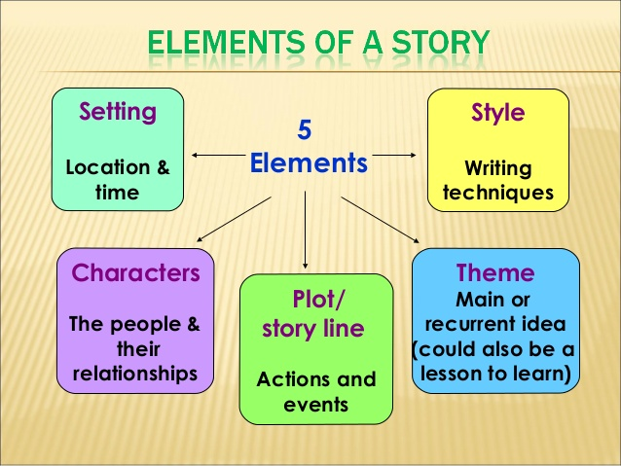

The diagram below shows how every story begins and ends. Exposition is the beginning of the story and normally this is where the description of the characters or the characters are introduced. In the rising action, this is where the conflicts come in which leads to the climax. The climax is the most interesting part of the story. Then we have the falling action where conflicts are being resolved and things become calm. The resolution is the ending part where one can tell if the author ends the story happily or sadly.

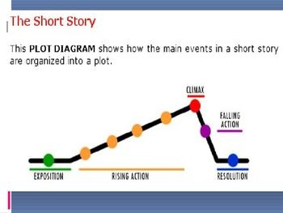

YEAR 12 A ACTIVITY (Chapter 12 Questions)
1. How do the people of Umuike develop their market?
2. The story of the man and the goat shows that the Umuike market is often filled with thieves. What happens in this story?
3. What do Okonkwo’s first and third wives contribute to the betrothal feast?
4. Why does Ekwefi join the betrothal feast later?
5. The members of Obierika’s extended family sit in a half-moon. When his in-laws arrive, they complete the circle. What is the significance of the seating arrangement?
6. Describe the difference in the attire of the married women and that of the girls who greet the in-laws.
7. What does the eldest man among the in-laws mean when he says, “This is not the first time my people have come to marry your daughter”?
8. Why does Obierika’s family say their daughter will be a good wife and bear nine sons?
9. What kinds of men are respected and praised by Obierika’s in-laws?
10. How do you know that Okonkwo is a respected member of Obierika’s extended family?

Chapter 13 Questions
1. What is the role of the esoteric language of the ekwe, or the drum?
2. What is the name of the clan, and what villages are part of the clan?
3. What is the name of Okonkwo’s village?
4. How do the men express their anguish at Ezeudu’s death?
5. What does the one-handed spirit mean when he asks Ezeudu to come again the way he came before?
6. How does Okonkwo accidentally kill Ezeudu’s son during the farewell dance?
7. Why do Okonkwo and his family leave their homestead?
8. Where do Okonkwo and his family go?
9. Why does Obierika begin to wonder about the justice of the Earth goddess?
10. What do the elders mean when they say “If one finger brought oil it soiled the others”?

Part Two, Chapter 14 Questions
1. Why does Okonkwo seek refuge in his motherland?
2. What is the frozen water called “the nuts of the water of heaven”?
3. How does Okonkwo start his yam farm in Mbanta?
4. How does Okonkwo feel about the elders’ belief that if a man says “yes,” his chi will also affirm him?
5. Explain the significance of the isa-ifi ceremony.
6. How does Uchendu establish his authority when he addresses Okonkwo?
7. Why was the name “Nneka,” or “Mother is Supreme,” a common name among the Igbo people?
8. According to Uchendu, what is Okonkwo’s duty and responsibility during his time of exile?
9. What is the meaning of the song the Igbo people sing when a woman dies that says, “For whom is it well, for whom is it well? There is no one for whom it is well.”
10. Why does Uchendu have nothing else to say to Okonkwo?

Chapter 15 Questions
1. Why does Uchendu say that Obierika’s generation stays at home and even a man’s motherland is strange to him?
2. What are the names of some of the clans Uchendu knows in the area?
3. What did the fearless men of Abame do when they met the white man?
4. Why did the Oracle say the white men were like locusts?
5. Why did the white man seem to speak through his nose?
6. Why did the white men wait for the market day to slaughter Abame?
7. Give an example proving that a great evil descended upon Abame just as the Oracle warned.
8. What is the significance of the story of Mother Kite, the bird?
9. Why does Obierika get a late start on his journey?
10. Why does Obierika bring Okonkwo the money?
Chapter 16 Questions
1. How do the leaders of Umuofia feel about the new religion?
2. What does Chielo, the priestess of Agbala, mean when she calls the converts “the excrement of the clan”?
3. Why doesn’t Okonkwo want to speak to Obierika about Nwoye?
4. Why do the Igbo people laugh at the interpreter even though he is speaking Igbo?
5. What is an iron horse?
6. Why are the people excited by what the missionary says?
7. Why do the men of Umuofia laugh at the missionary?
8. Why does Okonkwo stay and listen to the missionary?
9. How does the interpreter explain that the true God has a son but no wife?
10. How does Nwoye feel when he hears the Christians’ hymn?

Chapter 17 Questions
1. What difficulty do the missionaries encounter when they try to speak to the leaders of the village?
2. Describe the Evil Forest.
3. Why is the Evil Forest a strange site for the missionary’s church?
4. Why does Nneka convert to Christianity?
5. Why do some converts suspend their new faith until after the seventh market week?
6. Where does the white missionary go when he leaves Mbanta?
7. Why does it seem like the Evil Forest is going to gobble up the church?
8. What does Mr. Kiaga refer to when he says, “Blessed is he who forsakes his father and his mother for my sake. . . . Those that hear my words are my father and my mother”?
9. According to Okonkwo, what is Nwoye’s crime?
10. Why is Okonkwo called “Roaring Flame”?

Chapter 17 Questions
1. What difficulty do the missionaries encounter when they try to speak to the leaders of the village?
2. Describe the Evil Forest.
3. Why is the Evil Forest a strange site for the missionary’s church?
4. Why does Nneka convert to Christianity?
5. Why do some converts suspend their new faith until after the seventh market week?
6. Where does the white missionary go when he leaves Mbanta?
7. Why does it seem like the Evil Forest is going to gobble up the church?
8. What does Mr. Kiaga refer to when he says, “Blessed is he who forsakes his father and his mother for my sake. . . . Those that hear my words are my father and my mother”?
9. According to Okonkwo, what is Nwoye’s crime?
10. Why is Okonkwo called “Roaring Flame”?

Chapter 19 fill in the blanks
Okonkwo’s seven years of exile in _______________ are drawing to an end. Before he returns to Umuofia, he provides a large ___________ for his mother’s ______________. He is grateful to them but secretly ______________ the missed opportunity to have further increased his status and influence among his own_____________. He also regrets having spent time with such ___________________ people. At the feast, one ________ expresses surprise that Okonkwo has been so generous with his food and another praises Okonkwo’s devotion to the ____________bond. He also expresses concern for the younger generation, as _______________ is winning people away from their families and ________________.

Chapter 20 fill in the blanks
Okonkwo has planned since his first year in _____________ to rebuild his compound on a ___________ scale. He also wants to take two more __________ and get _____________ for his sons. He has managed to get over Nwoye’s disgraceful __________________, but he still regrets that ______________ is a girl. He asked that she wait to marry in Umuofia, after his exile, to which she consented. She even _______________ her sister, Obiageli, to do the same. Okonkwo hopes to attract interest when he returns with two beautiful, marriageable _________________.
However, Umuofia is much changed after _______________ years. The ______________ has grown in strength and the white men subject the villagers to their judicial system and rules of ___________________. They are harsh and arrogant, and Okonkwo cannot believe that his clan has not driven the __________________ and their church out. Sorrowfully, Obierika explains that the church has weakened the ties of kinship and that it is too late to drive the white men out. Many of the ________________ are now on the white man’s side. Okonkwo observes that the white man is very shrewd because he came in peace and appeared to have only benevolent interests in the Africans, who thus permitted him to stay. They discuss the story of_______________, who was hanged by the ___________________ after he killed a man with whom he had a dispute. Aneto had been unsatisfied with the new _______________ ruling on the dispute because it ignored custom. Obierika and Okonkwo conclude their discussion on a fatalistic note, sitting in _________________ together.

Chapter 21 questions
1. What arguments does Akunna use to convince Mr. Brown that lesser gods act as messengers to Chukwu?
2. Why does Mr. Brown disapprove of Enoch’s behavior?
3. What is Mr. Brown’s attitude toward the traditional Igbo religion?
4. Akunna explains that the Igbo know Chukwu as the great creator god because many children are named Chukwuka. What does the name mean?
5. Why does Mr. Brown visit Okonkwo?
6. What is Nwoye’s new Christian name?
7. How does Okonkwo respond to Mr. Brown’s visit?
8. Why does Mr. Brown leave his mission?
9. Why does Okonkwo feel as though he has returned in the wrong year?
10. Describe Okonkwo’s homecoming.

Chapter 22 fill in the blanks

Reverend James Smith, a strict and intolerant man, replaces Mr.____________. He demands the utmost obedience to the letter of the ____________ and disapproves of Mr. Brown’s tolerant and unorthodox policies. The more zealous converts are relieved to be free of Mr. Brown’s policy of _____________. One such convert, _____________, dares to unmask an egwugwu during the annual ceremony to honor the _____________ deity, an act equivalent to killing an _____________spirit. The next day, the egwugwu ________________ Enoch’s compound to the ground. They then gather in front of the church to ____________ Reverend Smith and his fellow Christians. They tell the Christians that they only wish to destroy the church in order to cleanse their village of Enoch’s horrible _________. Smith replies that he will stand his ground. He forbids them to touch the ___________, but his interpreter alters Smith’s statement for fear that the unvarnished truth will be too harsh and that he will ______________ as the messenger of bad news. He tells the egwugwu that Smith demands that they leave the matter in his ____________. They ignore Smith’s orders and _______________ the church.

Summary: Chapter 23 fill in the gaps
Okonkwo is almost happy again, despite the fact that his __________ did not agree to kill the ______________ or ____________ them away. Even so, he and the rest of the ___________ are on their guard, and for the next ______________ days they arm themselves with guns and ____________________. The District Commissioner returns from his tour and requests that the ____________ of Umuofia meet with him. They go, taking only their machetes because guns would be “_______________.” The ______________ talks to them in condescending terms and says that they should discuss the church’s burning “as _____________.” No sooner have they put their machetes on the floor than a group of ______________ surprises them. They are ________________ and thrown in jail for several days, where they suffer insults and ________________ abuse. A kind of bail is set at two hundred bags of _____________. The court messengers tell the people of Umuofia that they must pay a fine of __________________ bags of cowries or their _______________ will be hanged—by upping the price these messengers will make a profit as intermediaries. The town crier announces an _____________________ village meeting. Even Ezinma returns home from her twenty-eight-day visit to her future in-laws. The next morning they decide to collect the cowries necessary to pay the fine.

Chapter24- 25
In chapter 25 discuss the ending of the story in one paragraph. Is it a happy ending or a sad ending, state a reason for your answer? State why you think Chinua Achebe made the ending of the novel that way.
________________________________________________________________________________________________________________________________________________________________________________________________________________________________________________________________________________________________________________________________________________________________________________________________________________________________________________________________________________________________________________________________________________________________________________________________________________________________________________________________________________________________________________________________________________________________________________________________________________________________________________________________________________________________________________________________________________________________________________________________________________________________________________________________________________________________________________________________________________________________________________________________

WEEK 12-13 ESSAY WRITING

Essay question
In the novel studied last year and this year, describe how the setting of the novel has influenced the main characters behaviour in the story. Provide examples to support your point.

___________________________________________________________________________________________________________________________________________________________________________________________________________________________________________________________________________________________________________________________________________________________________________________________________________________________________________________________________________________________________________________________________________________________________________________________________________________________________________________________________________________________________________________________________________________________________________________________________________________________________________________________________________________________________________________________________________________________________________________________________________________________________________________________________________________________________________________________________________________________________________________________________________________________________________________________________________________________________________________________________________________________________________________________________________________________________________________________________________________________________________________________________________________________________________________________________________________________________________________________________________________________________________________________________________________________________________________________________________________________________________________________________________________________________________________________________________________
_________________________________________________________________________________________________________________________________________________________________________________________________________________________________________________________________________________________________________________________________________________________________________________________________________________________________________________________________________________________________________________________________________________________________________________________________________________________________________________________________________________________________________________________________________________________________________________________________________________________________________________________________________________________________________________________________________________________________________________________________________________________________________________________________________________________________________________________________________________________________________________________________________________________________________________________________________________________________________________________________________________________________________________________________________________________________________________________________________________ 20 marks
TERM 2 WEEK 1 -2: In this section we will look at reading comprehension passage as this will appear in your final exam. According to the overview or the scheme of work we are suppose to look at short stories but due to the state of emergency, we will look at some reading comprehension activities. Please ensure you do all the passage so you either do it in the hard copy but make sure you don’t lose this hand out as it will help you in your revision when we come back to school.

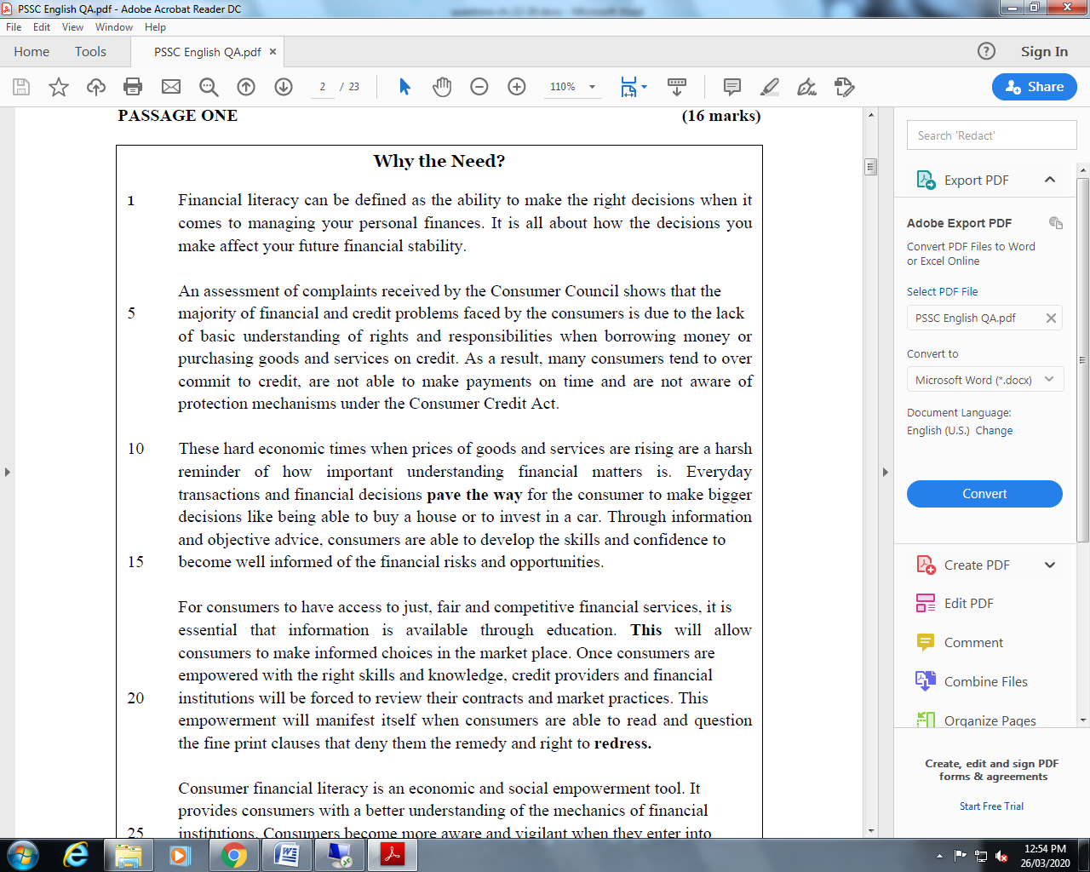

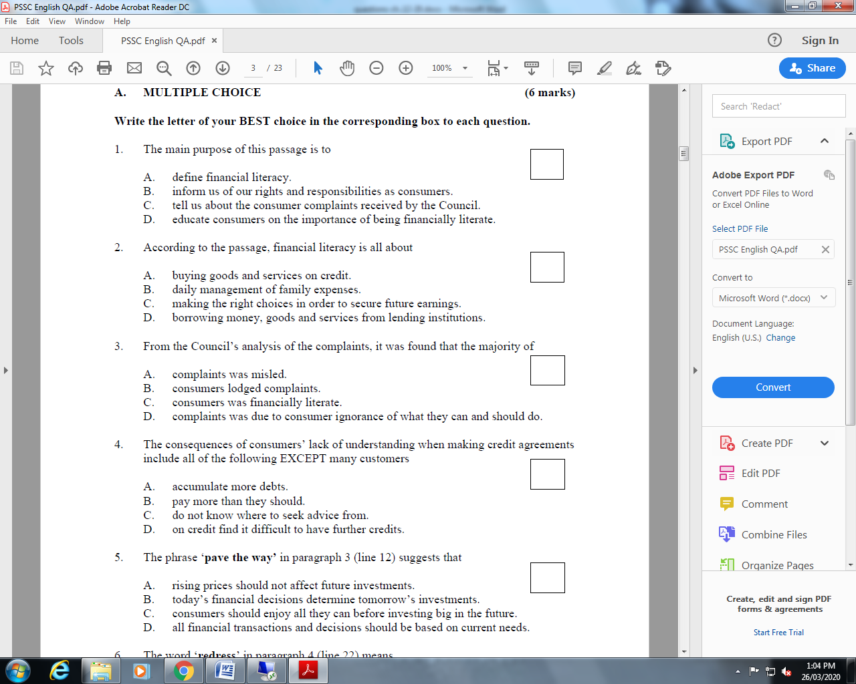

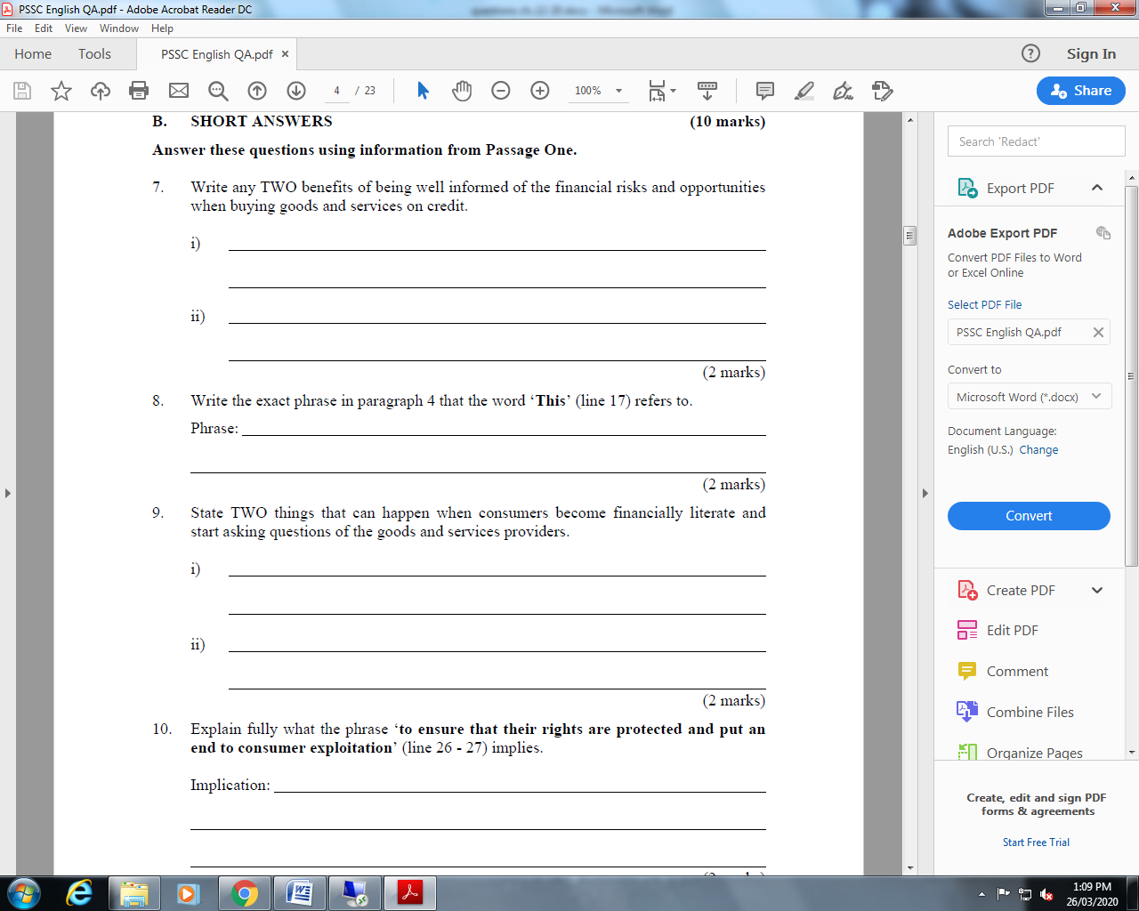
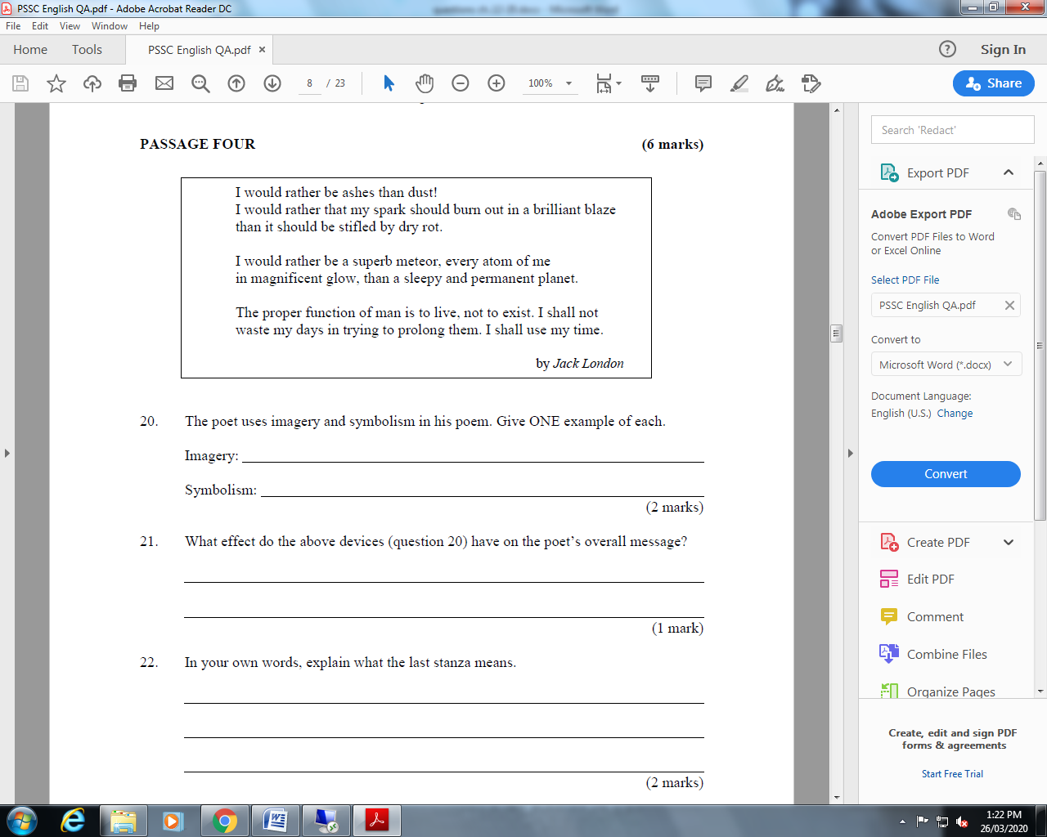
( 2 MARKS)

WEEK 3-4: PRACTICING FORMAL WRITING
Below are notes on how to write a formal essay. Please read it carefully before attempting the activity.
- Compose an introduction. The introductory paragraph should provide readers with sufficient information to know what the essay will be about and what you will seek to prove or disprove in the ensuing text.
- Provide the reader with any necessary background/expository information.
- Insert your thesis statement somewhere near the end of your introductory paragraph.

- Write body paragraphs. The body paragraphs contain the bulk of an essay. The body should come after the introduction and before the conclusion. The more research that you have done, or the more you have to say about your subject, the longer the body section will be in your essay.
- The standard expectation in academic writing is that each paragraph should introduce and explore each "point" that will ultimately prove or disprove your thesis statement.
- Compose a topic sentence for each paragraph, and insert that sentence somewhere near the beginning of the paragraph. The topic sentence is usually the first sentence of a body paragraph.
- A topic sentence should introduce or express the "proof point" of that paragraph, and the ensuing sentences should explain or elaborate on the topic sentence.
- Use the so-called "P.E.E. structure" of paragraphs: Point (make your point/offer the proof of that paragraph), Evidence (give supporting quotes/examples from a book or article), and Explain (relate the evidence to your thesis and elaborate on how it proves your point).[17]
- Each paragraph in the body of your essay should work toward addressing your thesis statement.

3. Form a conclusion. The final paragraph of a formal essay is called the conclusion. It should not introduce any new information, and should not actually say the words, "in conclusion".
- The conclusion paragraph may summarize the proof that was laid out in the preceding body paragraphs, or it may offer some larger implication based on the assumption that the thesis has been adequately proven.
- Some essays may require one or the other, while others may require both a summary and a prediction/implication. How you compose your conclusion will vary, depending on the assignment (if it's for school) or the goal of your essay.

*ACTIVITY: Now that you,ve all read how to write a formal essay, its your turn to try. Each student will write a formal writing based on given themes below. Make sure you structure your essay well.
Topic: ______________________________ Title: _______________________________

___________________________________________________________________________
___________________________________________________________________________
___________________________________________________________________________
___________________________________________________________________________
___________________________________________________________________________
___________________________________________________________________________
___________________________________________________________________________
___________________________________________________________________________
___________________________________________________________________________
___________________________________________________________________________
___________________________________________________________________________
___________________________________________________________________________
___________________________________________________________________________
___________________________________________________________________________
___________________________________________________________________________
___________________________________________________________________________
___________________________________________________________________________
___________________________________________________________________________
___________________________________________________________________________
___________________________________________________________________________
___________________________________________________________________________
___________________________________________________________________________
___________________________________________________________________________
___________________________________________________________________________
___________________________________________________________________________
___________________________________________________________________________
___________________________________________________________________________
___________________________________________________________________________
___________________________________________________________________________
___________________________________________________________________________
___________________________________________________________________________
___________________________________________________________________________
___________________________________________________________________________
___________________________________________________________________________
___________________________________________________________________________
___________________________________________________________________________
___________________________________________________________________________
___________________________________________________________________________
___________________________________________________________________________
___________________________________________________________________________
___________________________________________________________________________
___________________________________________________________________________
___________________________________________________________________________
___________________________________________________________________________
___________________________________________________________________________
___________________________________________________________________________
___________________________________________________________________________
___________________________________________________________________________
___________________________________________________________________________
___________________________________________________________________________
___________________________________________________________________________
___________________________________________________________________________
___________________________________________________________________________
___________________________________________________________________________
___________________________________________________________________________
___________________________________________________________________________
___________________________________________________________________________
___________________________________________________________________________
___________________________________________________________________________
___________________________________________________________________________
_____________________________________________________________________________________________________________________________________________________________________________________________________________________________________________________________________________________________________________________________________________________________________________________________________________________________________________________________________________________________________________________________________________
20 marks /

