Central School
Home School Package

Year : 12 ICT

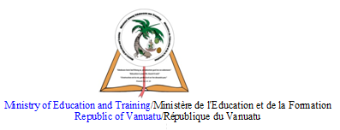

HOME SCHOOL PACKAGE CONTENT

Keyboarding skills
Computer Graphics
Digital Image Processing
Networking
Programming

LESSON Plan

Teacher | Name : Rensy Ilaisa  Subject : ICT
Date | June 1, 2020 to June 5, 2020
Topic : Keyboaording Skills
Lesson number : 1-5

Learning outcomes | - Place fingers correctly on home keys  - Identify position of several letters correctly on the keyboard  - Use correct placement of fingers on some keys of the keyboard  - Produce a capital letter by pressing the shift key, Caps Lock Key  - Type a given piece of information  - Type a passage of information at a rate of 30 words per minute
Introduction | A computer keyboard is an input device that allows a person to enter letters, numbers, and other symbols (these are called characters in a keyboard) into a computer. ... Using a keyboard to enter lots of data is called typing. A keyboard contains many mechanical switches or push-buttons called "keys"
 | Different keys/ functions keys/numeric keys
Learners notes | 5 PARTS OF A KEYBOARD : There are five main parts to most desktop keyboards. These parts include the alphanumeric keypad, the numeric keypad, the arrow keys, the control keys, and the function keys.  The keys on computer keyboards are often classified as follows:  - alphanumeric keys -- letters and numbers.  - punctuation keys -- comma, period, semicolon, and so on.  - special keys -- function keys, control keys, arrow keys, Caps Lock key, and so on.  Why is it important to have typing skills?  The productivity of a business depends on how things are done faster. To complete your work faster it is important to develop typing skills. Typing helps you to work comfortably on the computer, it aids in communicating with colleagues and customers, creating documents, and finding new information.  C:\Users\Rency.Kone\Documents\Year 11 ICT notes\Keyboard notes.pdf
https://www.youtube.com/watch?v=qYQRWW-1Yxg

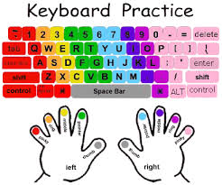

 | 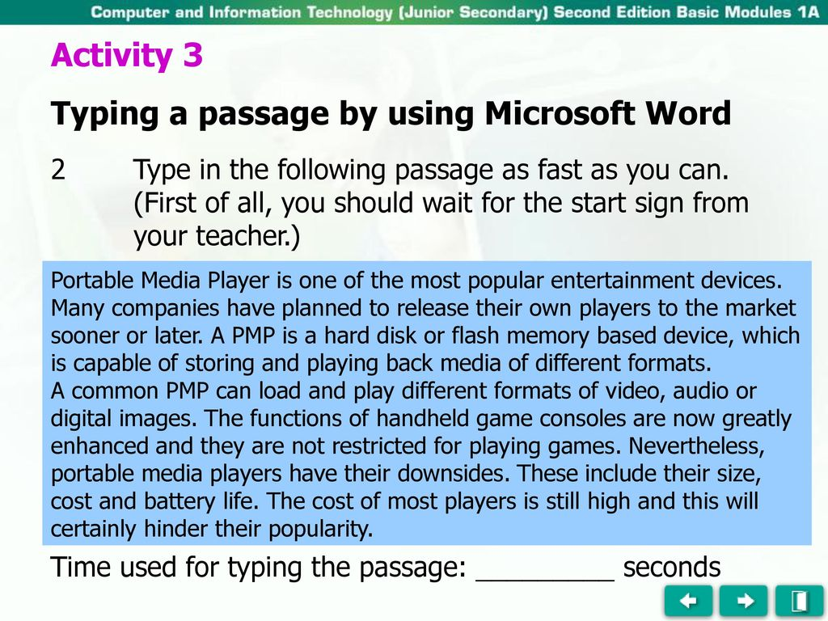
Assignment | - Make a list of all shortcut keys that can be used in Ms Word.  - Explain the use of Function keys F1 to F12
Assessment | Typing skills  Accuracy  Speed (how many words/character per seconds)
References

WEEKLY CHECKLIST For Parents:

Term: 2 Week number 1 Date: 1 to 5 Month: June

Subject | Number of lessons | Days | Tick when activity is complete | Parents comment | Signature
ICT (Keyboarding Skills) | 1 | Monday
ICT  (Keyboarding Skills) | 2 | Tuesday
ICT  (Keyboarding Skills) | 3 | Wednesday
ICT  (Keyboarding Skills) | 4 | Thursday
ICT  (Keyboarding Skills) | 5 | Friday

Lesson Plan
Teacher | Name : Rensy Ilaisa  Subject : ICT
Date | June 29- July 3
Topic : Computer Graphics
Lesson number : 1- 10

Learning outcomes | - State a key fundamental of 3D graphics  - Outline key fundamentals of 3D graphics  - Create a part of a draft sketch of a 3D graphic on paper  - Identify an appropriate design application for creating 3D graphics  - Produce a part of a basic design of a 3D graphic using a graphic design application  - Manipulate a part of a 3D image using an appropriate graphic design tool
Introduction | 3D graphic designers are digital artists who create visual images to communicate messages to target audiences. These images may be in the form of illustrations, animation, photographs or text.  Not only does 3D modeling help the designers and end users visualize space requirements, but also improves drawing efficiency and accuracy. 3D modeling for design allows the designer to see what they would not see when designing in 2D
 | 3D graphic design.
Learners notes | Why do we need a 3d model?  A 3D design can easily show dimensions in 3D space of objects and their relationships. This will help your customer to visualize space, movement, access, and so on. 3D models can be used to create 2D drawings directly. This means that the cost of changes to the design are much less.  Check your notes on Graphics folder in your flash drive or click on the link below.  C:\Users\Rency.Kone\Documents\Year 11 ICT notes\Graphics.pdf
https://www.youtube.com/watch?v=LUXbgN23ncc

https://www.youtube.com/watch?v=NsBg-m2hrIM

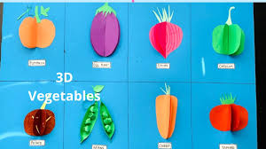

Graph the following shapes in your computer.
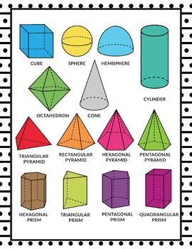
Assignment | Choose any 3D design plan and produce a 3Dimage using the required design tools to meet the design plan.
Assessment | This assignment is going to be assessed. 5% towards Mid-year report.
References | https://www.rundesroom.com/2019/07/back-to-school-graphing-activity.html

Term: 2 Week number: 2 Date 8 to 12 Month: June

Subject | Number of lessons | Days | Tick when activity is complete | Parents comment | Signature
ICT – 3D Graphics | 1 | Monday
ICT - 3D Graphics | 2 | Tuesday
ICT - 3D Graphics | 3 | Wednesday
ICT - 3D Graphics | 4 | Thursday
ICT - 3D Graphics | 5 | Thursday

Term: 2 Week number 6 Date 15 to 19 Month: June
Subject | Number of lessons | Days | Tick when activity is complete | Parents comment | Signature
ICT - 3D Graphics | 1 | Monday
ICT - 3D Graphics | 2 | Tuesday
ICT - 3D Graphics | 3 | Wednesday
ICT - 3D Graphics | 4 | Thursday
ICT - 3D Graphics | 5 | Thursday

Lesson Plan
Teacher | Name : Rensy Ilaisa  Subject : ICT
Date | 13 July to 24 July
Topic : Digital Image processing
Lesson number : 1- 10

Learning outcomes | - Identify a file type compatible with a specific imaging application  - List different file types that are compatible with specific imaging application  - Modify an image property using an imaging application tool  - Modify image properties using imaging tools according to required specifics  - Produce a part of a collage image using a collage maker  - Produce part of a panorama image using appropriate imaging tool  - Save a processed image  - Save multiple processed images  - Export a processed image to another application  - Print a processed image
Introduction | How to Import Photos with Windows 10  - Plug the phone or camera’s cable into your computer.  - Turn on your phone or camera (if it’s not already turned on) and wait for File Explorer to recognize it.  - Right-click your camera or phone, choose Import Pictures and Videos from the pop-up menu, and choose how to import your photos.  - Select the Import All New Items Now option, type a short description into the Add Tags box, and click Next.  How do you change the properties of a picture?  To change the properties of an image, perform these tasks: Place your mouse cursor anywhere on the image. Right-click, and select Image Properties from the menu. Specify or edit each image property as required: Image Info tab: URL: This is the URL of the image on the content server. Click OK to close the dialog.
 | How to process an image in any application software.
Learners notes | How to create image collage?  How to Make a Photoshop Collage in 9 Simple Steps  - Open the selected images in Photoshop.  - Create a new file.  - Add your images one at a time.  - Create your layout.  - Add image spacing.  - Merge all layers.  - Crop the final image.  - Resize for online usage.  - Add a watermark if desired.  How to Put Two Pictures Together  - Open a new Photoshop canvas.  - Open the images.  - Copy and paste the first picture in your blank canvas.  - Move the image into position.  - Move the image to one side to create a basic collage.  - Follow Steps 2-4 with your second picture.  - Add some finishing touches.
 | 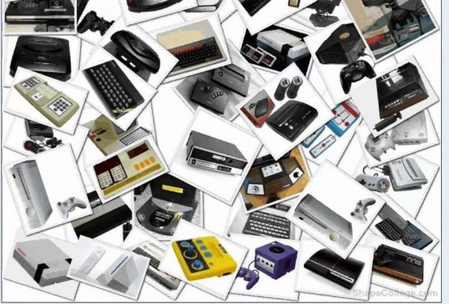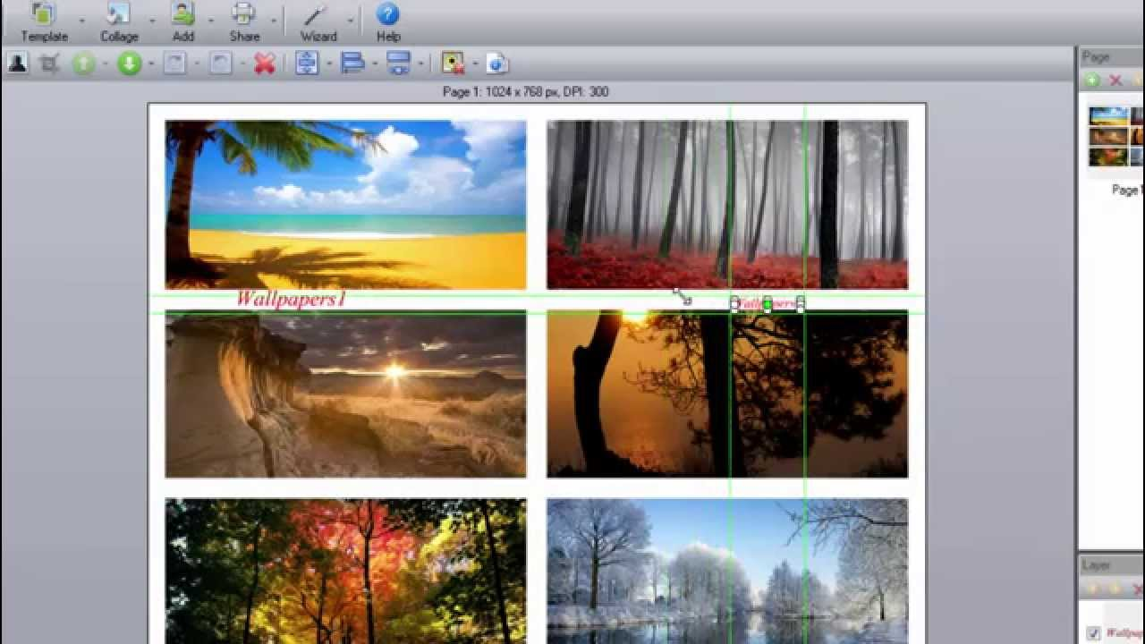
 | - Create a similar collage of images like example shown above on visual aid.
Assignment | - Produce a part of a collage image using a collage maker  - Produce part of a panorama image using appropriate imaging tool  - Save a processed image  - Save multiple processed images in your flash drive and bring to class or email it to me through my email address rnck2007@gmail.com
Assessment | Final product of the assignment will be assessed.  A total of 10% will go towards the mid-year report.
References | https://docs.oracle.com/cd/E10316_01/SiteStudio/10gr4/WebHelp-Contributor/c05_images005.htm

Term: 2 Week number 7 Date 13 to 17 Month: July

Subject | Number of lessons | Days | Tick when activity is complete | Parents comment | Signature
ICT – Digital Image processing | 1 | Monday
ICT – Digital Image processing | 2 | Tuesday
ICT – Digital Image processing | 3 | Wednesday
ICT – Digital Image processing | 4 | Thursday
ICT – Digital Image processing | 5 | Thursday

Term: 2 Week number 8 Date 20 to 24 Month: July

Subject | Number of lessons | Days | Tick when activity is complete | Parents comment | Signature
ICT – Digital Image processing | 1 | Monday
ICT – Digital Image processing | 2 | Tuesday
ICT – Digital Image processing | 3 | Wednesday
ICT – Digital Image processing | 4 | Thursday
ICT – Digital Image processing | 5 | Thursday

LESSON Plan

Teacher | Name : Rensy Ilaisa  Subject : ICT

Date
Topic :
Lesson number :

Learning outcomes
Introduction
Learners notes | Summary
Assignment
Assessment
References

WEEKLY CHECKLIST For Parents:

Term: 2 Week number 1 Date…… to…… Month: …………

Subject | Number of lessons | Days | Tick when activity is complete | Parents comment | Signature
 | 1
 | 2
 | 3
 | 4
 | 5

Term: 2 Week number 2 Date…… to…… Month: …………

Subject | Number of lessons | Days | Tick when activity is complete | Parents comment | Signature
 | 1
 | 2
 | 3
 | 4
 | 5
 | 6

Term: 2 Week number 3 Date…… to…… Month: …………

Subject | Number of lessons | Days | Tick when activity is complete | Parents comment | Signature
 | 1
 | 2
 | 3
 | 4
 | 5
 | 6

Term: 2 Week number 4 Date…… to…… Month: …………

Subject | Number of lessons | Days | Tick when activity is complete | Parents comment | Signature
 | 1
 | 2
 | 3
 | 4
 | 5
 | 6

Term: 2 Week number 5 Date…… to…… Month: …………

Subject | Number of lessons | Days | Tick when activity is complete | Parents comment | Signature
 | 1
 | 2
 | 3
 | 4
 | 5
 | 6

Term: 2 Week number 6 Date…… to…… Month: …………

Subject | Number of lessons | Days | Tick when activity is complete | Parents comment | Signature
 | 1
 | 2
 | 3
 | 4
 | 5
 | 6

Term: 2 Week number 7 Date…… to…… Month: …………

Subject | Number of lessons | Days | Tick when activity is complete | Parents comment | Signature
 | 1
 | 2
 | 3
 | 4
 | 5
 | 6

Term: 2 Week number 8 Date…… to…… Month: …………

Subject | Number of lessons | Days | Tick when activity is complete | Parents comment | Signature
 | 1
 | 2
 | 3
 | 4
 | 5
 | 6

