Central School
Home School Package

Year :2020

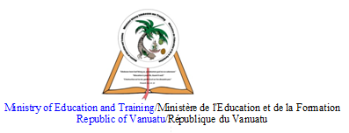

HOME SCHOOL PACKAGE CONTENT

- Cover page ……………………………………………pg 1
- Content page…………………........................................pg 2
- LESSON Plan………………………………………… Pg 3
- Short stories …………………………………………...pg 4-17
- Poems ………………………………………………….pg 17-37

LESSON Plan

Teacher | Name : Mr Tarihehe & Mr Garae  Subject : English
Date | Term 2 : June 2020
Topic : Short stories
Lesson number :1-2

Learning outcomes | At the end of lesson 1&2 students should be able to:  - Under stand the main facts mentioned in their notes  - understand key terms and events in their short stories  - Paraphrase each term outlined in the exercise for better understanding
Introduction | H.G Wells states that, ‘Short stories are pieces of fictions that can be read in half an hour. In this lesson we will focus on reviewing the three short stories that you have studied last year. We will start off with, ‘The waste land’ followed by ‘The pedestrain’ and conclude with ‘Taboo’
Catch phrase for the lesson
“The journey of a life time begins with the turning of a page”
Learners notes | 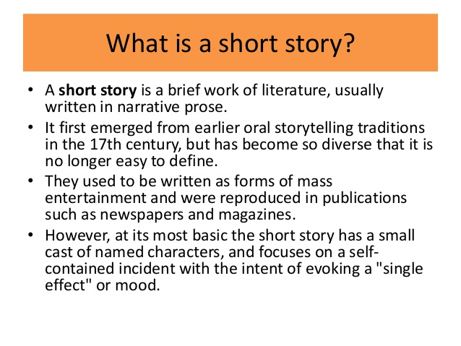  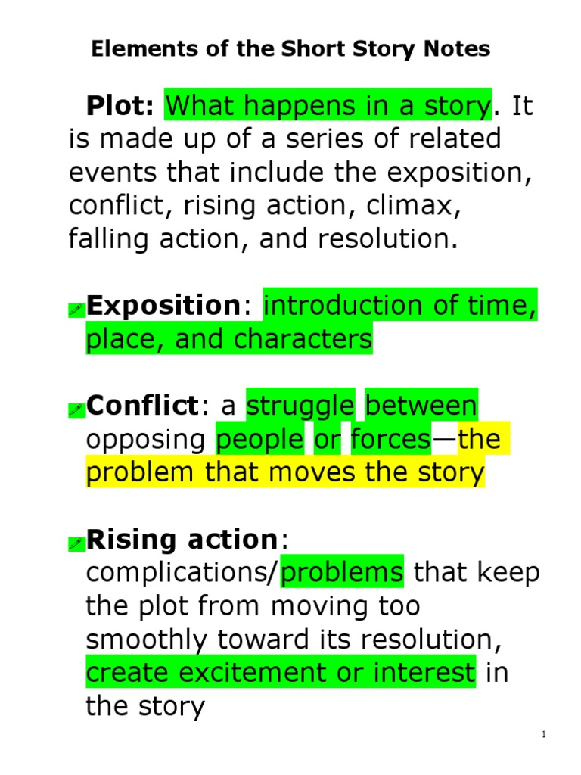  - Resolution : ending part of the story or the outcome of the problem/conflict.
We will start off with “The waste land.” These following words are randomly chosen in the short story and may seem to be hard to define so your task is to define and paraphrase into your own words to help make your reading easier.
- Irresolute –_______________________________________________________________________________________________________________________________________________________________
- Convent –_______________________________________________________________________________________________________________________________________________________________
- Loomed –_______________________________________________________________________________________________________________________________________________________________
- Pursuer-_______________________________________________________________________________________________________________________________________________________________
- Reeling-______________________________________________________________________________________________________________________________________________________________
- Wits –_______________________________________________________________________________________________________________________________________________________________
- Entrails –__________________________________________________________________________________________________________
- Obstruction –______________________________________________________________________________________________________________________________________________________________
- Idiom -______________________________________________________________________________________________________________________________________________________________

Assignment
Assessment | Test will be given to students every Friday of each week depending on the topics covered.
References | https://www.enotes.com/homework-help/when-was-wasteland-by-alan-paton-written-what-was-118043  https://primestudyguides.com/the-waste-land-alan-paton

LESSON Plan

Teacher | Name : Mr Tarihehe & Mr Garae  Subject : English
Date | Term 2 : 15th to 19th June 2020
Topic : Short stories
Lesson number :3-5

Learning outcomes | AIMS AND AOBJECTIVES:  At the end of this week students should be able to:  - Re-read the short stories studied last year and understand key terms  - Write an essay in review for assessment purposes
Introduction | H.G Wells states that, ‘Short stories are pieces of fictions that can be read in half an hour. In this lesson we will focus on reviewing the three short stories that you have studied last year. We will start off with, ‘The waste land’ followed by ‘The pedestrain’ and conclude with ‘Taboo’
Catch phrase for the lesson
“The journey of a life time begins with the turning of a page”
Learners notes | Now take 30 minutes to re-read the story again. After reading the story, here are some notes on the story that will help you understand more. Please read through the notes and then write an essay which will be provided in the assessment box.  Structure  “The Waste Land” by Alan Paton is a very brief short story structured around a single event – a man is ambushed by some thieves and eventually manages to escape them, but accidentally kills one of the attackers, who, most probably, turns out to be his son.  Most shorts stories are structured using a plot, which refers to a series of consecutive moments marking certain points in the narrative: exposition, rising action, climax, falling action, resolution.  Title: The title of the short story is very suggestive. Waste land usually refers to an abandoned area, either barren or full of waste.  Beginning: The short story has an abrupt exposition, in media res, which means the author starts the narrative in action, without giving details about the setting or the characters.  Middle: The middle of the short story is where the narrative develops by introducing tension points which mark the rising action and lead to a climactic moment. Most of the rising action in this text is very tense, as the short story is about a man who runs for his life trying to escape some thieves. The rising action takes place in the waste land, the only place in which the protagonist has a chance of escaping.  Ending: The ending of the short story comprises the falling action – the youngsters push Freddy’s body under the same lorry his father hides – and the resolution.  Characters  The old man: The most important character in the short story “The Waste Land” by Alan Paton is the old man from whose point of view the events are rendered. Additionally, the young men who want to rob him function as a collective character.  Most of the outer and inner characterisation of the old man in the short story is done indirectly, through his actions and thoughts, and many times it is only suggestive of his traits and not directly informative.  Outer characterisation: For instance, his outer characterisation is suggested through references to a “heavy stick” which implies he is old and the final mention that he is the father of one of the thieves.  Inner characterisation: When it comes to his inner characterisation, the man depicts himself directly as “hard-working and law-abiding”. Apart from this, most of his personality traits surface indirectly.  Because the man lives in a dangerous society, he has lost all optimism and even trust in God; for him, the world is a dangerous place, in which one is defenceless: “Mercy was the unknown word.” “…behind him was the high wall of the convent, and the barred door that would not open before a man was dead.”  The young men: The young men function as a collective character. Besides them being young, we also know that one of them is Freddy, the old man’s son. Apart from this, all we know about them is from the father’s perspective.  For the old man, this gang of young thieves is merciless and capable of murdering people for money  Setting and narrator  Here, you can read useful information regarding the setting and narrator of the short story “The Waste Land” by Alan Paton.  Setting: Published in 1961, “The Waste Land” by Alan Paton is most likely set in South Africa, where the author lived, and in a time contemporary to its publication. This is indicated by the reference to a local “idiom” which probably refers to an African dialect.  Physical setting: The main physical setting is the waste land next to a bus station and a convent, which also gives the title of the short story: “…behind him was the high wall of the convent, and the barred door that would not open before a man was dead. On the other side of the road was the waste land, full of wire and iron and the bodies of old cars.”  Social setting: For now, you should note that the physical setting becomes symbolic for the overall social setting the author is trying to pinpoint. Also, here we discuss the historical time of the story.  Narrator: “The Waste Land” by Alan Paton is a third-person narrative with a storyteller who confines himself to the point of view of one of the characters, the older man. As a result, everything narrated is only what the characters knows, hears, sees and feels.  Language  The language of the short story “The Waste Land” by Alan Paton is unpretentious, easy to understand and many times symbolic. Since the story is written using the perspective of one of the characters, the language is also designed to reflect the man’s way of thinking, his background, and his feelings: “Death was near him, and for a moment he was filled with the injustice of life, that could end thus for one who had always been hard-working and law-abiding.”  Imagery: In this short story, imagery is created through the depiction of the setting and the way the characters act. Descriptive words help us imagine them and the atmosphere, such as when the character looks around him and realises his only chance of escaping the thieves is the waste land  Themes  The main theme of the short story “The Waste Land” by Alan Paton is the decadence of society which is enhanced through sub-themes like violence, pain and fear. Though there are no direct references to society in South Africa, Alan Paton’s message is that South Africans are exposed to violence and anarchy, mostly because of their poverty which, in its turn, was largely a result of the apartheid regime in the country.  Summary  A hard working man gets off the bus and instantly feels that he's in danger. ... The theme is the crime and desperation (which drives a young man to rob his own father) that roams in South Africa.  “The Waste Land”, was written by the South African author Alan Paton (who was against apartheid) in 1961.
This website is to help you know more about the Author. Other than that, there are no youtube videos of the analysis of the text.

https://www.youtube.com/watch?v=n6IApEqj0Xc

In a paragraph,breifly discuss the plot of the short story studied.

________________________________________________________________________________________________________________________________________________________________________________________________________________________________________________________________________________________________________________________________________________________________________________________________________________________________________________________________________________________________________________________________________________________________________________________________________________________________________________________________________________________________________________________________________________________________________________________________________________________________________________________________
Assignment
Assessment | ESSAY QUESTION (Day 5) this Assessment will be done on Friday  Discuss an important theme with reference to a short story (the wasteland) you have studied, and how a particular character helped convey this theme.  _____________________________________________________________________________________________________________________________________________________________________________________________________________________________________________________________________________________________________________________________________________________________________________________________________________________________________________________________________________________________________________________________________________________________________________________________________________________________________________________________________________________________________________________________________________________________________________________________________________________________________________________________________________________________________________________________________________________________________________________________________________________________________________________________________________________________________________________________________________________________________________________________________________________________________________________________________________________________________________________________________________________________________________________________________________________________________________________________________________________________________________________________________________________________________________________________________________________________________________________________________________________________________________________________________________________________________________________________________________________________________________________________________________________________________________________________________________________________________________________________________________________________________________________________________________________________________________________________________________________________________________________________________________________________________________________________________________________________________________________________________________________________________________________________________________________________________________________________________________________________________________________________________________________________________________________________________________________________________________________________________________________________________________________________________________________________________________________________________________________________________________________________________________________________________________________________________________________________________________________________________________________________________________________________________________________________________________________________________________________________________________________________________________________________________________________________________________________________________________________________________________________________________________________________________________________________________________________________________________________________________________________________________________________________________________________________________________________________________________________________________________________________________________________________________________________________________________________________________________________________________________________________________
References | https://www.enotes.com/homework-help/when-was-wasteland-by-alan-paton-written-what-was-118043  https://primestudyguides.com/the-waste-land-alan-paton

Topic : short story
Lesson number :1-5

Learning outcomes | AIMS AND AOBJECTIVES:  At the end of this week students should be able to:  - Read and understand the reading plus the notes given  - Able to identify the plot structure of the story
Introduction | Short stories can be fiction and non-fiction depending on the authors. The story of the pedestrain is a story told about the future civilization that is predicted. It shows how everyone was concentrated on television while police cars patrol without drivers. This lessons will focus on the summary, analysis and themes of the story.  .
Catch phrase for the lesson
“life is a short story pretending to be a novel”
Learners notes | Summary  "The Pedestrian" offers a glance into the future, where a man, Leonard Mead, goes for long walks every evening by himself. The year is 2053, and Mr. Mead is the only pedestrian near his home. He has never seen another person out walking during the many hours that he has strolled. He lives by himself - he has no wife, and so it is a tradition for him to walk every evening. It is never said explicitly in the story, but it can be understood that he is the only, or one of the only, walker in society.  On this particular evening, a police car stops him and orders him to put his hands up. He answers a series of questions about his life and family, and his answers are unsatisfactory to the police. This car is the only remaining police car in the area. After the election last year, the force was reduced from three cars to one because crime was ebbing and they were seen as unnecessary. When Mr. Mead answers the question of employment by saying he is a writer, the police interpret his answer as "unemployed." They order him to enter the car despite his protests, and as he approaches he realizes there is no driver at all - the car is automated.  Mr. Mead is filled with fear as he sits down in the cell-like backseat. The car informs him that he is being taken to a psychiatric center because of his regressive tendencies. His behavior is not acceptable in society - no one walks anymore and it is queer that he continues to do so as his primary hobby. En route, they pass his house, which is the only house that is lit up and inviting to the outside eye. Mr. Mead's behavior is completely atypical of the society in which he lives.  Analysis  Once again, Bradbury shows his skepticism of technology and "progress" in "The Pedestrian." In this story, a popular pastime is viewed as regressive, outdated, and abnormal. Mr. Mead's behavior is deemed threatening even though it is not hurting anyone - the powers in charge believe that his determination to walk every night could upset their social stability. He does not have a viewing screen in his house, which is expected of the members of this society. His behavior proposes an alternative activity that the government does not approve of, and this threatens their monopoly on control.  The act of ostracizing someone who is different than the rest of the group appears again, which is a common theme in Bradbury's stories. The police car, a representative of the powers in control, disapprove of his behavior, but the entire society disapproves as well. Ostracizing him is another form of censorship. His lit up house is symbolic of his difference from the rest of society. He is very easily identified as someone who is different.  The story calls into question the idea of progress for the sake of progress. An automated police car is programmed to stop Mr. Mead, even though he has not committed an offense. There is no room for human discretion and judgment in a world that is fully automated. Additionally, the viewing screen is considered a way to distract the public and keep them under the watchful eye of the government. A roaming public that is out walking is much harder to control than one that is stationed in front of its television set. Thus Bradbury's story raises the question of, "What does progress really mean? Is advancement, regardless of the consequences, a positive step in the right direction?"  Additionally, this story highlights the dangers and "slippery slope" of a government determining what is best for a group of people without their input. What exactly does "regressive tendencies" mean, and who has decided that walking means being regressive? Does our society resemble that of the pedestrian's, and if it does, is that a good or bad thing? Once again, Bradbury's stories prompt us to reflect on our surroundings and continue to be relevant despite a different temporal age.  These are some themes that are taken in the story.  Theme: Numbing Effect of the Media  People in 2053 stay inside in the evenings to watch television. The programming seems designed to keep people passive—shows about cowboys, war, games, revues and slapstick comedy. There don't seem to be any shows that would make people think.  Related to this is the disappearance of reading. There's no serious writing being done about anything important. Of course, reading material can be purely for entertainment as the television lineup is. Even so, reading is a more active pass time than watching television.  People use television to stay connected to the world, not personal interaction. They seem to accept what they're given, and don't look for anything more.  Theme: Isolation  There's no evening activity in this world. Human interaction outside your own family seems to be limited to the day time. This is likely to take care of necessary things like working and running errands. There's no sense of community.  People "[sit] like the dead" in front of their viewing screens. This implies there isn't much interaction between family members.  These societal norms serve to isolate Leonard. He walks alone—certainly no one is going to walk with him if it will label them as deviant.  He's also not married. He says "Nobody wanted me," seemingly as a joke. There's probably some truth to this. His anomalous attitude and behavior could have been too alienating for anyone to see him as a suitable match.  A lack of personal connection is also seen in Leonard's arrest. The robotic police car is programmed to get certain information and make a decision. There's no room for a judgment call or any understanding. Leonard needs an exception to be made. He seems to be hoping for one when looks into the front window, even though he knows it will be empty.  The lack of any human element is also seen in the car, which smells of steel and antiseptic. There's nothing comforting, nothing soft in it.  Leonard's isolation looks like it will continue. He's being taken to a psychiatric facility, another authority like the police. There won't be much room, if any, for human compassion in his evaluation.  Theme: Societal Norms  The norm in this society is to stay inside and watch television. It's abnormal to be outside in the evening taking a walk.  To be seen walking is disruptive to the neighborhood. Leonard makes a point of wearing sneakers, not hard-soled shoes that would alert dogs to his presence.  The fact that Leonard doesn't have a viewing screen in his home is unusual, possibly unique. This seems to count as a major strike against him by the automated police car.  Leonard's walking is so abnormal that the police car is programmed to take him to a psychiatric facility.  The story makes it obvious that just because society views something as abnormal doesn't make it wrong.  1. What is symbolized by the image of Leonard's shadow as the “shadow of a hawk in midcountry”?  This represents Leonard's independence and freedom. He's “free as a bird” in the country as he takes his nighttime walk. When he's confined to the car's jail cell, he becomes a caged bird.  2. What is symbolized by the contrast of light and dark between Leonard's home and the other homes?  As the police car takes Leonard away, he sees his house which "had all of its electric lights brightly lit, every window a loud yellow illumination, square and warm in the cool darkness."  This could symbolize Leonard's enlightenment. He doesn't want to feed his mind with the vapid television programming, preferring the silence of a night time walk. The people who are conforming are in darkness, with only "gray phantoms" from their viewing screens.  It could also symbolize Leonard's aberrant attitude. Normal houses look cold and eerie, while Leonard's place looks warm and welcoming. His house stands out just as much as he does when he's out walking.  3. What is the significance of the title?  The title tells us how society views Mr. Mead.  The police car rejects his claim of being a writer. He isn't married, so he can't identify as a husband, which seems like something that would have helped him: “Now if you had a wife to give you an alibi,” the metallic voice said. His neighbors don't acknowledge him at all.  Ultimately, he can only be identified by his singular peculiarity, as a pedestrian, which makes him mentally unbalanced and possibly criminal.
https://study.com/academy/lesson/ray-bradburys-the-pedestrian-summary-analysis-theme.html

https://www.youtube.com/watch?v=PiF3rOVUx3o

Here are some follow up activities for you to do.
- Describe the setting of the story
______________________________________________________________________________________________

- Provide two reasons why the protagonist goes for walks at night. ?
_____________________________________________________________________________________________________________________________________________
- How does Mr. Mead's profession act as a threat to society in "The Pedestrian"?
_________________________________________________________________________________________________________________________________________________________
- What do phrases such as "grassy seams," "buckling concrete walk," and "lumpy walk" imply?
____________________________________________________________________________________________________________________________________________________________________________________________________________

- How does Mr. Mead contrast with his surroundings?
_________________________________________________________________________________________________________________________________________________________

- Why were the police suspicious of Mr. Leonard Mead?
_________________________________________________________________________________________________________________________________________________________
- How many police men were in the police car?
______________________________________________________________________________________________________

- What are The citizens in "The Pedestrian" controlled by ?
______________________________________________________________________________________________________
- What does the Metal voice from the police car imply ?
____________________________________________________________________________________________________________________________________________
- Provide a suitable theme of your choice and quote a phrase to support your theme.
____________________________________________________________________________________________________________________________________________________________________________________________

Assignment
Assessment | Write a paragraph stating why settings are important in a story  ________________________________________________________________________________________________________________________________________________________________________________________________________________________________________________________________________________________________________________________________________________________________________________________________________________________________________________________________________________________________________________________________________________________________________________________________________________________________________________________________________________________________________________________________

Topic : POEMS
Lesson number :1-2

Learning outcomes | AIMS AND AOBJECTIVES:  At the end of this week students should be able to:  - Know the different devices and terms studied in class  - Analyse a poem on their own
Introduction | A poem is a collection of spoken or written words that expresses ideas or emotions in a powerfully vivid and imaginative style.  Poems are meant to be read out loud to trigger people’s emotions and to bring about the powerful message which one is trying to portray.  Some important things to know; in novels and short stories, we call a group of sentences together as paragraph. In a poem this is known as Stanza.
Catch phrase for the lesson
“A poem begins in delight and ends in wisdom”
Learners notes | Here are the sound and language devices normally used in a poem.  - Metaphor – simply means saying that something is something else. Or treating something as if is something else. For example; The sun is a Gold coin  - Simile – is the comparison of two things using the word ‘Like’ or ‘As’. For instance; the grass is like a carpet.  - Personification – giving living qualities to non-living things. For example; “the trees laugh at Tom because he fell into the mud”.  - Alliteration – repetition of the same sound at the beginning of words. For example; “The furrow followed free”.  - Onomatopoeia- words that imitate the sound they represent. For example; “the lightning strikes”  - Repetition – repeating the same word twice. The sound and spelling remains the same. Example; Fire......Fire  - Rhythm- the measured flow of words and phrases in verse or prose as determined by the relation of long and short or stressed and unstressed syllables. Or basically it means the organisation of the poem (number of stanzas, lines in a stanza, movement in the poem.)  - Rhyme-have or end with a sound that corresponds to another.  - Diction – is the poets choice of words  - Persona – is the person who wrote the poem  - Imagery - visual images collectively. Or words used by the poet that triggers the senses. For example; when you see the word ‘fire’ already in your mind you can picture what fire looks like.  - Audience- people who are targeted or to whom the poet is reading his/her poem to.  - Irony – saying something but the opposite is intended. For example; Tom hates James but he says” his my friend”  - Allusion – is a brief and indirect reference to a person, place, thing or idea of historical, cultural, literary or political significance.  - Subject – what the poem is about  - Tone- the poets attitude towards the subject of the poem
 | https://literaryterms.net/poetry/
Having read the different terms used in any poem above, let’s test your knowledge of how well you read and understood. Now it’s your turn, for each of the terms below make up your own example for each word. Do not copy any examples above but create your own.
- Irony______________________________________________________________________________________________________
- Metaphor __________________________________________________________________________________________________________
- Onomatopoeia __________________________________________________________________________________________________________
- Simile __________________________________________________________________________________________________________
- Alliteration __________________________________________________________________________________________________________
- Personification __________________________________________________________________________________________________________
- Imagery __________________________________________________________________________________________________________
- Rhyme __________________________________________________________________________________________________________

Assignment
Assessment

Topic : POEMS
Lesson number : 3-5

Learning outcomes | AIMS AND AOBJECTIVES:  At the end of this week students should be able to:  - Know the different devices and terms studied in class  - Analyse a poem on their own
Introduction | A poem is a collection of spoken or written words that expresses ideas or emotions in a powerfully vivid and imaginative style.  Poems are meant to be read out loud to trigger people’s emotions and to bring about the powerful message which one is trying to portray.  Some important things to know; in novels and short stories, we call a group of sentences together as paragraph. In a poem this is known as Stanza.
Catch phrase for the lesson
“A poem begins in delight and ends in wisdom”
Learners notes | Before we review the poems that you’ve studied last year we will look at an example of a poem and test your prior knowledge if you still remember how to analyse a poem. The poem below is “Dulce et decorum est” written by Wilfred Owen.  Dulce et Decorum Est  BY: WILFRED OWEN  Bent double, like old beggars under sacks,  Knock-kneed, coughing like hags, we cursed through sludge,  Till on the haunting flares we turned our backs,  And towards our distant rest began to trudge.  Men marched asleep. Many had lost their boots,  But limped on, blood-shod. All went lame; all blind;  Drunk with fatigue; deaf even to the hoots  Of gas-shells dropping softly behind.  Gas! GAS! Quick, boys!—An ecstasy of fumbling  Fitting the clumsy helmets just in time,  But someone still was yelling out and stumbling  And floundering like a man in fire or lime.—  Dim through the misty panes and thick green light,  As under a green sea, I saw him drowning.  In all my dreams before my helpless sight,  He plunges at me, guttering, choking, drowning.  If in some smothering dreams, you too could pace  Behind the wagon that we flung him in,  And watch the white eyes writhing in his face,  His hanging face, like a devil’s sick of sin;  If you could hear, at every jolt, the blood  Come gargling from the froth-corrupted lungs,  Obscene as cancer, bitter as the cud  Of vile, incurable sores on innocent tongues,—  My friend, you would not tell with such high zest  To children ardent for some desperate glory,  The old Lie: Dulce et decorum Est  Pro patria mori.
https://www.youtube.com/watch?v=qB4cdRgIcB8
https://www.youtube.com/watch?v=PUBmoRuMwvk
https://www.youtube.com/watch?v=9DYbB6Lh03U
- Who is the poet in the story?

- Do a research on the title and state what it means and which country is it derive from?

______________________________________________________________________________________________________________________________________________________

- How many stanzas does the poem have?
___________________________________________________________________________
- Look at stanza 1 in the poem and identify 3 language devices in the space below and also quote the example.
_______________________________________________________________________________________________________________________________________________________________________________________________________________________________________________________________________________________________________

- The two words in the beginning of stanza two is an example of _______________________.
- Clumsy and stumbling in stanza 2 are examples of _________________________________.
- Line 6 in stanza 2 is an example of ___________________________________.
- What type of narration is used in stanza 3? ___________________________________________________________.
- What types of pronouns are used in the last stanza?
______________________________________________________________________________________________________________________
- List down two simile found in the last stanza
______________________________________________________________________________________________________________________
- Quote an example of Irony found in the last stanza.
______________________________________________________________________________________________________________________
- List down two onomatopoeia found in the last stanza
______________________________________________________________________________________________________________________
- Give an example of Allusion found in the poem.
______________________________________________________________________________________________________________________
- What tone is the poet using in his poem? State the tone provided with an example in the poem.
______________________________________________________________________________________________________________________
- What do you think the poem is about? (subject)
____________________________________________________________________________________________________________________________________________________________________________________________________________________________________________
- List down some imagery word found in the poem
____________________________________________________________________________________________________________________________________________________________________________________________________________________________________________
- What would be the best theme for the poem?
_________________________________________________________________________________________________________________________________________________________________________________

Assignment
Assessment | TEST ON DEFINITIONS OF TERMS COVERED (FRIDAY)

Topic : POETRY
Lesson number : 1-2

Learning outcomes | AIMS AND AOBJECTIVES:  At the end of this week students should be able to:  - Review the poems studied last year  - Understand the poem very well  - Answer any essay question given on that particular poem
Introduction | A poem is a collection of spoken or written words that expresses ideas or emotions in a powerfully vivid and imaginative style.  Poems are meant to be read out loud to trigger people’s emotions and to bring about the powerful message which one is trying to portray.  Some important things to know; in novels and short stories, we call a group of sentences together as paragraph. In a poem this is known as Stanza.
Catch phrase for the lesson
“A poem begins in delight and ends in wisdom”
Learners notes | This week we will review the three different poems you’ve studied last year. We will begin with kidnapped. Below is a sample of the whole poem. Please take time to read the poem before moving on.  Kidnapped by Ruperake Petaia  I was six when  Mama was careless  she sent me to school  alone  five days a week  One day I was  kidnapped by a band  Of Western philosophers  armed with glossy-pictured  textbooks and  registered reputations  ‚Holder of BA  and MA degrees‘  I was held  in a classroom  guarded by Churchill and Garibaldi  pinned up on one wall  and  Hitler and Mao dictating  from the other  Guevara pointed a revolution  at my brains  from his ‚Guerilla Warfare‘  Each three-month term  they sent threats to  my Mama and Papa  Mama and Papa loved  their son and  paid ransom fees  each time  Each time  Mama and Papa grew  poorer and poorer  and my kidnappers grew  richer and richer  I grew whiter and  whiter  On my release  fifteen years after  I was handed  (among loud applause  from fellow victims)  a piece of paper  to decorate my walls  certifying my release  Below are some analysis of the poem which are taken from the internet that are very helpful for students to read. Please take time to read as it will help you understand the poem more.  Analysis of Kidnapped by Ruperake Petaia  This poem interested me because it brought to my attention some negative views towards education that I may not have considered before. It allowed me to explore my feelings towards my own education and realised how fortunate I am to have had such a positive experience, and also how I almost struggled to relate to anything other than this positivity.  However, through reading this poem I can empathise with Petaia, and understand the angle he is coming from. It is an honest recording of a Samoan student’s experience with feeling indoctrinated in a foreign, predominantly white educational system. He expresses the loss of traditional Samoan knowledge and bemoans the Western influences on Samoan culture and society (similar to the work by Albert Wendt).  “Mama and Papa grew poorer and poorer and my kidnappers grew richer and richer I grew whiter and whiter.”  The poem criticises the legacy of British influence on different facets of Samoan life.  He implies that his teachers, the white colonialists, have stolen him from his mother. His education came with such a great cost to his parents, and he feels resentment that at the end of it all it had been detrimental to his parent’s and all he got was(what he feels to be) a worthless certificate.  Petaia depicts his academic achievement as a metaphorical ‘kidnapping’ or the completion of a jail sentence, “on my release fifteen years after....”  This feeling of being kidnapped is like he is losing his identity and having something forced upon him.  He illustrated a feeling of being forced to learn to value information and cultural habits that are not truly your own.  The poem in parts has an angry tone, and leads into one of resignation. There is an underlying feeling of Petaia being stripped of his culture, language and heritage and there is nothing he could do to change the situation.  Another facet of this poem which I found interesting was the references to historical figures.  “I was held in a classroom guarded by Churchill and Garibaldi pinned up on one wall and Hitler and Mao dictating from the other,”  These references are important as they allow us to in a way relate to the poem. Learning about these historical figures is a part of most children’s schooling in New Zealand, and so this allows us prior knowledge of the subject.  Also these references have a subtle sarcasm to them especially when Hitler and Mao are said to be dictating. This relates to the theme of imprisonment within education.  I thought it was so interesting that Petaia referred to his parent’s paying for school as ransom fees. Within this stanza it is said “Each time Mama and Papa grew poorer and poorer and my kidnappers grew richer and richer I grew whiter and whiter,” This once again speaks of resentment and the loss of the writer’s culture.  I found this poem quite sad when I finished reading it. It really makes me feel like I understand Petaia’s mourning for his loss of cultural identity and his bitterness towards his education. This surprised me because as I previously mentioned I had not expected to empathise with him. However, I believe that Petaia is such an amazing writer that he invites the reader to see his point of view and understand his feelings and loss.  This poem is considering the impact of the coloniser on the people's culture and reflects the negative effects on the colonies. It shows the emotional feeling by neglecting their land and ancestry. ... He wants to study about his own culture and ancestry.
https://gradesfixer.com/free-essay-examples/analysis-of-the-poem-kidnapped-by-ruperake-petaia/

https://www.studienet.dk/kidnapped-ruperake-petaia/themes-and-message

Exercise: Here is an exercise to test your knowledge of how well you remember the poem. Re-read the poem again before answering these questions.
- When was the speaker kidnapped?
_______________________________________________________________________________________________________________________________________________________________________________________
- Who kidnapped him?
__________________________________________________________________________________________________________________________
- What weapons did the kidnappers have?
__________________________________________________________________________________________________________________________
- Where was the speaker held captive?
__________________________________________________________________________________________________________________________
- Who were the guards?
__________________________________________________________________________________________________________________________
- What ransom fee did the kidnappers demand?
__________________________________________________________________________________________________________________________
- What was the effect on the parents?
__________________________________________________________________________________________________________________________
- What was the effect on the kidnappers?
__________________________________________________________________________________________________________________________
- What was the effect on the speaker?
__________________________________________________________________________________________________________________________
- When was the speaker released?
__________________________________________________________________________________________________________________________
- What did the kidnappers give him upon his release?
__________________________________________________________________________________________________________________________
- Who applauded the speaker?
__________________________________________________________________________________________________________________________

Assignment
Assessment | PLEASE FILL IN THE TABLE BELOW  BRIEF BACKGROUND OF THE POET :  THEME/MAIN MESSAGE :  SETTING :  DEVICES AND EXAMPLES :  WHAT THE POEM IS ABOUT (SUBJECT) :  WHY DO YOU LIKE OR DISLIKE THE POEM ?  CRITICISISM ON THE POEM :  IN YOUR OPINION HOW DOES THE POEM RELATE TO YOUR LIFE ?

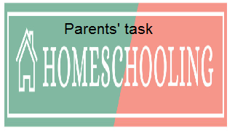

WEEKLY CHECKLIST For Parents:

Term: 2 Week number 1 Date…… to…… Month: …………

Subject | Number of lessons | Days | Tick when activity is complete | Parents comment | Signature
 | 1
 | 2
 | 3
 | 4
 | 5
 | 6

Term: 2 Week number 2 Date…… to…… Month: …………

Subject | Number of lessons | Days | Tick when activity is complete | Parents comment | Signature
 | 1
 | 2
 | 3
 | 4
 | 5
 | 6

Term: 2 Week number 3 Date…… to…… Month: …………

Subject | Number of lessons | Days | Tick when activity is complete | Parents comment | Signature
 | 1
 | 2
 | 3
 | 4
 | 5
 | 6

Term: 2 Week number 4 Date…… to…… Month: …………

Subject | Number of lessons | Days | Tick when activity is complete | Parents comment | Signature
 | 1
 | 2
 | 3
 | 4
 | 5
 | 6

Term: 2 Week number 5 Date…… to…… Month: …………

Subject | Number of lessons | Days | Tick when activity is complete | Parents comment | Signature
 | 1
 | 2
 | 3
 | 4
 | 5
 | 6

Term: 2 Week number 6 Date…… to…… Month: …………

Subject | Number of lessons | Days | Tick when activity is complete | Parents comment | Signature
 | 1
 | 2
 | 3
 | 4
 | 5
 | 6

Term: 2 Week number 7 Date…… to…… Month: …………

Subject | Number of lessons | Days | Tick when activity is complete | Parents comment | Signature
 | 1
 | 2
 | 3
 | 4
 | 5
 | 6

Term: 2 Week number 8 Date…… to…… Month: …………

Subject | Number of lessons | Days | Tick when activity is complete | Parents comment | Signature
 | 1
 | 2
 | 3
 | 4
 | 5
 | 6

Term: 2 Week number 9 Date…… to…… Month: …………

Subject | Number of lessons | Days | Tick when activity is complete | Parents comment | Signature
 | 1
 | 2
 | 3
 | 4
 | 5
 | 6

Term: 2 Week number 10 Date…… to…… Month: …………

Subject | Number of lessons | Days | Tick when activity is complete | Parents comment | Signature
 | 1
 | 2
 | 3
 | 4
 | 5
 | 6

Term: 2 Week number 11 Date…… to…… Month: …………

Subject | Number of lessons | Days | Tick when activity is complete | Parents comment | Signature
 | 1
 | 2
 | 3
 | 4
 | 5
 | 6

Term: 2 Week number 12 Date…… to…… Month: …………

Subject | Number of lessons | Days | Tick when activity is complete | Parents comment | Signature
 | 1
 | 2
 | 3
 | 4
 | 5
 | 6

Term: 2 Week number 13 Date…… to…… Month: …………

Subject | Number of lessons | Days | Tick when activity is complete | Parents comment | Signature
 | 1
 | 2
 | 3
 | 4
 | 5
 | 6

