Central School
Home School Package

Year : 12 Accounting

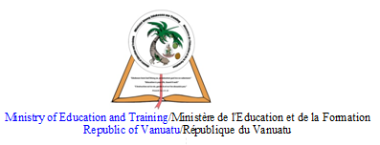

LESSON Plan Week 1

Teacher | Name :Felix  Subject : Accounting

Date
 | Week 1
Learning outcomes | INVENTORY SUB SYSTEM  - Identify the items making up merchandise inventory.  - Identify the cost of merchandise inventory.
Introduction | What is an inventory management system?  An inventory management system is a tool that allows you to track goods across your business’s supply chain. It optimizes the entire spectrum spanning from order placement with your vendor to order delivery to your customer, mapping the complete journey of a product.
 | Catch phrase for the lesson
Learners notes | Technically, goods in transit belong to the party holding legal ownership. Ownership depends on the F.O.B. terms. Goods sold F.O.B. destination do not belong to the purchaser until they arrive at their final destination. Goods sold F.O.B. shipping point become property of the purchaser once shipped by the seller. Therefore, when determining the amount of inventory owned at year end, goods in transit must be considered in light of the F.O.B. terms. In the case of F.O.B. shipping point, for instance, a buyer would need to include as inventory the goods that are being transported but not yet received. In the diagram, the buyer or seller shown in green would “inventory” the goods in transit.  Another inventory-related problem area pertains to goods on consignment. Consigned goods describe products that are in the physical custody of one party, but actually belong to another party. Thus, the party holding physical possession is not the legal owner. The person with physical possession is known as the consignee. The consignee is responsible for taking care of the goods and trying to sell them to an end customer.  The consignor is the party holding legal ownership/title to the consigned goods. Consigned goods should be included in the inventory of the consignor.  Consignments arise when the owner desires to place inventory in the hands of a sales agent, but the sales agent does not want to pay for those goods unless resold to an end customer. For example, auto parts manufacturers produce many types of parts that are very specialized and expensive. A retail auto parts store may not be able to afford to stock every variety. In addition, there is the real risk of ending up with numerous obsolete units. But, the manufacturer desperately needs these units in the retail channel. As a result, the parts manufacturer may consign their inventory to auto parts retailers.  MyExceLab  Conceptually, it is fairly simple to understand the accounting for consigned goods. Practically, there is a significant record keeping challenge. When examining a company’s inventory on hand, special care must be taken to identify both goods consigned out to others (which are to be included in inventory) and goods consigned in (which are not to be included in inventory). When the consignee sells consigned goods to an end user, the consignee would keep a portion of the sales price, and remit the balance to the consignor. All of this activity requires an accounting system capable of identifying consigned units, tracking their movement, and knowing when they are actually sold.  Summary
 | 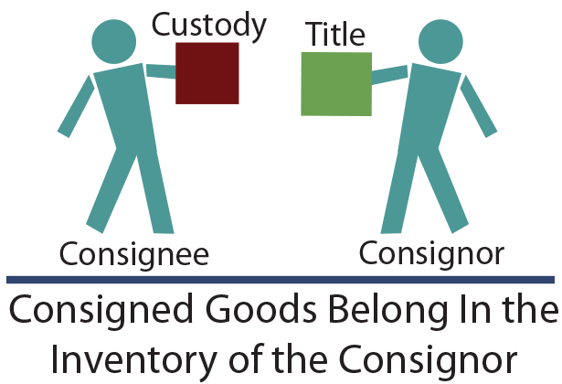
1 : Defline inventory ____________________________________________________________________________________________________
2 : Identify 3 important concepts from the notes provided above.
- ________________________
- ________________________
- ________________________
Assignment
Assessment | This topic is Assesse in the end of year exam
References | ``

LESSON Plan Week 2

Teacher | Name : Felix  Subject : Accounting

Date
 | INVENTORY SUB SYSTEM
Learning outcomes | - Recording inventory using FIFO
Introduction | FIFO stands for “First-In, First-Out”. It is a method used for cost flow assumption purposes in the cost of goods sold calculation. The FIFO method assumes that the oldest products in a company’s inventory have been sold first. The costs paid for those oldest products are the ones used in the calculation.
Learners notes | Notes  The first in, first out (FIFO) method of inventory valuation is a cost flow assumption that the first goods purchased are also the first goods sold. In most companies, this assumption closely matches the actual flow of goods, and so is considered the most theoretically correct inventory valuation method. The FIFO flow concept is a logical one for a business to follow, since selling off the oldest goods first reduces the risk of inventory obsolescence.  Under the FIFO method, the earliest goods purchased are the first ones removed from the inventory account. This results in the remaining items in inventory being accounted for at the most recently incurred costs, so that the inventory asset recorded on the balance sheet contains costs quite close to the most recent costs that could be obtained in the marketplace. Conversely, this method also results in older historical costs being matched against current revenues and recorded in the cost of goods sold; this means that the gross margin does not necessarily reflect a proper matching of revenues and costs. For example, in an inflationary environment, current-cost revenue dollars will be matched against older and lower-cost inventory items, which yields the highest possible gross margin.  The FIFO method is allowed under both Generally Accepted Accounting Principles and International Financial Reporting Standards. The FIFO method provides the same results under either the periodic or perpetual inventory system.
 | 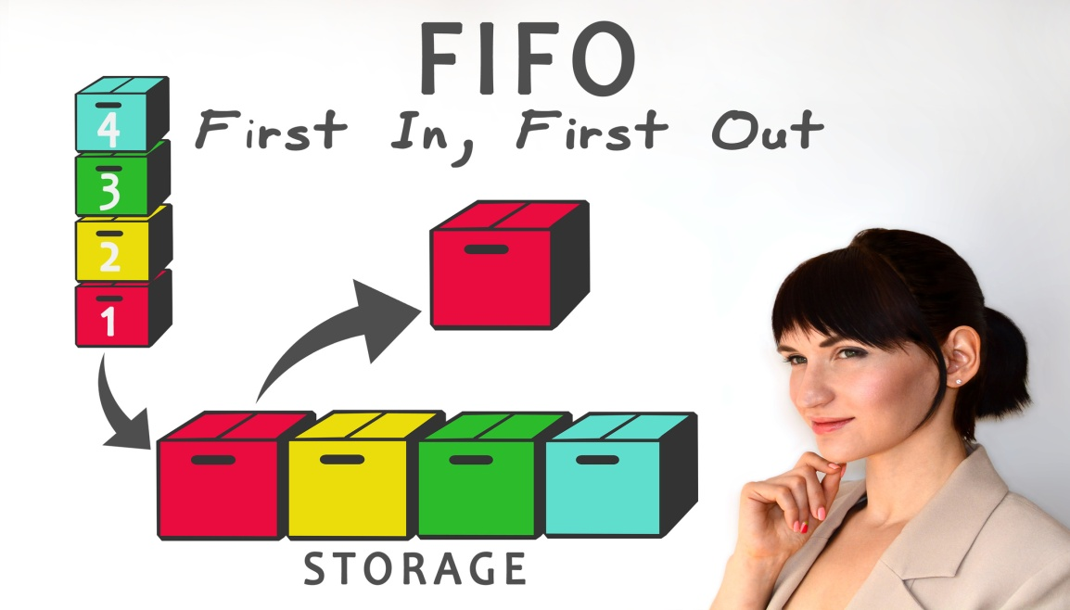
Quiz

True of False
First in first out is a system to record the flow of fixed asset. ___________
Practical Exercise
Refer to page 353 of your text book. Do activity 9.20 (FIFO only)

Assignment
Assessment | This topic is assessed in the end of year assessment.
References | ``

LESSON Plan Week 2
Teacher | Name : Felix  Subject : Accounting

Date
 | INVENTORY SUB SYSTEM
Learning outcomes | - Recording inventory using LIFO
Introduction | An accounting method for inventory and cost of sales in which the last items produced or purchased are assumed to be sold first; allows business owner to value inventory at the less expensive cost of the older inventory; typically used during times of high inflation.
Learners notes | Notes  The LIFO method of accounting assumes that you'll sell the most recently purchased inventory first. For instance, suppose you bought 10 ceiling fans a year ago at $30 each. A week ago, you purchased a second lot of 10 ceiling fans, but now the price has gone up to $50 each. By using the LIFO method, you sell your customers the $50 ceiling fans first, which allows you to keep the less expensive units (in terms of your inventory cost) in inventory. Then, when you have to calculate inventory value for tax purposes, LIFO allows you to value your remaining inventory (the $30 fans) at substantially less than the $50 fans, so you pay less in taxes. The advantage of using this accounting method is that the cost of sales in a period will closely match the current period values of your inventory; the drawback is that this method values inventory at old cost levels.  How it works/Example:  Let's assume you own the XYZ grocery store and you've decided to start selling cookies. You purchased a case of cookies last week for $25 and a case of cookies this week for $30. Which cookies do you sell first? Under the LIFO method, you would assume you sell the freshest cookies first (regardless of which cookie actually gets sold first).  To see the accounting effects, let's further assume you sell one case of cookies a month. Under the LIFO method, your cost of goods sold for the month would be:  Gross Cookie Sales: $100  Cost of Goods Sold: $30  Gross Margin: $70  Now consider the store's gross profit margin if you sold the older case of cookies first (that is, you used the first-in-first-out, or FIFO, method):  Gross Cookie Sales $100  Cost of Goods Sold: $25  Gross Margin $75  Inventory methods exist to deal with the fact that prices of commodities, raw materials, labor, and other inputs tend to change. When prices are rising, LIFO tends to deflate net income because new, more expensive inventory is used in the cost of goods sold calculation (this is not always bad; lower net income means a lower tax bill). When prices are falling, LIFO tends to overestimate net income because newer, less expensive inventory is used in the cost of goods sold calculation (and also results in a higher tax bill).
 | 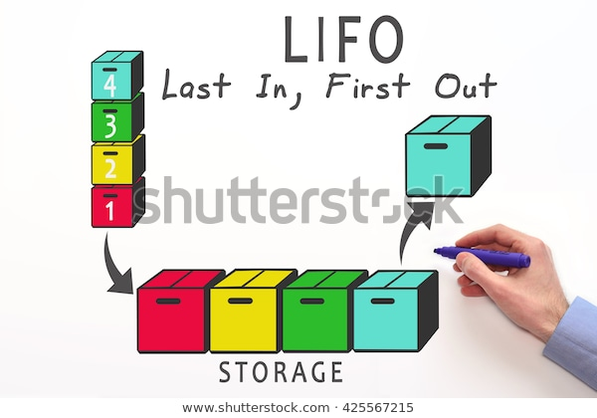
 | Quiz
Assignment
Assessment | This topic is assessed in the end of year assessment.
References | ``

LESSON Plan Week 3
Teacher | Name : Felix  Subject : Accounting

Date
 | INVENTORY SUB SYSTEM
Learning outcomes | - To understand the principles of internal control principal.
Introduction | Inventory is one of the major concerns of a small business. Having what your customers need when they need it matters. Maintaining control of your inventory can be a challenge, however, as even in the most efficient of operations items tend to get lost or stolen. Assets in inventory are an important part of financial reporting as well. Internal controls are essential procedures for managing inventory and accounting for revenue and expenses.
Learners notes | Tracking  The most basic step in inventory control is maintaining a catalog of exactly what a business has and where it is. Most businesses today rely on electronic inventories of some sort, often using bar-codes and RFID tags to keep close track of items. All inventory locations should be numbered and inventory items identified with those numbers. Tracking systems should be in place.  Security  The reason that most businesses keep their inventory in a central location is that this allows them to also keep it secure. Added measures such as locks and security codes can help ensure that only certain trusted personnel have access to inventory. All deliveries from suppliers require a count before they go into inventory so that discrepancies between deliveries and purchase orders are immediately remedied. Periodic counts of small sections of inventory are conducted to pick up any discrepancies.  Review  Its important that a company maintain an up-to-date inventory. If supplies and items are allowed to sit on shelves for too long they will lose value. It is better to sell some items at a loss than allow them to sit any longer in inventory. The storage space that is wasted on out-of-date inventory is a loss in profits for a small business that could instead be using that space for a faster selling product.  Audits  Periodic audits of bills of materials, negative balances in inventory and scrap tracking will offset inventory location errors, misallocation of raw materials, overpurchasing and overstatements of materials in inventory. For example, if materials are taken from one warehouse, but mistakenly recorded as taken from a second, the second warehouse may show a negative inventory balance, triggering automatic overpurchasing, when in fact the materials are still in the second location.
 | 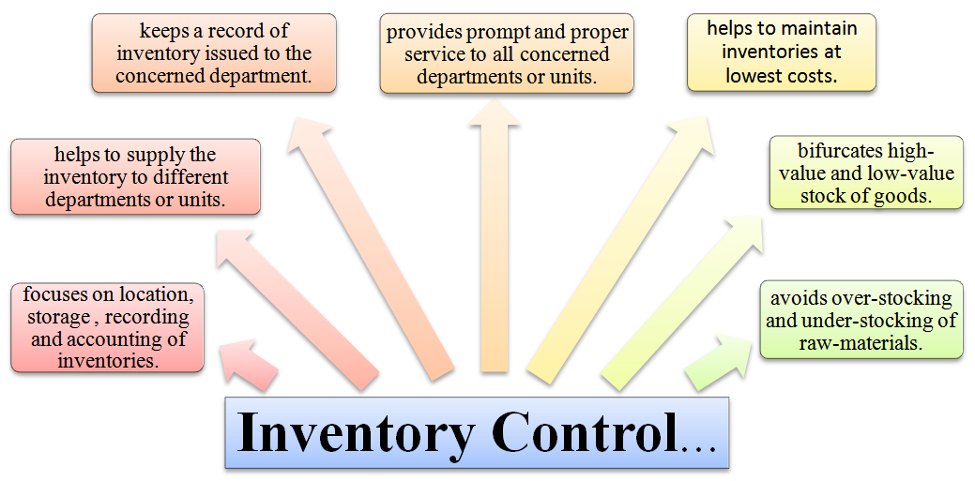
1: State and describe two internal control principal.
- __________________________
________________________________________________________________
________________________________________________________________
- ___________________________
_____________________________________________________________________
_____________________________________________________________________
2: Give three brief reasons why it is important to have strick control over inventories.

- _________________________________
- ________________________________
- _________________________________

Assignment
Assessment | This topic is assessed in the end of year assessment.
References

