Content of learning Outcome for year 11
What is History?
“is knowing about the past to give meaning to the present and hope for the Future”.
“ is an investigation and interpretation of the past”.
Why is History Important?
“if you know your history you’ll know where you’re coming from”
“We cannot know the village where we were going, unless we know the village from where we came.
How do Historians work?
Historians try to understand what happened in the past.....what people did.....why they did it and how their lives changed. They began by looking for sources (Primary and Secondary) and Evidence about the past. They tell the story accurately before they can write. Historians are like Detectives who look for clues that will help them to write a story
- Using Clues( Gathering Clues, example a person’s history)
- Understanding Time( BC –Before Christ, AD –Anno Domini – in the years of Christ)

DEFINITION OF TERMS
Oral traditions – is a form of human communication where knowledge, arts, ideas and cultural material is received or transmitted orally.
Imperialism – Extension of a nation’s power by territorial, acquisition or economic and political dominance of other nation.
Colonialism – A policy of acquiring full political control over another country.
Aristocracy- The Highest class in certain societies typically comprising people of noble birth hereditary titles.
Democracy - Asystem of government by the whole population through elected representatives.
Condominium - The joint control of a states affairs by other states.

National Consciousness- is a shared sense of national identity which a share understanding that a group of people share.
Dual System- is a system combines apprenticeships in a company –government.
Colonial power – powerful nations maintaining control over other countries.
Colony – A country or area under full partial control of another country and occupied by settlers from that country.
Colonial administration- a system of governance used by British and France to control parts of their colonial empire.
Protectorate- Astate that is controlled and protected by another
Century- is a period of 100years
Decade- is the period of 10years.
History testimony – A description by someone of things they witnessed.
Historian –A person who study history
Oral Sources – something that is spoken, such as a speech or a song.
Artefact – A made object.
Eye witness – A person who an event that happened.
Enquiry – An investigation to find answers to questions.
Physical Source – artefacts, such as building, weapos and tools left behind from the past.
Visual Source – something in the form of picture, such as a photograph or a cartoon.
Written source – anything written that may give as information about something.
Evidence – Anything that proves something is true or suggests that it could be true
Clues –A piece of information or an idea that suggests a solution to a problem of an answer.

Activity 1: You have been asked to help an historian in the future. It is the 2050. The historian is trying to find out about life in your school.
In groups, discuss and write a list of five things which could tell an historian in 2050 something about life in you School.

Three periods of History
- Pre –Contact History – The time from the first people in our islands to the arrival of Europeans in 1606.
- Early contact History – The time between the arrival of the Europeans and the Second worls war
- Recent History – things that happened during ours, own, our parents and our grandparents lifetimes. Approximately, the last 50 to 60 years.
Non –Verbal Text – refers to the use of Photograph, pictures, films and cartoons that portrayed a message related to a historical event.
Different sources where historians can obtained information from:
- Written Source
- Oral Source
- Visual Source
- Examining Artefacts
- Historical Site.
Exercise 1:
A): Name the Century in which the following dates occur:
- 350BC
- 75BC
- 350AD
- 1606AD
- 1814AD
- 1939AD
B): Write down any year in each of the following centuries:
- 2nd Century BC
- 18th Century AD
- 6th Century AD
Historians interpret evidence; clues then came up with their judgements, conclusions about what happen in the past. The process is of investigation is called an ‘’ENQUIRY”. An enquiry involves asking and try to find answers, Six questions: What, when, why, where, how, who.
Activity 2: Use the table below to Write five sentance about different sources of evidence
Written source | are | Any artefact left by people in the Past | Example | Raga, Paamese and Ngunese
Oral source |  | Any form of picture |  | Customs stories and songs
Pictorial source |  | Any form of document |  | Maps and photographs
Achaeological sources |  | The different language spoken by people |  | Old ruins, irrigation ditches, old tools and weapons.
Linguistic source |  | What people say about the past |  | Letters, books and newspaper.

Look at the list of sources below. Say whether each one is written, oral, pictorial, archaeological or linguistic
- Documents of the catholic church from 1900 to 1980
- An interview with a plantation worker in santo
- A poster of 1st arts festival on Malekula.
- Shell necklaces found in a burial site on Pentecost
- The words people of North Pentecost and Ambae use for “Dog”
Three tools for studying History
- Evidence
- Clue
- Understanding time
Activity 3: write the Title “understanding time”
Read the paragraph below and fill in the missing words
There are _________________seconds in a minute and ________________minutes in one___________________. There are twenty four____________ in a day and ____________weeks in a year. A year is divided into twelve_____________________.A century is a period of__________years. A decade is _______________years.
Working with Sources
We look at various sources of information to find evidence.
1: Primary Source – sources which come from the actual time of the people and event you are investigating( First hand information) example. Grave, stone axe, talking with old people, Personal daries etc....
2: Secondary Sources – when historians often write about people and events after they have happened. Example: History textbook, newspaper and written source.

Exercise 2: Decide which of the following are Primary or Secondary Sources
- A fish hook made about 2000 years ago?
- Rock painting
- Letters written by a missionary between 1870 and 1924 to a bishop in Paris.
- The stories of an old man about life during the Second World War.
- A lecture on Blackbirding in the South Pacific by Professor Tor at USP.
- A copy of “the Journal of the Pacific History”
- The last Census
- A play about 50 years ago by theatre group.
- The private diary of a plantation owner from 1948 -1979.
- A photograph of Abu John in 1925.
Written Sources
Sources that include newspaper, books, plantation records, private letters, diaries and government report.
Physical sources
Oral Source
Historical sites
Visual Source
Artefacts

Historical Enquiry – This is a situation where Historians enquire or investigate on finding out about a happening. They did investigate by asking this six(6) questions are as follow:
- Why
- Who
- When
- What
- How
- Where
Example:
- What happened?
- When did it happened?
- Why did it happened?
- What did it mean to the people involed?
- How did the social, economic and political situation at the time influence the people and events you are researching?
- What is the significance of the past for the present and future

Other sources of Information
- Questionnaires
- Distance questionnaires
- Face to face Questionnaires
- Interviews
- Observation
- Using Libraries, schools, churches etc...

Traditional Values – refer to the values that we Ni –vans mostly treasure in our everyday life, For example, respect, love, smile, care and so ford.
Sources includes places where events happened as well as artefacts from the past. Example, old type of fan, Reef sandals.
Interviews
Photographs
We have names given to the traditional or island Gods relating to our ancestral custom stories of traditional creations. For example, Tagaro, Majikjiki, Bwatgulgul, and so ford. Therefore, it is believed by our ancestors and prove by archaeologist that we Pacific people originated from Africa ( From Africa –South Asia and into the Pacific). The evidence that proven this pattern of migration was the Lapita Pottery (pattern).

Despite our Pacific way, different Pacific islanders have difference and Similarities between them interm of religion and traditional creations. For example, ethical beliefs. Respect, togetherness, love, caring, smile and collaboration were few of the traditional values of Vanuatu. “Vanuatu “simplymean -Our Land Forever.
In Vanuatu Most of the percentage of land were owned customarily, meaning that they were owned by the indigenous people. Citizens owned land, although they can lease it to foreigners and investors or indigenous owned through the Matrilineal and Patrilineal system. Most of the indigenous see land as a commodity n the ach economy rather than heritage or custom. For example, selling of land to the Foreigners.

Students should have the knowledge on how they ancestors first settled the village they are currently living in and how thy get their names (surname). Also they must be able to address they family members correctly. Meaning that they should have the full knowledge of their history.

The History of Vanuatu

The Early Explorers
Many of the islands of Vanuatu have been inhabited for thousands of years, the oldest archaeological evidence dates back to 2000 BC. Vanuatu is one of the most culturally diverse countries on earth, with a population of approximately 217,750, 113 distinct languages and innumerable dialects. This amazing diversity is a result of 4,000 years of sporadic immigration from many Pacific countries. Although most settlers arrived from Melanesia, the larger built, lighter skinned Polynesians also settled in the islands.
In 1605, the Portuguese explorer Pedro Fernández de Quirós became the first European to reach the islands, believing it to be part of Terra Australis. Europeans began settling the islands in the late 18th century, after British explorer James Cook visited the islands on his second voyage, and gave them the name New Hebrides.
In 1887, the islands began to be administered by a French-British naval commission, with the French and British agreeing to an Anglo-French Condominium on the New Hebrides in 1906.

Missionaries
The first two missionaries set foot in Vanuatu, on Erromango in 1839. An inauspicious beginning, with the death of one of their most famous members (John Williams of the London Missionary Society), prompted the mission societies to proceed cautiously.
For the following nine years, they used converted Polynesian missionaries. Polynesians were regarded as a form of cannon fodder and if they survived, Europeans could safely follow.
In 1845, Samoan teachers landed on Efate, but most had been killed within a few years. The following years saw Catholic, Presbyterian and Anglican missionaries from England, Noumea and France making various short lived (through death) or aborted (rapid retreat) attempts to convert the ni-Vanuatu. However, through perseverance, by the 1860's various denominational mission stations existed throughout the islands.
The effect on the local populations varied. For those who converted to Christianity in one form or another, many died, due to the exposure of an entire range of introduced diseases. By then these included not only measles and dysentery, but smallpox, influenza, pneumonia, scarlet fever, mumps, whooping cough and the simple, but often quite deadly, common cold.
Traditional medicines when combined with a degree of genetic immunity, proved effective against endemic diseases, but had no impact on these new medical conditions. Consequently some considered that the new religion and its God were impotent in the face of disease.
Others took a more pragmatic view; as all illnesses stemmed from sorcery anyway, Christianity must be a particularly malevolent religion to attack its converts in such a violent manner. This attitude resulted in the death of several missionaries following epidemics.
However, the missionaries kept coming and eventually had profound impact on the Melanesian society, by destroying rich cultural heritage centuries old. Catholicism in particular was more readily embraced as Catholic missionaries did not take a dim view of converts merging elements of their own beliefs with Catholicism. In the end, the success of the Catholics had an extraordinary effect on the way the country was to be eventually governed.

World War 2
With the fall of France to Germany in World War 2, the French side of the condominium technically became at war with the other half - Britain.
However in 1940, the French population of the New Hebrides immediately declared their support for General De Gaul's Free French Forces – the first of France's Pacific colonies to do so. This would be on of the only times of the Condominium that the French and British were not at odds with each other.
With France under German rule, the French Ambassador was placed in a difficult position as there was no support structure of a functioning French government. However, these concerns were overshadowed by the fast approaching Japanese forces.
In early 1942, the Japanese reached the nearby Solomon Islands and the New Hebridean's lived in fear that they would be next. The Americans, however, arrived first, totally unannounced, in May 1942 filling Mele Bay with warships.
Due to this unannounced arrival, a large number of the Vila population fled into the hills believing the Japanese had arrived. It took time to convince them otherwise, but the stealthy nature of the American arrival was key in its defensive strategy against the seemingly unbeatable Japanese.
Being at war, the Americans simply took over and built an entire infrastructure to support their introduced military population and the necessary equipment to wage a counter offensive. They brought in tens of thousands of tons of machinery, built barracks and hospitals, a road around the entire island, airstrips and wharves in a desperate attempt to push back the Japanese, leaving France and Britain in shame for all they had not done for the islands.
In Espiritu Santo, 100,000 troops arrived in short order, doubling the population of the country almost overnight.
Throughout the islands, an interesting social phenomenon took place. New Hebrideans were astounded at the equality with which black and white military personnel were treated, so when they went to work for the Americans, they received respect and wages far in excess to anything they had ever experienced before. The typically generous Americans would also look at New Hebridean living conditions and provided clothes and beds, ice boxes and furniture where needed.
The early 1940's were calm years for the native New Hebrideans. Vanuatu was attacked only once by a Japanese plane (that was shot down), resulting in one casualty on Santo - Besse the cow.
Thus they never experienced the horrors of Japanese occupied New Guinea or Solomon Islands. Instead, they saw fair treatment, better living conditions, modern medical aid, economic growth and a vast expansion of facilities, many of which are still in use years later.

End of the War
Three years later, the Americans left as swiftly as they arrived. As the policy that had funded the war effort meant the American economy could not sustain the influx of returning goods, the Americans suggested to the Condominium Government they might like to purchase plant equipment, bulldozers, modern workshop machinery, cranes, trucks and office equipment for a price of only seven cents in the dollar on the real value of the goods.
However, since the Americans were going to leave it behind anyway, the Condominium questioned the need to pay for it. So, the decision was made to bulldoze every movable object into the ocean. This reckless discard contributed to the already proliferating Cargo Cults throughout the islands, and the growing resentment of native New Hebridean's to Condominium rule. There are places around Efate Island where divers can discover much of this discarded war material; the most famous spot being Million Dollar Point in Espiritu Santo.
Perhaps the most well-known remnants of war and one of the most famous dive spots in the world is that of the SS Coolidge.
On February 21 1931, the widow of the 30th President of the United States, Calvin Coolidge, christened the bow of the largest and finest merchant ship ever built by an American shipyard, before it set sail and ended its journey on Santo. The 654 foot, 21,936 ton "President Coolidge" was the one of the last truly opulent vessel s to bebuilt anywhere.
In 1941 the Coolidge went into service with the American Army as a transport ship for reinforcing Pacific garrisons. Once fully converted in 1942 she was able to carry 5,000 troops.
The Coolidge made several South Pacific runs in 1942. In October, she departed San Francisco for New Caledonia and Espiritu Santo laden with the 5,092 officers and troops of the 172nd Regiment, 43rd Infantry division. They were to be much needed reinforcements for the American assault on Guadalcanal.
On the morning of 26th October 1942, the Coolidge approached Espiritu Santo by the Eastern side of the Segond Channel. Due to security, the navy were unable to radio the Captain special instructions on how to enter the channel.
As the ship began to enter the channel, and the failure of a patrol boat to stop her, radio officers had no choice but to break silence and issue a warning, but it came too late.

An explosion struck the aft fire room - an explosion from a mine, one of many scattered in a deadly mine field across the channel. Thirty seconds later a second explosion hit the engine room - the ship was mortally wounded. Captain Nelson ordered the now listing ship to be turned to the shore and run aground. Immediately, abandon ship order issued.
Everyone aboard was told to leave their possessions and equipment, they could return for them later. Men abandoned hard hats, guns and personal equipment as they scrambled to leave the dying vessel.
Many suffered chemical burns as they landed in the oily waters and Santo had few facilities to accommodate such large numbers of injured. However, the ship was fully laden with the supplies need to treat the injured. But the Coolidge would never let her troops return for their possessions. Fifty five minutes after the she was beached, the great vessel gave a shuddering lurch and slid backwards into the oily water, disappearing to her grave at the edge of the Segond Channel.
As she sank, she rolled onto her Port side, taking with her two men who were never found.
The loss of millions of dollars’ worth of equipment and the setback to the war effort were not large in the overall scheme of the War, but it was nevertheless a costly mistake.
Still, such a costly mistake has turned Espiritu Santo into a Mecca for divers worldwide, as the Coolidge is the largest, most intact and accessible wreck of World War 2.
Located only a few kilometres from Luganville, the second largest town in Vanuatu on the island of Espiritu Santo, the wreck lies only a few paces from the relatively calm shore. Divers can reach it by boat or by foot, through one of several dive operations based in Santo.

With visibility normally around 15-25 meters, such a wreck dive offers exceptional underwater clarity. The outer parts of the ship can be safely seen by novice divers. For penetration diving, most areas of interest, allow divers to see outside the vessel at all times. However it is strongly recommended that divers take it easy at first, exploring the outside on the first few dives and making gradual penetrations of the wreck.
Following the war, Condominium authorities were left with a legacy of, from their perspective, overpaid and over ambitious New Hebridean natives. Today, many ni-Vanuatu recall how the authorities came into their homes and took what the Americans had given their fathers. Britain and France were left in tatters at the end of the War. They were left with little enough to rebuild their own nation and thus the New Hebridean economy staggered along under its hopelessly inadequate dual political system. But a spark had been lit and it would not die. By the 1960's it was ready to ignite.

Father of Independence
Land, from the perspective of Ni-Vanuatu before Independence, was not something that could be owned. And therefore it could not be sold. It is held in trust by families, from one generation to the next, as has been the tradition for many since before Christ was born. One might give away, or sell the use of land, but not the land itself.
Europeans, however, took an entirely different viewpoint. By the mid 1960's European settlers claimed ownership of almost 30% of the county's land mass. These settlers had, for the most part, cleared land to grow coconuts - copra being the mainstay of the economy for some time.
But as the price of copra fell, planters began to look at alternatives. With the idea of expanding into cattle production, planters began clearing jungle adjoining their properties. This led to immediate protests in Santo and Malekula from local villagers who objected strongly to yet more of their 'custom' land being pilfered.
The objections grew and natural resentment that started at the end of the war sparked the formation of political parties.
On the one hand were French backed parties such as the supposedly custom-oriented Nagriamel movement. Led by the colourful and charismatic Jimmy Stevens, it claimed to protect Melanesian's claim to traditional lands.

On the other hand, in 1971 when Stevens petitioned the United Nations for early Independence, the Anglican Minister Father Walter Lini formed the Anglophone backed Vanua'aku Party.
As the country became more politicised, the (minority) Anglicans joined the Vanua'aku Party, but the (majority) French fragmentised. Many mixed race and educated Melanesian considered themselves more French than Melanesian and were adamantly opposed to the British declared aim of early Independence.
Some wanted the Condominium to remain, whilst others wanted the British out and France to annex the country entirely. This division, and the added confusion the push for Santo autonomy, set the stage upon which the first general election was held.
After enough wrangling and accusations to fill several books, in November 1979, Lini'sVanua'aku Party emerged victorious. But being the winner did not mean everyone agreed. As Vanuatu is one of the most culturally diverse countries on earth, trying to govern it gave the Condominium more grief than it could have imagined. With virtually no preparation for Independence under the British/French rule, Lini was not going to have an easy time of it.
The French are notoriously possessive about their colonies, but despite their objections, Independence was set for mid-1980. However in May of that year, a few weeks prior to the end of Condominium rule, an insurrection on Tanna split the island in two. One faction supported the new government while the other supported the French.
In Santo, Stevens seized the opportunity to blockade the airport, run the police from their small station and declare Santo independent of Vanuatu, and raised the flag of the independent country of Venerama.
Pandemonium took hold for the next few weeks. France would not agree to British troops intervening and French troops did nothing. Steven's men were armed with only bows and arrows yet they managed to hold Santo to ransom. Lini was given virtually no support from the exiting colonial powers, except verbal sympathy and assurances that all would be taken care of.
With Independence Day fast approaching, Lini was clearly at a political impasse. Officially he could do nothing because Vanuatu was not yet his to govern. However, he asked the neutral Papua New Guinea troops to step into what the world farcically began to call, the ‘Coconut War’.
It was a strange war, of words and diplomatic double talk, bows and arrows and Francophone shrugs. It ended suddenly when Steven's son was shot and killed as he sat in the rear of a utility that ran through a PNG troop roadblock. Following Steven's statement that he had meant no-one to be harmed, he surrendered and was arrested.
Documents also came to light that indicated the French administration had been deceitful; they officially backed Lini as the duly elected representative of the people of Vanuatu, but they had secretly supported the secessionist citizens and Stevens.
On midnight June 1980, the French and British flags were lowered for the last time, amidst tears and brave salutes and the flag of the Republic of Vanuatu was raised in celebration at the birth of a new nation. The vast majority of French nationals left Vanuatu and land ownership reverted entirely to the indigenous ni-Vanuatu with leases of land set at 60 years.

Chief Roimata - Ancient King of Vanuatu

In July 2008, Chief Roi Mata’s Domain was formally registered as a World Heritage site – the first in Vanuatu. At just half an hour’s drive north of Port Vila, the site features a string of perfect beaches, a breathtaking harbour, spectacular views of the hat-shaped island of Artok and so much more.
Throughout the middle and southern islands of Vanuatu there existed the story of a great and powerful chief, who united the warring and cannibalistic tribes of the area into a unified, and peaceful group of tribes, a first in ancient Vanuatu.
In a cultures where language is unwritten, oral traditions are faithfully passed down from generation to generation. The accuracy of such history is frequently disputed by Western cultures, for what is heard can be changed in the retelling. And in any case, how does one separate fact from legend?
As the story goes, a paramount chief beyond paramount chiefs, Chief Roi Mata took on the title of King. Through sheer personal magnetism, Roymata, managed to unite the warring and cannibalistic tribes of the area into a unified, peaceful group in what are fondly 'remembered' as halcyon years.
But sibling jealousy ended the life of this much revered man, when his brother shot a poison dart into his throat. He did not die quickly, but suffered a lingering malaise.
His grieving family and clan carried the dying King around the island of Efate, to say farewell to those whom he had unified.
Finally, he was taken to the famous Feles Cave on Lelepa Island where he died. It is then told how he was carried to Devil's Point, the entry to the underworld, and through the underwater caverns of Tukutuku to the nearby Island or Retoka (Hat Island) where he was interred. And, say the legends, following the custom of the era, men and women were interred with him. But perhaps most spine chilling was that many of these people were entombed alive.
How true could the legend be? One version tells of how the waters between Tukutuku and Retoka Island parted to allow the funeral party across. Certainly that could not be fact.
As to the caverns of Tukutuku, they are very real. Lava tunnels and coral encrusted lava flows create an underwater labyrinth that could easily be thought to lead to a mythical underworld. But the caves have been explored extensively by scuba divers and do not lead to Retoka Island.
But how long ago did this happen? By matrilineal decent, the people of Tongoa (who retain an extensive oral history going back to their first settlement in Vanuatu over 5,000 years ago) narrowed it down to 1265 A.D. Following the interment, a seven hundred year-long tabu, on pain of death had been placed on Retoka. As such, no-one lived there and few plucked up the courage to sleep, or even go there, despite its wealth of turtle eggs and abundant fish life. Retoka became known as the Island of the Dead and a ghost island.
In 1967 a French archaeologist, Jose Garanger, offered to search for the grave of Roymata to determine if he was a real, or mythological figure. The chiefs of Lelepa, equally curious, gave their go-ahead on condition that the grave be returned to its original state after investigation.
Once on Retoka, the site was surprisingly easy to find. Two rock slabs, like tombstones, at the base of a large white wood tree were located in a natural 'clearing' only 100m from the beach, on the North West side of the small island. Oral tradition stated that no tree or bush would ever grow over the site of Roymata's grave.
In an area 20m x 10m, the archaeological team dug down a metre; carefully uncovering skeletons as they went. According to oral history, they were to discover 47 skeletons. As bones were uncovered it quickly became evident that a mass burial had taken place.
Finally, with the entire grave site exposed, the evidence was carefully documented, photographed and reburied intact, complete with rich adornments. Forty seven skeletons were unearthed with radio-carbon dating placing their time of death between 1250 and 1300 AD.
These facts verified the oral histories was true. And from such history was revealed what the discoveries at the site really meant. Hundreds of mourners had accompanied Roymata to his final resting place and forty six were never to leave.
Traditionally, when a prominent Chief died, he required the company of his family and supporters to join him in his journey to the subterranean netherworld. At least one of his wives must go - Roymata was reputed to have had ten.
Those also to accompany Roymata were the very old, incurably sick or incapacitated, children whose mothers had died in childbirth, lesser chief's wives where a daughter had died, sick witch doctors and wives of dead sorcerer's.
Practically, this was a general clearing out of economically unproductive people, and those who may have caused the deaths of others. For the men, being buried alive followed the ritual kava ceremony where the kava would have been laced with a soporific poison. But women were not allowed to drink kava, so they were either buried alive or strangled with a cord, then laid out beside their husband. All were orientated towards the southwest, so their spirits entered the dry 'country of the dead' out from Devil's Point. Those buried closest to Roymata were richly adorned with bracelets, shells and carved bones.
These were most likely immediate family or honoured volunteers. Roymata's arms were ringed with valuable full circle pig's tusks, and white 'magic' shells placed strategically around his body. His head was supported on a slab of dressed limestone. Many skulls appear elongated, following the fashion of some northern islands to stretch the skull by biding after birth.
Retoka Island is now no longer tabu. The customary owners of the island offer tours to explore the island and Roymata's grave.

Map of first people into the Pacific

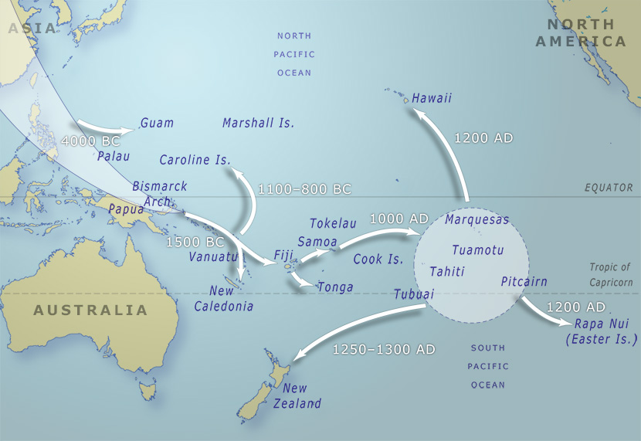

The first people to settled the islands of Vanuatu/Pacific were the Lapita people. This was proven by archaeologist along with the remains of Lapita found in certain parts of Vanuatu with similar decoration patterns. For example, Teouma.
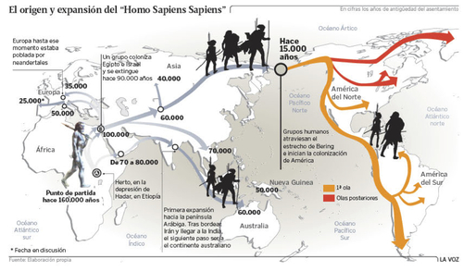

Difference between Religion and Tradition

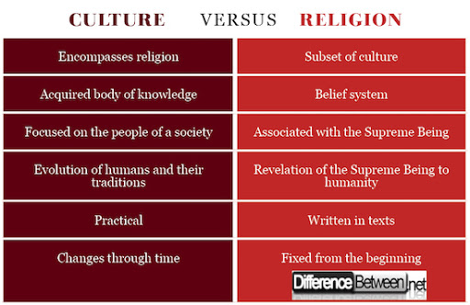

Land system in Vanuatu

Land in Vanuatu falls into two main categories: (1) custom land owned by its indigenous custom owners(70%); and (2) public land vested in the Government (30%). All urban land is public land; all rural land is custom land.
Leased land.
Matrilineal and Patrilineal society. This system allows properties, titles, names and land to passed from one generation to another following both sides, the father’s and mother’s side.

Therefore, they are two(2) farming system in Vanuatu:
- The subsistence sector accounts for 75 per cent of agricultural production and is predominantly centred on root crops such as taro, yam, cassava and sweet potato. Bananas, breadfruit and leafy
vegetables are also grown. Many households also raise small livestock such as chickens, especially in rural areas.
- Commercial. There are four main cash crops in Vanuatu: Cocoa, kava, coffee and coconut. Pepper and Vanilla are also grown for cash crops.
Education System
The education system consists of 6 years of primary school education (Years 1-6), 4 years of junior secondary education (years 7-10) and 3 years of senior secondary school (Years 11-13). Progression though the system is determined by national "gated" examinations at Years 6, 10, 12 and 13.
The British and French jointly governed Vanuatu before it achieved independence in 1980. This dual governance created diverse educational systems that utilize both English and French languages; however, Bislama (the native language) is practiced in some primary schools.
The Ministry of Education administers the formal system of education, which consists of six years of primary education, four years of junior secondary education, and three years of senior secondary education. Only the first six years are compulsory, leading to an adult literacy rate of 64 percent (1995). Government expenditures on public and private education were 19.2 percent of the annual budget and 4.4 percent of the gross national product in 1990.
Students from grades one to seven attend primary school. In 1990, some 26,267 (96 percent) children in this grade range were enrolled in the 78 primary schools. The ratio of female to male teachers in primary school was 2:3. Junior secondary school includes students from grade 8 to 10 and senior secondary school includes grade 11 to 13. Only 20 to 25 percent of students graduating from primary school continue to junior secondary education. In 1990, some 3,799 (17 percent) of students in this age group were enrolled in one of the 14 secondary schools. Female to male teacher ratios were 3:7 in 1990.
A Pacific Senior Secondary Certificate will be introduced to senior secondary students (for both English-speaking and French-speaking) at grade 12. After passing the examination, students complete the last year of foundation studies before admission to the University of the South Pacific. Tertiary (higher) education requires students to go overseas as there is no university in Vanuatu.

Difference between formal and Informal Education
Formal education is classroom-based, provided by trained teachers. Informal education happens outside the classroom, in after-school programs, community-based organizations, museums, libraries, or at home.
“Formal” education results in some kind of certification, for example a diploma or other validation of competency in some subject area. Non-formal education is what we do every day and is the greatest share of most person’s learning experience. For example, you learn from reading blogs like Quora, the newspaper, talking to others etc. The difference is that no one or no institution “certifies” what you have learned.

Map of the Shepherds Group
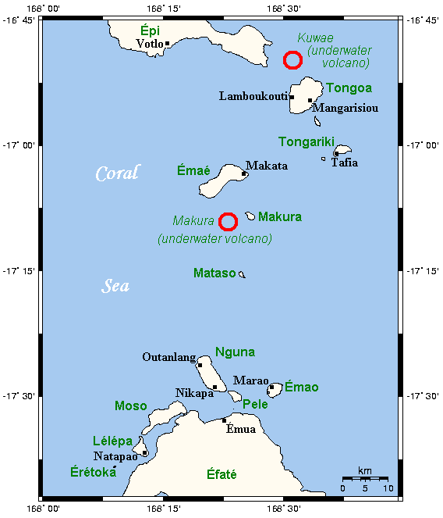
The Shepherd Islands (coordinates 16.8°S 168.5°ECoordinates: 16.8°S 168.5°E) are a group of islands lying between the larger islands of Epi and Éfaté, in the Shefa province of Vanuatu.^{[1]} The aggregate land area is 88 square kilometres (34 square miles). They were named by Captain Cook after Anthony Shepherd, a British astronomer and friend of Cook.
From north to south, the principal islands are: Laika, Tongoa (Kuwaé), Buninga (Mbining), Ewose, Falea, Tongariki (Atong), Émaé (Mai), Makura (Emwae), Mataso (Matah), and Monument (Étarik). Émaé and Tongoa are the largest islands in the group.^{[2]}
The region includes two submarine volcanoes, Kuwae and Makura. The islands are principally in the outlines of the calderas of these volcanoes. The highest of the islands is Émaé, at 644 metres (2,113 feet) above sea level,Tongariki is also above 500 metres (1,640 feet).

Population and languages
At the 2009 census the population numbered 3634. The Shepherd Islands are quite densely populated. There is little economic activity although fishing is very good. Many people move to Port Vila to find work.^{[3]}
Most of the islands are inhabited by Melanesians like most of Vanuatu, but Émaé and Makura are Polynesian outliers. Other than Emae, on which is spoken a Futunic language, there are, according to Ethnologue, two languages spoken on the other islands: North Éfaté, spoken on Tongoa; and Namakura, spoken on Mataso, Makura, Tongoa, and Tongariki. These are all also spoken on the island of Éfaté, and are closely related to one another and the other languages of Éfaté and central Vanuatu in the language group Central Vanuatu languages.

Cultural groupings in the Pacific
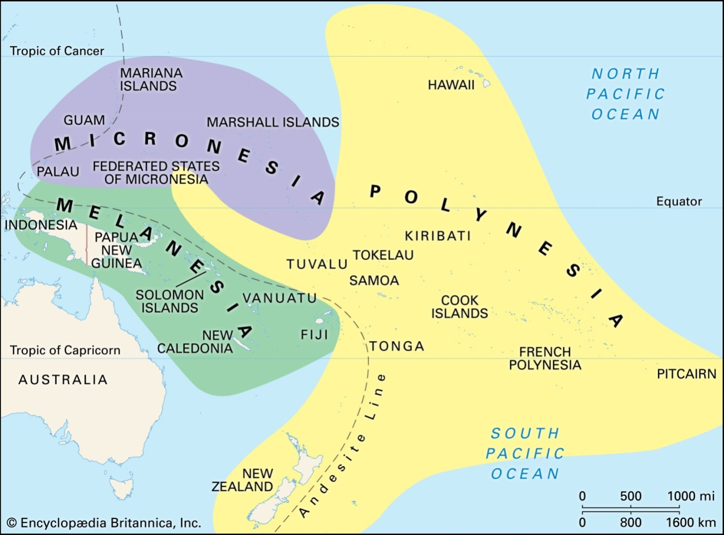

Pacific Leadership – big men and chiefs
Big Man
• Personal power • Status gained through the demonstration of skills (e.g. magic, oratory, bravery) • Status gained and maintained via generosity in the distribution of wealth • Influence over fluctuating factions
Chief
Power resides in the position, not the person • Authority over permanent groups • Status inherited, not achieved • Authority to call upon the support of others without inducement
Micronesia –Based on Raw Materials/Resources
Polynesia - Polynesia is characterized by rank consciousness and large-scale political units organized around hierarchical power structures. In Tonga and Samoa, traditional leadership has been incorporated into the centralized state to a greater degree than elsewhere in the Pacific.

World War 1(1900 -1914)
World war 1 began in 1914 and ended in 1918. It lasted for 4years. The causes towards the outbreak of this Great War are as follow:
- Imperialism/Colonialism
- Militarism
- Nationalism
- Arm Race
- Personalities

Allied powers vs Axis/central powers
- Britain 1. Germany
- France 2. Austria- Hungary
- Russia 3.

Sketch map of World War 1
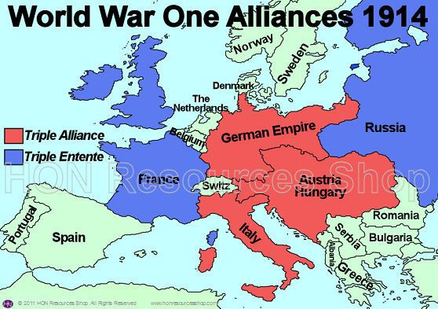
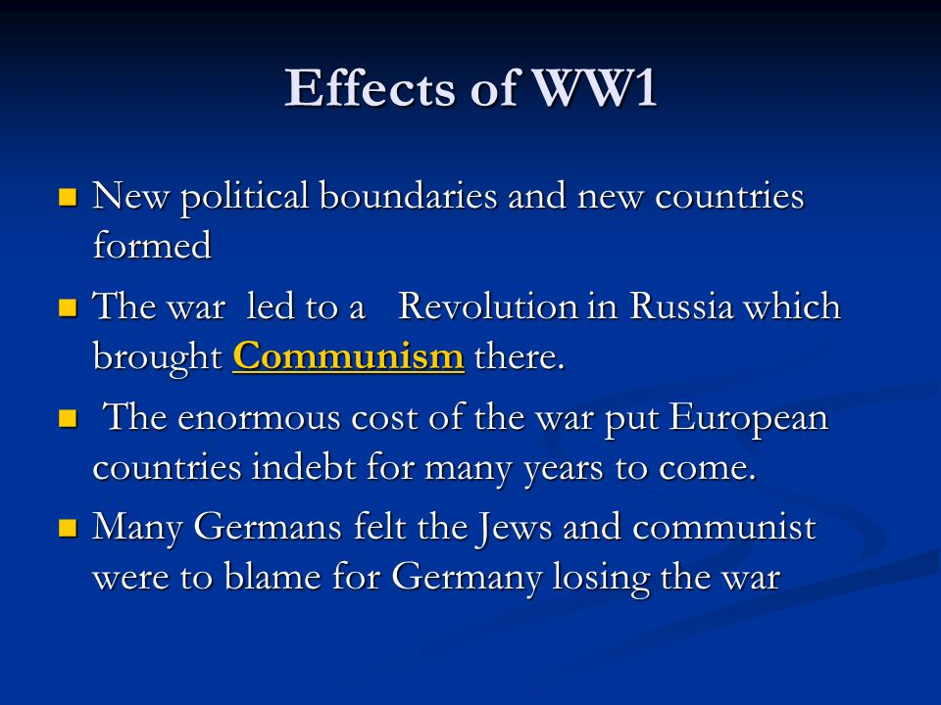

Causes towards the outbreak of WWII are:
- 1931, Manchuria Crisis
- 1935, Abyssinian Crisis
- 1936 -39 Spanish war
- 1936, Reoccupation of Rhineland
- 1938, Czechoslovakia
- 1939, invasion of Poland
- 1940 The fall of France, the battle of Britain, operation barbarrossa
- 1941, USA involvement in the war

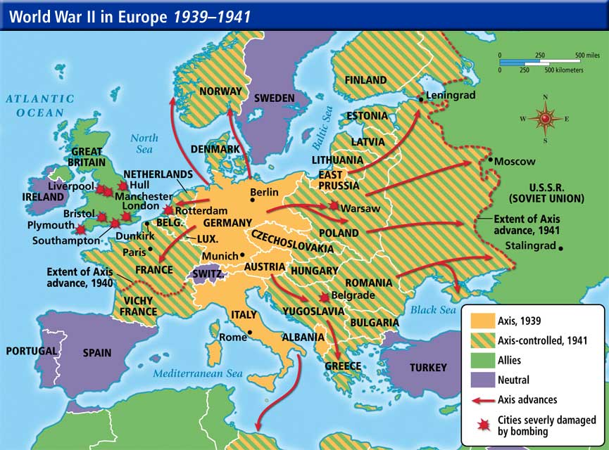
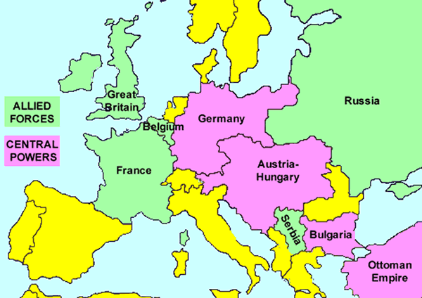

Effects of WWII on the Pacific islanders.
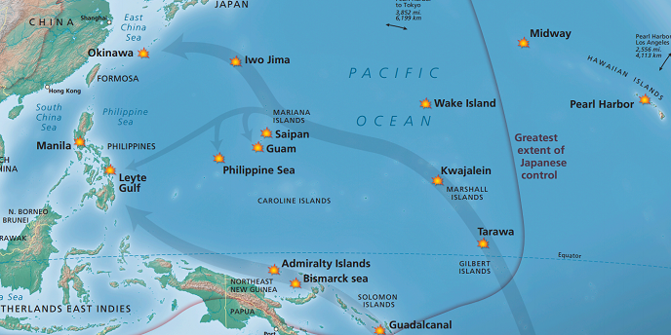
When war broke out the Japanese Imperial forces moved rapidly down the western rim of the Pacific. Within months the islands of New Guinea, New Britain, Bougainville and parts of the British Solomon Islands were engulfed in war.
To make way for battlegrounds and Japanese and Allied bases, villages, farms and sometimes entire island populations were relocated. The population of Mavea in Vanuatu, for example, was moved by the Allies to make space for target practice.
The labour needs of war were immense and untold thousands of Pacific Islanders were enlisted as labourers. In New Guinea alone, August Kituai estimated that the labour of at least 40,000 men and women supported the war effort.

At the cenotaph on Palau’s Peleliu Island, Japan’s Emperor Akihito and Empress Michiko bow towards the battleground of Angaur Island. Reuters/Kyodo
As workers, Pacific Islanders were also relocated. Palauan workers were shipped to Rabaul, Nauruans to Truk and Kiribati, and Pohnpeians were sent to Kosrae Island. They worked as general labourers, but also as armed scouts, coastwatchers and soldiers in island regiments beside Allied and Japanese troops.
By 1942 the Allies had halted the Japanese advance southwards with intense air and land battles on the island of Guadalcanal in the Solomon Islands. As an indicator of scale, within six months the Japanese and Allied dead outnumbered the entire indigenous population of 15,000 by two to one.
For coastal villagers on and around Guadalcanal, their sea was turned toxic as the dead, and the detritus of oil and debris from naval and airborne warfare, washed up on their beaches.
During 1943, the Allies island-hopped north in an attempt to sever the supply lines to Japanese bases in the islands. The intent was to starve the Japanese into retreat. As their supplies dried up in New Guinea and Bougainville, and on Kosrae, Guam and Palau, tens of thousands of Japanese servicemen leaned on indigenous locals for sustenance.
With farms unable to keep up, everyone was plunged into prolonged famine. On Kosrae, labourers from Kiribati survived on potato leaves. On Bougainville, soldiers recorded eating grass and tree sprouts to survive. Reporting from an Allied camp on Bougainville on May 25, 1945, the Ellesmere Guardian noted a constant stream of “emaciated natives” who were “mere skeletons” emerging from the jungles in search of sanctuary.
The Allies eventually “liberated” Japanese-occupied islands in Micronesia with a brutal twin campaign of severing supplies and conducting indiscriminate bombing raids. With nowhere to evacuate, Indigenous peoples were repeatedly bombed, strafed and starved alongside the Japanese.
On many islands, including Chuuk, Pohnpei and Palau, these strafing raids left the landscape utterly denuded. Elsewhere in the Solomons, New Guinea and Bougainville, villages and farms along entire fertile strips of land were left ruined and deserted as the war ended.
It is probably not possible to enumerate the full impact of the war on the Pacific. In New Guinea alone, Douglas Oliver has suggested that at least 15,000 civilians perished in the crossfire.
Air and maritime bombardment also left tens of thousands of people displaced, missing and unaccounted for. The New York Times reported on September 2, 1944, that 60,000 were still missing in the southern mountain areas of Bougainville, as were thousands on Guam and the former Japanese mandates. These are rubbery figures, but they hint at the scale of devastation of a war not of Islanders’ making. For example in the Solomon Islands where they perform the same task as military forces do.
How World War did came into the Pacific
However, it is more widely accepted that the Pacific War itself began on 7/8 December 1941, when the Japanese invaded Thailand and attacked the British colonies of Malaya, Singapore, and Hong Kong as well as the United States military and naval bases in Hawaii, Wake Island, Guam, and the Philippines.
The turning point in the Pacific war came with the American naval victory in the Battle of Midway in June 1942. The Japanese fleet sustained heavy losses and was turned back. In August 1942, American forces attacked the Japanese in the Solomon Islands, forcing a costly withdrawal of Japanese forces from the island of Guadalcanal in February 1943. Allied forces slowly gained naval and air supremacy in the Pacific, and moved methodically from island to island, conquering them and often sustaining significant casualties. The Japanese, however, successfully defended their positions on the Chinese mainland until 1945.
In October 1944, American forces began retaking the Philippines from Japanese troops, who surrendered in August 1945. That same year, the United States Army Air Forces launched a strategic bombing campaign against Japan. British forces recaptured Burma. In early 1945, American forces suffered heavy losses during the invasions of Iwo Jima (February) and Okinawa (April), an island of strategic importance off the coast of the Japanese home islands. Despite these casualties and suicidal Japanese air attacks, known as Kamikaze attacks, American forces conquered Okinawa in mid-June 1945.

Atomic Bomb
On August 6, 1945, the United States Army Air Force dropped an atomic bomb on the Japanese city of Hiroshima. Tens of thousands of people died in the initial explosion, and many more died later from radiation exposure. Three days later, the United States dropped a bomb on the Japanese city of Nagasaki. Estimates vary, but at least 120,000 civilians died as a result of the two blasts. On August 8, the Soviet Union declared war on Japan and invaded Japanese-occupied Manchuria.
After Japan agreed to surrender on August 14, 1945, American forces began to occupy Japan. Japan formally surrendered to the United States, Great Britain, and the Soviet Union on September 2, 1945.
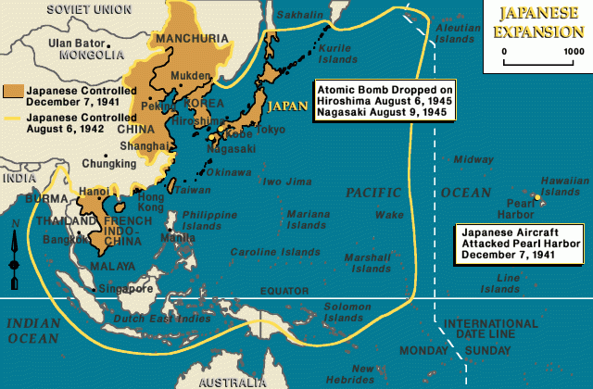
Examples of countries under Condominium/cooperative Ruling are:
- New Hebrides (1906 -1980) British and France.
- Samoan Island( 1889 -1899) German and America/United States/Great Britain
- Austria –Hungary –Ottoman Empire

Importance of UNDHR

Universal Declaration of Human Rights:

The UDHR provides “a common standard of achievement for all peoples and all nations.” Every “individual and every organ of society” shall promote “respect for these rights and freedoms … by progressive measures ...” The goal was “to secure their universal and effective recognition and observance.

#1: Human rights ensure people have basic needs met
Everyone needs access to medicine, food and water, clothes, and shelter. By including these in a person’s basic human rights, everyone has a baseline level of dignity. Unfortunately, there are still millions of people out there who don’t have these necessities, but saying it’s matter of human rights allows activists and others to work towards getting those for everyone.
#2: Human rights protect vulnerable groups from abuse
The Declaration of Human Rights was created largely because of the Holocaust and the horrors of WII. During that time in history, the most vulnerable in society were targeted along with the Jewish population, including those with disabilities and LGBT. Organizations concerned with human rights focus on members of society most vulnerable to abuse from the powers that be, instead of ignoring them.
#3: Human rights allow people to stand up to societal corruption
The concept of human rights allows people to speak up when they experience abuse and corruption. This is why specific rights like the right to assemble are so crucial because no society is perfect. The concept of human rights empowers people and tells them that they deserve dignity from society, whether it’s the government or their work environment. When they don’t receive it, they can stand up.
#4: Human rights encourage freedom of speech and expression
While similar to what you just read above, being able to speak freely without fear of brutal reprisal is more expansive. It encompasses ideas and forms of expression that not everybody will like or agree with, but no one should ever feel like they are going to be in danger from their government because of what they think. It goes both ways, too, and protects people who want to debate or argue with certain ideas expressed in their society.
#5: Human rights give people the freedom to practice their religion (or not practice any)
Religious violence and oppression occur over and over again all across history, from the Crusades to the Holocaust to modern terrorism in the name of religion. Human rights acknowledges the importance of a person’s religion and spiritual beliefs, and lets them practice in peace. The freedom to not hold to a religion is also a human right.
#6: Human rights allows people to love who they choose
The importance of freedom to love cannot be understated. Being able to choose what one’s romantic life looks like is an essential human right. The consequences of not protecting this right are clear when you look at countries where LGBT people are oppressed and abused, or where women are forced into marriages they don’t want.
#7: Human rights encourage equal work opportunities
The right to work and make a living allows people to flourish in their society. Without acknowledging that the work environment can be biased or downright oppressive, people find themselves enduring abuse or insufficient opportunities. The concept of human rights provides a guide for how workers should be treated and encourages equality.
#8: Human rights give people access to education
Education is important for so many reasons and is crucial for societies where poverty is common. Organizations and governments concerned with human rights provide access to schooling, supplies, and more in order to halt the cycle of poverty. Seeing education as a right means everyone can get access, not just the elite.
#9: Human rights protect the environment
The marriage between human rights and environmentalism is becoming stronger due to climate change and the effects it has on people. We live in the world, we need the land, so it makes sense that what happens to the environment impacts humanity. The right to clean air, clean soil, and clean water are all as important as the other rights included in this list.
#10: Human rights provide a universal standard that holds governments accountable
When the UDHR was released, it had a two-fold purpose: provide a guideline for the future and force the world to acknowledge that during WWII, human rights had been violated on a massive scale. With a standard for what is a human right, governments can be held accountable for their actions. There’s power in naming an injustice and pointing to a precedent, which makes the UDHR and other human right documents so important.
UN role in UDHR
The United Nations (UN) is an international organisation whose stated aims are to facilitate cooperation in international law, international security, economic development, social progress and human rights issues.United nation replaced the league of nation at the Yalta conference in 1945.
Its role is to prevent human rights violations and secure respect for human rights by promoting international cooperation and coordinating the United Nations' human rights activities. ... It also works directly in areas where there are severe human rights violations though field offices and as part of UN peace missions.
Indigenous Movement/response to colonial ruling
There are few indigenous movements that occurred in the Pacific in response to colonial ruling, example, the Mau movement in samoa, Nagriamel/John Frum movement in New Hebrides, riots in West Papua/Solomon recently and so ford.

Examples of Colonialism and Imperialism
- Great Britain controlled over Fiji
- Germany over western Samoa
- Britain/France over Vanuatu
- France over New Caledonia
- USA over Hawaii
The two(2) main reason why European came into the Pacific was in search for Raw Material and to spread civilization.

