Central School
Home School Package

Year 11 : Biology

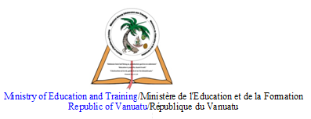

LESSON Plan

Date | Term 2 Week 8  Thursday – 9th July, 2020
Strand 3 : Organism Level Biology
Sub-strand 3.3 : Animal Digestion
Lesson number : 9

Learning outcomes | - Differentiate between the digestive system of the sea anemone, earthworm and humans. (BIO3.3.3.3 - Skill Level 3)  - Discuss how the digestive systems of the sea anemone, earthworm and humans help each organism to survive, using examples. (BIO3.3.4.1 - Skill Level 4)
Learners notes | Sea anemone digestive system  - Sea anemone have a very simple sac-like digestive system.  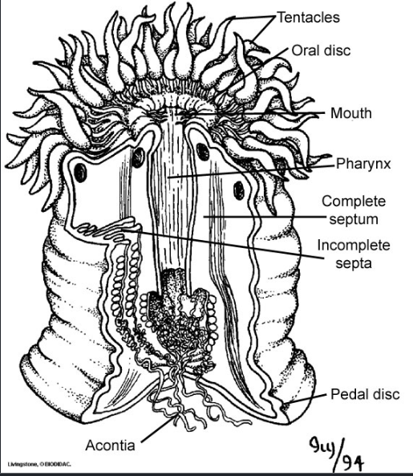  (digestive system of a sea anemone)  - Food captured by the sea anemone’s tentacles passes through the mouth into the gut cavity.  - Enzymes are secreted which begin digestion.  - Digestion is completed within the cells lining the gut cavity.  - Undigested food passes through the mouth.  Earthworm  - The digestive system is partitioned into many regions, each with a certain function.  - The digestive system consists of the pharynx, the esophagus, the crop, the intestine and the gizzard.  - Food such as soil enters the earthworm’s mouth where it is swallowed by the pharynx.  - The soil passes through the esophagus, which has calciferous glands that release calcium carbonate to rid the earthworm’s body of excess calcium.  - After it passes through the esophagus, the food moves into the crop where it is stored and then eventually moves into the gizzard.  - The gizzard uses stones that the earthworm eats to grind the food completely.  - The food moves into the intestines as gland cells in the intestine release fluids to aid in the digestive process.  - The intestinal wall contains blood vessels where the digested food is absorbed and transported to the rest of the body.  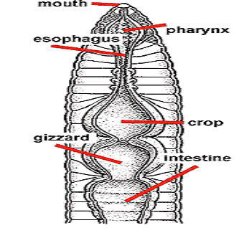  (earthworm digestive system)
https://www.youtube.com/watch?v=Ao-CFFHqb5I

https://www.youtube.com/watch?v=K8rAvIf5GZQ

https://www.youtube.com/watch?v=qtCRI2UYiGo

https://www.youtube.com/watch?v=X3TAROotFfM&t=99s

ACTIVITY

1. Explain the differences between the digestive systems of the sea anemone, earthworm, and humans.
__________________________________________________________________
__________________________________________________________________
__________________________________________________________________
__________________________________________________________________
__________________________________________________________________
__________________________________________________________________
__________________________________________________________________
__________________________________________________________________
__________________________________________________________________
__________________________________________________________________
__________________________________________________________________
2. Discuss how the digestive system of the sea anemone, earthworm and humans help each organism to survive, using examples.
__________________________________________________________________
__________________________________________________________________
__________________________________________________________________
__________________________________________________________________
__________________________________________________________________
__________________________________________________________________
__________________________________________________________________
__________________________________________________________________
__________________________________________________________________
__________________________________________________________________
__________________________________________________________________
__________________________________________________________________
__________________________________________________________________
__________________________________________________________________
__________________________________________________________________
__________________________________________________________________
__________________________________________________________________
__________________________________________________________________
__________________________________________________________________
__________________________________________________________________
__________________________________________________________________
__________________________________________________________________
__________________________________________________________________
__________________________________________________________________
__________________________________________________________________
__________________________________________________________________
__________________________________________________________________
__________________________________________________________________
__________________________________________________________________
__________________________________________________________________
__________________________________________________________________
__________________________________________________________________
__________________________________________________________________
__________________________________________________________________
__________________________________________________________________
__________________________________________________________________
__________________________________________________________________
__________________________________________________________________
__________________________________________________________________
__________________________________________________________________

References | Bunn, T. & Roberts, A. (2008). NCEA Level 2 Biology. New Zealand : ESA Publications, p.167  https://myclassification.weebly.com/sea-anemone.html  https://www.sas.upenn.edu/~rlenet/Earthworms.html

