Central School
Home School Package

Year 11 : Biology

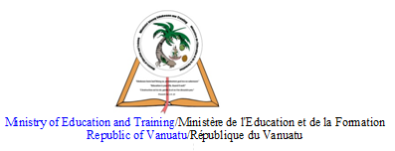

LESSON Plan

Date | Term 2 Week 7  Tuesday – 30th June, 2020
Strand 3 : Organism Level Biology
Sub-strand 3.3 : Animal Digestion
Lesson number : 2

Learning outcomes | - Define digestion. (BIO3.3.1.2 - Skill Level 1)  - Describe the process of digestion. (BIO3.3.2.2 - Skill Level 2)
Learners notes | Digestion  - Digestion involves the chemical breakdown of the chemicals (carbohydrates, proteins, fats, vitamins, minerals, water) that makeup food into small, soluble molecules that can pass through cell membranes into the transport system.  - Examples :  - Carbohydrates (including starches) are digested to become the sugar, glucose.  - Proteins are digested to become amino acids.  - Fats (lipids and oils) are digested to become fatty acids and glycerol.  - Vitamins, minerals, and water do not need breaking down.  - Digestion is a complex series of chemical reactions carried out by enzymes secreted into the stomach and/or small intestine by glands lining the digestive system.  - The enzymes act as catalyst to speed up the breakdown of carbohydrates, proteins, and fats.  Omnivore system  - Example of omnivores digestive system : humans  - The tongue mixes saliva with food and rolls the food into a ball that can be swallowed. The salivary glands produce water and mucus to lubricate the passage of food, and the enzyme amylase to break down starch.  - Food passes down the oesophagus by muscular action (swallowing) and by gravity. Movement of food throughout the rest of the gut system is by regular muscle movements called peristalsis.  - The stomach stores and mixes food with gastric juices.  - Hydrochloric acid is secreted to enable pepsin to work, to kill any bacteria or harmful micro-organisms in the food, and chemically breaks down food into a soup called chyme.  - The enzyme pepsin in the juices begins the breakdown of protein.  - Food takes about 3 – 4 hours to completely leave the stomach after a meal, a process which is regulated by pyloric sphincter, a valve which frequently opens as pressure from the chyme increases.  - The stomach slowly released food into the first part of the small intestine, the duodenum. This means the small intestine works on a small but continuous supply of chyme from the stomach.  - In the duodenum, digestive juices from the pancreas are mixed with the food. The juices contain enzymes that digest carbohydrates, proteins, and fats : amylase digests starch, lipase digest fats, trypsin continues the digestion of protein.  - Bile from the liver also mixes with food in the duodenum.  - Bile which stored in the gall bladder, is basic, so it neutralises stomach acid.  - Bile also acts to emulsify fats, breaking fats up to increase their surface area to enable fast action of the enzyme, lipase.  - More enzymes from the duodenum are added to complete the digestive process, so producing a mixture of glucose, amino acids, fatty acids, and glycerol.  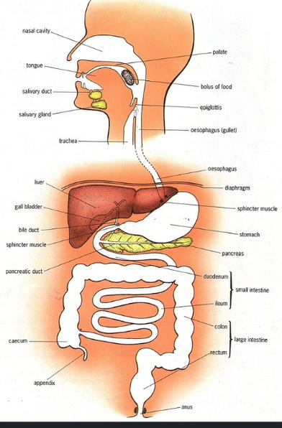  (Human alimentary canal)  Carnivore system  - Example of carnivore digestive system : dogs and cats  - Small and large intestines of carnivores are shorter than humans. Therefore, animal tissues eaten by carnivores require little digestion before absorption  - Dogs gulp food because their jaws cannot move sideways for effective chewing, unlike the jaws of humans and cows.  - Carnivores eat meat which is rich in protein, fat and bones with few carbohydrates. Carnivores do not have amylase in their saliva.  - The stomach has large amounts of hydrochloric acid which is essential for killing harmful bacteria consumed along with food.  - Hydrochloric acid is also for digestion of bones, protein, and fat.  - The stomach juices contain the enzymes pepsin which digests protein and enzyme lipase which digests fat.  - Food spends more time in the carnivore stomach than it does in the human stomach.  - Food spends far less time in the small intestine, where absorption of amino acids, fatty acids, glycerol is the main process.  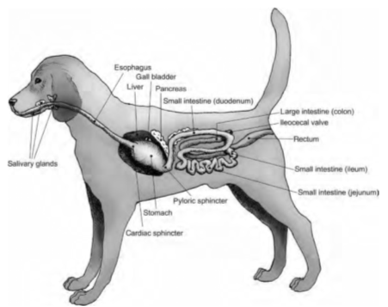  (Digestive system of dog)  Herbivore system  - Because plant tissue requires complex digestion before it can be assimilated, herbivores have a very long digestive system compared with carnivores.  - Foregut herbivores such as cattle and sheep are ruminants and have a complex stomach to house the mutualistic bacteria that digest cellulose in plant tissue.  - The stomach in cattle is a huge, four-chambered structure taking up to 75% of the gut cavity and is up to 200L in volume.  - Digestion in cattle begins in the stomach.  - Grass is partially digested by bacteria and other micro-organisms in the rumen and reticulum. These organisms break down the cellulose of the plant cell walls, releasing the nutrients from the cells to the cattle.  - The mix of the grass and bacteria regurgitated (brought up again) to the mouth from the reticulum for further chewing to assist in breakdown (chewing the cud).  - The cud passes back down the oesophagus again but bypasses the rumen and reticulum to enter the compartments of the ‘true’ stomach, which contain acid and protein-digesting enzymes (as for humans).  - Food then moves into the small intestine.  - Further fermentation by bacteria can occur in the caecum.  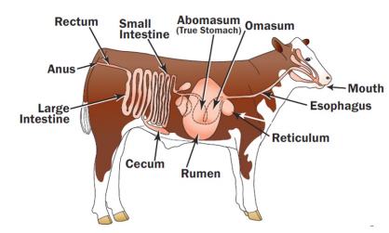  (Digestive system of cattle)
https://www.youtube.com/watch?v=X3TAROotFfM

https://www.youtube.com/watch?v=Og5xAdC8EUI

https://www.youtube.com/watch?v=v7PoFLV6T-Q

https://www.youtube.com/watch?v=URrXh0LJ6JE

https://www.youtube.com/watch?v=RGpwF_X2KAg

https://www.youtube.com/watch?v=VLK2wANjQm0

ACTIVITY
1. Define digestion.
__________________________________________________________________
__________________________________________________________________
2. Describe the process of digestion in humans.
__________________________________________________________________
__________________________________________________________________
__________________________________________________________________
__________________________________________________________________
__________________________________________________________________
__________________________________________________________________
__________________________________________________________________
__________________________________________________________________
__________________________________________________________________
__________________________________________________________________
__________________________________________________________________
__________________________________________________________________
__________________________________________________________________
__________________________________________________________________
3. Describe the process of digestion in carnivores.
__________________________________________________________________
__________________________________________________________________
__________________________________________________________________
__________________________________________________________________
__________________________________________________________________
__________________________________________________________________
__________________________________________________________________
__________________________________________________________________
__________________________________________________________________
__________________________________________________________________
__________________________________________________________________
__________________________________________________________________
__________________________________________________________________
__________________________________________________________________
4. Describe the process of digestion in herbivores.
__________________________________________________________________
__________________________________________________________________
__________________________________________________________________
__________________________________________________________________
__________________________________________________________________
__________________________________________________________________
__________________________________________________________________
__________________________________________________________________
__________________________________________________________________
__________________________________________________________________
__________________________________________________________________
__________________________________________________________________
__________________________________________________________________
__________________________________________________________________

References | Bunn, T. & Roberts, A. (2008). NCEA Level 2 Biology. New Zealand : ESA Publications, pp 166 - 170  Roberts, A. (2011). ESA Study Guide Level 2 Biology. New Zealand : ESA Publications, pp 190 – 193  https://pmgbiology.com/2015/10/29/the-human-alimentary-canal-a-understanding-for-igcse-biology/  https://www.ukessays.com/essays/biology/digestive-system-of-a-dog.php  https://fyi.extension.wisc.edu/wi4hvolunteers/files/2017/09/2-A-Stomach-at-Work-4H1659_AnimalScienceAnywhere-DigestiveSystem1.pdf

