YEAR 10 MATHEMATICS PACKAGE

This package contains all the Year 10 Mathematics notes from Week 9 of Term 1 to Week 3 of Term 2.
Each student must read the hand out provided for each lesson carefully and must make their own notes in the Mathematics Exercise Book. Make sure you refer closely to the Examples provided for each Lesson to help you understand the Topic better. Do the Exercises provided for each lessons in your Mathematics Exercise Book.
All the best in your Home Schooling.

MATHEMATICS DEPARTMENT YEAR 10 CENTRAL SCHOOL

WEEK: 9  TERM: 1 | STRAND NAME | SUB STRAND | STUDENTS LEARNING OUTCOMES
Monday | ALGEBRA | LINEAR EQUATION | Solve equation with pronumerals on both sides.
Tuesday | ALGEBRA | MIXED PROBLEMS | Solve assorted equations
Wednesday | ALGEBRA | ALGEBRA IN WORDED PROBLEMS | Convert worded questions or sentences into algebraic expressions
Thursday | ALGEBRA | SOLVING QUADRATICS BY FACTORISING | Solve quadratic equations by factorizing
Friday | ALGEBRA | REVISION | Complete this week’s activities and revise the topics you have covered this week.

WEEK 9 ACTIVITIES
(1) Linear Equations
To solve an equation with pronumerals on both sides, first remove the term with the smaller coefficient.

EXAMPLE 1:
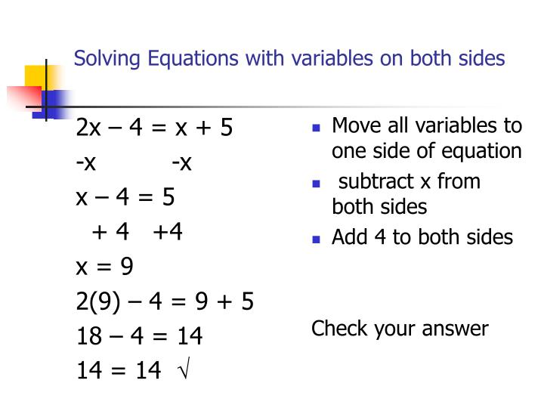
EXAMPLE 2:

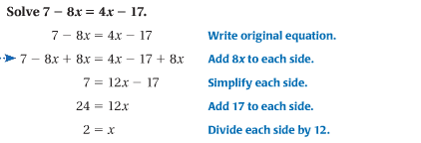
EXERCISE: Solve the following equations: SOLUTIONS
- $4x=3x+9$ $x=9$
- $8x=6x-10$ $x=-5$
- $5x-3=3x$ $x=\frac{3}{2}$
- $x=8+3x$ $x=-4$
- $3x+5=2x+10$ $x=5$
- $6x-3=4x-11$ $x=-4$
- $10+4x=2x+20$ x = 5
- $x=-3x-40$ x = -10
- $-3x+10=3x-8$ x = $\frac{1}{3}$
- $16+3x=4-3x$ x = -2

(2). MIXED PROBLEMS
EXERCISE: Solve the following equations:
- $x+9=34$
- $16-x=55$
- $36=x+11$
- $2x=46$
- $\frac{3x}{7}=12$
- $5+8x=14$
- $\frac{2x}{3}+75=85$
- $9\left(4x-2\right)=90$
- $\frac{2x-3}{5}=7$
- $5x+1=57-3x$
(3) ALGEBRA IN WORDED PROBLEMS
An important skill in algebra is to be able to convert worded questions, or sentences, into algebraic expressions.
STEPS:
- Identify the unknown quantities.
- Identify the coefficients, the constants and the arithmetic operations that connect them to form an algebraic expression
- Assign a pronumeral(s) to the unknown quantity (or quantities).
- Define the pronumeral(s) in terms of the quantity it represents.

EXAMPLE 1: If it takes 8 minutes to iron a single shirt, how long would it take to iron all of Alan’s shirts?

- The number of Alan’s shirt is unknown
- The algebraic expression is “8 minutes to iron a shirt” and “how long it take to iron all of Allan’s shirt?”
- Let n = the number of Alan’s shirt
- The total time is $8×n=8n$
EXAMPLE 2: If I multiply the number by 3 and then add 4, the answer is 13. Find the ‘mystery’ number
1. The mystery number is unknown
2. The algebraic expression “multiply the number by 3 and then add 4, the answer is 13”
3. Let the mystery number be x.
Then 2x + 3 = 14
2x = 11
x = $5\frac{1}{2}$
The mystery number is $5\frac{1}{2}$

EXERCISE:
- Jacqueline studies 5 more subjects than Helena. How many subjects does Jacqueline study if:
a). Helena studies 6 subjects
b). Helena studies x subjects
c). Helena studies y subjects

- If I treble the number and then subtract 11, the answer is 10. Find the ‘mystery number’

- If I subtract 4 from x and then multiply the result by 5, the answer is 3. Find the value of ‘x’.

- If I add 5 to the number and then multiply the result by 4, I get the same answer as when I add 1 to the number and then multiply the result by 2.

- The width of a rectangle is 5 cm less than its length. If the perimeter of the rectangle is 18 cm, find its length.

(4). SOLVING QUADRATICS
A Quadratic equation is an equation where the highest power of the unknown is 2. Consider the equation $x^{2}=16.$ To solve equations we have learned to do the inverse operation to both sides; here this means taking the square root of both sides.
$x^{2}=16$
$\sqrt{x^{2}}$ = $\sqrt{16}$
$x=4$

The square root of 16 is 4, but there is another answer. Another number that multiples by itself to give 16 is -4. So the solution to $x^{2}=16$ is x = 4 or x =-4, which may be written as $x=∓4.$
EXAMPLE 1: Solve$x^{2}=0.25$. $=>$ $\sqrt{x^{2}}$ = $\sqrt{0.25}$ $=>$ $∓0.5$ i.e. – 0.5 or 0.5
EXAMPLE 2: Solve ${3x}^{2}=12$ (In this case, the x is squared, then multiplied by 3, so you need to undo by dividing by 3 first.)
$\frac{{3x}^{2}}{3}=\frac{12}{3}$
$x^{2}=4$
$\sqrt{x^{2}}$ =$\sqrt{4}$
$x=∓2$
EXERCISE 1: Solve the following quadratic equations
- $a^{2}=25$
- $p^{2}=0.81$
- $x^{2}=-9$
- ${-4x}^{2}=-100$
- ${10f}^{2}=490$

SOLVING QUADRATIC EQUATIONS – THE NULL FACTOR LAW
We can use the Null Factor Law to obtain solution algebraically.
Null Factor Law

If the product of a certain factors equals zero, then one or more of the factors must be zero.

For example, for two numbers a and b, if $a×b=0, then a=0 or b=0 or both a and b equal 0.$
Solve $x^{2}-4x=0.$ In this form, $x^{2}-4x$ is not expressed as the product of factors. However, $x^{2}-4x$ can be factorized to $x (x-4)$ by taking out a common factor of x from both terms.
$x^{2}-4x=0$ Becomes $x (x-4)$ =0

As x is multiplied by x – 4 and the product is equal to zero, we can use the Null Factor Law. This means that
x = 0 or x – 4 = 0
Solving x = 0 or x - 4 + 4 = 0 + 4
x = 4

EXAMPLE 1: Solve (a) $x\left(x+3\right)=0$ (b) $(x+3)(x-2)$ = 0
STEPS:
- Write down the equation.
- Use the Null Factor Law.
- Solve each individual equation.
- Check your solution.
x = 0 or x + 3 = 0 $x+3=0$ or $x-2$ =0
Solving: x = 0 or x + 3 - 3 = 0 – 3 Solving: $x+3-3=0-3$ or $x-2+2$ =0 + 2
x = 0 or x = – 3 $x=-3$ $or x$ = 2
Check: x = 0: $x\left(x+3\right)$ x = – 3$: x\left(x+3\right)$ Check: $x=-3:$ $(x+3)(x-2)$ $x$ = 2: $(x+3)(x-2)$
$=0\left(0+3\right)$ $=-3\left(-3+3\right)$ = $(-3+3)(-3-2)$ $= (2+3)(2-2)$
= 0 = 0 = 0 $×-5$ = $5×0$
$=0$ $=0$

EXAMPLE 2: Solve (a) ${2x}^{2}+4x=0$ (b) $x^{2}+24x=-144$ (c) $x^{2}-6x+8=0$
STEPS:
- Write down the equation
- Change to factorized form. (Take out a common factor)
- Use the Null Factor Law
- Solve each individual equation.
- Check your solution

- ${2x}^{2}+4x=0$ (b) $x^{2}+24x=-144$
$2x\left(x+2\right)=0$ $x^{2}+24x+144=0$ (Use Perfect Square Pattern)
$2x=0 or x+2=0$ ${\left(x+12\right)}^{2}$
$x=0 or x=-2$ $x+12=0$
$x=-12$

EXAMPLE 3: Solve $x^{2}-6x+8=0$
$\left(x-2\right)\left(x-4\right)=0$ (Use the quadratic trinomial method)

$x-2=0 or x-4=0$
$x-2+2=0+2$ Or $x-4+4=0+4$
$x=2$ Or $x=4$

EXERCISE:

Q1. Solve the following equations using the Null Factor Law.
(a). $x\left(x-11\right)=0$ (b). $3x\left(x-6\right)=0$
(c). $\left(x+7\right)\left(x+2\right)=0$ (d). ${\left(x-4\right)}^{2}=0$
Q2. Solve the following equations. (Factorise, taking out common factors first)
(a). $x^{2}-6x=0$ (b)$x^{2}-4x=-4$ (First rewrite each equation so that the RHS is zero)
(c). $x^{2}+9x+18=0$ (d) $x^{2}-14x+45=0$
(e). $2x^{2}+4x-30=0$ (f) $x^{2}-x-30=0$

WEEK: 10  TERM: 1 | STRAND NAME | SUB STRAND | STUDENTS LEARNING OUTCOMES
Monday | ALGEBRA | SOLVING QUADRATICS BY FORMULA | Solve quadratic equation using the formula
Tuesday | ALGEBRA | SOLVE PROBLEMS WITH LINEAR EQUATIONS | Write linear equations for each statement and solve the unknown.
Wednesday | ALGEBRA | REARRANGING FORMULAS | Use inverse operation to change the subject of a formula.
Thursday | ALGEBRA | INEQUATIONS | Solve quadratic equations by factorizing
Friday | ALGEBRA | REVISION | Complete this week’s activities and revise the topics you have covered this week.

WEEK 10 ACTIVITIES

- SOLVING QUADRATICS BY FORMULA
A formula has been worked out to solve quadratic equations in the form${ax}^{2}+bx+c=0$. If you can remember the formula, then it is a very much simpler and faster method of solving quadratic equations.
STEPS:
- Compare the given quadratic equation to the formula ‘${ax}^{2}+bx+c=0$’
- Determine the values of the constants $a, b, and c.$
- Substitute these values into the quadratic formula
- Calculate to find your answer.

FORMULA:
$x=\frac{-b∓\sqrt{b^{2}-4ac}}{2a}$

EXAMPLE 1: Solve $x^{2}+3x+2=0$

Compare $x^{2}+3x+2=0$ to ${ax}^{2}+bx+c=0$ $∴a=1, b=3 and c=2$

$x=\frac{-b∓\sqrt{b^{2}-4ac}}{2a}$

$x=\frac{-3∓\sqrt{3^{2}-4×1×2}}{2×1}$
$x=\frac{-3∓\sqrt{9-8}}{2}$
$x=\frac{-3∓\sqrt{1}}{2}$
$x=\frac{-3+\sqrt{1}}{2}$ or $\frac{-3-\sqrt{1}}{2}$
$x=-1 or x=-2$

EXERCISE: Solve these quadratic equations. SOLUTIONS
- $x^{2}-11x+28=0$ $x=4 or x=7$
- $x^{2}+2x-8=0$ $x=-4 or x=2$
- $x^{2}+8x+7=0$ $x=-7 or x=-1$
- $3x^{2}-18x-48=0$ $x=-2 or x=8$
- $5x^{2}+20x-60=0$ $x=-6 or x=2$

- SOLVE PROBLEMS WITH LINEAR EQUATIONS
STEPS:
- Identify the unknown quantities.
- Identify the algebraic expressions
- Form an equation
- Solve
EXAMPLE:
The length of a rectangle is twice the width. If the perimeter is 36 cm, find the width.
STEP 1: The width of the rectangle is unknown.
STEP 2: Let the width of the rectangle be x cm. Then the length of the rectangle is 2x cm.
STEP 3: x + 2x + x + 2x = 36
STEP 4: 6x = 36
x = 6
The width of the rectangle is 6 cm.

EXERCISE: Solve each problem by forming an equation.
- The length of a rectangle is five times the width. If the perimeter is 42 cm, find the width.

- If the perimeter of the triangle is 29 units, find x.

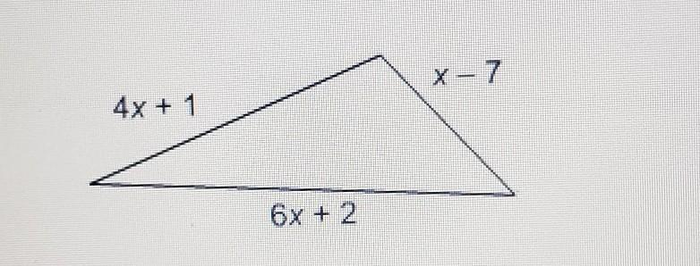

- When a number is doubled and then added to 9, the result is 31. Find the number.

- If AB is a straight line, find x.
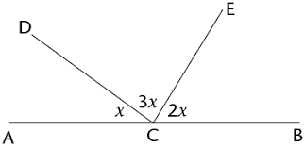
- If we multiply the number by 5 and subtract 4, we get the same answer as when we add 3 to the number and then double the result.

- REARRANGING FORMULAS

EXAMPLE 1: Make x the subject in the formulae below.

(a). $ax-p=t$ (b) $y\left(x+y\right)=v^{2}$
$ax=t+p$ $yx+y^{2}=v^{2}$
$x=\frac{t+p}{a}$ $yx=v^{2}-y^{2}$
$x=\frac{v^{2}-y^{2}}{y}$

EXERCISE: Make x the subject.
- $k+x=m$
- $xm-e=k$
- $n\left(x-n\right)=t^{2}$
- $\frac{x}{(a+b)}=c$
- $cx^{2}=z+k$

- INEQUATIONS

Inequations contain one of the 4 inequality signs shown below:

$$≥ > ≤ <$$
‘greater than or equal to’ ‘greater than’ ‘less than or equal to’ ‘less than’

Inequations are solved in exactly the same way as ordinary equations, except that the INEQUALITY SIGN IS REVERSED whenever we multiply or divide both sides by a negative number.

EXAMPLE 1: Solve $4(x+2)≥10$

$4(x+2)≥10$
$4x+8≥10$ (Expand brackets)
$4x≥10-8$ (Subtract 8 from both sides
$4x≥2$ (Divide both sides by 4)
$∴x≥\frac{1}{2}$

EXAMPLE 2:
Solve $\frac{1-2m}{5}<3$
$1-2m<15$ (Multiply both sides by 5)
$-2m<14$ (Subtract 1 from both sides)
$\frac{-2m}{-2}<\frac{14}{-2}$ (Divide both sides by -2)
$m>-7$ (When we divide both sides by -2, then the inequality sign must be reversed.)

EXERCISE: Solve the following inequations: SOLUTIONS
- $4(x-3)>8$ $x>5$

- $\frac{2x}{5}≥4$ $x≥10$

- $\frac{6-2x}{8}<-2$ $x>11$

- $4x-3\left(x+6\right)≥5x-22$ $x≤1$

WEEK: 11  TERM: 1 | STRAND NAME | SUB STRAND | STUDENTS LEARNING OUTCOMES | ACTIVITIES
Monday | ALGEBRA | SIMULTANEOUS EQUATION 1 | Solve simultaneous equations using graphical method | Exercise 5.11 Pages 130-131  Do Q1 a, c, e Q2 b, d, f  Q3 a, c, e
Tuesday | ALGEBRA | SIMULTANEOUS EQUATION 2 | Solve simultaneous equations using substitution method | Exercise 5.12 Pages 134-135  Do Q 1 b, d, f Q2 e, g, i  Q3 f, h, j
Wednesday | ALGEBRA | SIMULTANEOUS EQUATION 3 | Solve simultaneous equations using elimination method | Exercise 5.13 Pages 136-137  Do Q1a, c Q2 b, f, j  Q3 a, e, I Q4 d, f, h
Thursday | ALGEBRA | SIMULTANEOUS EQUATIONS | Solve Simultaneous equations using elimination, substitution and graphical method | Problem Solving Page 137  Do Q’s 1, 3, 4
Friday | ALGEBRA | REVISION | Complete this week’s activities and revise the topics you have covered this week.

WEEK: 12  TERM : 1 | STRAND NAME | SUB STRAND | STUDENTS LEARNING OUTCOMES | ACTIVITIES
Monday | STATISTICS | GRAPHING DATA | Graph given data using bar graph, pictograph, line graph | Exercise 3.1 Page 55  Do Q1 a, Q2 b, Q3 a,
Tuesday | STATISTICS | GRAPHING DATA | Graph given data using pie graph and a frequency table | Exercise 3.1 Pages  56-57  Q4 b, Q7 & Q10
Wednesday | STATISTICS | GROUPED DATA | Sort data into groups | Exercise 3.2 Page 59  Do Q1 a, b, c, d, e, f
Thursday | STATISTICS | AVERAGES | Calculate mean, median, and mode from given data. | Exercise 3,2 Pages  61-62  Do Q1 b, e, h, Q2, Q7
Friday | STATISTICS | REVISION | Complete this week’s activities and revise the topics you have covered this week.

WEEK: 13  TERM : 1 | STRAND NAME | SUB STRAND | STUDENTS LEARNING OUTCOMES | ACTIVITIES
Monday | STATISTICS | PROBABILITY | Identify events from experience and observation on a scale of 0-1 | Exercise 3.4 Pages  63-64  Do Q1, Q3 a & b
Tuesday | STATISTICS | CALCULATING PROBABILITY | Calculate probability of an event based on theory | Exercise 3.5 Pages  65-67  Do Q1, Q5 & Q6
Wednesday | STATISTICS | PROBABILITY EXPERIMENT | Demonstrate probability from experiment and recording | Exercise 3.6 Page 59  Do Q1 a, b, c, d, e,
Thursday | STATISTICS | MULTIPLE EVENTS | Calculate probability of two or more events from theory | Exercise 3,7 Pages  70-71  Do Q1, Q2, Q4, Q5
Friday | STATISTICS | REVISION | Complete this week’s activities and revise the topics you have covered this week.

WEEK: 1  TERM : 2 | STRAND NAME | SUB STRAND | STUDENTS LEARNING OUTCOMES | ACTIVITIES
Monday | GEOMETRY | ANGLE FACTS REVIEW | Find value of pronumerals using angle facts they know | Exercise 3.1 Pages  39-41  Do Q1 a, c, e. Q2 b, d, f Q3 a, d, g Q4 a, f, j, m, r  Q5 f, I, n, q Q6 b, c, d + Q7 a, b ,c
Tuesday | GEOMETRY | ANGLES IN PARALLEL LINES | Apply knowledge of angles on parallel lines to find unknown angles | Exercise 3.2 Pages  44 - 45  Do Q1 d, f, I, l, m, p, q, s Q2 a, c, e
Wednesday | GEOMETRY | ANGLES AND TRIANGLES | Apply knowledge of angles in triangles to find unknown angles | Exercise 3.3 Page  46-47  Do Q1 a, c, e, g, I, k, m, o, q, s Q2 b, d, f
Thursday | GEOMETRY | ANGLES AND QUADRILATERAL | Apply knowledge of angles in quadrilateral to find unknown angles | Exercise 3.4 Pages  49-50  Do Q1 a, d, e, h, i, l, m, p, q, t  Q2a, c, e, g
Friday | GEOMETRY | REVISION | Complete this week’s activities and revise the topics you have covered this week.

WEEK: 2  TERM : 2 | STRAND NAME | SUB STRAND | STUDENTS LEARNING OUTCOMES | ACTIVITIES
Monday | GEOMETRY | CONSTRUCTION | Review basic constructions | Exercise 3.5 Pages  53-54  DO Q1 a, b, c Q2, Q3, Q4, Q5, Q6, Q7
Tuesday | GEOMETRY | MEDIANS | Construct medians | Exercise 3.5 Pages 54  Do Q8
Wednesday | GEOMETRY | INCENTRE AND INCIRCLE | Draw the inscribed circle of a triangle | Exercise 3.5 Page 54  Do Q9
Thursday | GEOMETRY | CIRCUMCENTRE AND CIRCUMCIRCLE | Draw the circumscribed circle of a triangle | Exercise 3.5 Pages 54  Do Q10
Friday | GEOMETRY | REVISION | Complete this week’s activities and revise the topics you have covered this week.

WEEK: 3  TERM : 2 | STRAND NAME | SUB STRAND | STUDENTS LEARNING OUTCOMES | ACTIVITIES
Monday | GEOMETRY | ALTITUDES | Construct the altitudes of a triangle | Exercise 3.5 Page 54  DO Q11
Tuesday | GEOMETRY | GEOMETRIC DESIGN- CARDIOD | Construct cardioid | Exercise 3.5 Page 55  Do Q1 a, b, c, d
Wednesday | GEOMETRY | GEOMETRIC DESIGN- 12 POINTED STAR | Construct 12 pointed star | Exercise 3.5 Page 55  Do Q2 a, b, c, d, e, f, g, h
Thursday | GEOMETRY | GEOMETRIC DESIGN- VANISHING CIRCLES | Construct the vanishing circles | Exercise 3.5 Page 56  Do Q3 a, b, c, d, e, f, g, h
Friday | GEOMETRY | REVISION | Complete this week’s activities and revise the topics you have covered this week.

