Strand 5: Organic Chemistry
Lesson 2 of Week 5, Term 2: Carboxylic Acid
Resource: Esa study Guide, Level 2 Chemistry, Chapter 15, online as well
The learning outcomes targeted in this activity are provided in the table below,
SLO Code | SPECIFIC LEARNING OUTCOMES (SLO): | SKILL LEVEL
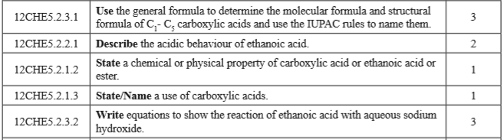

Activity
- Write the general formula for Carboxylic acid

- Use the general formula for carboxylic acid to determine the molecular formula and structural formula of C₁ – C₅ carboxylic acids and name them using IUPAC nomenclature rules.
Carbon Number | Structural formula | Molecular Formula Structure | Name
1
2
3
4
5
6

3. Describe the acidic behaviour of ethanoic acid

4. State four properties of carboxylic acid / ethanoic acid /ester

5. State four uses of carboxylic acid

6. i. Describe the reaction of ethanoic acid with aqueous sodium hydroxide

ii. Write in equation the reaction of above acid with aqueous sodium hydroxide

