Strand 5: Organic Chemistry
Lesson 3 of Week 4, Term 2: Alcohols, Ketones and Aldehydes
Resource: Esa study Guide, Level 2 Chemistry, Chapter 14, online as well
The learning outcomes targeted in this activity are provided in the table below,
SLO Code | SPECIFIC LEARNING OUTCOMES (SLO): | SKILL LEVEL
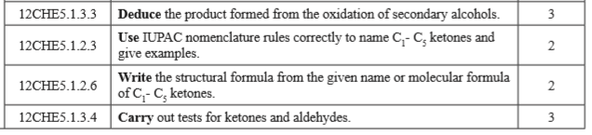

Activity
- Deduce/gather the product formed from the oxidation of secondary alcohols

- Write the general formula for Ketones

- Determine the molecular formula and structural formula of C₁ – C₅ Ketones and name them using IUPAC nomenclature rules.
Carbon Number | Structural formula | Molecular Formula Structure | Name
1
2
3
4
5
6

4. Watch a video on carrying out a test for Ketones and aldehydes

