Strand 3: Physical Chemistry
Lesson 3 of Week 3, Term 2: Chemical Equilibrium System
Resource: Esa study Guide, Level 2 Chemistry, Chapter 18 (was photocopied last year 2019), online as well
The learning outcomes targeted in this activity are provided in the table below,
SLO Code | SPECIFIC LEARNING OUTCOMES (SLO): | SKILL LEVEL
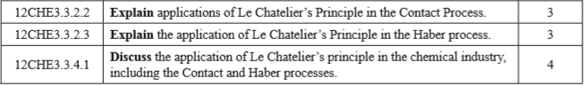

Activity
- Explain the following term:
  - Contact Process

  - Haber Process

- Explain the application of Le Chatelier’s Principle in the Contact Process

- Explain the application of Le Chatelier’s Principle in the Haber Process

- Discuss the application of Le Chatelier’s principle in the chemical industry including/in terms of Contact and Haber processes

