Strand 3: Physical Chemistry
Lesson 1 of Week 3, Term 2: Rate of Reaction
Resource: Esa Study Guide, Level 2 Chemistry, Chapt 17, online
The learning outcomes targeted in this activity are provided in the table below,
SLO Code | SPECIFIC LEARNING OUTCOMES (SLO): | SKILL LEVEL
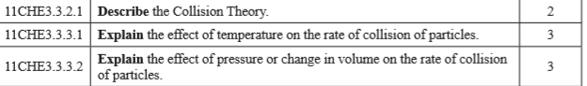

Activity
- Describe the term collision theory

- List four factors causes changes to the rate of reaction

- Explain the effect of temperature on the rate of collision of particles

- Explain the effect of pressure or change in volume on the rate of collision of particles.

