Strand 3: Physical Chemistry
Lesson 3 of Week 2, Term 2: Rate of Reaction
Resource: Esa study Guide, Level 2 Chemistry, Chapter 17 (was photocopied last year 2019), online as well
The learning outcomes targeted in this activity are provided in the table below,
SLO Code | SPECIFIC LEARNING OUTCOMES (SLO): | SKILL LEVEL
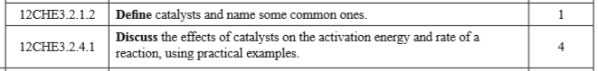

Activity
- Define the term Catalysts

- Name/List four common catalysts

- Discuss/point out the effect of a catalysts on the
  - activation energy

  - rate of the reaction

