Strand 3: Physical Chemistry
Lesson 2 of Week 1 of Term 2: Energy Change
Resource: Esa study Guide, Level 2 Chemistry, Chapter 11 (was photocopied last year 2019), online as well
The learning outcomes targeted in this activity are provided in the table below,
SLO Code | SPECIFIC LEARNING OUTCOMES (SLO): | SKILL LEVEL
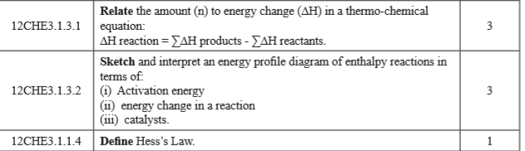

Activity
- Define/Interpret the following terms in terms of energy changes
  - Hess’s Law

  - Activation energy

  - Energy change in a reaction

  - Catalysts

- Sketch an energy profile diagram of enthalpy reactions and label as activation energy, energy change in a reaction and addition of a catalysts.

- Relate/show how the amount of energy change in a thermo-chemical equation

- The equation for the burning of carbon is
C + O2 CO2 = -400KJ mol
Calculate when 6 g of carbon is burned

