Strand 4: Oxidation and Reduction
Lesson 1 of Week 10: Oxidation and Reducation
Resource: Esa study Guide, Level 2 Chemistry, Chapter 21 & 24 (chpt 24 was photocopied last year 2019), online as well
The learning outcomes targeted in this activity are provided in the table below,
SLO Code | SPECIFIC LEARNING OUTCOMES (SLO): | SKILL LEVEL
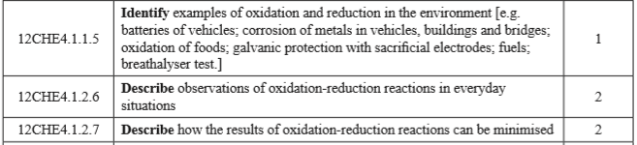

Activity
- Point out seven common oxidation-reduction in the environment

- Point out four common oxidation-reduction reaction you observe everyday

- Describe/point out four ways the result of oxidation-reduction reactions can be minimised/reduced

