Central School
Home School Package

Year :12

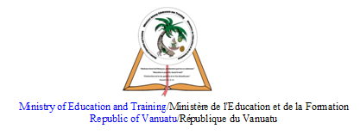

HOME SCHOOL PACKAGE CONTENT
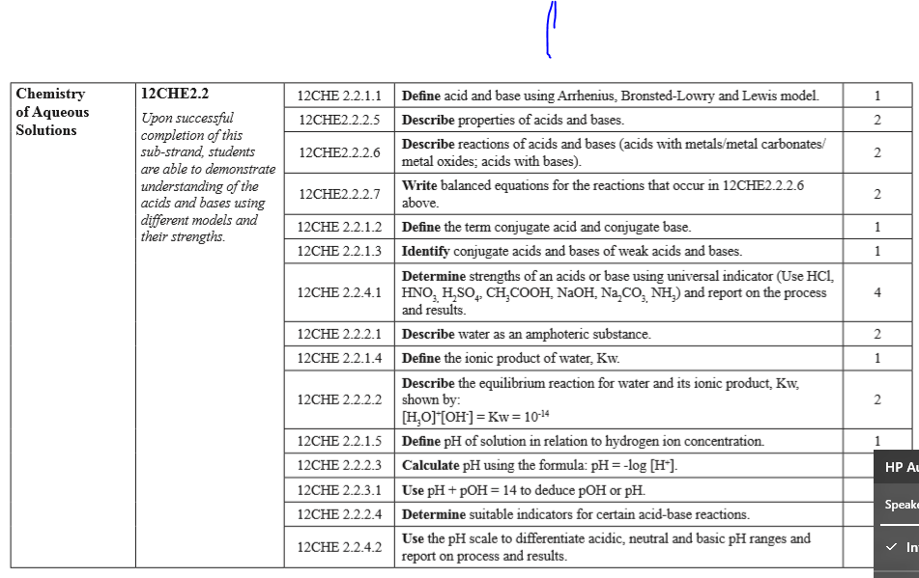

LESSON Plan

Teacher | Name :Judy W Vire  Subject : Chemistry
Date | Week 8 of term 2
Topic : Chemistry of Aqueous solution
Lesson number : 4

Learning outcomes | - Use pH + pOH = 14 to deduce pOH or pH  - Determine suitable indicator for certain acid-base reactions  - Use the pH scale to differentiate acidic, neutral and basic pH ranges and report on process and results
Introduction | The color of hydrangea flowers can vary depending on the pH of the soil. Blue flowers usually come from acidic soil with a pH less than 6, and pink flowers come from soil with a pH above 6.
Catch phrase for the lesson
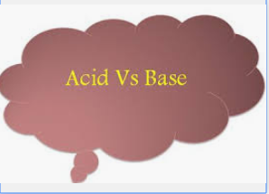
Learners notes | Summary  pH and pOH denote the negative log of the concentration of hydrogen or hydroxide ions. High pH means that a solution is basic while high pOH means that a solution is acidic. Neutral solutions have pH and pOH of 7.  pH and pOH are the log concentrations of protons and hydroxide ions, respectively. The sum of pH and pOH is always 14. This is because the product of proton concentration and hydroxide concentration must always equal the equilibrium constant for the ionization of water, which is equal to. So pH is the measure of hydrogen ion concentration, [H+], while pOH is a measure of the hydroxide ion concentration, [OH-]. The scales for both are 1-14. So remember that pH+pOH=14.  For example, Given pH =4.42, Find pOH. Need to use the expression pOH = 14 – pH. Now substitute the known quantity into the equation and solve. pOH=14−4.42=9.58. The pH is that of an acidic solution, and the resulting pOH is the difference after subtracting from 14.  Below are the list of suitable indicators used in acid-base reaction :  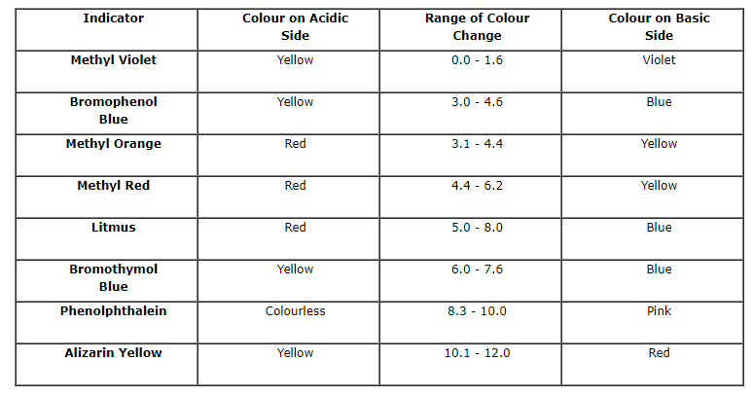  pH ranges  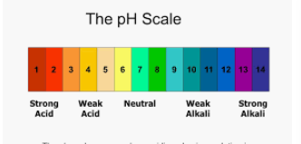  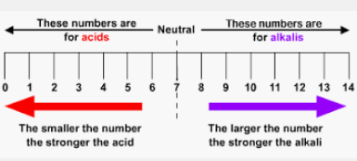
- Introduction to pH, pOH and pKW by Khan Academy https://www.youtube.com/watch?v=2q4vSKwaBtw
- Difference between pH, pOH and pKw by Shawn Shields https://www.youtube.com/watch?v=d_12-95d0GE

- What is the pH of a 0.0235 M HCl solution ?
- What is the pOH of a 0.0235M HCl solution ?
- What is the pH of a 6.2 x 10⁻⁵ M NaOH solution ?
- List four common indicators suitable for certain acid-base reactions
- Draw pH scale locating acid, base, neutral, strong and weak acid, strong and weak base.

Assignment
Assessment | Written test on week 9 of term 2
References | - https://sciencing.com/how-to-calculate-ph-and-poh-13710435.html  - https://vlab.amrita.edu/?sub=2&brch=193&sim=352&cnt=1

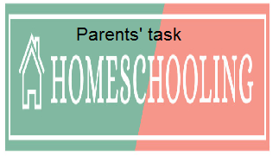

WEEKLY CHECKLIST For Parents:

Term: 2 Week number 1 Date…… to…… Month: …………

Subject | Number of lessons | Days | Tick when activity is complete | Parents comment | Signature
 | 1
 | 2
 | 3
 | 4
 | 5
 | 6

Term: 2 Week number 2 Date…… to…… Month: …………

Subject | Number of lessons | Days | Tick when activity is complete | Parents comment | Signature
 | 1
 | 2
 | 3
 | 4
 | 5
 | 6

Term: 2 Week number 3 Date…… to…… Month: …………

Subject | Number of lessons | Days | Tick when activity is complete | Parents comment | Signature
 | 1
 | 2
 | 3
 | 4
 | 5
 | 6

Term: 2 Week number 4 Date…… to…… Month: …………

Subject | Number of lessons | Days | Tick when activity is complete | Parents comment | Signature
 | 1
 | 2
 | 3
 | 4
 | 5
 | 6

Term: 2 Week number 5 Date…… to…… Month: …………

Subject | Number of lessons | Days | Tick when activity is complete | Parents comment | Signature
 | 1
 | 2
 | 3
 | 4
 | 5
 | 6

Term: 2 Week number 6 Date…… to…… Month: …………

Subject | Number of lessons | Days | Tick when activity is complete | Parents comment | Signature
 | 1
 | 2
 | 3
 | 4
 | 5
 | 6

Term: 2 Week number 7 Date…… to…… Month: …………

Subject | Number of lessons | Days | Tick when activity is complete | Parents comment | Signature
 | 1
 | 2
 | 3
 | 4
 | 5
 | 6

Term: 2 Week number 8 Date…… to…… Month: …………

Subject | Number of lessons | Days | Tick when activity is complete | Parents comment | Signature
 | 1
 | 2
 | 3
 | 4
 | 5
 | 6

Term: 2 Week number 9 Date…… to…… Month: …………

Subject | Number of lessons | Days | Tick when activity is complete | Parents comment | Signature
 | 1
 | 2
 | 3
 | 4
 | 5
 | 6

Term: 2 Week number 10 Date…… to…… Month: …………

Subject | Number of lessons | Days | Tick when activity is complete | Parents comment | Signature
 | 1
 | 2
 | 3
 | 4
 | 5
 | 6

Term: 2 Week number 11 Date…… to…… Month: …………

Subject | Number of lessons | Days | Tick when activity is complete | Parents comment | Signature
 | 1
 | 2
 | 3
 | 4
 | 5
 | 6

Term: 2 Week number 12 Date…… to…… Month: …………

Subject | Number of lessons | Days | Tick when activity is complete | Parents comment | Signature
 | 1
 | 2
 | 3
 | 4
 | 5
 | 6

Term: 2 Week number 13 Date…… to…… Month: …………

Subject | Number of lessons | Days | Tick when activity is complete | Parents comment | Signature
 | 1
 | 2
 | 3
 | 4
 | 5
 | 6

