Central School
Home School Package

Year :12

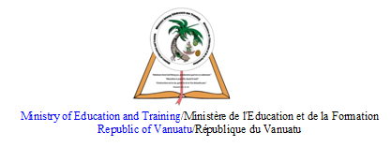

HOME SCHOOL PACKAGE CONTENT
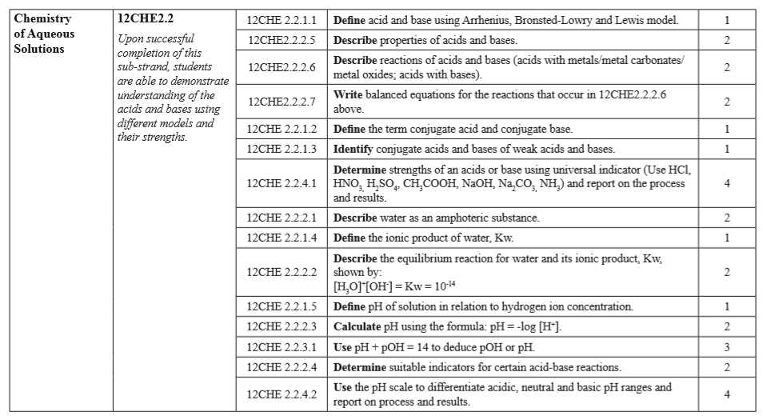

LESSON Plan

Teacher | Name : Judy W Vire  Subject : Chemistry
Date | Week 8 of term 2
Topic :Chemistry of Aqueous solution
Lesson number : 3

Learning outcomes | - Define the ionic product of water, Kw  - Describe the equilibrium reaction for water and its ionic product, Kw shown by [H₃O]⁺ [OH⁻] = Kw = 10⁻¹⁴  - Define pH of solution in relation to hydrogen ion concentration  - Calculate pH using the fomula: pH = -log[H⁺]
Introduction | There’s no need for evidence. Science, Technology, Engineering and Math (STEM) has radically changed the world right-side up with discoveries and innovations that keep life going, people growing, and the times ever changing. Just look around you! Its magic manifests in the big and small, in the skies up above and in the veins deep inside you.
Catch phrase for the lesson
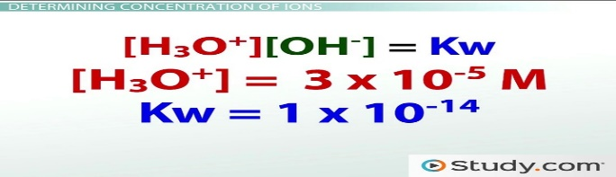
Learners notes | Summary  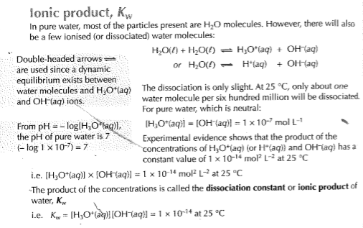  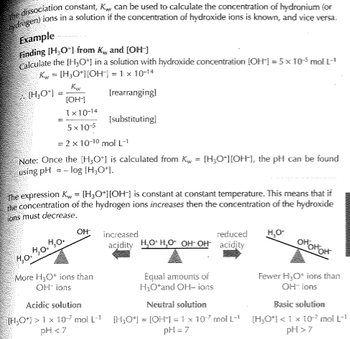  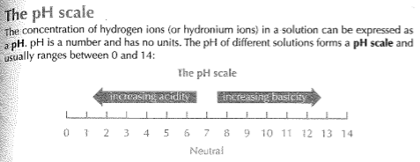  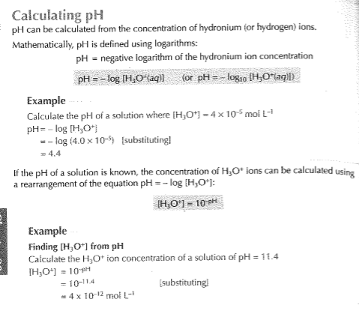  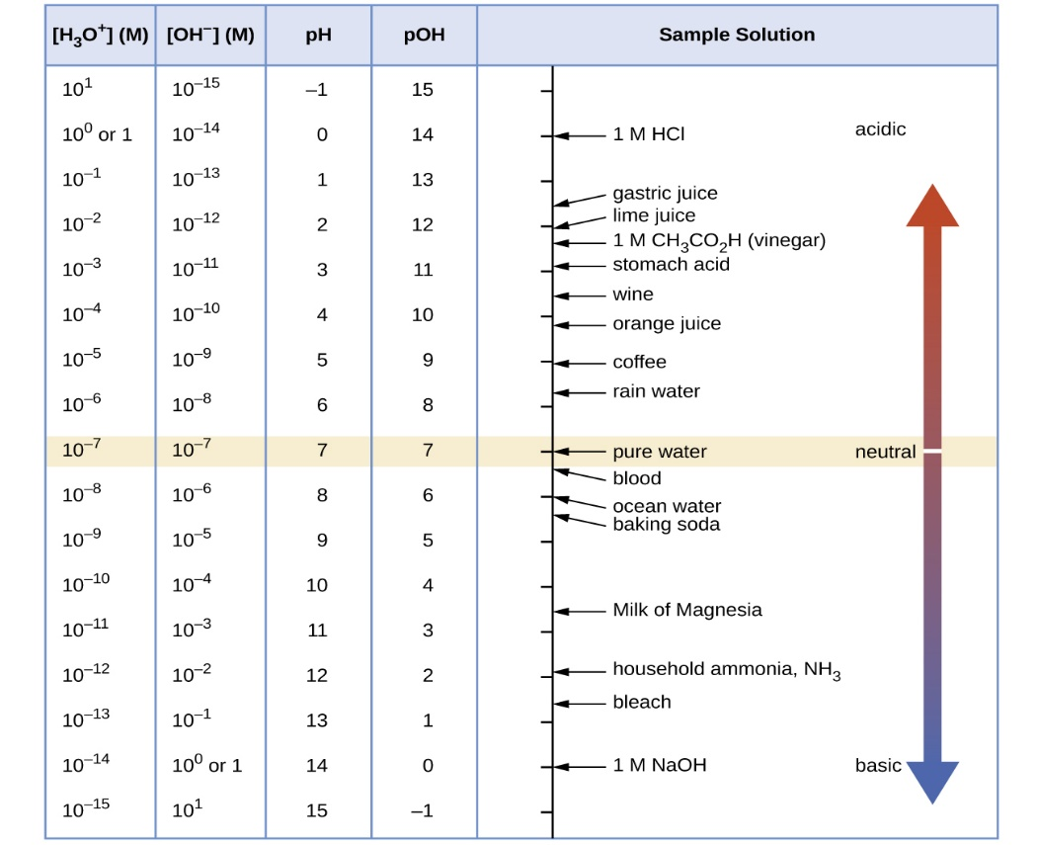
- The ionic product of water Kw by MaChemGuyhttps://www.youtube.com/watch?v=_tCfeqnWdoM
- Kw-Ionic product of water by Allery Chemistry - https://www.youtube.com/watch?v=Rh2wBBxOZq8

- Define the ionic product of water, Kw
- Describe the equilibrium reaction for water and its ionic product
- Define pH of solution in relation to hydrogen ion concentration
- Calculate the pH of a solution with a hydronium ion concentration, [H₃O+] of 0.0850 mol/L.
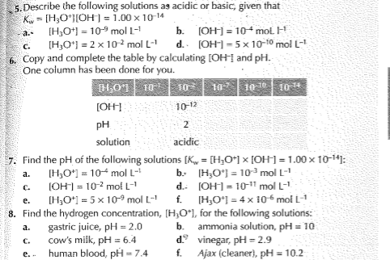
Assignment
Assessment | Written test after the completion of topic
References | - https://portal.edukasyon.ph/blog/a-story-of-students-turned-scientists  - Boniface, S. (2004) Esa study Guide Level 2 Chemistry. Esa publication Ltd : New Zealand.

WEEKLY CHECKLIST For Parents:

Term: 2 Week number 1 Date…… to…… Month: …………

Subject | Number of lessons | Days | Tick when activity is complete | Parents comment | Signature
 | 1
 | 2
 | 3
 | 4
 | 5
 | 6

Term: 2 Week number 2 Date…… to…… Month: …………

Subject | Number of lessons | Days | Tick when activity is complete | Parents comment | Signature
 | 1
 | 2
 | 3
 | 4
 | 5
 | 6

Term: 2 Week number 3 Date…… to…… Month: …………

Subject | Number of lessons | Days | Tick when activity is complete | Parents comment | Signature
 | 1
 | 2
 | 3
 | 4
 | 5
 | 6

Term: 2 Week number 4 Date…… to…… Month: …………

Subject | Number of lessons | Days | Tick when activity is complete | Parents comment | Signature
 | 1
 | 2
 | 3
 | 4
 | 5
 | 6

Term: 2 Week number 5 Date…… to…… Month: …………

Subject | Number of lessons | Days | Tick when activity is complete | Parents comment | Signature
 | 1
 | 2
 | 3
 | 4
 | 5
 | 6

Term: 2 Week number 6 Date…… to…… Month: …………

Subject | Number of lessons | Days | Tick when activity is complete | Parents comment | Signature
 | 1
 | 2
 | 3
 | 4
 | 5
 | 6

Term: 2 Week number 7 Date…… to…… Month: …………

Subject | Number of lessons | Days | Tick when activity is complete | Parents comment | Signature
 | 1
 | 2
 | 3
 | 4
 | 5
 | 6

Term: 2 Week number 8 Date…… to…… Month: …………

Subject | Number of lessons | Days | Tick when activity is complete | Parents comment | Signature
 | 1
 | 2
 | 3
 | 4
 | 5
 | 6

Term: 2 Week number 9 Date…… to…… Month: …………

Subject | Number of lessons | Days | Tick when activity is complete | Parents comment | Signature
 | 1
 | 2
 | 3
 | 4
 | 5
 | 6

Term: 2 Week number 10 Date…… to…… Month: …………

Subject | Number of lessons | Days | Tick when activity is complete | Parents comment | Signature
 | 1
 | 2
 | 3
 | 4
 | 5
 | 6

Term: 2 Week number 11 Date…… to…… Month: …………

Subject | Number of lessons | Days | Tick when activity is complete | Parents comment | Signature
 | 1
 | 2
 | 3
 | 4
 | 5
 | 6

Term: 2 Week number 12 Date…… to…… Month: …………

Subject | Number of lessons | Days | Tick when activity is complete | Parents comment | Signature
 | 1
 | 2
 | 3
 | 4
 | 5
 | 6

Term: 2 Week number 13 Date…… to…… Month: …………

Subject | Number of lessons | Days | Tick when activity is complete | Parents comment | Signature
 | 1
 | 2
 | 3
 | 4
 | 5
 | 6

