Central School
Home School Package

Year :12

HOME SCHOOL PACKAGE CONTENT
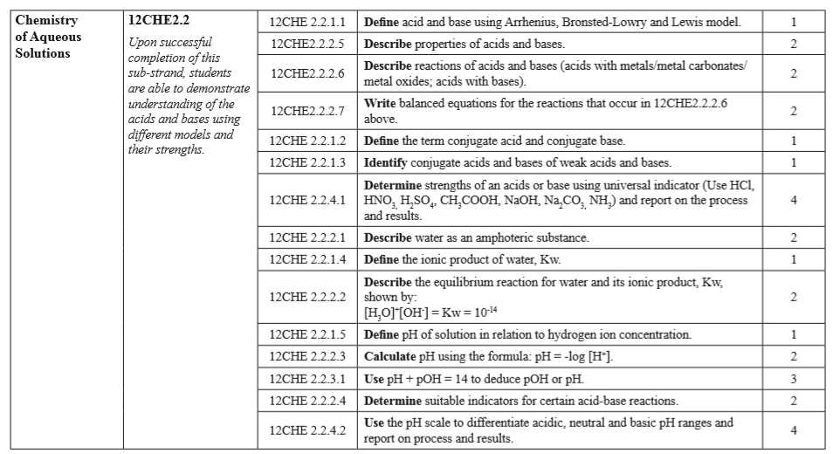

LESSON Plan

Teacher | Name :Judy W Vire  Subject : Chemistry
Date | Week 8 of term 2
Topic :Chemistry of Aqueous solution
Lesson number : 2

Learning outcomes | - Define the term conjugate acid and conjugate base  - Identify conjugate acids and based of weak acids and bases  - Describe water as an amhoteic substance  - Determine the strength of the following: HCL, HSO₄, HNO₃, CH₃COOH, NaOH, Na₂CO₃, NH₃
Introduction | Strong and weak acids are important to know both for chemistry class and for use in the lab. There are very few strong acids, so one of the easiest ways to tell strong and weak acids apart is to memorize the short list of strong ones. Any other acid is considered a weak acid.
 | Catch phrase for the lesson
Learners notes | Summary  There are several ways for identifying conjugate acid-base in a given reaction. This is the easier way to look at it by lesser or morer H atom in the reaction.  A conjugate acid contains one more H atom and one more + charge than the base that formed it.  A conjugate base contains one less H atom and one more - charge than the acid that formed it.  Let us take the example of bicarbonate ions reacting with water to create carbonic acid and hydronium ions.  HCO₃⁻ + H₂O → H₂CO₃ + OH⁻  base + acid → Conj A + Conj B  We see that HCO₃⁻ becomes H₂CO₃. It has one more H atom and one more + charge (-1 + 1 = 0). So H₂CO₃ is the conjugate acid of HCO₃⁻.  The H₂O becomes OH⁻. It has one less H atom and one more – charge. So OH⁻ is the conjugate base of H₂O.  In chemistry, an amphoteric compound that can react both as an acid and as a base. Amphoteric substance is that substance which has ability to donate as well as accept a Proton. According to Bronsted -Lowry concept,bases stronger than water,tend to accept proton from it. Thus water can donate as well as accept proton therefore shows an amphoteric nature.  There are strong and weak of acids and bases. Study the table below carefully :  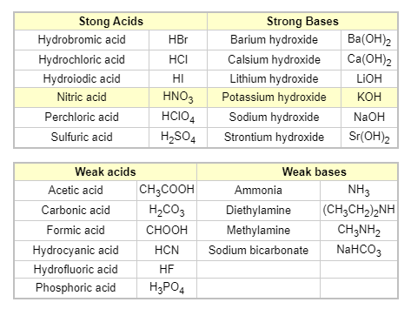
- Conjugate acid-base pairs by Khan Academy https://www.khanacademy.org/science/chemistry/acids-and-bases-topic/copy-of-acid-base-equilibria/v/conjugate-acid-base-pairs-acids-and-bases-chemistry-khan-academy
- Distinguish between strong and weak acids and bases by Mike Sugiyama https://www.youtube.com/watch?v=dr1-ZRYCt40
- Chemistry help : strong vs weak acids by 5minute school - https://www.youtube.com/watch?v=vQMafEpwaTU
- Define the term conjugate acid and conjugate base
- Identify base, acid , conjugate acids and based of the following:
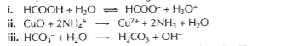
- Describe the movement of water? What does it called?
- Determine the strength of the following acids and bases. If they are weak, state beside weak or moveon to next: HCL, HSO₄, HNO₃, CH₃COOH, NaOH, Na₂CO₃, NH₃
Assignment
Assessment | Written test after the topic covered
References | - https://socratic.org/chemistry/acids-and-bases/conjugate-acids-and-conjugate-bases  - https://www.engineeringtoolbox.com/acid-base-strong-weak-d_1962.html

WEEKLY CHECKLIST For Parents:

Term: 2 Week number 1 Date…… to…… Month: …………

Subject | Number of lessons | Days | Tick when activity is complete | Parents comment | Signature
 | 1
 | 2
 | 3
 | 4
 | 5
 | 6

Term: 2 Week number 2 Date…… to…… Month: …………

Subject | Number of lessons | Days | Tick when activity is complete | Parents comment | Signature
 | 1
 | 2
 | 3
 | 4
 | 5
 | 6

Term: 2 Week number 3 Date…… to…… Month: …………

Subject | Number of lessons | Days | Tick when activity is complete | Parents comment | Signature
 | 1
 | 2
 | 3
 | 4
 | 5
 | 6

Term: 2 Week number 4 Date…… to…… Month: …………

Subject | Number of lessons | Days | Tick when activity is complete | Parents comment | Signature
 | 1
 | 2
 | 3
 | 4
 | 5
 | 6

Term: 2 Week number 5 Date…… to…… Month: …………

Subject | Number of lessons | Days | Tick when activity is complete | Parents comment | Signature
 | 1
 | 2
 | 3
 | 4
 | 5
 | 6

Term: 2 Week number 6 Date…… to…… Month: …………

Subject | Number of lessons | Days | Tick when activity is complete | Parents comment | Signature
 | 1
 | 2
 | 3
 | 4
 | 5
 | 6

Term: 2 Week number 7 Date…… to…… Month: …………

Subject | Number of lessons | Days | Tick when activity is complete | Parents comment | Signature
 | 1
 | 2
 | 3
 | 4
 | 5
 | 6

Term: 2 Week number 8 Date…… to…… Month: …………

Subject | Number of lessons | Days | Tick when activity is complete | Parents comment | Signature
 | 1
 | 2
 | 3
 | 4
 | 5
 | 6

Term: 2 Week number 9 Date…… to…… Month: …………

Subject | Number of lessons | Days | Tick when activity is complete | Parents comment | Signature
 | 1
 | 2
 | 3
 | 4
 | 5
 | 6

Term: 2 Week number 10 Date…… to…… Month: …………

Subject | Number of lessons | Days | Tick when activity is complete | Parents comment | Signature
 | 1
 | 2
 | 3
 | 4
 | 5
 | 6

Term: 2 Week number 11 Date…… to…… Month: …………

Subject | Number of lessons | Days | Tick when activity is complete | Parents comment | Signature
 | 1
 | 2
 | 3
 | 4
 | 5
 | 6

Term: 2 Week number 12 Date…… to…… Month: …………

Subject | Number of lessons | Days | Tick when activity is complete | Parents comment | Signature
 | 1
 | 2
 | 3
 | 4
 | 5
 | 6

Term: 2 Week number 13 Date…… to…… Month: …………

Subject | Number of lessons | Days | Tick when activity is complete | Parents comment | Signature
 | 1
 | 2
 | 3
 | 4
 | 5
 | 6

