Central School
Home School Package

Year :11

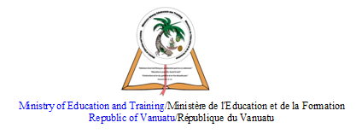

HOME SCHOOL PACKAGE CONTENT
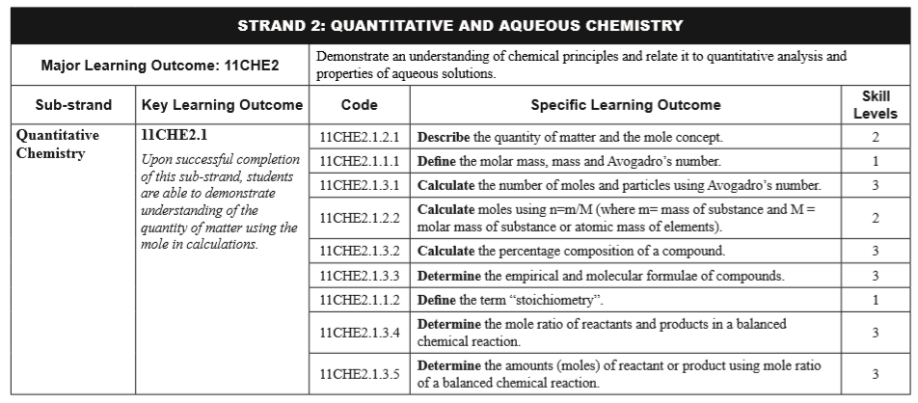

LESSON Plan

Teacher | Name :Judy W Vire  Subject :Chemistry
Date | Week 7 of term 2
Topic : Quantitative Chemistry
Lesson number :3

Learning outcomes | - Define the term stoichiometry  - Determine the mole ratio of reactants and products in a balanced chemical reactions  - Determine the amount (moles) of reactant or product using mole ratio of a balanced chemical reaction.
Introduction | What do cookies and chemistry have in common? Many things, it turns out! A balanced chemical equation is the recipe for a reaction: it contains a list of all the reactants (the ingredients) and products (the cookies) as well as their relative proportions.
Catch phrase for the lesson
Balancing for mole ratio
Learners notes | Summary  Using a balanced chemical equation to calculate amounts of reactants and products is called stoichiometry. It is a super technical-sounding word that simply means using ratios from the balanced equation  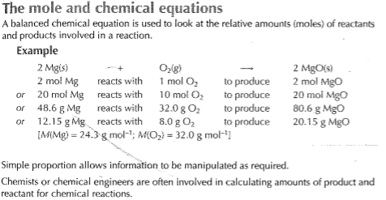  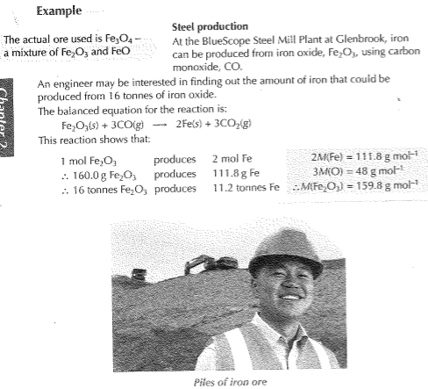  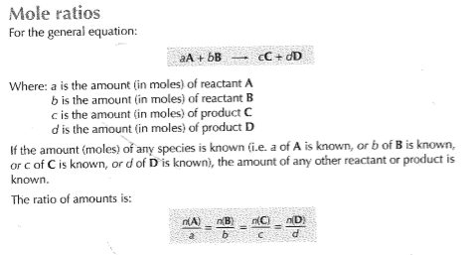  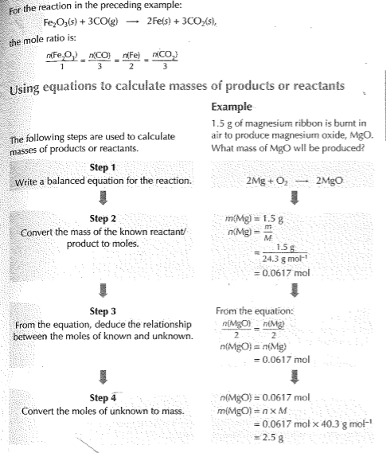
Calculating moles in a balanced equation iwth the mole ratio by Mr Causey - https://www.youtube.com/watch?v=p_vh_uiZ2QI
Using mole ratio to determine moles of product by Mr Causey - https://www.youtube.com/watch?v=9vzobcx15dI
Stoichimetry - https://www.khanacademy.org/science/chemistry/chemical-reactions-stoichiome/stoichiometry-ideal/v/stoichiometry

 | 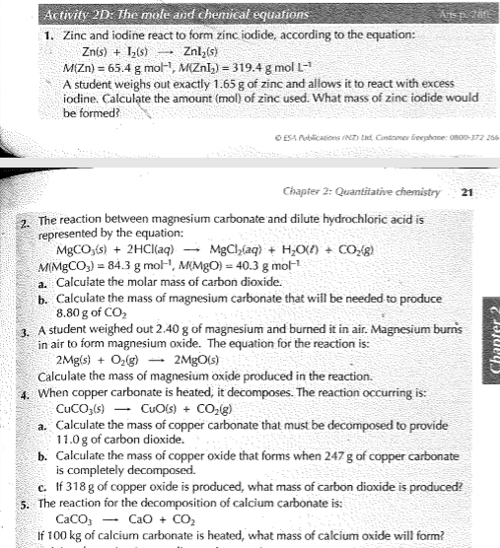
Assignment
Assessment | Written test will be on week 9 of term 2.
References | - https://www.khanacademy.org/science/chemistry/chemical-reactions-stoichiome/stoichiometry-ideal/a/stoichiometry  - https://www.khanacademy.org/science/chemistry/chemical-reactions-stoichiome/stoichiometry-ideal/v/stoichiometry  - https://www.youtube.com/watch?v=9vzobcx15dI  - https://www.youtube.com/watch?v=p_vh_uiZ2QI  - Boniface, S. (2012) Level 2 Chemistry study guide – Chapter 2. ESA publication Ltd : New Zealand.

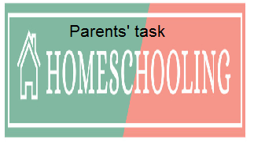

WEEKLY CHECKLIST For Parents:

Term: 2 Week number 1 Date…… to…… Month: …………

Subject | Number of lessons | Days | Tick when activity is complete | Parents comment | Signature
 | 1
 | 2
 | 3
 | 4
 | 5
 | 6

Term: 2 Week number 2 Date…… to…… Month: …………

Subject | Number of lessons | Days | Tick when activity is complete | Parents comment | Signature
 | 1
 | 2
 | 3
 | 4
 | 5
 | 6

Term: 2 Week number 3 Date…… to…… Month: …………

Subject | Number of lessons | Days | Tick when activity is complete | Parents comment | Signature
 | 1
 | 2
 | 3
 | 4
 | 5
 | 6

Term: 2 Week number 4 Date…… to…… Month: …………

Subject | Number of lessons | Days | Tick when activity is complete | Parents comment | Signature
 | 1
 | 2
 | 3
 | 4
 | 5
 | 6

Term: 2 Week number 5 Date…… to…… Month: …………

Subject | Number of lessons | Days | Tick when activity is complete | Parents comment | Signature
 | 1
 | 2
 | 3
 | 4
 | 5
 | 6

Term: 2 Week number 6 Date…… to…… Month: …………

Subject | Number of lessons | Days | Tick when activity is complete | Parents comment | Signature
 | 1
 | 2
 | 3
 | 4
 | 5
 | 6

Term: 2 Week number 7 Date…… to…… Month: …………

Subject | Number of lessons | Days | Tick when activity is complete | Parents comment | Signature
 | 1
 | 2
 | 3
 | 4
 | 5
 | 6

Term: 2 Week number 8 Date…… to…… Month: …………

Subject | Number of lessons | Days | Tick when activity is complete | Parents comment | Signature
 | 1
 | 2
 | 3
 | 4
 | 5
 | 6

Term: 2 Week number 9 Date…… to…… Month: …………

Subject | Number of lessons | Days | Tick when activity is complete | Parents comment | Signature
 | 1
 | 2
 | 3
 | 4
 | 5
 | 6

Term: 2 Week number 10 Date…… to…… Month: …………

Subject | Number of lessons | Days | Tick when activity is complete | Parents comment | Signature
 | 1
 | 2
 | 3
 | 4
 | 5
 | 6

Term: 2 Week number 11 Date…… to…… Month: …………

Subject | Number of lessons | Days | Tick when activity is complete | Parents comment | Signature
 | 1
 | 2
 | 3
 | 4
 | 5
 | 6

Term: 2 Week number 12 Date…… to…… Month: …………

Subject | Number of lessons | Days | Tick when activity is complete | Parents comment | Signature
 | 1
 | 2
 | 3
 | 4
 | 5
 | 6

Term: 2 Week number 13 Date…… to…… Month: …………

Subject | Number of lessons | Days | Tick when activity is complete | Parents comment | Signature
 | 1
 | 2
 | 3
 | 4
 | 5
 | 6

