Central School
Home School Package

Year :11

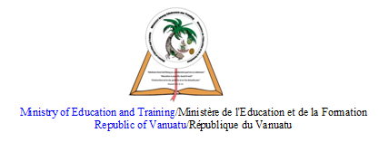

HOME SCHOOL PACKAGE CONTENT
zzzzzzzzzzzz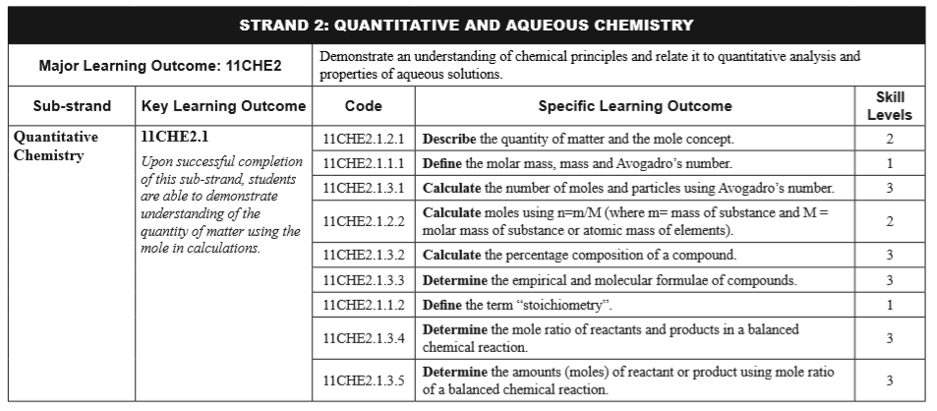

LESSON Plan

Teacher | Name : Judy W Vire  Subject : Chemistry
Date | Week 7 of term 2
Topic :Quantitative Chemistry
Lesson number : 2

Learning outcomes | - Calculate moles using n=m/M (where m=mass of substance and M=molar mass of substance or atomic mass of elements.)  - Calculate the percentage composition of a compound  - Determine the empirical and molecular formulae of compounds.
Introduction | If you were to ask to prepare some solutions in the laboratory, you first need to learn and familiar with quantitative calculation. You first need to learn the following :  - Mole  - Percentage composition  - Empirical formula  - Molecular formula
Catch phrase for the lesson
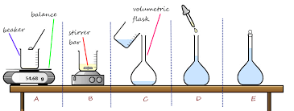
Learners notes | Summary Mole calculations  This equation shows how molar mass, number of moles and mass are related:  number of moles = mass ÷ molar mass  n= $\frac{m}{M}$  This can be rearranged to find the mass if the number of moles and molar mass (its relative formula mass in grams) are known. It can also be rearranged to find the molar mass if the mass and number of moles are known.  The triangle diagram may help you with this.  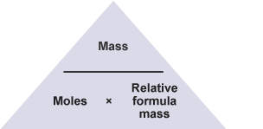  1. Calculate the number of moles of carbon dioxide molecules in 22 g of CO₂.  n=$\frac{m}{M}$ therefore, $\frac{22g}{44g/mol}$ = 0.5mol  2. Calculate the mass of 2 mol of carbon dioxide (CO₂).  m=n x M therefore, 2mol X 44g/mol = 88g  3. 10 mol of carbon dioxide has a mass of 440 g. What is the relative formula mass of carbon dioxide?  M = $\frac{m}{n}$ therefore, $\frac{440g}{10mol}$ = 44g/mol  Definition of Percentage Composition  The percentage composition of an element in a compound is the mass percentage of the element present in the compound. It tells the mass percentage of each element present in a compound.  How to Calculate Percentage Composition  All we need is the molecular formula and the molar mass of each element present in a compound to determine percentage composition. It is the percentage ratio of the total mass of an element to the total mass of the compound. The formula below is used to calculate the percentage of an element.  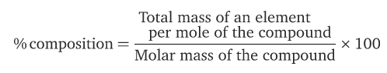  Let us take an example of water (H₂O). Water has 2 molecules of hydrogen and one mole of oxygen. One mole of water is of 18.0152 grams.  Therefore, H = 2 x 1.008g/mol = 2.016g/mol  O = 1 x 16g/mol = 16g/mol  So H₂O = 2.016g/mol + 16g/mol  = 18.016g/mol  Therefore, % of hydrogen element in H2O  % H = $\frac{2.016g/mol}{18.016g/mol }$ X 100  = 11.1 %  % O = $\frac{16g/mol}{18.016g/mol }$ X 100  = 88.8%  To prove : 11.1 + 88.9 = 100  Empirical Formula – It tells us the simplest or most reduced ratio of atoms in a compound. Eg $\frac{4 Carbon ÷4}{8 Hydrogen ÷4 }$ = $\frac{1 carbon}{2 hydrogen}$  Molecular Formula – It tells us how many atom of each element are in compound. Eg C₄H₈  Steps to calculate empirical formula :  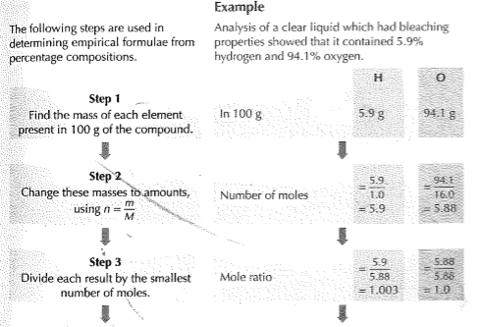  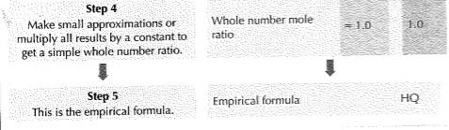  Steps to calculate molecular formula :  - Need the empirical formula  - Need the mass of the empirical formula  - Need the molar mass which will alway be provided  Example :  The empirical formula of a liquid was found to be HO. In a separate analysis, the liquid was shown to have a molar mass of 34g/mol.  Therefore, the formula below is used :  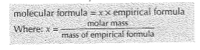  Find value of x = $\frac{34g/mol}{17g/mol (M:HO)}$ = 2  Find molecular formula = x X empirical formula  = 2 X HO  = H₂O₂

Empirical Formula and Molecular Formula Introduction by Tyler Dewitt - https://www.youtube.com/watch?v=wnRaBWvhYKY

Empirical Formula & Molecular Formula Determination form -https://www.youtube.com/watch?v=JeSSucG-CVw

- Calculate the mole of carbon in 88.0g of propance, C3H8
- Calculate the molar mass of carbon dioixde
- Calculate the mass of 10.7mol of C4H10
- Calculate the mole of 10.0g of CuCO4
- What is the percentage composition of oxide in magnesium oxide, MO
- Find the empirical formulae of 80% copper and 20% oxygen
- Calculate the empirical formula of the oxide of sulfur, SO which is 60% oxide by weight.
- The empirical formula of a substance is CH2. Its molar mass is 84g/mol. Find the molecular formula of the substance.
- A hydrogen contains 82.7% carbon and 17.3% hydrogen by weight.
- Work out the empirical formula
- The molar mass of the compound is 58g/mol. What is its molecular formula ?

Assignment
Assessment | Assessment will be on week 9 of term 2
References | - https://www.toppr.com/guides/chemistry/some-basic-concepts-of-chemistry/percentage-composition/  - https://chemistrygod.com/percentage-composition#definition-of-percentage-composition  - https://www.youtube.com/watch?v=wnRaBWvhYKY  - https://www.youtube.com/watch?v=JeSSucG-CVw  - Boniface, S. (2012) Level 2 Chemistry study guide – Chapter 2. ESA publication Ltd : New Zealand.

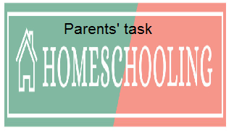

WEEKLY CHECKLIST For Parents:

Term: 2 Week number 1 Date…… to…… Month: …………

Subject | Number of lessons | Days | Tick when activity is complete | Parents comment | Signature
 | 1
 | 2
 | 3
 | 4
 | 5
 | 6

Term: 2 Week number 2 Date…… to…… Month: …………

Subject | Number of lessons | Days | Tick when activity is complete | Parents comment | Signature
 | 1
 | 2
 | 3
 | 4
 | 5
 | 6

Term: 2 Week number 3 Date…… to…… Month: …………

Subject | Number of lessons | Days | Tick when activity is complete | Parents comment | Signature
 | 1
 | 2
 | 3
 | 4
 | 5
 | 6

Term: 2 Week number 4 Date…… to…… Month: …………

Subject | Number of lessons | Days | Tick when activity is complete | Parents comment | Signature
 | 1
 | 2
 | 3
 | 4
 | 5
 | 6

Term: 2 Week number 5 Date…… to…… Month: …………

Subject | Number of lessons | Days | Tick when activity is complete | Parents comment | Signature
 | 1
 | 2
 | 3
 | 4
 | 5
 | 6

Term: 2 Week number 6 Date…… to…… Month: …………

Subject | Number of lessons | Days | Tick when activity is complete | Parents comment | Signature
 | 1
 | 2
 | 3
 | 4
 | 5
 | 6

Term: 2 Week number 7 Date…… to…… Month: …………

Subject | Number of lessons | Days | Tick when activity is complete | Parents comment | Signature
 | 1
 | 2
 | 3
 | 4
 | 5
 | 6

Term: 2 Week number 8 Date…… to…… Month: …………

Subject | Number of lessons | Days | Tick when activity is complete | Parents comment | Signature
 | 1
 | 2
 | 3
 | 4
 | 5
 | 6

Term: 2 Week number 9 Date…… to…… Month: …………

Subject | Number of lessons | Days | Tick when activity is complete | Parents comment | Signature
 | 1
 | 2
 | 3
 | 4
 | 5
 | 6

Term: 2 Week number 10 Date…… to…… Month: …………

Subject | Number of lessons | Days | Tick when activity is complete | Parents comment | Signature
 | 1
 | 2
 | 3
 | 4
 | 5
 | 6

Term: 2 Week number 11 Date…… to…… Month: …………

Subject | Number of lessons | Days | Tick when activity is complete | Parents comment | Signature
 | 1
 | 2
 | 3
 | 4
 | 5
 | 6

Term: 2 Week number 12 Date…… to…… Month: …………

Subject | Number of lessons | Days | Tick when activity is complete | Parents comment | Signature
 | 1
 | 2
 | 3
 | 4
 | 5
 | 6

Term: 2 Week number 13 Date…… to…… Month: …………

Subject | Number of lessons | Days | Tick when activity is complete | Parents comment | Signature
 | 1
 | 2
 | 3
 | 4
 | 5
 | 6

