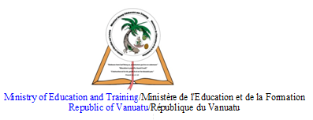

Central School
Home School Package

Year :11

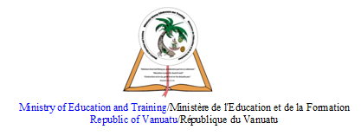

HOME SCHOOL PACKAGE CONTENT
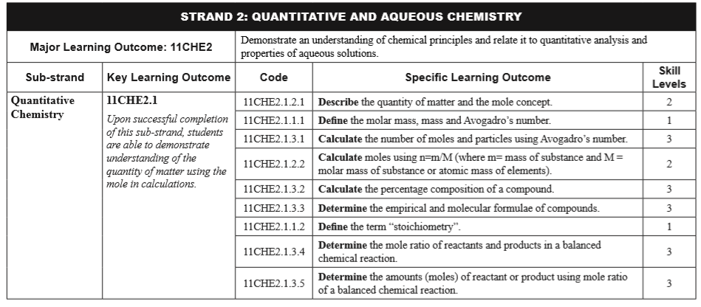

LESSON Plan

Teacher | Name : Judy W Vire  Subject : Chemistry
Date | Week 7 of term 2
Topic : Quantitative and Aqueous Chemistry
Lesson number : 1, Term 2

Learning outcomes | - Describe the quanity of matter and the mole concept  - Define the molar mass, mass and Avogadro’s number  - Calculate the number of moles and particles using Avogadro’s number
Introduction | The difference between qualitative and quantitative analysis in chemistry is that the qualitative analysis in chemistry gives the presence or absence of different chemical components/what is reacts or is produced in a sample whereas quantitative analysis in chemistry gives the amount of different chemical components/how much react or present in a given sample
Catch phrase for the lesson
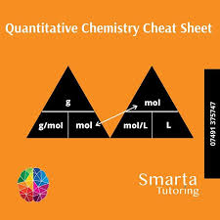
Learners notes | Summary  Quantitative chemistry is the study of how much reacts or is produced – it deals with quantities. When large qanitites are involved, the number is never counted. Weighing is one method commonly used to specify a large number of items. For instance, in a bank, large quanitites of one dolar coins are weighed instead of being counted. A famer needing staples to wire up a fence will order a 25kg box of staples rather than specifying a particular number of staples.  In chemistry the quantity chosen to describe the amount of substance is the mole (mol) when used as a unit. The amount of substance (in mol) is represented by the symbol n. For example, n(H₂O) means the amount of water in moles. The mole is defined as the amount of substance which contains the same numner of particles (atoms, ions or molecules) as there are atoms in exactly 12g of carbon-12. To calculate amount of substance (mol),we use the general formula n = m/M  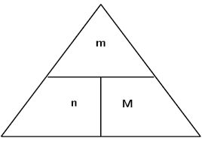  Where m = mass, n = mole and M = molar mass of a substance.  Molar mass (M) is the mass of one mole of a substance (element or compound) using unit grams per mole or g mol. The molar mass of a compound can be calculated by adding together the molar masses of all the elements in the compound. For example, the malor mass of ammonia (NH₃) is :  M(NH₃) = M(N) + 3 x M(H)  = 14.0 + 3 x 1.0  = 17.0  Therefore, M(NH₃) = 17.0 g mol  Mass is the amount of matter or substance that makes up an object. It is measured in units called kilograms ( kg). Mass always stays the same, while weight changes with changes in gravity.  The number 6.02 × 10²³ indicating the number of atoms or molecules/particle in a mole of any substance. This is called Avogadro number. For example, 1 mol of carbon contains 6.02 x 10²³ atoms. 0.5mol of carbon dioxide contains 0.5 x 6 x 10²³ = 3 x 10²³ carbon dioxide molecules.
- Define the following terms
- How many particles of magnesium in 1 mol
- How many moles of sodium atom in 3 x 10²³ atom
- For hte compound methane, CH4, find the
- Molar mass
- Mass to wo moles
- Amount of compound in 64.0g
- Mass of 3.00 mol
- For the ionic compound calcium carbonate, CaCO3, find the
- Molar mass
- Mass of 0.0500mol
- Amount of calcium carbonate in 10.0g of calcium carbonate

Assignment
Assessment | Written test on week 9, term 2
References | Boniface, S. (2012) Level 2 Chemistry study guide – Chapter 2. ESA publication Ltd : New Zealand.  https://www.google.com/search?q=mole+calculation+in+chemistry&sxsrf=ALeKk03fpaxabadYuuRrYggnMGaUH4WzAQ:1588852930284&source=lnms&tbm=isch&sa=X&ved=2ahUKEwjb3om02qHpAhXhzjgGHcdWB1AQ_AUoAXoECAwQAw&biw=1242&bih=597  https://www.google.com/search?q=avogadro%27s+number+in+chemistry+means&oq=avogadro%27s+number+in+chemistry+means&aqs=chrome..69i57.16847j1j7&sourceid=chrome&ie=UTF-8  https://www.google.com/search?sxsrf=ALeKk03mThdOS12F0MgOY-cnSkLme7Q72w%3A1588852013783&ei=LfWzXvS8L-aortoPyvOh2AM&q=mass+in+chemistry+means&oq=mass+in+chemistry+means&gs_lcp=CgZwc3ktYWIQAzIECAAQHjIGCAAQCBAeOgQIABBHOgYIABAHEB5QoKIBWIq_AWC7xwFoAHACeACAAf4CiAG3HZIBBjItMTAuM5gBAKABAaoBB2d3cy13aXo&sclient=psy-ab&ved=0ahUKEwi0h4f_1qHpAhVmlEsFHcp5CDsQ4dUDCAw&uact=5

WEEKLY CHECKLIST For Parents:

Term: 2 Week number 1 Date…… to…… Month: …………

Subject | Number of lessons | Days | Tick when activity is complete | Parents comment | Signature
 | 1
 | 2
 | 3
 | 4
 | 5
 | 6

Term: 2 Week number 2 Date…… to…… Month: …………

Subject | Number of lessons | Days | Tick when activity is complete | Parents comment | Signature
 | 1
 | 2
 | 3
 | 4
 | 5
 | 6

Term: 2 Week number 3 Date…… to…… Month: …………

Subject | Number of lessons | Days | Tick when activity is complete | Parents comment | Signature
 | 1
 | 2
 | 3
 | 4
 | 5
 | 6

Term: 2 Week number 4 Date…… to…… Month: …………

Subject | Number of lessons | Days | Tick when activity is complete | Parents comment | Signature
 | 1
 | 2
 | 3
 | 4
 | 5
 | 6

Term: 2 Week number 5 Date…… to…… Month: …………

Subject | Number of lessons | Days | Tick when activity is complete | Parents comment | Signature
 | 1
 | 2
 | 3
 | 4
 | 5
 | 6

Term: 2 Week number 6 Date…… to…… Month: …………

Subject | Number of lessons | Days | Tick when activity is complete | Parents comment | Signature
 | 1
 | 2
 | 3
 | 4
 | 5
 | 6

Term: 2 Week number 7 Date…… to…… Month: …………

Subject | Number of lessons | Days | Tick when activity is complete | Parents comment | Signature
 | 1
 | 2
 | 3
 | 4
 | 5
 | 6

Term: 2 Week number 8 Date…… to…… Month: …………

Subject | Number of lessons | Days | Tick when activity is complete | Parents comment | Signature
 | 1
 | 2
 | 3
 | 4
 | 5
 | 6

Term: 2 Week number 9 Date…… to…… Month: …………

Subject | Number of lessons | Days | Tick when activity is complete | Parents comment | Signature
 | 1
 | 2
 | 3
 | 4
 | 5
 | 6

Term: 2 Week number 10 Date…… to…… Month: …………

Subject | Number of lessons | Days | Tick when activity is complete | Parents comment | Signature
 | 1
 | 2
 | 3
 | 4
 | 5
 | 6

Term: 2 Week number 11 Date…… to…… Month: …………

Subject | Number of lessons | Days | Tick when activity is complete | Parents comment | Signature
 | 1
 | 2
 | 3
 | 4
 | 5
 | 6

Term: 2 Week number 12 Date…… to…… Month: …………

Subject | Number of lessons | Days | Tick when activity is complete | Parents comment | Signature
 | 1
 | 2
 | 3
 | 4
 | 5
 | 6

Term: 2 Week number 13 Date…… to…… Month: …………

Subject | Number of lessons | Days | Tick when activity is complete | Parents comment | Signature
 | 1
 | 2
 | 3
 | 4
 | 5
 | 6

