TOURISM AND HOSPITALITY
Strand 2: The development of tourism and hospitality | Sub Strand 2.2: Flow of tourists into and within the Pacific
Lesson Activity 2

The learning outcomes targeted in this activity are outlined below:

SLO | Specific Learning Outcomes (SLO) | Skill score | SLO code | Achieved
8 | List the categories of tourists who travel to and within the Pacific countries and the student’s country, in particular | 2 | Toh2.2.2.7
11 | Explain why categories of tourists travel to and within the student’s country | 3 | Toh2.2.3.1

Learning Objectives

Upon completion of this lesson, students should be able to:
- List the categories of tourists who travel into the Pacific countries and the student’s own country.
- Explain why there are different categories of tourists travelling into the pacific countries and the student’s own country.

OVERVIEW

Types of Tourists
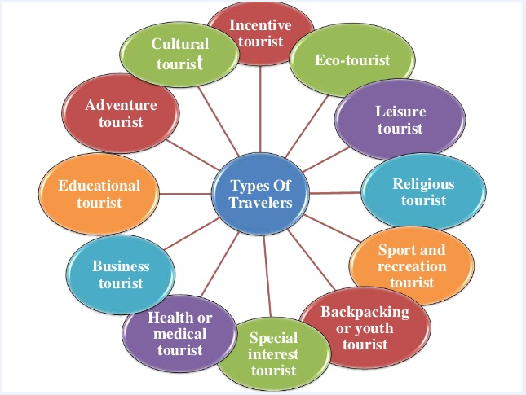

Lesson Activity
This is an individual research activity which to be carried under the guidance of the teacher. The above resource is a general one but each student must use the internet plus any other resource to identify the types of tourists coming to the region and his/her own country.

- List
- the categories of tourists who travel into the Pacific countries (skill level 2 / SLO code Toh2.2.2.7)
- the categories of tourists who travel into your own country. (skill level 2 / SLO code Toh2.2.2.7)

- Explain why there are different categories of tourists travelling into the pacific countries and the student’s own country.

