TOURISM AND HOSPITALITY
Strand 2: The development of tourism and hospitality | Sub Strand 2.1: History and developments of tourism in the Pacific
Lesson Activity 3

The learning outcomes targeted in this activity are outlined below:

SLO | Specific Learning Outcomes (SLO) | Skill score | SLO code | Achieved
1 | State the important dates in the history and development of tourism in the region and country | 1 | Toh2.1.1.1
22 | Discuss with examples of the factors that have influenced the development of tourism and hospitality in the South Pacific | 4 | Toh2.1.4.2
21 | Discuss the trends in the development of tourism and hospitality in the Pacific, | 4 | Toh2.1.4.1

Learning Objectives

Upon completion of this lesson, students should be able to:

- State the important dates in the history and development of tourism in the region and the student’s country.
- Discuss the trends in the development of tourism and hospitality in the Pacific
- Discuss with examples of the factors that have influenced the development of tourism and hospitality in the South Pacific
OVERVIEW

Factors That Have Brought About Change To Tourism And Hospitality Industry

The factors that bring about changes to tourism are categorized into economic, political, socio-cultural, environmental.

ECONOMIC factors that bring about changes to tourism  - Demand, Supply, Transport,Price  - Income,Inflation, Exchange rates | SOCIO-CULTURAL factors that bring about changes to tourism  - Perception  - Attitudes
POLITICAL factors that bring about changes to tourism  - Government stability  - Political conflict | ENVIRONMENTAL factors that bring about changes to tourism  - Natural disasters  - Seasonality  - Pollution and resource management
Flows Of Tourism Into The Pacific Island Countries

Destinations in the Pacific ACP and SPTO member countries welcomed 2,137,538 tourist arrivals (by air) to its shores in 2017. This represents a 3.1% gain over 2016, or 65,004 more tourist arrivals during the period. Growth reflected the shared positive performances by majority of the destinations triggered by the sustained outbound travel demand, increased connectivity, massive promotional campaigns and improved infrastructure developments over the year. By destinations, double digit growth were recorded for Cook Islands, Kiribati, Niue, Timor Leste, Solomon Islands and Vanuatu with moderate growth from FSM, Fiji, French Polynesia, New Caledonia, Samoa, Tonga and Tuvalu. By sea arrivals, mainly by cruise, the region received a total of 982,798from nine Pacific destinations in 2017. This brings the total visitor arrivals (both air and sea) to the region at 3,120,336 during the year. Refer to the table below:

Tourist arrivals to ACP Pacific and SPTO member countries, 2017
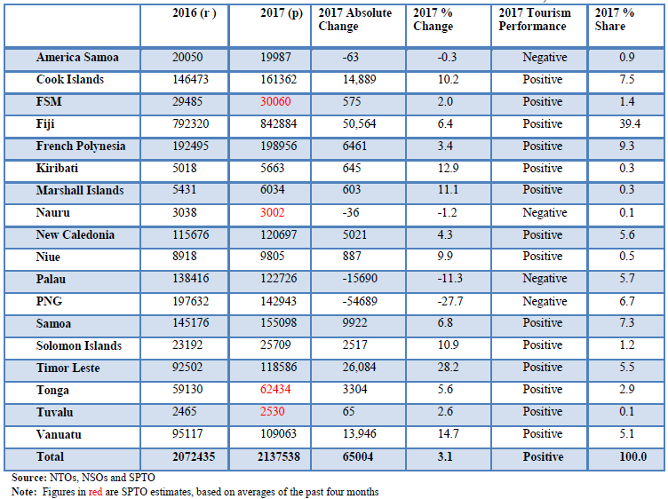

On shares, Fiji, the lead tourism destination in the region attracted an incremental 39.4% share of the total arrivals. French Polynesia the second-highest accounted for 9.3% share, followed by Cook Islands at 7.5%, Samoa 7.3%, PNG 6.7%, Palau 5.7%, New Caledonia 5.6%, Timor Leste 5.5% and Vanuatu at 5.1%. The remaining 7.7% was shared among all the other destinations. Refer to table above.

Source Markets

In terms of market shares, Australia and New Zealand continued to top the source markets ranking with 29.5% and 20.8%. However, both shares of 50.3% in 2017, is slightly below their 51.4% share in 2016. USA, the third largest source market represented 10%, Europe and Other Asia edged at 8.9% each and Other Pacific Islands elevated to 7.5% whilst China reduced to 6.7%. All other source markets represented the remaining 7.7% share. Refer to the table below:

Tourist Arrivals in Pacific ACP and SPTO Member Countries by Source Market, 2017
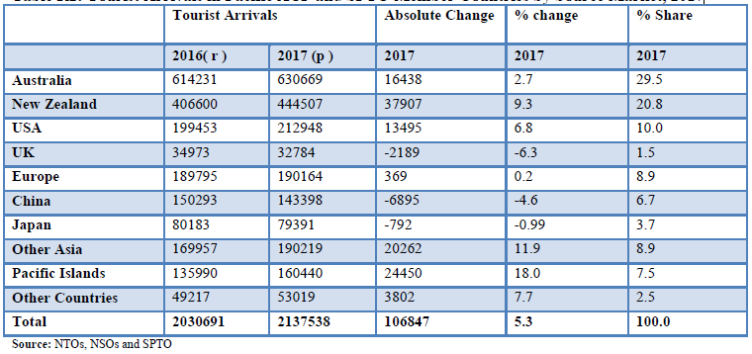

Exercise 3
This task is a research activitywhich to be carried out by each student from each country with the assistance from his/her teachers. Students are to use the resources above, the use of internet and their own knowledge to do the tasks.

- State the important dates in the history and development of tourism in the region and the student’s country. L1 (Toh2.1.1.1)

- Discuss the trends in the development of tourism and hospitality in the Pacific L4 (Toh2.1.4.1)

- Discuss with examples the factors that have influenced the development of tourism and hospitality in the South Pacific L4 (Toh2.1.4.2)

