TOURISM AND HOSPITALITY
Strand 2: The development of tourism and hospitality | Sub-Strand 2.1: History and developments of tourism in the Pacific
Lesson Activity 1

The learning outcomes targeted in this activity are outlined below:

SLO | Specific Learning Outcomes (SLO) | Skill score | SLO code | Achieved
2 | Locate - major Pacific Rim market segments and their main international airports: Australia (Sydney SYD, Brisbane BNE), New Zealand (Auckland AKL), Japan (Tokyo TYO), China (Beijing BJS) United States of America (Los Angeles LAX, Honolulu HNL) | 1 | Toh2.1.1.2
3 | Name - major Pacific Rim market segments and their main international airports: Australia (Sydney SYD, Brisbane BNE), New Zealand (Auckland AKL), Japan (Tokyo TYO), China (Beijing BJS) United States of America (Los Angeles LAX, Honolulu HNL) | 1 | Toh2.1.1.3
4 | Locate - Countries: Cook Islands, Fiji, Kiribati, Nauru, New Caledonia, Niue, Papua New Guinea, Samoa, Solomon Islands, Tahiti, Tokelau, Tonga, Tuvalu, Vanuatu | 1 | Toh2.1.1.4
5 | Name - Countries: Cook Islands, Fiji, Kiribati, Nauru, New Caledonia, Niue, Papua New Guinea, Samoa, Solomon Islands, Tahiti, Tokelau, Tonga, Tuvalu, Vanuatu | 1 | Toh2.1.1.5
6 | Locate - cities/major towns: Avarua, Suva, Nadi, Tarawa, Noumea, Port Moresby, Apia, Honiara, Papeete, Nuku’alofa, Funafuti, Port VilaTokelau, Tonga, Tuvalu, Vanuatu | 1 | Toh2.1.1.6
7 | Name - cities/major towns: Avarua, Suva, Nadi, Tarawa, Noumea, Port Moresby, Apia, Honiara, Papeete, Nuku’alofa, Funafuti, Port VilaTokelau, Tonga, Tuvalu, Vanuatu | 1 | Toh2.1.1.7
8 | Locate - international airports and their 3 letter IATA codes: Avarua, Rarotonga (RAR), Nadi (NAN), Suva (SUV), Tarawa (TRW), Noumea (NOU), Port Moresby (POM), Faleolo, Samoa (APW), Henderson, Honiara (HIR), Fua’amotu, Tonga (TBU), Port Vila (VLI) | 1 | Toh2.1.1.8
9 | Name - international airports and their 3 letter IATA codes: Avarua, Rarotonga (RAR), Nadi (NAN), Suva (SUV), Tarawa (TRW), Noumea (NOU), Port Moresby (POM), Faleolo, Samoa (APW), Henderson, Honiara (HIR), Fua’amotu, Tonga (TBU), Port Vila (VLI) | 1 | Toh2.1.1.9
19 | Explain the importance of international airlines in the region and the student’s own country. Major airlines may include but are not limited to: Samoan Air, Air Vanuatu, Aircalin, Air New Zealand, Qantas, Korean Air, Japan Airlines, Air Nauru, Fiji Airways. | 3 | Toh2.1.3.1.
20 | Explain the importance of international cruise ships - Locations may include but are not limited to: Christmas Island, Fanning Island (Kiribati), Champagne Beach (Vanuatu), Vava’u (Tonga), Yasawa Islands (Fiji) | 3 | Toh2.1.3.2

Learning Objectives

Upon completion of this lesson, students should be able to:

- Locate and name the major Pacific Rim market segments and their main international airports
- Locate and name the countries in the Pacific region.
- Locate and name the cities/major towns in the Pacific region.
- Locate and name the International airports in the region and their IATA codes.
- Explain the importance on the international airlines in the region and the student’s own country.
- Explain the importance of international cruise ships in the region and the student’s own country

OVERVIEW

World map
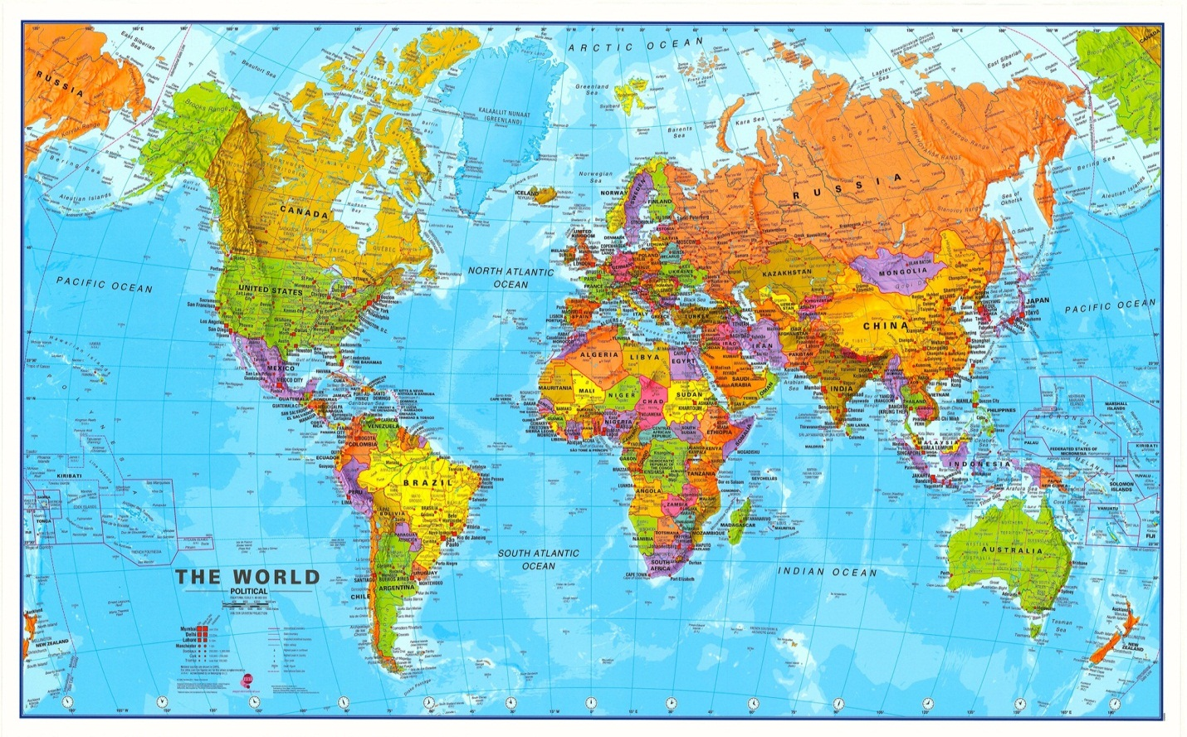

Map of the South Pacific 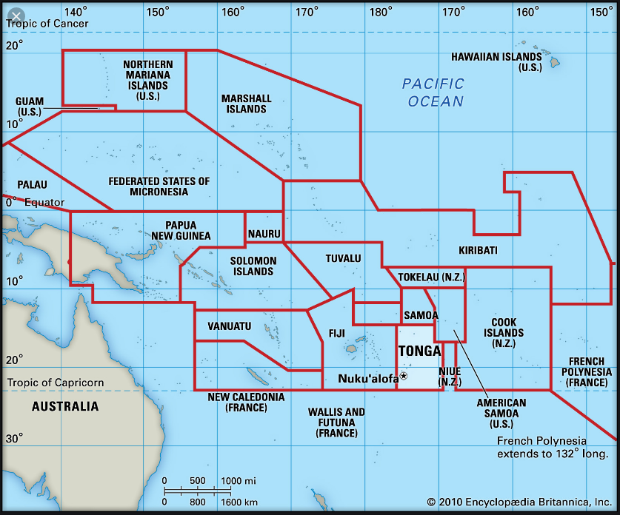

IATA
IATA stands for the International Air Transport Association and is the official trade organization for the world’s airlines (more than 85 participating nations).For air carriers, IATA provides a polled resource for scheduling, traffic and routes, standardizing services and the creation of a worldwide public service for the air industry.
For consumers, IATA sets the international standard for services and business practices amongst member airlines. As an example, the three-digit airport codes used internationally are an IATA convention. Additionally, IATA aims to achieve the following mandate:
- To promote safe, regular and economic air transport
- To foster air commerce
- To study problems connected with airline industry
- To provide a means of collaborating between air transport companies and agencies
- To co-operate with other international air transportation organizations Essentially, IATA is airlines working together to standardize and improve service internationally Due to the vital role played by IATA in air transportation issues, it is recommended that you ensure that your carrier/forwarder is an IATA agent.
Role of international airlines in the Tourism and Hospitality industry

The role of international airlines in the tourism industry is to provide mass and quick transportation between countries under safe, standardized and economic conditions. Its relationship to the tourism industry is better understood by breaking down the entire activity of tourism into its components parts.

Because of quick and efficient transportation, people are motivated to travel for various reasons as destinations have become more accessible. Some of these reasons to travel are:
- Sightseeing – historical, cultural, social and technological sights
- Relaxation – beach and mountain resorts.
- Sports – mountain climbing, skiing, surfing, scuba diving etc.
- Special interest – study tours on art, history, religions, culture and science.
- Shopping – personal and professional
- Business
- Governmental – political, cultural, social and scientific reasons.

The travel industry requires an efficient infrastructure which put together constitutes the tourism industry which is the world’s second-largest industry. The infrastructure is thus:

- Transportation
- Accommodation
- Travel agents
- Communications
- Other services

Cruise Ships

A cruise ship is a luxury vessel that is used to take passengers on a pleasure voyage in a journey that is as much a part of the experience as the various destinations on the way. In contrast to an ocean liner that transports passengers from one point on the globe to the other often across the oceans, a cruise ship or a cruise liner as it is known by most, takes the people on board to a round trip that is of varied duration, from a single day to possibly a week and culminates at the originating port. This is a very refreshing mode of enjoyment and recreation, which relaxes the mind and replenishes energies to a great extent.

Advantages
- Less expensive – Because repositioning cruises are usually smaller and quieter, they’re likely to be cheaper than their round-trip counterparts.
- More locations accessible – River cruises show you different parts of countries not accessible on normal open water cruises with a heavier focus on sports activities and excursions.
- You’ll get to see many more destinations than you would on a normal cruise, and you’ll have the opportunity to make the most out of the cruise’s whole entertainment offering
- In good company – The advantage of going on a themed cruise is that you’ll be surrounded by people who share the same passion that brought you on board.

Exercise 1

This task is a practical activity and should be carried out as follow:
- Students are to work in pairs
- Students are to use the resources provided above plus the atlases, the internet (computer lab) plus their own knowledge to carry out this task.
- Teacher to provide to each student, 2 blank maps (1 Pacific Region map and 1 world map)

- Use the blank map of the world to carry out the following tasks.

 | Skill level | SLO code
- Locate - major Pacific Rim market segments and their main international airports: Australia (Sydney SYD, Brisbane BNE), New Zealand (Auckland AKL), Japan (Tokyo TYO), China (Beijing BJS) United States of America (Los Angeles LAX, Honolulu HNL) | 1 | Toh2.1.1.2
- Name - major Pacific Rim market segments and their main international airports: Australia (Sydney SYD, Brisbane BNE), New Zealand (Auckland AKL), Japan (Tokyo TYO), China (Beijing BJS) United States of America (Los Angeles LAX, Honolulu HNL) | 1 | Toh2.1.1.3

- Use the blank map of the Pacific region to carry out the following tasks.

 | Skill level | SLO code
- Locate - Countries: Cook Islands, Fiji, Kiribati, Nauru, New Caledonia, Niue, Papua New Guinea, Samoa, Solomon Islands, Tahiti, Tokelau, Tonga, Tuvalu, Vanuatu | 1 | Toh2.1.1.4
- Name - Countries: Cook Islands, Fiji, Kiribati, Nauru, New Caledonia, Niue, Papua New Guinea, Samoa, Solomon Islands, Tahiti, Tokelau, Tonga, Tuvalu, Vanuatu | 1 | Toh2.1.1.5
- Locate - cities/major towns: Avarua, Suva, Nadi, Tarawa, Noumea, Port Moresby, Apia, Honiara, Papeete, Nuku’alofa, Funafuti, Port VilaTokelau, Tonga, Tuvalu, Vanuatu | 1 | Toh2.1.1.6
- Name - cities/major towns: Avarua, Suva, Nadi, Tarawa, Noumea, Port Moresby, Apia, Honiara, Papeete, Nuku’alofa, Funafuti, Port VilaTokelau, Tonga, Tuvalu, Vanuatu | 1 | Toh2.1.1.7
- Locate - international airports and their 3 letter IATA codes: Avarua, Rarotonga (RAR), Nadi (NAN), Suva (SUV), Tarawa (TRW), Noumea (NOU), Port Moresby (POM), Faleolo, Samoa (APW), Henderson, Honiara (HIR), Fua’amotu, Tonga (TBU), Port Vila (VLI) | 1 | Toh2.1.1.8
- Name - international airports and their 3 letter IATA codes: Avarua, Rarotonga (RAR), Nadi (NAN), Suva (SUV), Tarawa (TRW), Noumea (NOU), Port Moresby (POM), Faleolo, Samoa (APW), Henderson, Honiara (HIR), Fua’amotu, Tonga (TBU), Port Vila (VLI) | 1 | Toh2.1.1.9

- Explain the importance of international airlines in the region and the student’s own country.
(Skill level 3. SLO code Toh2.1.3.1)

- Explain the importance of international cruise ships (Skill level 3 / SLO code Toh2.1.3.2)

