GEOGRAPHY
STRAND 4: GEOGRAPHICAL SKILLS AND IDEAS
Different directions using a compass
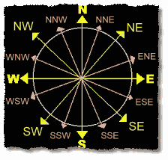
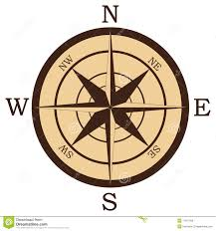

Conventional signs on a map
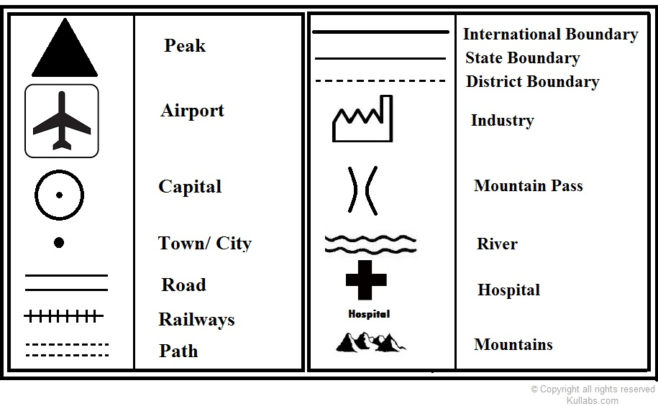
Different techniques for representing relief on a topographic map 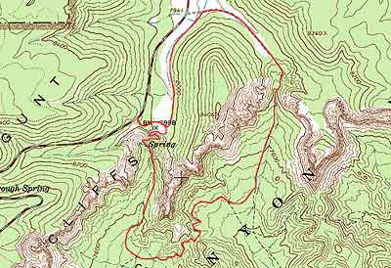
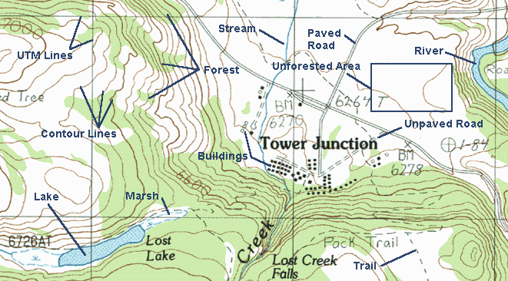
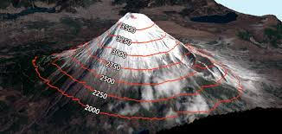
The important methods of representing relief features are hachure’s , contours, form lines, spot heights, bench marks, trigonometrical points, hill shading, layer-coloring, and so on. Each method has its own merits and demerits in depicting the relief of the land.
Advantage and Disadvantage of the different techniques of presenting relief on a map
Topographic maps are an important tool because they can represent the three-dimensional landscape in two dimensions. A person who can read a topographic map can find out the location of peaks, valleys, ridges and saddles, among other land features.
Perhaps the biggest drawback of using a topographical map is that the information can be dated. Every map gives the date as to when the survey was made, but map readers should be aware that the landscape and places on a map can change over time. These changes can be man-made, such as a newly built road or building.
Another disadvantage of a topographic map is that the information displayed is not exact. This can be particularly apparent when traveling through roadless or trailless areas. In these cases, a topographic map does not supply much information as to the nature of the vegetation.
Contour line- a line on a map joining points of equal height above or below sea level.
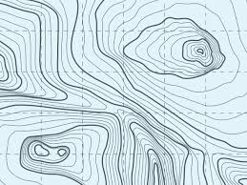
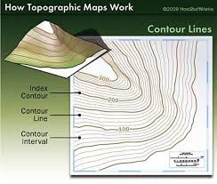
Land forms
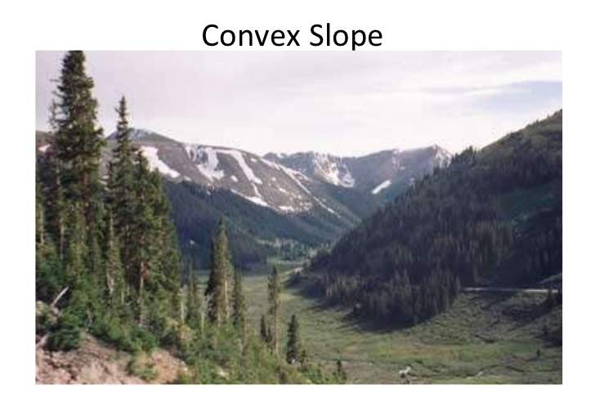
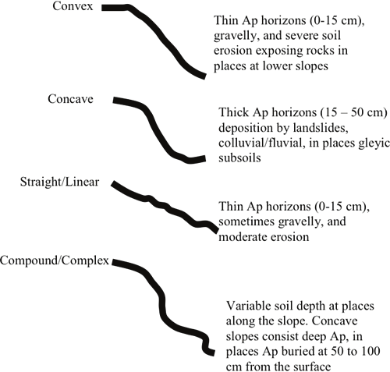

Escarpment Landform
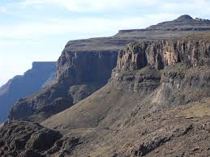
Tectonic Landform
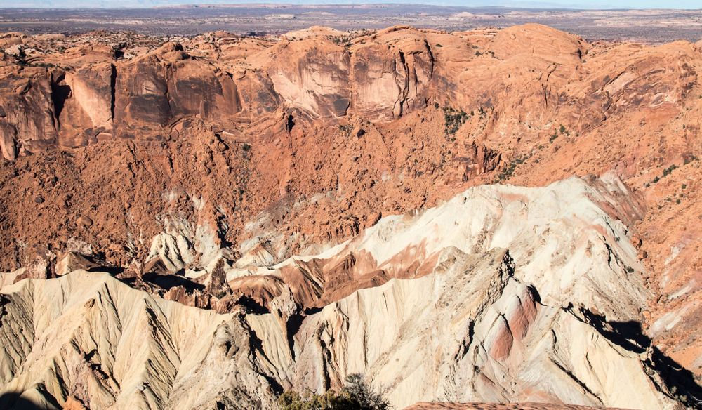

Erosion Landform
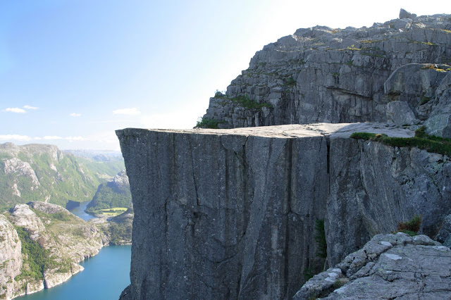

Arial Photograph
Example:
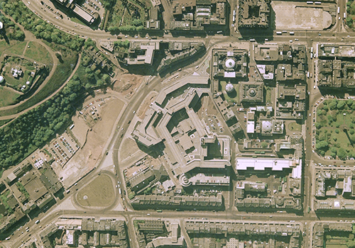
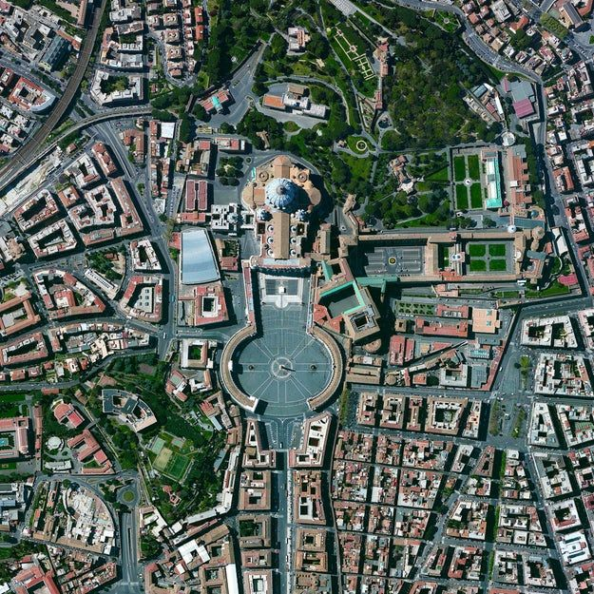

Different types of landforms on the Maps
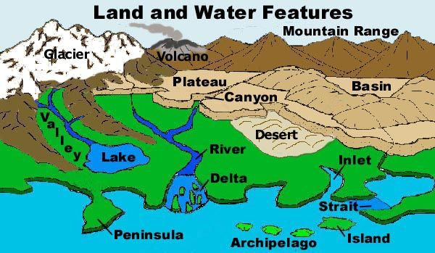
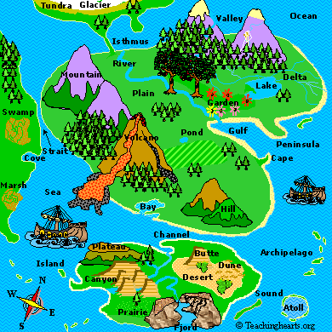
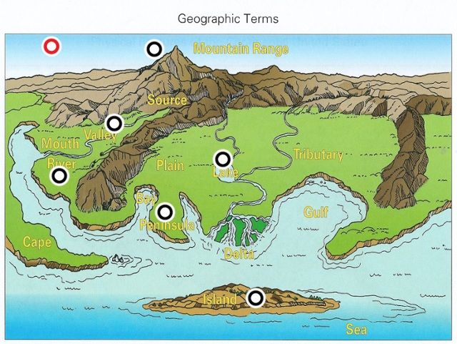

Different types of settlement patterns on maps
- Dispersed
- Linear
- Nucleated
- Isolated
- Clustered
