TERM 2: WEEK 6 – 7 (22nd June – 3rd July)

Strand 3: Organism Level Biology

Sub-strand 3.4 Nervous System

Lesson Activity 3.3

The specific learning outcomes (SLO) targeted in this activity are provided below:

Specific Learning Outcomes: Students are able to | Skill level | SLO code | Achieved  (Yes / No)
Describe the structure of neurons | 2 | Bio3.4.2.1
Describe the characteristics of neurons | 2 | Bio3.4.2.2
Explain the mechanism of nervous signal production and transmission | 3 | Bio3.4.3.1
Define action potential, resting potential | 1 | Bio3.4.1.1
Differentiate between an action potential and a resting potential | 3 | Bio3.4.3.2
Differentiate the actions of neuro transmitters between an action potential and a resting potential | 3 | Bio3.4.3.3
Explain the function of chemical messengers provided by the nervous system | 3 | Bio3.4.3.4
Discuss how the nervous, excretory and circulatory systems in a named animal work together to maintain a constant body environment | 4 | Bio3.4.4.1

Instructions:

- If you have access to the internet, refer to Central School’s website: www.centralschool.edu.vu, Year 12 Biology folder Term 2 Week 6 – 7, to watch videos on nervous system and access other resources.
- Answer the following questions.

- Neuron structure

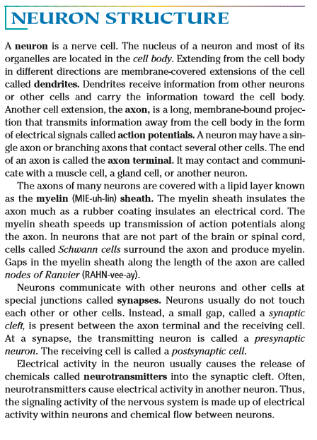
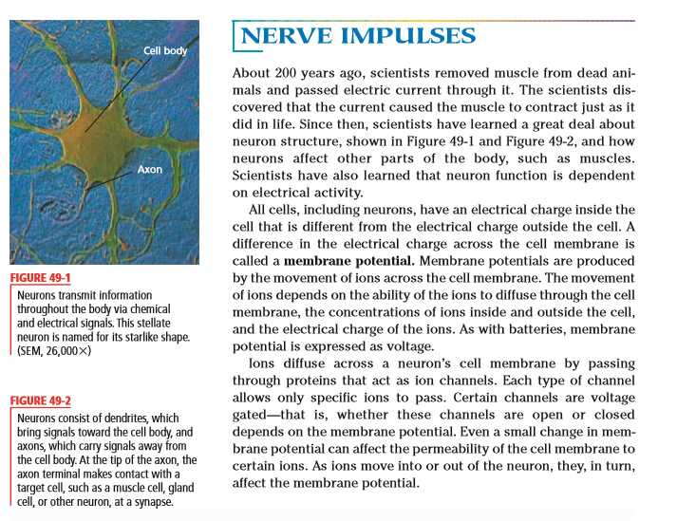

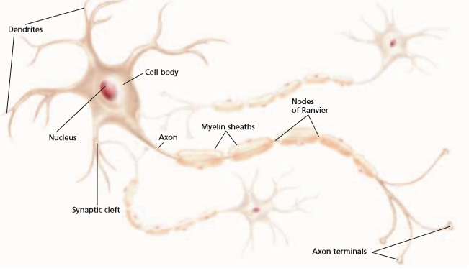
(Source: Holt, Rinehart, & Winston, 2006, pp.1005 – 1006)

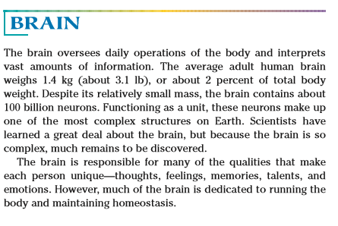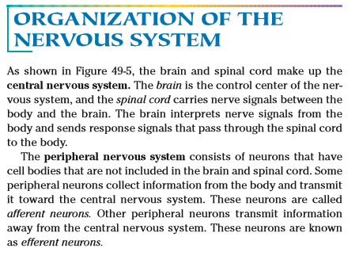
(Source: Holt, Rinehart, & Winston, 2006, p 1010)

- Describe the structure of a neuron.

______________________________________________________________________

______________________________________________________________________

______________________________________________________________________

______________________________________________________________________
- Describe the function of the neuron.

______________________________________________________________________

______________________________________________________________________

______________________________________________________________________

- Explain the mechanism of nervous signal production and transmission.

______________________________________________________________________

______________________________________________________________________

______________________________________________________________________

______________________________________________________________________

______________________________________________________________________

______________________________________________________________________

______________________________________________________________________

______________________________________________________________________

______________________________________________________________________

______________________________________________________________________

______________________________________________________________________

______________________________________________________________________

______________________________________________________________________

______________________________________________________________________

______________________________________________________________________

______________________________________________________________________

- Action potential and Resting potential
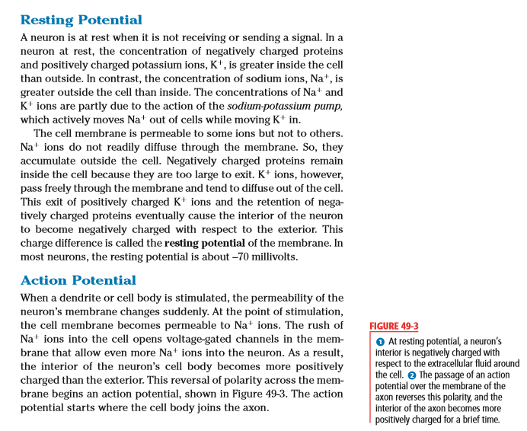

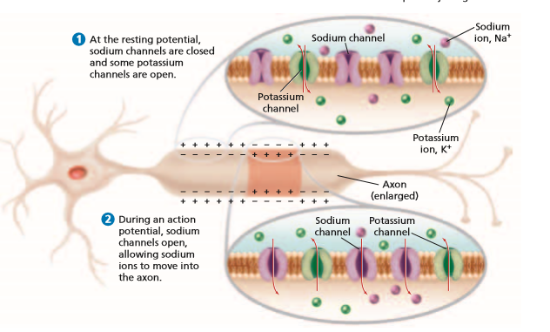
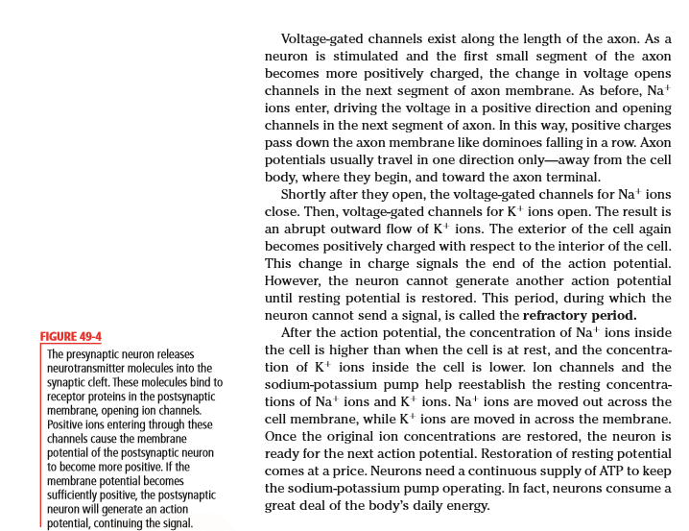
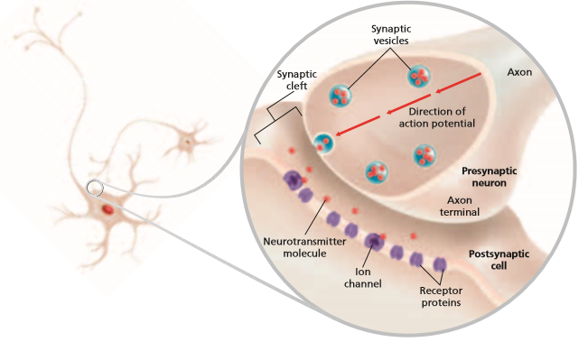
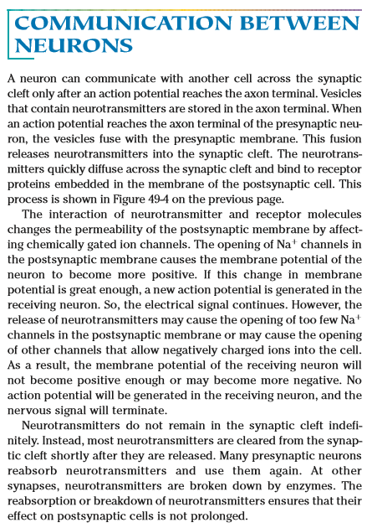

(Source: Holt, Rinehart, & Winston, 2006, pp1007 - 1009)

- Define action potential

______________________________________________________________________

______________________________________________________________________

- Define resting potential

______________________________________________________________________

______________________________________________________________________

- Explain the differences between action potential and resting potential

______________________________________________________________________

______________________________________________________________________

______________________________________________________________________

______________________________________________________________________

______________________________________________________________________

______________________________________________________________________

______________________________________________________________________

______________________________________________________________________

______________________________________________________________________

- Explain the differences in the actions of neuro transmitters between action potential and resting potential.

______________________________________________________________________

______________________________________________________________________

______________________________________________________________________

______________________________________________________________________

______________________________________________________________________

______________________________________________________________________

______________________________________________________________________

______________________________________________________________________

______________________________________________________________________

______________________________________________________________________

- Explain the function of chemical messengers provided by the nervous system.

______________________________________________________________________

______________________________________________________________________

______________________________________________________________________

______________________________________________________________________

______________________________________________________________________

______________________________________________________________________

______________________________________________________________________

______________________________________________________________________

______________________________________________________________________

- Discuss how the nervous, excretory and circulatory systems in a named animal work together to maintain a constant body environment.

______________________________________________________________________

______________________________________________________________________

______________________________________________________________________

______________________________________________________________________

______________________________________________________________________

______________________________________________________________________

______________________________________________________________________

______________________________________________________________________

______________________________________________________________________

______________________________________________________________________

______________________________________________________________________

______________________________________________________________________

______________________________________________________________________

______________________________________________________________________

______________________________________________________________________

______________________________________________________________________

______________________________________________________________________

______________________________________________________________________

______________________________________________________________________

______________________________________________________________________

______________________________________________________________________

______________________________________________________________________

______________________________________________________________________

______________________________________________________________________

______________________________________________________________________

______________________________________________________________________

______________________________________________________________________

______________________________________________________________________

______________________________________________________________________

______________________________________________________________________

______________________________________________________________________

______________________________________________________________________

______________________________________________________________________

______________________________________________________________________

______________________________________________________________________

______________________________________________________________________

______________________________________________________________________

______________________________________________________________________

