TERM 1: WEEK 11 – 12 (13th – 24th April)

Strand 2: Genetics

Sub-strand 2.2 Diversity and relatedness of organisms

Lesson Activity 2.2

The specific learning outcomes (SLO) targeted in this activity are provided below:

Specific Learning Outcomes: Students are able to | Skill level | SLO code | Achieved  (Yes / No)
Define homeotic genes | 1 | Bio2.2.1.1
Explain the control of homeotic genes on major body plans | 3 | Bio2.2.3.3
List/Describe the different levels of organization (cells, DNA and organism) leading to common origin of species | 2 | Bio2.2.2.3
Explain the similarities or differences between the different levels of organization | 3 | Bio2.2.3.4
Describe the different stages of the embryonic development in vertebrates | 2 | Bio2.2.2.2

Instructions:

- If you have access to the internet, refer to Central School’s website: www.centralschool.edu.vu, Year 12 Biology folder Term 1 Week 11 – 12, to access other resources.
- Answer the following questions.

- Homeotic genes

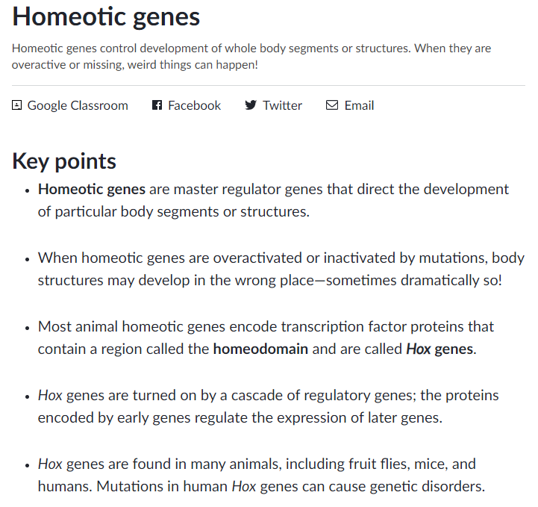
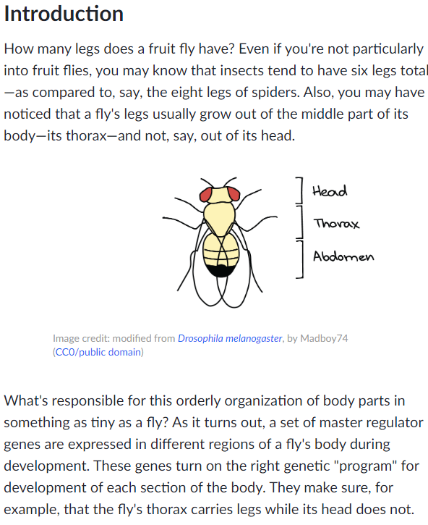
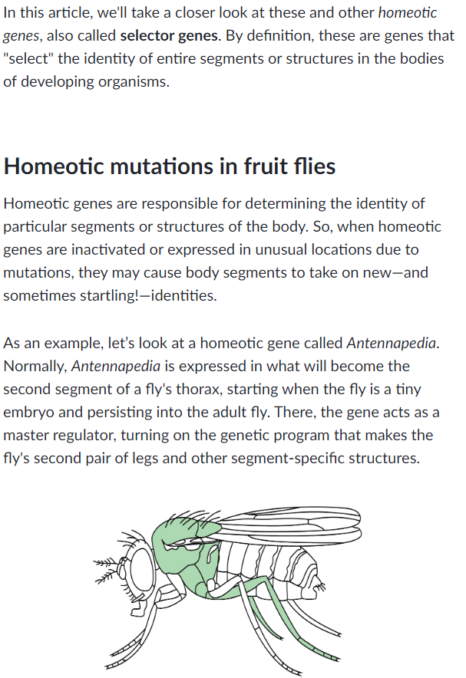
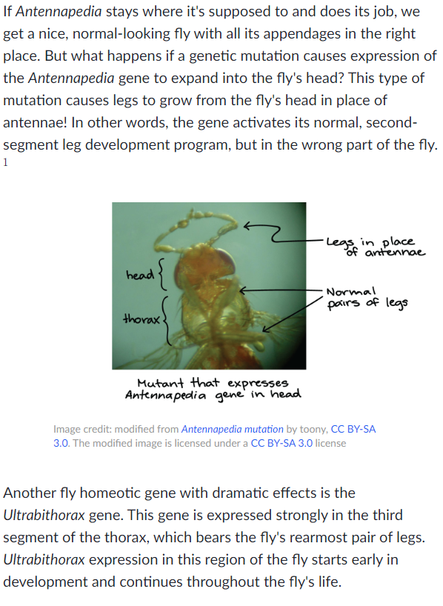
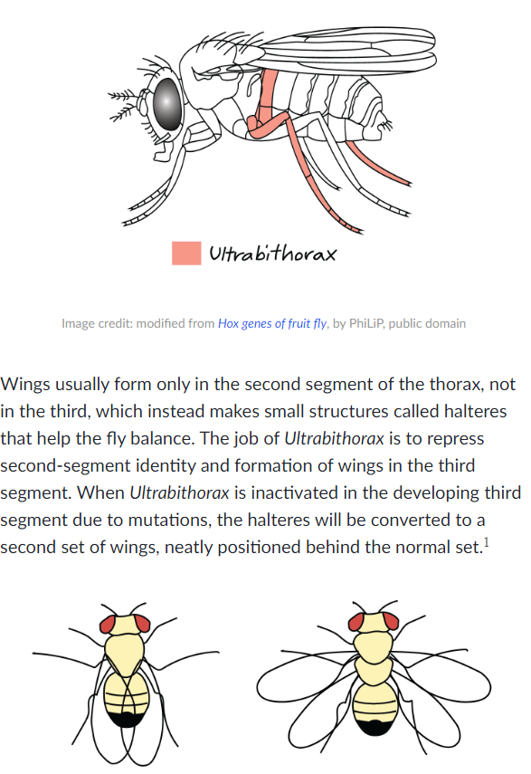
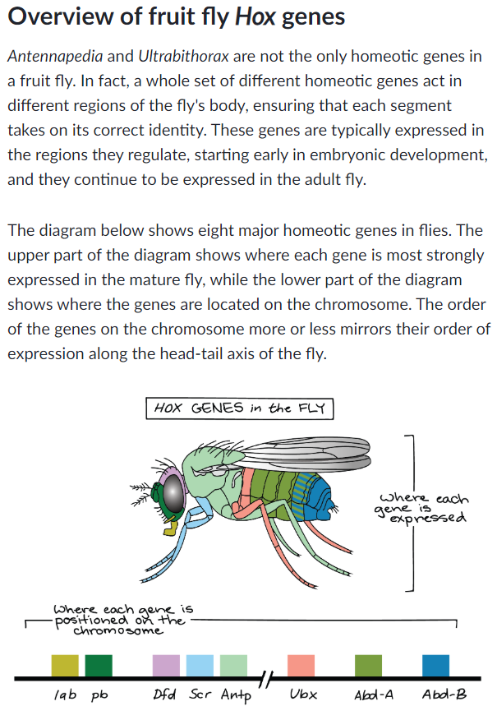
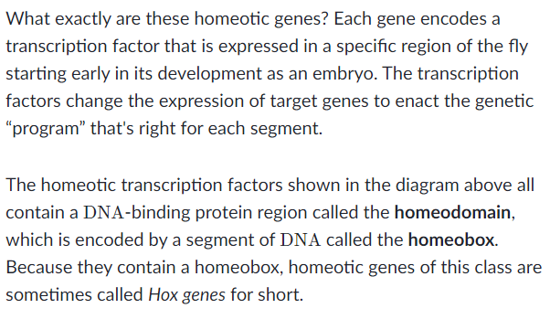
(Source: https://www.khanacademy.org/science/biology/developmental-biology/signaling-and-transcription-factors-in-development)

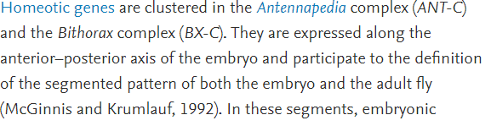
(Source: https://www.sciencedirect.com/topics/agricultural-and-biological-sciences)

- Define homeotic genes

______________________________________________________________________

______________________________________________________________________

- Explain how homeotic genes control major body plans of Drosophila.

______________________________________________________________________

______________________________________________________________________

______________________________________________________________________

______________________________________________________________________

______________________________________________________________________

______________________________________________________________________

______________________________________________________________________

______________________________________________________________________

______________________________________________________________________

______________________________________________________________________

______________________________________________________________________

______________________________________________________________________

______________________________________________________________________

______________________________________________________________________

______________________________________________________________________

______________________________________________________________________

- Levels of organization

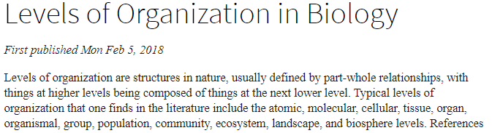
(Source: https://plato.stanford.edu/entries/levels-org-biology/)

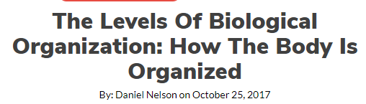
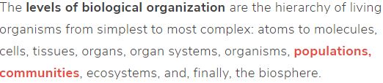
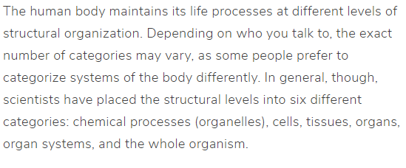
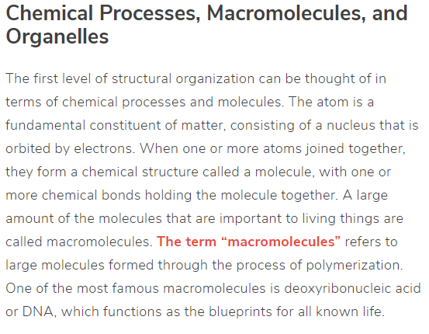
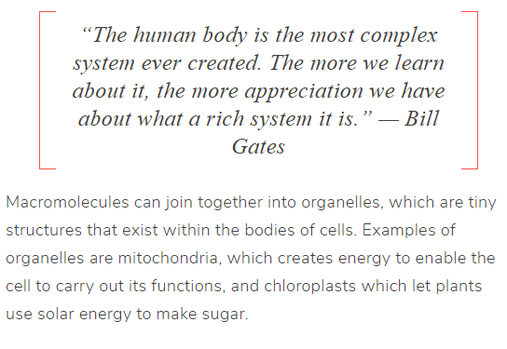
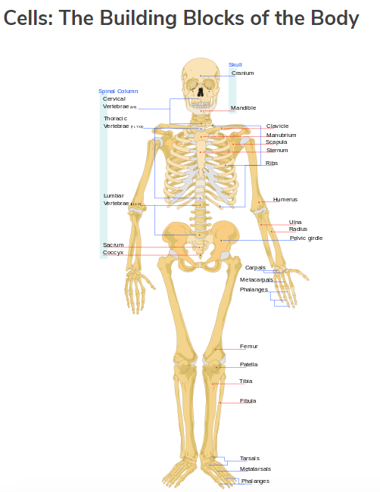
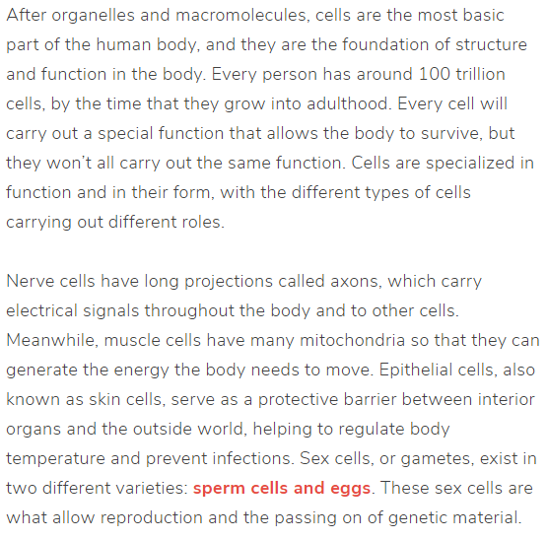
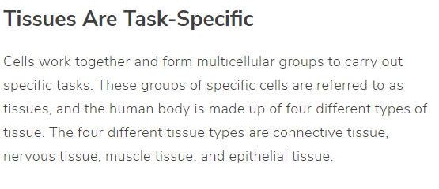
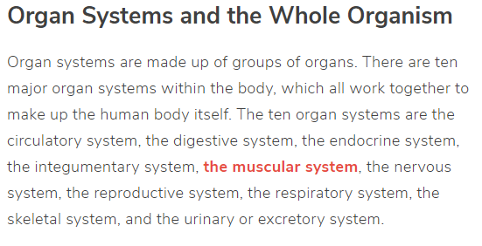
(Source: https://sciencetrends.com/levels-biological-organization)

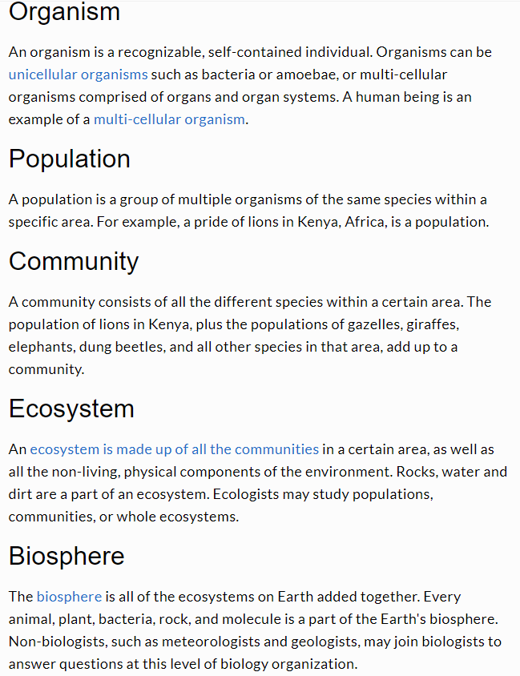
(Source: https://sciencing.com/levels-organization-biology)

- List the different levels of organization from the simplest to the most complex level.

______________________________________________________________________

______________________________________________________________________

______________________________________________________________________

______________________________________________________________________

______________________________________________________________________

______________________________________________________________________

______________________________________________________________________

______________________________________________________________________

______________________________________________________________________

______________________________________________________________________

______________________________________________________________________

______________________________________________________________________

- Explain the similarities between the different levels of organization.

______________________________________________________________________

______________________________________________________________________

______________________________________________________________________

______________________________________________________________________

______________________________________________________________________

______________________________________________________________________

______________________________________________________________________

- Explain the differences between the different levels of organization.

______________________________________________________________________

______________________________________________________________________

______________________________________________________________________

______________________________________________________________________

______________________________________________________________________

______________________________________________________________________

______________________________________________________________________

______________________________________________________________________

______________________________________________________________________

______________________________________________________________________

______________________________________________________________________

______________________________________________________________________

______________________________________________________________________

______________________________________________________________________

______________________________________________________________________

______________________________________________________________________

- Stages of embryonic development in vertebrates.

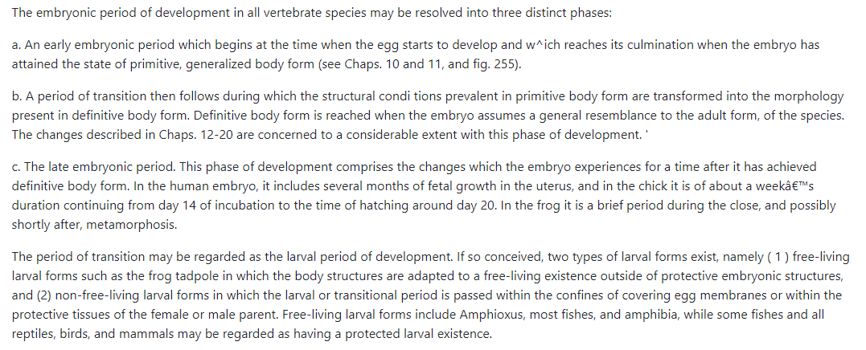

Summary of Developmental Phenomena Associated with the Life of an Individual Vertebrate Animal

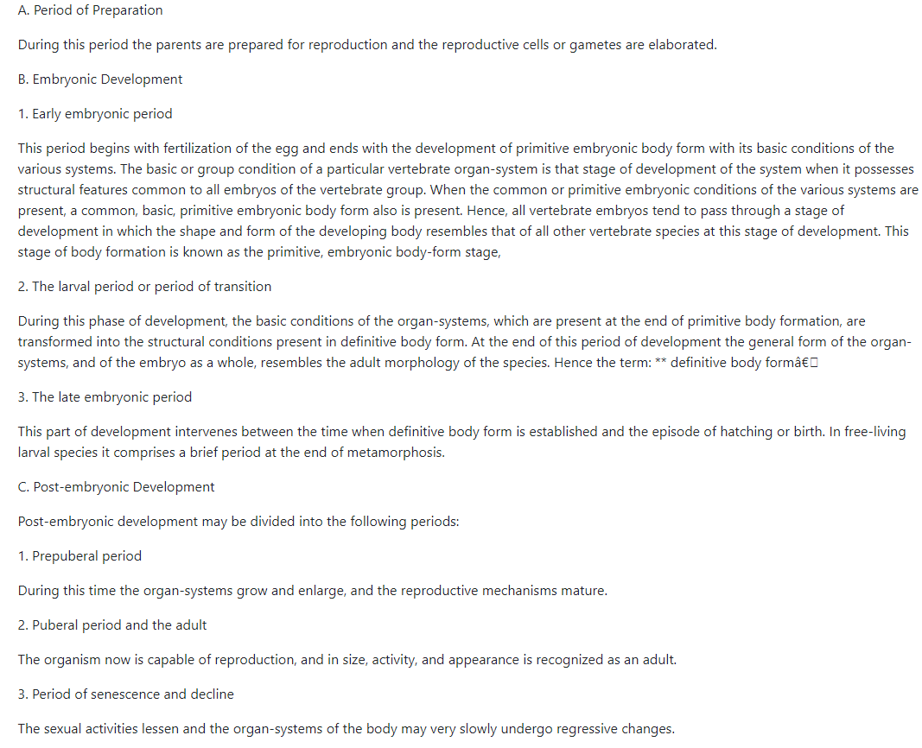

- Describe the different stages of the embryonic development in vertebrates.

- Early embryonic period

______________________________________________________________________

______________________________________________________________________

______________________________________________________________________

- Larval period or period of transition

______________________________________________________________________

______________________________________________________________________

______________________________________________________________________

______________________________________________________________________

- Late embryonic period

______________________________________________________________________

______________________________________________________________________

______________________________________________________________________

______________________________________________________________________

