Strand 4: Processes & Patterns of Evolution

Sub-strand 4.2 Natural Selection

LESSON 1: NATURAL SELECTION

Key Learning Outcome:

Students are able to demonstrate understanding of natural selection and factors that influence this, and things that are impacted by natural selection
- theory of natural selection as proposed by Darwin; selecting agents / selection pressures (e.g. predators)

The specific learning outcomes targeted in this lesson are provided below: Tick the last column when you have achieved the learning outcome.
SLO# | Specific Learning Outcomes: Students are able to | Skill level | SLO code
1 | Define natural selection, selection pressure, sexual selection | 1 | Bio4.2.1.1
2 | Identify/natural selection / selection pressure / sexual selection, in a given context | 1 | Bio4.2.1.2
3 | Outline the main points of the theory of natural selection as proposed by Darwin; | 2 | Bio4.2.2.1
4 | List the selecting agents for selection pressures[biotic and abiotic factors] that contribute to natural selection | 2 | Bio4.2.2.2
5 | Explain with examples of how biotic and abiotic factors act as forces of Natural Selection | 3 | Bio4.2.2.1
6 | Explain the related ideas in the theory of natural selection as proposed by Darwin | 3 | Bio4.2.3.2
7 | Evaluate the theory of natural selection as proposed by Darwin; presenting your own opinion on the relative truth of the theory | 4 | Bio4.2.4.1
17 | Define ‘fitness’ | 1 | Bio4.2.1.5
18 | Identify/State a feature or example of fitness, in a given context | 1 | Bio4.2.1.6
19 | Explain how ‘fitness’ contributes to frequency of alleles in the gene pool | 3 | Bio4.2.3.7

Key Terms:
Term | Achieved |  | Term | Achieved
Natural selection |  |  | Selection pressure
Fitness |  |  | Darwin’s theory
Stabilizing selection |  |  | Allele frequency
Disruptive selection |  |  | Gene pool
Directional selection

Recommended Readings:
Reading Text | Page(s) | Achieved
Hanson, M., & Sinclair, M. (2006). Year 13 Biology Study Guide, NCEA Level 3. Auckland: ESA Pubilcations Ltd. | 291 – 292
Bradfield, P., Dodds, J., Dodds, J., and Taylor, N. (2002). A2 Level Biology. Essex: Pearson Education Limited. | 110 – 132
NATURAL SELECTION
This is the process in nature by which, according to Darwin's theory of evolution, organisms that are better adapted to their environment tend to survive longer and transmit more of their genetic characteristics to succeeding generations than do those that are less well adapted.
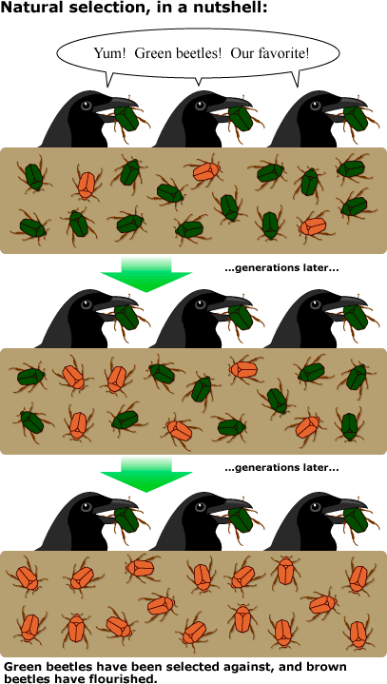
Darwin’s theory of evolution by natural selection states simply that:
- There is variation in traits between individuals of a population. There is differential reproduction.
Since the environment cannot support unlimited population growth due to limited resources, not all individuals get to reproduce to their full potential. The most adapted and ‘fittest’ survive and reproduce while the ‘weaker’ or ‘less fit’ are not able to find mates, die or migrate out.

- The ‘fittest’ genes are inherited.
The ‘fittest’ reproduce and pass on their genes to the next generation.

- There is change in the gene pool.
The alleles which represent the more advantageous trait that allows individuals within the population to have more offspring, becomes more common. If this process continues, eventually most individuals in the population will inherit this trait.
Adapted https://evolution.berkeley.edu/

The ‘fittest’ individual does not necessarily mean the strongest, most attractive or the most adapted. It refers most importantly to those individuals within a population who are best able to reproduce successfully and produce fertile offspring.pass on their genes to the next generation. Being strong, attractive and most adapted are important requirements but if such an individual is not able to reproduce successfully to produce fertile offspring, then it is not the ‘fittest’. Individuals that are able to pass on their genes to the next generation will increase the frequency of their alleles in the gene pool of their population.
Selection pressures are factors within the environment which may increase or decrease the traits that promote survival and reproduction within a population.
Examples of selection pressure on a population.
- Competition for food
- Competition for a mate
- Changes in the environment (e.g. removal or changes in the habitat
- Predators (changes in number, type, prey preference)
- Parasites
Types of Natural Selection
Selection pressures act upon the different traits of a population and can result in changes in the dominant phenotypes (traits) within the population over time. There are three types of natural selection which result from the effects of selection pressure.
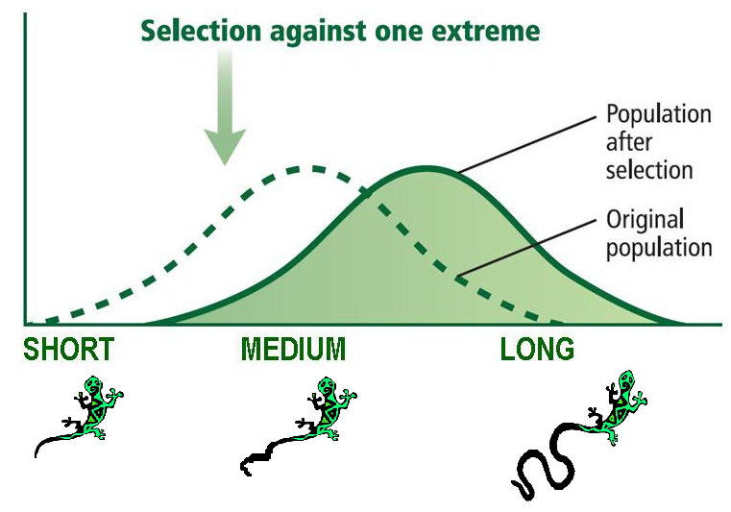
- Directional Selection
- Selective pressures favor one extreme trait against that of the other. The trait for long tail will become more common in the population over time.
- For example: chicken (predators) avoid lizards (prey) with long wiggly tails because it looks like a snake and scares them away. Lizards with medium to short tails are preyed upon instead (these are therefore unfavorable traits).

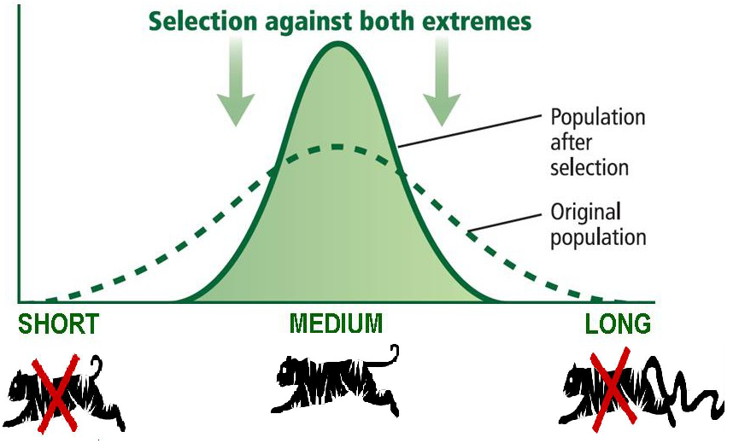
- Stabilizing selection
- Selection pressures favor moderate (average traits) against those of the extremes. There will be more average-tailed cats over time.
- For example: Speed of movement is restricted in cats with very long tails as it creates friction when it drags on the ground. Short tails also restrict speed as they mess up the cats balance. Medium tails allow cats to run fast.

- Disruptive selection
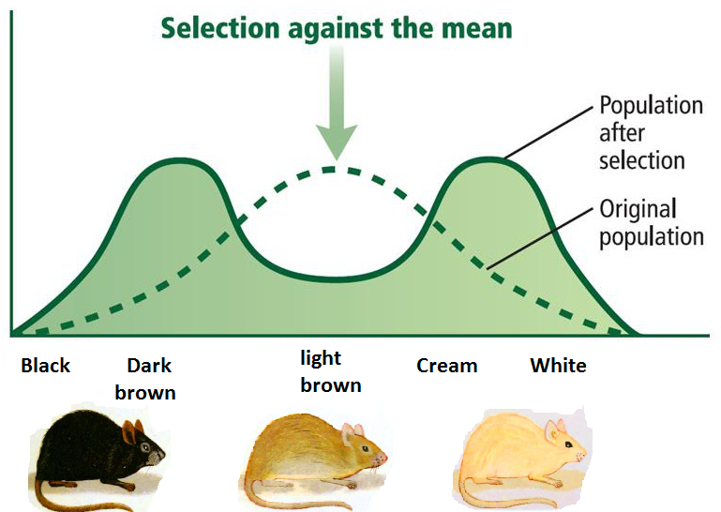
- Selection pressures favor both the extreme phenotypes against those of the average. Two distinct populations with contrasting features will result (dark-colored mice and light colored mice).
- For example: The owner of a house paints the interior walls of his house a creamy white color and all his cupboards a dark color. Cream, white, dark brown and black colored mice would be able to camouflage against the color of the background and avoid detection. Light colored mice (average traits) would be easily seen and therefore are unfavorable traits.
Adapted from: https://mrkubuske.files.wordpress.com/2014/03/types-of-selection.jpg

LESSON ACTIVITY
Question One
Define the following terms: (L1) (Bio4.2.1.1)
(i)Natural selection:
________________________________________________________________________________________________________________________________________________________________________________________________________________________________________________________________________________________________________________
(ii)Selection Pressure:
________________________________________________________________________________________________________________________________________________________________________________________________________________________________________________________________________________________________________________
(iii)Sexual Selection:
________________________________________________________________________________________________________________________________________________________________________________________________________________________________________________________________________________________________________________
Question Two
For each of the scenarios in (a) and (b), identify the selection pressure acting upon the organisms and name the type of selection pressure occurring. (L1) (Bio4.2.1.2)
  - A population of finches lives on an island with an abundant food supply. These finches have highly variable beak lengths, allowing them to feed on different types of food. Then several other species of birds move into the area, making food supplies scarce. The only types of food left for the finches are small seeds and nectar from long tubular flowers. Finches with small beaks can easily grasp and crack the seeds. Finches with long beaks can reach inside the long flowers to reach the nectar. However, some finches have beaks that are too large to deal with the small seeds, but too small to reach inside the flowers. After several generations, there are two populations of finches: those with short beaks and those with long beaks.

Selection pressure: _________________________________________________________
______________________________________________________________________
Type of natural selection: ____________________________________________________

  - A population of arboreal rodents lives in one species of pine tree. These pine trees have very evenly spaced branches of uniform thickness. Rodents that are too small cannot reach between the branches to move around in the tree. Rodents that are too big and heavy break through the branches and fall out of the trees. The rodent population contains adults of moderately average size.

Selection pressure: _________________________________________________________
______________________________________________________________________
Type of natural selection: ____________________________________________________

Question Three
Outline the main points of the theory of natural selection as proposed by Darwin.
(L2) (Bio4.2.2.1)

____________________________________________________________________________________________________________________________________________________________________________________________________________________________________________________________________________________________________

Question Four
List down the selecting agents for the biotic and abiotic factors which contributes to natural selection. (L2) (Bio4.2.2.2)
(i)Biotic Factors:
____________________________________________________________________________________________________________________________________________________________________________________________________________________________________
(ii)Abiotic Factors:
____________________________________________________________________________________________________________________________________________________________________________________________________________________________________

Question Five
Explain with examples how the following factors act as forces of Natural Selection.
(L3)(Bio4.2.2.1)
(i)Biotic Factors:
________________________________________________________________________________________________________________________________________________________________________________________________________________________________________________________________________________________________________________________________________________________________________________________________________________________________________________________________________

(ii)Abiotic Factors:
________________________________________________________________________________________________________________________________________________________________________________________________________________________________________________________________________________________________________________________________________________________________________________________________________________________________________________________________________

Question Six
Explain the related ideas in the theory of natural selection as proposed by Darwin.
(L3)(Bio4.2.3.2)
__________________________________________________________________________________________________________________________________________________________________________________________________________________________________________________________________________________________________________________________________________________________________________________________________________________________________________________________________________________________________________________________________________________________________________________________________________________________________________________________________________________________________________________________________________________________

Question Seven
Evaluate the theory of natural selection as proposed by Darwin presenting your own opinion on the relative truth of the theory. (L4)(Bio4.2.4.1)
_______________________________________________________________________________________________________________________________________________________________________________________________________________________________________________________________________________________________________________________________________________________________________________________________________________________________________________________________________________________________________________________________________________________________________________________________________________________________________________________________________________________________________________________________________________________________________________________________________________________________________________________________________________________________________________________________________________________________________________________________________________________________________________________________________________________________________________________________________
Question Seven
Define the term ‘fitness’. (L1)(Bio4.2.1.5)
_____________________________________________________________________________________________________________________________________________________________________________________________________________________________________________________________________________________________________________________________________________________________________________

Question Eight
Living things that are well adapted to their environment survive and reproduce. Those that are not well adapted don’t survive and reproduce. An adaptation is any characteristic that increases fitness, which is defined as the ability to survive and reproduce. The table below gives descriptions of four female mice that live in a beach area which is mostly tan sand with scattered plants.
Color of fur | Black | Tan | Tan & Black | Cream
Age at death | 2 months | 8 months | 4 months | 2 months
Number of pups produced by each female | 0 | 11 | 3 | 0
Running speed | 8 cm/sec | 6 cm/sec | 7 cm/sec | 5 cm/sec

- According to the definition given for fitness, which mouse would biologists consider the fittest? (L1) (Bio4.2.1.6)

__________________________________________________________

- Explain how ‘fitness’ contributes to frequency of alleles in the gene pool.
(L3)(Bio4.2.3.7)

__________________________________________________________________________________________________________________________________________________________________________________________________________________________________________________________________________________________________________________________________________________________________________________________________________________________________________________________________________________________________________

LESSON 2: SEXUAL SELECTION

Key Learning Outcome:

Students are able to demonstrate understanding of natural selection and factors that influence this, and things that are impacted by natural selection
- sexual selection as a special case of natural selection – females act as the selecting agent for which males (strongest / biggest / most showy / healthiest ) will breed

The specific learning outcomes targeted in this lesson are provided below: Tick the last column when you have achieved the learning outcome.
8 | Outline the main features of sexual selection as a special case of natural selection (females act as the selecting agent for which males (strongest /biggest/ most showy/healthiest) will breed) | 2 | Bio4.2.2.3
9 | Explain the interrelationships within the sexual selection as a special case of natural selection | 3 | Bio4.2.3.3
10 | Discuss the impact of sexual selection on populations using specific examples[limit your example to Peacocks/Wolves] | 4 | Bio4.2.4.2

Term | Achieved |  | Term | Achieved
Sexual selection |  |  | Intrasexual selection
Sexual dimorphism |  |  | Intersexual selection
Mate selection

Recommended Readings:

Reading Text | Page(s) | Achieved
Hanson, M., & Sinclair, M. (2006). Year 13 Biology Study Guide, NCEA Level 3. Auckland: ESA Pubilcations Ltd. | 240-241

SEXUAL SELECTION
The success of an individual is measured not only by the number of offspring it leaves, but also by the quality or likely reproductive success of those offspring. This means that it becomes important who its mate will be. Sexual selection is a special type of natural selection that produces anatomical and behavioral traits that affect an individual’s ability to acquire mates. The selecting agent in sexual selection is either the male or the female (the one choosing the mate).
Sexual selection is determined by choice and competition.
- Choice of mates

This is also known as intersexual selection as it occurs between different sexes. It is where individuals of one sex advertise themselves as potential mates so that the opposite sex can choose from among them whom to mate with. The need to attract a mate leads to the development of exaggerated body ornamentation (Figure 1) which can normally be dangerous for the individual as it makes them easy prey to predators. It also leads to sexual dimorphism (Figure 2) and elaborate courtship behaviors (Figure 1). Fitness of the individual is seen in their ability to survive predation and still attract the opposite sex of their species and reproduce successfully.
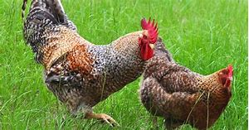
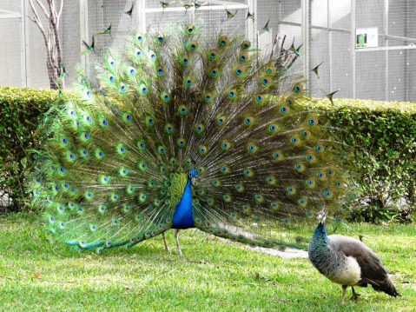
Fig.2. The rooster is larger in body size compared to the hen. This is just one example of sexual dimorphism where one sex (most dominant) tends to be more dominant than its opposite sex. Development of horns, antlers, tusks are also other examples.

Fig.1. Peacocks display of their colorful feathers makes them attractive not only to peahens but also to predators.

- Competition for mates

This is also known as intrasexual selection because it occurs between members of the same sex (usually males). The males compete through highly ritualized fights to establish dominance and secure territories for breeding and mating. The winner gains dominance over rival mates and maintain the best territories which can attract more mates.

LESSON ACTIVITY
Question One
Outline the main features of sexual selection as a special case of natural selection. (L2)(Bio4.2.2.3)
_______________________________________________________________________________________________________________________________________________________________________________________________________________________________________________________________________________________________________________________________________________________________________________________________________________________________________________________________________________________________________________________________

Question Two
Explain the interrelationships within the sexual selection as a special case of natural selection.
(L3)(Bio4.2.3.3)
____________________________________________________________________________________________________________________________________________________________________________________________________________________________________________________________________________________________________________________________________________________________________________________________________________________________________________________________________________________________________________________________________________________________________________________________________________________________________________________________________________________________________________________________________________________________________________________________________________________________________________________________________________________________________________

Question Three
Discuss the impact of sexual selection on populations using the example of Peacocks or Wolves. (L4) (Bio4.2.4.2)
______________________________________________________________________________________________________________________________________________________________________________________________________________________________________________________________________________________________________________________________________________________________________________________________________________________________________________________________________________________________________________________________________________________________________________________________________________________________________________________________________________________________________________________________________________________________________________________________________________________________________________________________________________________________________________________________________________________________________________________________________________________________________________________________________________________________________________________________________________________________________________________________________________________________________________________________________________________________________________________________________________________________________________________________________________________________________________________________________________________________________________________________________________________________________________________________________________________

LESSON 3: ARTIFICIAL SELECTION

Key Learning Outcome:

Students are able to demonstrate understanding of natural selection and factors that influence this, and things that are impacted by natural selection
- artificial selection (selective breeding) – humans act as the selecting agent for which plants and animals (those with the desirable traits) will breed • ‘fitness’ in terms of the organisms which breed successfully to produce the most offspring, so their alleles increase in frequency in the gene pool

The specific learning outcomes targeted in this lesson are provided below: Tick the last column when you have achieved the learning outcome.
SLO # | Specific Learning Outcomes:  Students are able to | Skill level | SLO code | √
10 | Define selective breeding | 1 | Bio4.2.1.3 | 3
11 | Identify/State a feature or example of selective breeding, in a given context | 1 | Bio4.2.1.4 | 3
12 | Describe the features of artificial selection or selective breeding | 2 | Bio4.2.2.4 | 3
13 | Explain the role of humans in artificial selection (selective breeding) | 3 | Bio4.2.3.3 | 3
14 | Discuss the impact of artificial selection (selective breeding) on variations in populations | 3 | Bio4.2.3.4 | 3
15 | Compare the ‘effectiveness’ of methods of sexual selection and selective breeding in terms of their contribution to variations in populations | 3 | Bio4.2.3.5 | 3
20 | Evaluate the contribution of natural selection, sexual selection and selective breeding on a population, providing an opinion on the preferred method | 4 | Bio4.2.4.3 | 4

Recommended Readings:
Reading Text | Page(s) | Achieved
Hanson, M., & Sinclair, M. (2006). Year 13 Biology Study Guide, NCEA Level 3. Auckland: ESA Pubilcations Ltd.
Bradfield, P., Dodds, J., Dodds, J., and Taylor, N. (2001). AS Level Biology. Essex: Pearson Education Limited.

ARTIFICIAL SELECTION
Artificial selection (also known as selective breeding) is the process whereby humans become the selecting agents upon the phenotypic traits of a population of organisms. The phenotypic traits of the hybrids are determined by humans therefore hybrids are produced depending upon human preferences. This increases the frequency of desirable traits within a population over time. The ability of people to control the breeding of domesticated animals and crop plants has resulted in an astounding range of phenotypic variations over relatively short time periods.
Purpose & Advantages
- To maintain a desirable trait that is commercially demanded.
- To produce more of a desirable trait in an organism.
For example: Growing plants which only produce purple flowers because customers pay more for this type of flower at the market.
- To eliminate diseases in plants and animals
In order for any of the above to be achieved humans would only allow individuals with the desired traits to reproduce. Those lacking the trait are prevented from breeding. This procedure can have its disadvantages.
Disadvantages
- Leads to lack of genetic diversity in the population over time.
- Increases the occurrence of genetic problems, for example, genetic diseases.
- Traits that lower the fitness of a species can be increased in frequency over time.
- Most of these ‘desirable’ traits do not necessarily convey greater ‘fitness’ for the organism. If the trait does not promote successful reproduction for the organism then it will be selected against by the environment.

LESSON ACTIVITY
Question One
Define the term selective breeding. (L1) (Bio4.2.1.3)

__________________________________________________________________________________________________________________________________________________________________________________________________________________________________________________________________________________________________________________________________________________________________________________________________________________

Question Two

A farmer sells tomatoes and he notices no one buys his green tomatoes. He has a few red tomato plants and he crosses them to make sure he gets more red tomatoes so he can feed his family.
Identify the type of selection shown in the above example. (L1) Bio4.2.1.4)

___________________________________________________________________

Question Three

Describe the features of artificial selection or selective breeding.
(L2) (Bio4.2.2.4)

_____________________________________________________________________________________________________________________________________________________________________________________________________________________________________________________________________________________________________________________________________________________________________________________________________________________________________________________________________________________

Question Four

Explain the role of humans in artificial selection (selective breeding). (L3) (Bio4.2.3.4)

______________________________________________________________________________________________________________________________________________________________________________________________________________________________________________________________________________________________________________________________________________________________________________________________________________________________________________________________________________________________________________________________________________________________________________________________________________________________________________________________________________________________

Question Five

Discuss the impact of artificial selection (selective breeding) on variations in populations. (L3) (Bio4.2.3.5)

_______________________________________________________________________________________________________________________________________________________________________________________________________________________________________________________________________________________________________________________________________________________________________________________________________________________________________________________________________________________________________________________________________________________________________________________________________________________________________________________________________________________________________________________________________________________________________________________________________________________________________________________________________________________________________

Question Six
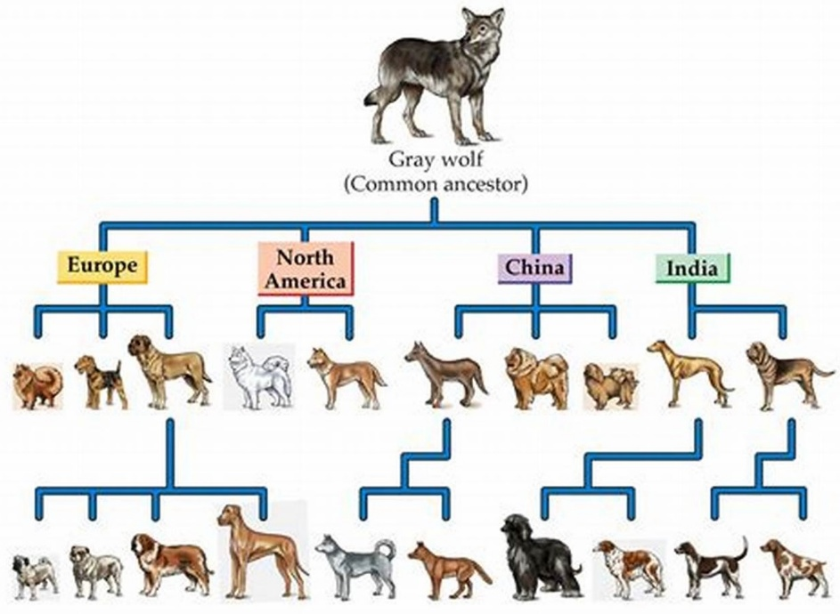
The graphic below shows how the many different breeds of dogs around the world today are related to the Gray Wolf (Canis lupus pallipes).

The different dog breeds could have been produced through the different selection methods: natural, sexual and artificial. Using the information from the graphic, evaluate the contribution of natural selection, sexual selection and artificial selection on the breeds of dogs pictured. Provide an opinion on the preferred method that would have resulted in the maintenance of the five different breeds. (L4)(Bio4.2.4.3)
____________________________________________________________________________________________________________________________________________________________________________________________________________________________________________________________________________________________________________________________________________________________________________________________________________________________________________________________________________________________________________________________________________________________________________________________________________________________________________________________________________________________________________________________________________________________________________________________________________________________________________________________________________________________________________

