Strand 4: Processes & Patterns of Evolution

Sub-strand 4.1 Variation

Major Learning Outcome 4: Students are able to describe, explain and discuss processes and patterns of evolution
Key Learning Outcome:

Students are able to demonstrate understanding of variations in forms and functions and the contribution of genetics in these variations
- role of meiosis in producing variation and recombinant genotypes / gametes (independent assortment, segregation, crossing over) – revision and extension of form 6
- role of mutation as source of new alleles

The specific learning outcomes targeted in this lesson are provided below: Tick the last column when you have achieved the learning outcome.

Lesson 1: Variation
SLO # | Specific Learning Outcomes:  Students are able to | Skill level | SLO code | √
1 | Define the terms independent assortment / segregation / crossing over / recombinant genotypes | 1 | Bio4.1.1.1
2 | Identify/State a feature or example of independent assortment / segregation / crossing over / recombinant genotypes, in a given context | 1 | Bio4.1.1.2
3 | Describe the process of independent assortment/segregation/crossing over during meiosis | 2 | Bio4.1.2.1
4 | Explain how independent assortment/segregation/crossing over during meiosis contribute to variation. | 3 | Bio4.1.3.1
5 | Describe the process of mutation that leads to the formation of new alleles. | 2 | Bio4.1.2.2
6 | Explain the contribution of mutation to the gene pool of the population. | 3 | Bio4.1.3.2
7 | Discuss the positive and negative impacts of mutation on a population. | 4 | Bio4.1.4.1
8 | Identify the process of meiosis and mitosis from a given context. | 1 | Bio4.1.1.3
9 | Identify/State a feature or example of meiosis/gametes/fertilization/mitosis in a given context | 1 | Bio4.1.1.4
10 | Describe the process of fertilization in terms of the combination of chromosomes from gametes. | 2 | Bio4.1.2.3
11 | Explain how fertilization in sexual reproduction produces variation. | 3 | Bio4.1.3.3
12 | Discuss the role of fertilization in sexual reproduction in producing variation and enhancing biological success using named examples | 4 | Bio4.1.4.2

Key Terms: Tick when you are able to define and use the term correctly in context.
Term | Achieved |  | Term | Achieved
Variation |  |  | Crossing over
Independent assortment |  |  | Recombinant genotypes
segregation |  |  | Fertilization
Mitosis |  |  | Sexual reproduction
Mutation |  |  | Gene flow
Gene pool

Recommended Readings:

Reading Text | Page(s) | Achieved
Hanson, M., & Sinclair, M. (2006). Year 13 Biology Study Guide, NCEA Level 3. Auckland: ESA Pubilcations Ltd. | 40 – 47
Bradfield, P., Dodds, J., Dodds, J., and Taylor, N. (2002). A2 Level Biology. Essex: Pearson Education Limited. | 105 – 110

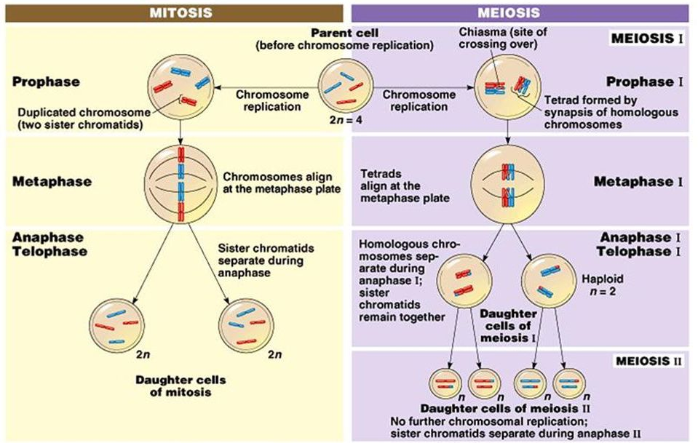
REVIEW OF MEIOSIS & MITOSIS – YEAR 12 REVISION

http://slideplayer.com/slide/10723903/37/images/2/Mitosis+vs.+Meiosis.jpg

VARIATION

The differences between one individual and another within the same species and another, is called variation. Some organisms have features which make them more adaptable to their environment than others. If such characteristics are genetically inherited then they will also be passed onto offspring as parents survive and reproduce.
Processes that cause variation

Genetic variation comes about through the process of meiosis, sexual reproduction (random mating and fertilization) and mutation. In meiosis, the processes of random assortment,crossing overand segregation cause the shuffling and mixing of genes within gametes.

- Meiosis (the cell division process that produces gametes (eggs in females; sperm in males).

  - Random assortment

This is where chromatid pairs line up randomly along the cell equator during metaphase of the first meiotic division. The side of the cell where a chromatid lines up will determine which gamete the chromatid will segregate to at the end of meiosis. Each chromatid carries an allele for a specific gene and this allele will be passed onto the gamete.
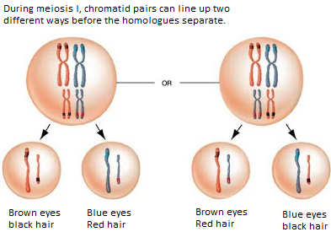

  - Crossing over
This is where chromatid pairs exchange sections of their strands when they entangle and synapse during Prophase of meiosis I. Alleles that are on these strands exchange places and therefore become part of a different chromatid. Chromatids that possess these new alleles are called recombinant chromatids. The gametes that inherit these recombinant chromatids will be called recombinant gametes because they possess genes which are a combination of different alleles (recombinant genotype).
Recombinant gametes carry recombinant genotypes
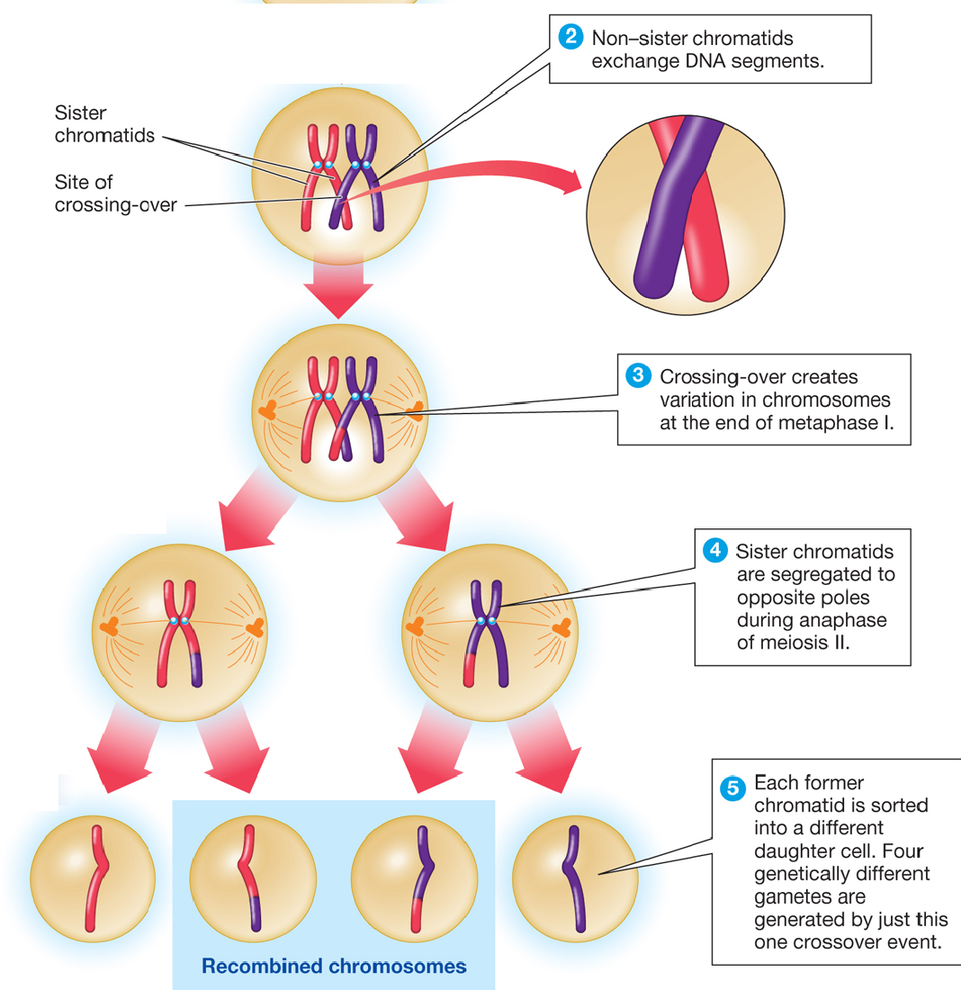

  - Segregation: This is the separation of chromatid sisters into different gametes during meiosis after independent assortment and crossing over.

- Sexual Reproduction

Sexual reproduction is a process whereby individuals mate to produce the offspring. In this process random mating and random fertilization of gametes occur to create variations in the offspring produced.

  - Random mating
This is where selection of mates between males and female members of a species is non-selective. Selection of mates is random. This ensures the mixing of alleles in the offspring as different individuals possess different phenotypes therefore different genotypes for a particular characteristic.

  - Random fertilization
- Fertilization is a random process because:
  - Any ovum can be released during ovulation.
  - During fertilization any sperm can fuse with the ovum that is released during ovulation.
- Each sperm and egg carry varying alleles for the genes in their chromosomes.
- The type of sperm that fertilizes the type of egg is a random process.
- The alleles of each sperm and egg that fuse during fertilization will give the overall genotype of the offspring produced.
- The genotype that results after allele combination from fertilization will determine the overall phenotype of the offspring.

THE ROLE OF MUTATION IN GENETIC VARIATION
- Mutation refers to any permanent changes to the DNA within the cells of an organism.
- If the mutation occurs in the DNA found within the gametes, then the mutation will be passed on through the generations. If the mutation occurs in the DNA within the body cells of an organism, then it will not be passed on to future generations.
- Mutation adds new alleles to a population’s gene pool when gametes carrying the mutation fuse to produce offspring. The offspring inherits the mutation and can continue to pass it on to future generations through the process of meiosis and sexual reproduction.

LESSON ACTIVITY

Question One

Define the following terms: (L1) (Bio4.1.1.1)

(i) Independent assortment:
_________________________________________________________________________
_________________________________________________________________________
__________________________________________________________________________________________________________________________________________________

(ii) Segregation:
____________________________________________________________________________________________________________________________________________________________________________________________________________________________________

(iii) Crossing over:
____________________________________________________________________________________________________________________________________________________________________________________________________________________________________

(iv) Recombinant genotype:
____________________________________________________________________________________________________________________________________________________________________________________________________________________________________

Question 2

Identify the processes taking place in the following diagrams: (L1) (Bio4.1.1.2)

(i)

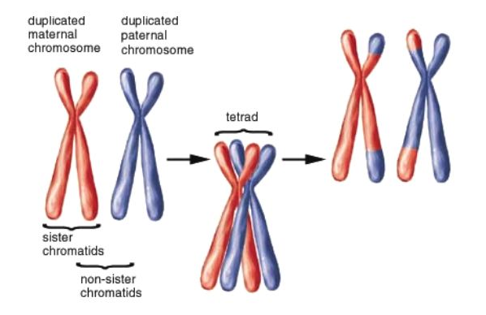 ___________________________________

(ii)

__________________________________

Question Three

Describe how the following processes occur during meiosis: (L2) (Bio4.1.2.1)

(i) Independent assortment:
____________________________________________________________________________________________________________________________________________________________________________________________________________________________________________________________________________________________________________________________________________________________________________________________

(ii) Segregation:
____________________________________________________________________________________________________________________________________________________________________________________________________________________________________________________________________________________________________________________________________________________________________________________________

(iii) Crossing-over:
____________________________________________________________________________________________________________________________________________________________________________________________________________________________________________________________________________________________________________________________________________________________________________________________

Question Four

Explain how the following processes contribute to variation. (L3) (Bio4.1.3.1)

(i) Independent assortment:
____________________________________________________________________________________________________________________________________________________________________________________________________________________________________________________________________________________________________________________________________________________________________________________________

(ii) Segregation:
____________________________________________________________________________________________________________________________________________________________________________________________________________________________________________________________________________________________________________________________________________________________________________________________

(iii) Crossing-over:
____________________________________________________________________________________________________________________________________________________________________________________________________________________________________________________________________________________________________________________________________________________________________________________________

Question Five
Describe how mutation can lead to the formation of new allele. (L2) (Bio4.1.2.2)
_____________________________________________________________________________________________________________________________________________________________________________________________________________________________________________________________________________________________________________________________________________________________________________
_________________________________________________________________________

Question Six

Mutations add new alleles to the gene pool of a population. Explain what this means.
(L3) (Bio4.1.3.2)
______________________________________________________________________________________________________________________________________________________________________________________________________________________________________________________________________________________________________________________________________________________________________________________________________________________________________________________

Question Seven
One positive impact of mutation is that it increases the presence of new alleles within a population. However, a negative impact of mutation is that most mutations can be harmful for the organism. Discuss how the positive and negative impact of mutation stated affects a population. In your answer you should mention the following: (L4) (Bio4.1.4.1)

- Describe how new alleles are created by the process of mutation.
- Describe an example of a mutation that may be beneficial and one that may be potentially harmful for an organism.
- Explain how these mutations can benefit or harm the population.

____________________________________________________________________________________________________________________________________________________________________________________________________________________________________
____________________________________________________________________________________________________________________________________________________________________________________________________________________________________
____________________________________________________________________________________________________________________________________________________________________________________________________________________________________
____________________________________________________________________________________________________________________________________________________________________________________________________________________________________
____________________________________________________________________________________________________________________________________________________________________________________________________________________________________
____________________________________________________________________________________________________________________________________________________________________________________________________________________________________
__________________________________________________________________________________________________________________________________________________

Question Eight
Identify the type of cell division occurring in Diagram A and Diagram B. (L1) (Bio4.1.1.3)
Diagram A Diagram B
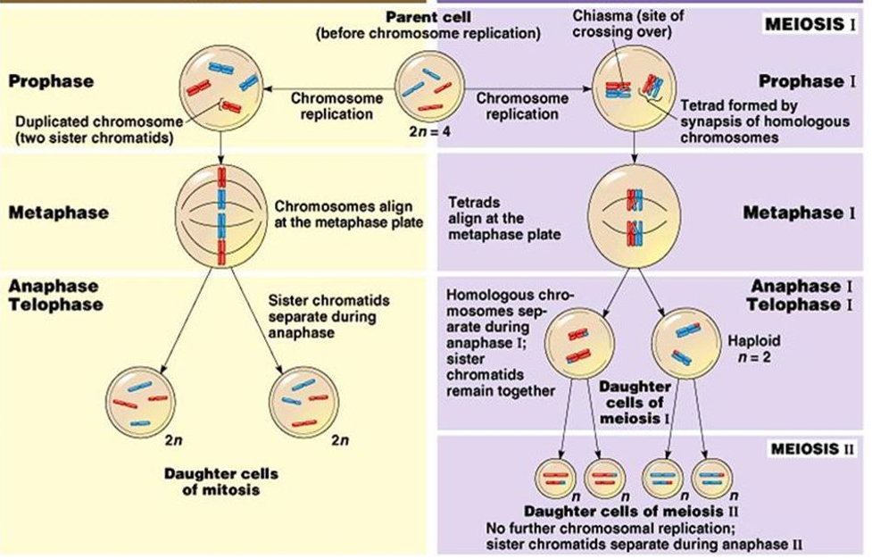
Diagram A: ________________________________________________
Diagram B: ________________________________________________

Question Nine
State a feature of the following processes: (L1) (Bio4.1.1.4)
(i)meiosis: ____________________________________________________________________________________________________________________________________________________________________________________________________________________________________
(ii) Gametes
____________________________________________________________________________________________________________________________________________________________________________________________________________________________________
(iii) Fertilization:
____________________________________________________________________________________________________________________________________________________________________________________________________________________________________
(iv) Mitosis:
____________________________________________________________________________________________________________________________________________________________________________________________________________________________________

Question Ten
Describe the process of fertilization in terms of combination of chromosomes from gametes.
(L2) (Bio4.1.2.3)
____________________________________________________________________________________________________________________________________________________________________________________________________________________________________
__________________________________________________________________________________________________________________________________________________

Question Eleven
Explain how fertilization in sexual reproduction produces variation. (L3) (Bio4.1.3.3)
_______________________________________________________________________________________________________________________________________________________________________________________________________________________________________________________________________________________________________________________________________________________________________________________________________________________________________________________________________________________________________________________________

Question Twelve
Discuss how the process of fertilization produces variation in offspring. In your answer you should include the following points: (L4) (Bio4.1.4.2)

- Describe the process of fertilization
- Explain how fertilization is a random process.
- Describe how different allele combinations can result in phenotypic differences in offspring.

_________________________________________________________________________________________________________________________________________________________________________________________________________________________________________________________________________________________________________________________________________________________________________________________________________________________________________________________________________________________________________________________________________________________________________________________________________________________________________________________________________________
_________________________________________________________________________________________________________________________________________________________________________________________________________________________________________________________________________________________________________________________________________________________________________________________________________________________________________________________________________________________________________________________________________________________________________________________________________________________________________________________________________________
_____________________________________________________________________________________________________________________________________________________________________________________________________________________________________________________________________________________________________________________________________________________________________________

Lesson 2: Role of variation in evolution

Key Learning Outcome:

Students are able to demonstrate understanding of variations in forms and functions and the contribution of genetics in these variations

The specific learning outcomes targeted in this lesson are provided below: Tick the last column when you have achieved the learning outcome.
- role of mutation as source of new alleles

SLO # | Specific Learning Outcomes:  Students are able to | Skill level | SLO code | √
13 | Define evolution | 1 | Bio4.1.1.5
14 | Identify/State a feature or example of evolution, in a given context | 1 | Bio4.1.1.6
15 | List the key features of the process of evolution | 2 | Bio4.1.2.4
16 | Explain the importance of variation in evolution | 3 | Bio4.1.3.4
17 | Discuss the impact of evolution in the survival of species and the critical role of variation in promoting evolution | 4 | Bio4.1.4.3

Recommended Readings:

Reading Text | Page(s) | Achieved
Hanson, M., & Sinclair, M. (2006). Year 13 Biology Study Guide, NCEA Level 3. Auckland: ESA Pubilcations Ltd. | 291 – 296
Bradfield, P., Dodds, J., Dodds, J., and Taylor, N. (2002). A2 Level Biology. Essex: Pearson Education Limited. | 110 – 120

EVOLUTION
Evolution is the gradual process in which something undergoes changes into a different and usually more complex or better form.
Evolution can take place in the following conditions:
- Variations in characteristics and adaptations are present within members of a population
- There is gene flow (exchange of genes through mating) between members of the same population (intraspecific) and with members of other species (interspecific).
- Members of a population are exposed to varying environmental conditions within their habitat.

Importance of variation to the process of evolution
- Organisms differ in their adaptations and characteristics because of the genes they possess.
- Variations that are genetic are passed on to future generations through successful mating.
- Successful mating depends upon how adapted the organism is to survive and find a mate. Those that are not able to will die or never pass their genes onto future generations. These characteristics become less common in a population.
- An organism that is more adapted is better able to reproduce effectively within a population. Their genes get passed on and are maintained in the gene pool of the population.
- Mixing of alleles during crossing over and independent assortment creates new genotypes and adaptations for an organism. Mutation also creates new genes for an organism. If these genes produce beneficial adaptations for the organism, the organism will survive, reproduce and pass them on.
- Changes within an environment (e.g. food availability, climate) determine who survives and who does not. Those that survive will reproduce and pass on their genes to future generations. The adaptations they pass on become more common, thus leading to evolution within a population.

LESSON ACTIVITY
Question One
Define the term evolution. (L1) (Bio4.1.1.5)
____________________________________________________________________________________________________________________________________________________________________________________________________________________________________________________________________________

Question Two
Refer to the diagram below to answer the following question.
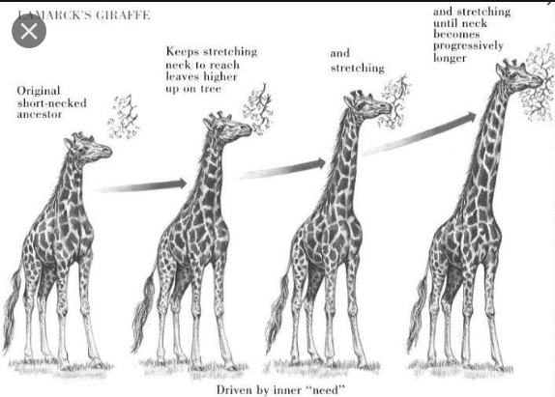
The change in the length of neck in giraffes over time is an example of:
(L1) Bio4.1.1.6
_____________________________________________________

Question Three
List the key features of the process of evolution (L2) Bio4.1.2.4
____________________________________________________________________________________________________________________________________________________________________________________________________________________________________________________________________________________________________________________________________________________________________________________________________________________________________________________________________________________________________________

Question Four
Explain the importance of variation in evolution (L3) (Bio4.1.3.4)
__________________________________________________________________________________________________________________________________________________________________________________________________________________________________________________________________________________________________________________________________________________________________________________________________________________________________________________________________________________________________________________________________________________________________________________________________________________________________________________________________________________________________________________________________________________________________

Question Five
The following diagram shows a scenario of how evolution may have taken place in the length of the necks of giraffes in Africa. Discuss how this evolutionary process impacts upon the survival of the giraffe species and the critical role of variation in promoting evolution in neck length. (L4) (Bio4.1.4.3)
In your answer, include the following points:
- Describe how variations in neck length are important for its evolution to take place.
- Explain how changes in neck length are inherited
- Describe the factors that may have contributed to the maintenance of long necks in giraffe today.
___________________________________________________________________________________________________________________________________________________________________________________________________________________________________________________________________________________________________________________________________________________________________________________________________________________________________________________________________________________________________________________________________________________________________________________________________________________________
________________________________________________________________________________________________________________________________________________________________________________________________________________________________________________________________________________________________________________________________________________________________________________________________________________________________________________________________________________________________________________________________________________________________________________
________________________________________________________________________________________________________________________________________________________________________________________________________________________________________________________________________________________________________________________________________________________________________________________________________________________________________________________________________________________________________________________________________________________________________________

