Strand 3: Biotechnology Applications
Major Learning Outcome 3:
Students are able to describe, explain and discuss biotechnology applications and the human needs and demands for the applications.

Sub-strand 3.1 Gene cloning, Transgenesis and DNA Profiling
Key Learning Outcome: Students are able to demonstrate understanding of gene cloning, trans genesis and DNA profiling and ways in which these influence gene functioning:
- the formation of recombinant DNA using techniques of restriction enzymes and ligation.
- the use of bacterial plasmids to produce multiple copies of the desired gene.
- Trans genesis using techniques of Agrobacterium tumefaciens; ballistic (‘gene gun’) method; pronuclear (‘micro’) injection; viral vectors.
- formation of DNA profiles using the techniques of PCR and gel electrophoresis.

Lesson Activity 3.1A

The specific learning outcomes (SLO) targeted in this activity are provided below:

SLO# | Specific Learning Outcomes: Students are able to | Skill level | SLO code | Achieved  (Yes / No)
1 | Define gene cloning/ trans genesis/ bacterial plasmids | 1 | Bio3.1.1.1
2 | Identify gene cloning/ trans genesis/ bacterial plasmids, in a given context | 1 | Bio3.1.1.2
3 | Describe the steps of using bacterial plasmids to produce multiple copies of the desired gene | 2 | Bio3.1.2.1
8 | Discuss how recombinant DNA is formed using restriction enzymes and ligation and the impacts (benefits and dangers) of the transgenic organism | 4 | Bio3.1.4.2

Notes:

- Gene cloning and Transgenesis both involve studying the base (nucleotide) sequence of sections of DNA.
Vocabulary
- Bacterial plasmids are small circular sections of DNA that are present in most bacteria. Plasmids carry genes for resistance to antibiotics.
- Gene cloning is a process of making large quantities of a desired piece of DNA once it has been isolated.
- Ligation is a process whereby an enzyme called DNA ligase joins the pieces of DNA together.
- Recombinant DNA refers to the DNA made by joining specific sections of DNA from two sources.
- Restriction enzymes (also known as restriction endonucleases) are bacterial enzymes that have the ability to cut DNA molecules at specific sites or very precise sequences of 4 to 8 base pairs called recognition sites.
- Transgenesis is concerned with the movement of genes from one species to another.

Gene Cloning
- The purpose of gene cloning is to make many identical copies of a gene, in order to ensure that there is sufficient DNA for later genetic manipulations (uses).
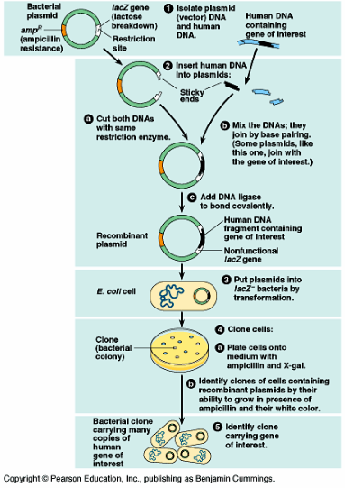
Picture of gene cloning process retrieved from: http://www.onlinebiologynotes.com/gene-cloning-steps-involved-gene-cloning/

- First of all the foreign gene is inserted into bacterial DNA using restriction enzymes and ligation. The desired gene is inserted into a ‘carrier’ DNA molecule called a plasmid. The resulting recombinant DNA molecule consists of DNA from two sources.
- Plasmids are small circular DNA molecules that have a special ability. When inserted into host bacterial cells they can replicate (produce two identical copies). Plasmids are often used in biotechnology as ‘carrier’ DNA molecules.
- The plasmid with the foreign gene is taken up by a host bacterial cell in a process called transformation. As bacteria naturally reproduce at a fast rate, they can then be used as mini-factories to rapidly clone multiple copies of the desired gene.

- In your own words, define the following terms (L1) (SLO#1 – Bio3.1.1.1):

a. gene cloning: _________________________________________________________

______________________________________________________________________

b. trans genesis: _________________________________________________________

______________________________________________________________________

c. bacterial plasmids: _____________________________________________________

______________________________________________________________________

- The diagram shows an Escherichia coli bacteria cell. On the diagram, label plasmid (L1) (SLO#2 – Bio3.1.1.2).

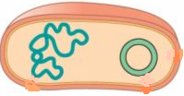

Picture retrieved from: http://genomics.alliedacademies.com/events-list/genomics-14

- The diagram shows Gene Cloning. Identify features A and B. (L1) (SLO#2 – Bio3.1.1.2)

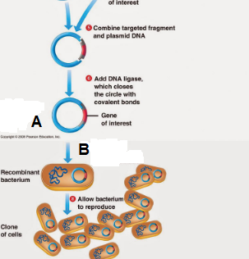

Picture retrieved from: https://microbenotes.com/gene-cloning-requirements-principle-steps-applications/

A: ____________________________________________________________________

B: ____________________________________________________________________

- Describe the steps of using bacterial plasmids to produce multiple copies of the desired gene. (L2) (SLO#3 – Bio3.1.2.1)

______________________________________________________________________

______________________________________________________________________

______________________________________________________________________

______________________________________________________________________

______________________________________________________________________

______________________________________________________________________

______________________________________________________________________

______________________________________________________________________

______________________________________________________________________

- Discuss the formation of recombinant DNA using techniques of restriction enzymes and ligation and the possible impacts of these on bodily functions. (L4) (SLO#8 – Bio3.1.4.2)

______________________________________________________________________

______________________________________________________________________

______________________________________________________________________

______________________________________________________________________

______________________________________________________________________

______________________________________________________________________

______________________________________________________________________

______________________________________________________________________

______________________________________________________________________

______________________________________________________________________

______________________________________________________________________

______________________________________________________________________

______________________________________________________________________

______________________________________________________________________

______________________________________________________________________

______________________________________________________________________

______________________________________________________________________

______________________________________________________________________

______________________________________________________________________

______________________________________________________________________

______________________________________________________________________

______________________________________________________________________

______________________________________________________________________

______________________________________________________________________

BIBLIOGRAPHY

Hanson, M. & Sinclair, M. (2006). Year 13 study guide. NCEA level 3 Biology. ESA Publications: Auckland, New Zealand. pp. 334 – 367.
Biozone. (2009). Senior Biology 1 student workbook 2009. Biozone International Ltd: New Zealand. pp. 245 – 280.
Jarvis, S. & Schofield, A. (2004). New Zealand pathfinder series. Biology year 13. NCEA level three new edition. Nelson Cengage Learning: Australia. pp. 103 – 121.
Roberts, A. & Sinclair, M. (2013). ESA study guide level 3 Biology. ESA Publications: Auckland, New Zealand. pp. 363 – 372.
Roberts, A. & Sinclair, M. (2013). Level 3 Biology. Learning workbook. ESA Publications: Auckland, New Zealand. pp. 254 – 279.

Lesson Activity 3.1B

The specific learning outcomes (SLO) targeted in this activity are provided below:

SLO# | Specific Learning Outcomes: Students are able to | Skill level | SLO code | Achieved  (Yes / No)
4 | Define Agrobacterium tumefaciens | 1 | Bio3.1.1.3
2 | Identify trans genesis in a given context | 1 | Bio3.1.1.2
5 | Describe transgenesis using techniques of Agrobacterium tumefaciens | 2 | Bio3.1.2.1
6 | Explain the positive and negative impacts of the use of trans genesis on the gene pool for a population | 3 | Bio3.1.3.1
7 | Discuss the positive and negative impacts of the use of trans genesis on the human gene pool | 4 | Bio3.1.4.1

Notes:

Vocabulary
- Agrobacterium tumefaciens is a common soil bacterium used to insert plasmids into flowering plant cells.
Transgenesis
- The purpose of transgenesis is to obtain organisms with a new and desirable genetic make-up. Proteins, and consequently traits, which are not normally present are expressed.
- An organism developing from a cell into which foreign DNA has been inserted is called a transgenic organism. Transgenic organisms are able to express foreign genes because the genetic code is universal for all organisms. This means that a specific DNA sequence will code for the same protein in all organisms.
- Transgenic organisms contain one or more genes that have been artificially introduced. The foreign genes have been obtained from another species, and are referred to as transgenes.
- The transgenes are added to the first cell of a developing multicellular organism, which results in each cell of the adult organism containing it. With animals, it is added to the egg cell. With plants, it is added to any cell, and this cell will become the first cell of the new plant.
- The process of placing a foreign gene into a recipient plant or animal cell is also called transformation. In mammals it is done directly by microinjection into an egg cell, and in plants the Ti plasmid is used to insert a foreign gene. (This plasmid occurs naturally in strains of the crown gall bacterium Agrobacterium tumefaciens, which infects plant cells.
- Transgenic techniques have been applied to plants, animals, and bacteria. They allow direct modification of a genome and enable traits to be introduced that are not naturally present in a species.
- This technology can be applied to improving crops and livestock, producing human proteins, and treating genetic defects through gene therapy. Cloning technology can be used to propagate transgenic organisms so that introduced genes quickly become part of the germ line (and are inherited). Some methods involved in transgenesis are show below:
Picture retrieved from: http://www.bio-rad.com/en-cn/applications-technologies/instrument-based-transfection-methods?ID=LUSONV30E
Ballistic DNA injection
This remarkable way of introducing foreign DNA into living tissue literally shoots it directly into the organism using a ‘gene gun’ (e.g. Helios gene gun made by Bio-Rad). Microscopic particles of gold or tungsten are coated with DNA. They are propelled by a burst of helium into the skin and organs of animals (e.g. mouse, pig, fish, etc.) and tissues of intact plants. Some of the cells express the introduced DNA as if it were their own.

Plasmid Vectors
Plasmids are naturally occurring accessory chromosomes found in bacteria. Plasmids are usually transferred between closely related microbes by cell-to-cell contact (conjugation). Simple chemical treatments can make mammalian cells, yeast cells and some bacterial cells that do not naturally transfer DNA, able to take up external DNA. Agrobacterium tumefaciens (a bacterium) can insert part of its plasmid directly into plant cells. Transforming plant cells is a multistage process. Ti plasmid-transgene recombinants are made, which are then taken up by crown gall bacteria to create transgenic bacteria. The plant is then infected with these bacteria. Part of the Ti plasmid and the transgene become integrated into the plant’s genome. The transgenic bacteria are added to only small samples (explants) of the recipient plant (e.g. small leaf discs). Many new transgenic plants can be grown from each successfully transformed explant using sue culture techniques. All cells of the new plants will have the desired genetic

make-up. Transgenic Agrobacterium readily infect dicotyledon plants, but only immature (embryonic) cells of monocotyledon plants (e.g. grasses) can be infected by them. It is a much better method than other, less accurate methods such as using a gene gun to fire tiny, gene-coated gold bullets into plant tissue.

Picture retrieved from:
https://www.sciencedirect.com/science/article/pii/S0974694313003289

Pronuclear injection
DNA can be introduced directly into an animal cell by microinjection. Multiple copies of the desired transgene are injected via extremely fine glass micropipette into a recently fertilized egg cell, which is then transferred to a surrogate mother. This is done with the egg outside of the body, and then the egg is grown into an embryo in a petri dish before being implanted into a recipient (surrogate) mother to complete its development naturally. Transgenic mice and livestock are produced in this way, but the process is inefficient: only 2-3% of eggs give rise to transgenic animals and only a proportion of these animals express the added gene adequately.
Picture retrieved from: https://en.wikipedia.org/wiki/Microinjection

Viral Vectors
Viruses, such as those shown on the right, are well suited for gene therapy. They can accommodate up to 7500 bases of inserted DNA in their protein capsule. When viruses infect and reproduce inside the target cells, they are also spreading the recombinant DNA. They have already been used in several clinical traits of gene therapy for different diseases. A problem with this method involves the host immune reaction to the virus.
Picture retrieved from: http://www.mun.ca/biology/scarr/Somatic_Therapy_for_SCID.htm

Transformation using a Ti Plasmid in Agrobacterium
Transformation
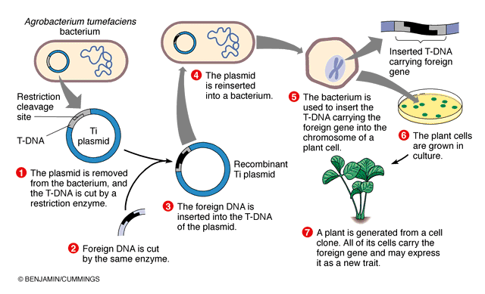

Picture retrieved from: http://sphweb.bumc.bu.edu/otlt/MPH-Modules/PH/GMOs/GMOs3.html

- Define Agrobacterium tumefaciens. (L1) (SLO#4 – Bio3.1.1.3)

______________________________________________________________________

______________________________________________________________________

- Describe trans genesis using the techniques of Agrobacterium tumefaciens. (L2) (SLO#5 – Bio3.1.2.1)

______________________________________________________________________

______________________________________________________________________

______________________________________________________________________

______________________________________________________________________

______________________________________________________________________

______________________________________________________________________

______________________________________________________________________

- The diagram below shows transgenesis. Identify features A and B.
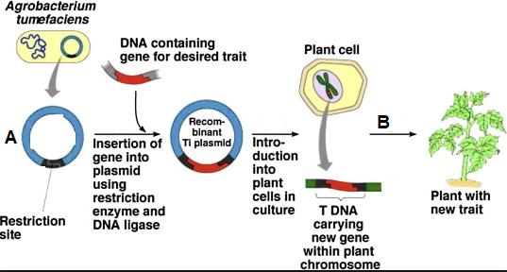

Picture retrieved from: https://www.sciencedirect.com/science/article/pii/S0974694313003289

A: ____________________________________________________________________

B: ____________________________________________________________________

- Explain the positive and negative impacts of the use of trans genesis on the gene pool for a population. (L3) (SLO#6 – Bio3.1.3.1)

______________________________________________________________________

______________________________________________________________________

______________________________________________________________________

______________________________________________________________________

______________________________________________________________________

______________________________________________________________________

______________________________________________________________________

- Discuss the positive and negative impacts of the use of trans genesis on the human gene pool. (L4) (SLO#7 – Bio3.1.4.1)

______________________________________________________________________

______________________________________________________________________

______________________________________________________________________

______________________________________________________________________

______________________________________________________________________

______________________________________________________________________

______________________________________________________________________

______________________________________________________________________

______________________________________________________________________

______________________________________________________________________

______________________________________________________________________

______________________________________________________________________

______________________________________________________________________

______________________________________________________________________

______________________________________________________________________

______________________________________________________________________

______________________________________________________________________

______________________________________________________________________

______________________________________________________________________

______________________________________________________________________

______________________________________________________________________

BIBLIOGRAPHY

Hanson, M. & Sinclair, M. (2006). Year 13 study guide. NCEA level 3 Biology. ESA Publications: Auckland, New Zealand. pp. 334 – 367.
Biozone. (2009). Senior Biology 1 student workbook 2009. Biozone International Ltd: New Zealand. pp. 245 – 280.
Jarvis, S. & Schofield, A. (2004). New Zealand pathfinder series. Biology year 13. NCEA level three new edition. Nelson Cengage Learning: Australia. pp. 103 – 121.
Roberts, A. & Sinclair, M. (2013). ESA study guide level 3 Biology. ESA Publications: Auckland, New Zealand. pp. 363 – 372.
Roberts, A. & Sinclair, M. (2013). Level 3 Biology. Learning workbook. ESA Publications: Auckland, New Zealand. pp. 254 – 279.

Lesson Activity 3.1C

The specific learning outcomes (SLO) targeted in this activity are provided below:

SLO# | Specific Learning Outcomes: Students are able to | Skill level | SLO code | Achieved  (Yes / No)
9 | Define short tandem repeat (STR) in DNA | 1 | Bio3.1.1.4
10 | Describe why every person’s DNA is unique in terms of STR’s | 2 | Bio3.1.2.2
11 | Define DNA profiling | 1 | Bio3.1.1.5
12 | Identify DNA profiling in a given context | 1 | Bio3.1.1.6
18 | Explain the positive and negative impacts of DNA profiling on medical health sciences | 3 | Bio3.1.3.3
19 | Discuss how DNA profiling has made the work of criminal justice easier. | 4 | Bio3.1.4.3

Notes:

DNA Profiling
‘Genetic fingerprinting’, or DNA profiling, or DNA typing is a technique that makes it possible to determine relationships between individuals by comparing their DNA. The technique was developed by Alec Jeffreys in 1985, and it has been of enormous significance in forensic science (the science of obtaining evidence to be used in court).
- The purpose of DNA profiling is to compare the base sequence of two or more DNA samples to determine whether they are related. It is very useful in forensic science, particularly when there is only a tiny amount of target DNA available.
- The result of DNA profiling is a series of bands, resembling a bar-code pattern, on a gel. The bands contain DNA fragments of different lengths. This pattern is highly specific to the contributing individual.
- The process of DNA profiling uses parts of the genome called VNTRs (variable Nucleotide Tandem Repeats) and/or STRs (short tandem repeats) or microsatellites

VNTRs (Variable Nucleotide Tandem Repeats)

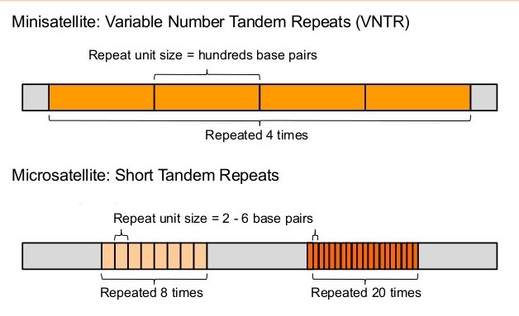Picture retrieved from: https://ramneetkaur.com/dna-fingerprinting/

- These are sections of non-protein coding DNA that are repeated over and over again, e.g. the GA dinucleotide repeated many times to form the VNTR, GAGAGAGAGA… The repeat unit (GA in this example) is present at the same location within the genome in all members of a populations, but the number of repeats varies between chromosomes. Individuals usually have a different-length version of this allele on each homologous chromosome, and these will be different in length from those of other members of the population.
How VNTR are used in DNA profiling
- The diagram shows how three people can have quite different microsatellite arrangements at the same point (locus) in their DNA. Each will produce a different DNA profile using gel electrophoresis:
1. Extract DNA from sample
A sample collected from the tissue of a living or dead organisms is treated with chemicals and enzymes to extract the DNA, which is separated and purified.
2. Amplify microsatellites using PCR
Specific primers that attach to the flanking (nearby) regions either side of the microsatellite are used to make large quantities of the microsatellite and flanking regions sequence only (no other part of the DNA is amplified/replicated).
3. Visualize fragments on a gel
The fragments are separated by length, using gel electrophoresis. DNA, which is negatively charged, moves toward the positive terminal. The smaller fragments travel faster than larger ones.

Picture retrieved from: http://www.vce.bioninja.com.au/aos-3-heredity/molecular-biology-technique/dna-profiling.html
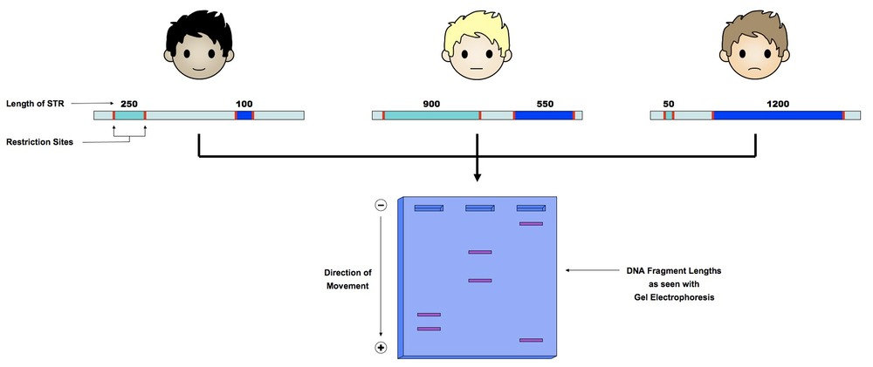

Criminal Identification DNA Profile
DNA profiling of four samples using two VNTR loci.

Picture retrieved from: https://geneed.nlm.nih.gov/topic_subtopic.php?tid=37&sid=38

Suspect 2 is very likely to be the source of the DNA left at the scene.

- The VNTRs are amplified by the polymerase chain reaction (PCR).
- Specific primers for regions immediately outside of the VNRTs are used to make large quantities of the VNTR section. The PCR products are separated using gel electrophoresis, and the bands in different samples compared.
- If the lengths of the amplified VNTRs from different samples are identical, the two samples are highly likely to have come from the same individual.
- VNTRs are inherited in a Mendelian way. Each VNTR has a specific locus on a particular pair of homologous chromosomes. One version (allele) of the VNTR will be from the mother and one from the father. Therefore, the DNA profile of a child will contain certain bands, half of which will be identical to those of the mother, and the rest will be identical to those of the father (see Special Skill below).
- About then different VNTR regions are amplified in a DNA profile, which, due to the two copies of each VNTR per person, would result in 20 bands on the DNA profile. The chance of the profile of two unrelated people being identical is 1 in a million. The more regions that are analysed, the lower the chances of a random match.
Special Skill: Identifying paternity
- Identify which of the child’s bands is maternal is maternal (derived from the mother) and strike them out.
- The remaining bands must be paternal.
- For each paternal band, systematically check if it is found on the profile on any of the potential fathers.
- The biological father is the one whose profile contains all of the child’s paternal bands.

Short Tandem Repeat (STR) Typing
The human genome which consists of about 3 billion base pairs harbours genetically relevant information which is essential for the characterization of each individual. It is believed that genetically relevant information represents less than 10 % of the human genome. This minor part of the gene-coding DNA has been subjected to evolutionary pressure and selection mechanisms ensuring the development of higher organized organisms. The other 90% of the genome is junk DNA, a term which is more of a misnomer since their functions are still unknown rather than useless. A part of this non-coding DNA is comprised of repetitive sequences. Highly polymorphic spots in these non-coding regions are referred to as mini- or micro-satellites characterized by repeated blocks of DNA. The single-locus satellites are localized at a specific site of a given human chromosome, while multi-locus satellite elements or short tandem repeats (STRs) are spread throughout the entire genome.
STRs are highly polymorphic, and alleles of the STR loci are differentiated by the number of copies of the repeat sequence within each of the STR locus. The more STR loci being used for typing, the greater the discrimination value since the likelihood that a single individual has an identical STR profile, that possesses the exact same number of repeat units for all the STR being analyzed, with another individual taken at random in the population becomes extremely rare.
The STRs chosen and validated for typing for personal identification contain tetranucleotide repeats comprising of alleles of discrete size. Commercially robust and validated STR multiplex kits are available. The kits also include allelic ladder for each STR locus, which incorporates all the alleles of the STR locus so far known. This helps in the precise assignment of each allele and also in assigning the allele number.
The microsatellite alleles for a particular locus are codominant. In a given individual there are 2 alleles which are inherited in a Mendelian fashion. This means that an individual receives one allele from the mother and the other allele from the father. The two alleles are either heterozygous - the alleles are different or, homozygous - both the alleles are of the same type. In the case of a heterozygous situation, the individual shows two bands indicating the two different alleles, and, in a homozygous situation the individual shows only one band since both the alleles are of the same type and are superimposed.
The following example of STR typing is to explain the above principle. Say in a given case of paternity dispute the alleged father, the mother and the child are tested for the STR locus vWA. The vWA locus – von Willebrand factor gene contains 8 alleles in the population and the alleles are numbered 13 to 20. Though 8 alleles are present in the population for this STR locus, only two alleles can be found in an individual. A hypothetical STR vWA locus typing result is as follows: Alleged Father – [13,15]; Child – [14,15]; Mother – [14,14]
In this case-example the child has received one allele [15] from the heterozygous alleged father [13, 15] and the other one allele [14] from the homozygous mother [14, 14] (Diagram below). It is evident that the bands indicating the alleles inherited by the child appear in the exact positions corresponding to the allelic ladder; and, there is no ambiguity in the allele number indicated by the bands of the ladders. Thus based on this one STR typing, the alleged father cannot be ruled out as the biological father. However, as mentioned above, the more the number of STRs being utilized for typing, the more discriminatory this method will be for personal identification. At present, 15 STRs are being used for typing, providing a level of discrimination as high as 1 in 30 to several hundred billion! This means that in the absence of identical twins, the probability of finding a matching DNA profile to an individual in a random population is, for example, 1 in 30 billion!

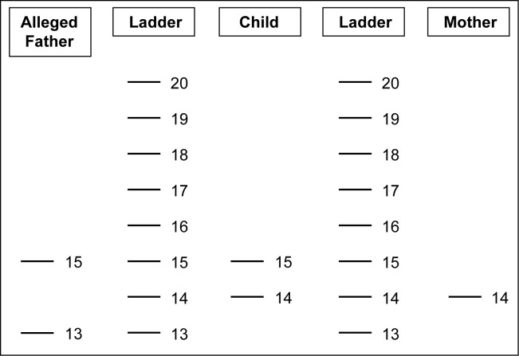
Schematic representation of a hypothetical case of paternity dispute showing the STR vWA locus typing result of the alleged father, the child and the mother with allelic ladders run adjacent to the test samples. Note that the allelic number assignment commences from the bottom and ascends by one unit increment to the top. Reading of the profile is easy and unambiguous - Alleged Father – [13,15]; Child – [14,15]; Mother – [14,14]. The alleged father cannot be ruled out as the biological father.
(Source of information: https://www.ncbi.nlm.nih.gov/pmc/articles/PMC3561883/)

- Define DNA profiling. (L1) (SLO#11 – Bio3.1.1.5)

______________________________________________________________________

______________________________________________________________________

- Identify the technique in the picture below. (L1) (SLO#12 – Bio3.1.1.6)
feature
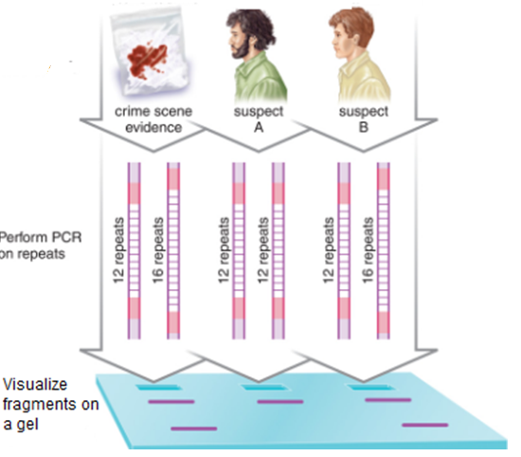
Picture retrieved from: https://www.pinterest.com/pin/560768591071917788/

______________________________________________________________________

- Define short tandem repeat (STR) in DNA. (L1) (SLO#9 – Bio3.1.1.4)

______________________________________________________________________

______________________________________________________________________

- Describe why every person’s DNA is unique in terms of STRs. (L2) (SLO#10 – Bio3.1.2.2)

______________________________________________________________________

______________________________________________________________________

______________________________________________________________________

______________________________________________________________________

______________________________________________________________________

- Explain the positive and negative impacts of DNA profiling on medical health sciences (L3) (Bio3.1.3.3)

______________________________________________________________________

______________________________________________________________________

______________________________________________________________________

______________________________________________________________________

______________________________________________________________________

______________________________________________________________________

______________________________________________________________________

- Discuss how DNA profiling has made the work of criminal justice easier using examples. (L4) (Bio3.1.4.3)

______________________________________________________________________

______________________________________________________________________

______________________________________________________________________

______________________________________________________________________

______________________________________________________________________

______________________________________________________________________

______________________________________________________________________

______________________________________________________________________

______________________________________________________________________

______________________________________________________________________

______________________________________________________________________

______________________________________________________________________

______________________________________________________________________

______________________________________________________________________

______________________________________________________________________

______________________________________________________________________

______________________________________________________________________

______________________________________________________________________

______________________________________________________________________

______________________________________________________________________

______________________________________________________________________

______________________________________________________________________

______________________________________________________________________

BIBLIOGRAPHY

Hanson, M. & Sinclair, M. (2006). Year 13 study guide. NCEA level 3 Biology. ESA Publications: Auckland, New Zealand. Pp. 334 – 367.
Biozone. (2009). Senior Biology 1 student workbook 2009. Biozone International Ltd: New Zealand. Pp. 245 – 280.
Jarvis, S. & Schofield, A. (2004). New Zealand pathfinder series. Biology year 13. NCEA level three new edition. Nelson Cengage Learning: Australia. Pp. 103 – 121.
Roberts, A. & Sinclair, M. (2013). ESA study guide level 3 Biology. ESA Publications: Auckland, New Zealand. Pp. 363 – 372.
Roberts, A. & Sinclair, M. (2013). Level 3 Biology. Learning workbook. ESA Publications: Auckland, New Zealand. Pp. 254 – 279.

Lesson Activity 3.1D

The specific learning outcomes (SLO) targeted in this activity are provided below:

SLO# | Specific Learning Outcomes: Students are able to | Skill level | SLO code | Achieved  (Yes / No)
13 | Define PCR / gel electrophoresis | 1 | Bio3.1.1.7
14 | Identify PCR / gel electrophoresis, in a given context | 1 | Bio3.1.1.8
15 | Describe the formation of DNA profiles using the techniques of PCR | 2 | Bio3.1.2.3
16 | Describe the formation of DNA profiles using the techniques of gel electrophoresis | 2 | Bio3.1.2.4
17 | Explain the interrelationships of processes in the formation of DNA profiles using the techniques of PCR and gel electrophoresis | 3 | Bio3.1.3.2
20 | Discuss the impact of the formation of DNA profiles using the techniques of PCR and gel electrophoresis on criminal justice, medicine and other areas | 4 | Bio3.1.4.4

Notes:

PCR (Polymerase Chain Reaction)
PCR is a technique used to make large amounts of (‘amplify) DNA for use in applications such as gene cloning, DNA profiling, DNA sequencing, genome analysis. PCR is a three-step process which can be used to make billions of identical copies of a piece of DNA in just a few hours.

Step 1 DNA of interest (‘target’ DNA) is denatured by being exposed to high temperatures for a short period of time (e.g. 98 ºC for 5 minutes). The high temperatures break the hydrogen bonds (H bonds) holding the two strands together, so the DNA molecule becomes single strands.

Step 2 Temperatures are lowered (e.g. to 60 ºC) and DNA primers added. These anneal (harden, strengthen) to the DNA – i.e. bond to a short sequence of bases that indicate the starting sequence for the DNA replication in the final step.

Step 3 Free nucleotides (mixture of A, T, C, G) are added, together with DNA polymerase (heat-stable Taq polymerase extracted from thermophile bacteria). The polymerase bonds to each primer and synthesizes a new DNA strand using the nucleotides and base pairing (the DNA is extended). Two identical DNA molecules result.

This cycle is repeated many times, with denaturing, annealing, and extending of the accumulating DNA to produce large amounts of DNA needed for an application.

Care must be taken with PCR to ensure no contamination with foreign DNA occurs. PCR is widely used in biotechnological applications.
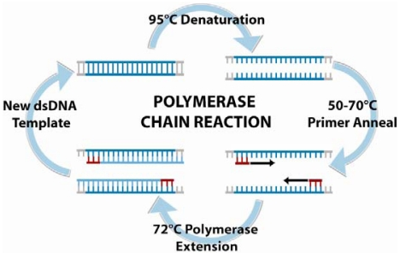
Picture retrieved from: https://www.researchgate.net/figure/Polymerase-chain-reaction-PCR-is-an-amplification-based-technique-for-DNA-detection_fig5_223138442

Gel electrophoresis
Gel electrophoresis is a technique used to separate segments of DNA based on the size of the molecules and their subsequent rate of movement through a gel under the influence of an electric field.
A gel tray is prepared with either agarose or acrylamide gel sandwiched between two plates. Wells are made with comb at one end to take the molecules being separated. The tray is placed in an electrophoresis chamber filled with a buffer solution to cover the gel – allows current to flow through the gel. DNA fragments mixed with a marker dye are inserted in the wells. Electrodes are attached to each end of the gel – negative at the top end where the DNA is. The current is switched on and the DNA fragments migrate through the gel attracted to the positive electrode (phosphate groups in DNA have a negative charge). Rate of movement is related to size of fragments – smaller particles have less resistance so move more rapidly. When the dye making the DNA reaches the end of the gel, the current is switched off. DNA molecules are made visible by immersing the gel in a dye such as methylene blue (which attaches to the DNA), or a chemical such as ethidium bromide (which binds to the DNA and will become visible (fluoresces orange) when exposed to UV light, producing an autoradiograph). Accumulations of DNA fragments of the same length produce distinctive bands on the gel and these can then be used in applications such as DNA profiling, DNA sequencing, genome analysis.

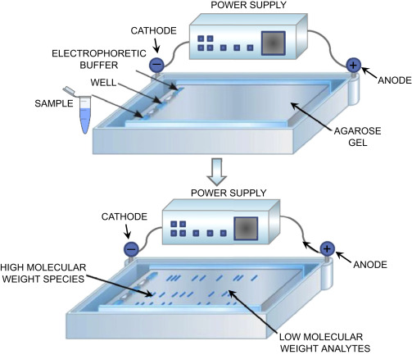
Picture retrieved from:
https://www.sciencedirect.com/topics/neuroscience/gel-electrophoresis

- Define the following terms (L1) (SLO#13 – Bio3.1.1.7):

a. PCR: ________________________________________________________________

______________________________________________________________________

b. gel electrophoresis: ____________________________________________________

______________________________________________________________________

- The diagram shows a PCR. Identify the features A, B, and C. (L1) (SLO#14 – Bio3.1.1.8)
PCR (Polymerase Chain Reaction)
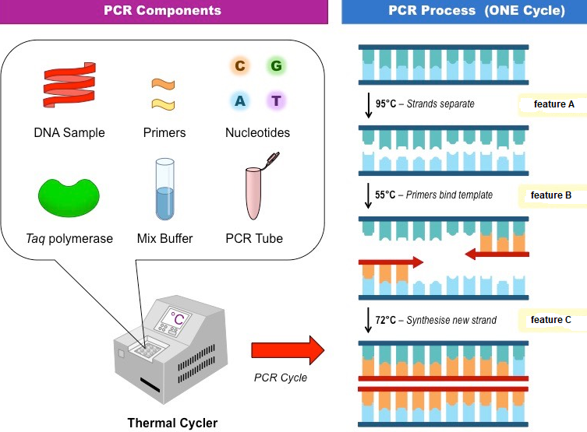

Picture retrieved from: http://ib.bioninja.com.au/standard-level/topic-3-genetics/35-genetic-modification-and/pcr.html

A: ____________________________________________________________________

B: ____________________________________________________________________

C: ____________________________________________________________________

- Describe the formation of DNA profiles using the techniques of PCR. (L2) (SLO#15 – Bio3.1.2.3)

______________________________________________________________________

______________________________________________________________________

______________________________________________________________________

______________________________________________________________________

______________________________________________________________________
- Describe the formation of DNA profiles using the techniques of gel electrophoresis. (L2) (SLO#16 – Bio3.1.2.4)

______________________________________________________________________

______________________________________________________________________

______________________________________________________________________

______________________________________________________________________

______________________________________________________________________

- Explain the interrelationships of the processes in the formation of DNA profiles using the techniques of PCR and gel electrophoresis. (L3) (SLO#17 – Bio3.1.3.2)

______________________________________________________________________

______________________________________________________________________

______________________________________________________________________

______________________________________________________________________

______________________________________________________________________

______________________________________________________________________

______________________________________________________________________

______________________________________________________________________

______________________________________________________________________

______________________________________________________________________

- Discuss the impact of the formation of DNA profiles using the techniques of PCR and gel electrophoresis on criminal justice, medicine and other areas using examples. (L4) (SLO#20 - Bio3.1.4.4)

______________________________________________________________________

______________________________________________________________________

______________________________________________________________________

______________________________________________________________________

______________________________________________________________________

______________________________________________________________________

______________________________________________________________________

______________________________________________________________________

______________________________________________________________________

______________________________________________________________________

______________________________________________________________________

______________________________________________________________________

______________________________________________________________________

______________________________________________________________________

______________________________________________________________________

______________________________________________________________________

______________________________________________________________________

______________________________________________________________________

______________________________________________________________________

______________________________________________________________________

______________________________________________________________________

______________________________________________________________________

______________________________________________________________________

______________________________________________________________________

______________________________________________________________________

BIBLIOGRAPHY

Bill van den Ende. (2017). Level 3 Biology AME workbook. ESA Publications (NZ) Ltd: Auckland,
New Zealand. pp. 29 – 51.
Biozone. (2003). Senior Biology 2 student resources and activity manual 2003. Biozone International Ltd: Australia. pp. 116 – 117.
Jarvis, S. & Schofield, A. (2004). New Zealand pathfinder series. Biology year 13. NCEA level three new edition. Nelson Cengage Learning: Australia. pp. 71 – 74.
Roberts, A. & Sinclair, M. (2013). ESA study guide level 3 Biology. ESA Publications: Auckland, New Zealand. pp. 233 – 250.
Roberts, A. & Sinclair, M. (2013). Level 3 Biology. Learning workbook. ESA Publications: Auckland, New Zealand. pp. 254 – 279.

Sub-strand 3.2 Contemporary biotechnology issue
Major Learning Outcome 5:

Students are able to research and process information to write a report on a chosen contemporary issue regarding biotechnology.

Key Learning Outcome: Students are able to demonstrate understanding of biotechnology issues:
- human needs or demands that have led to the development of a biotechnological application which is an issue.
- techniques needed to carry out the application.
- any potential biological, social, ethical, economic impacts of the application.
- the differing opinions of named people or groups, including their own justified opinion, on the issue.

Lesson Activity 3.2A

The specific learning outcomes (SLO) targeted in this activity are provided below:

SLO# | Specific Learning Outcomes: Students are able to | Skill level | SLO code | Achieved  (Yes / No)
1 | Name a biotechnology issue | 1 | Bio3.2.1.1
2 | Locate the area in which selected issue is commonly encountered | 1 | Bio3.2.1.2
3 | List contemporary biotechnology issues as established through research | 2 | Bio3.2.2.1
6 | Provide elaboration on at least two critical steps in the selected biotechnology application. | 3 | Bio3.2.3.1

Notes:

- Biotechnology involves the development of techniques for the application of biological processes to the production of materials useful in medicine, agriculture or industry. It encompasses (includes, covers) a wide range of applications.
- Genetic engineering is major area of biotechnology that involves the manipulation of genetic material (DNA and RNA) from living things. Usually this is for the purpose of benefiting the lives of humans.
- Biotechnological applications involve applying techniques to biological processes in order to produce useful organisms, information or chemicals. Many applications make use of genetic engineering techniques.
Biological issues/Biotechnology issues
- Gene cloning and transgenesis both involve altering the genetic make-up of an organism.
- DNA profiling and genome analysis both involve studying the base (nucleotide) sequence of sections of DNA.
- Xenotransplantation and stem cell research have the potential to provide replacement organs or tissue when they are combined with genetic engineering.

- Name a biotechnology issue. (L1) (SLO#1 – Bio3.2.1.1)

______________________________________________________________________

- Locate the area in which the selected issue in question 1 above is commonly encountered. (L2) (SLO#2 – Bio3.2.1.2)

______________________________________________________________________

- Make a list of the contemporary biotechnology issues as established through research. You may use the internet to help you answer this question. (L2) (SLO#3 – Bio3.2.2.1)

______________________________________________________________________

______________________________________________________________________

______________________________________________________________________

______________________________________________________________________

______________________________________________________________________

- Provide elaboration on at least two critical steps for the list of contemporary biotechnology issues in question 3 above. You may use the internet to help you answer this question. (L3) (SLO#6 – Bio3.2.3.1)

______________________________________________________________________

______________________________________________________________________

______________________________________________________________________

______________________________________________________________________

______________________________________________________________________

______________________________________________________________________

______________________________________________________________________

______________________________________________________________________

______________________________________________________________________

______________________________________________________________________

______________________________________________________________________

______________________________________________________________________

______________________________________________________________________

______________________________________________________________________

______________________________________________________________________

______________________________________________________________________

______________________________________________________________________

______________________________________________________________________

______________________________________________________________________

BIBLIOGRAPHY

Bill van den Ende. (2017). Level 3 Biology AME workbook. ESA Publications (NZ) Ltd: Auckland,
New Zealand. pp. 29 – 51.
Biozone. (2003). Senior Biology 2 student resources and activity manual 2003. Biozone International Ltd: Australia. pp. 116 – 117.
Jarvis, S. & Schofield, A. (2004). New Zealand pathfinder series. Biology year 13. NCEA level three new edition. Nelson Cengage Learning: Australia. pp. 71 – 74.
Roberts, A. & Sinclair, M. (2013). ESA study guide level 3 Biology. ESA Publications: Auckland, New Zealand. pp. 233 – 250.
Roberts, A. & Sinclair, M. (2013). Level 3 Biology. Learning workbook. ESA Publications: Auckland, New Zealand. pp. 254 – 279.

ANSWERS

Strand 1: Animal Behaviour

Sub-strand 1.1 Ecological Niche - Lesson Activity 1.1A

- Ecological niche is the role of an organism within its ecological community.
2a. The fundamental niche of Chthamalus occupies all the intertidal zone from high tide to low tide, while the realised niche is restricted to the upper 1/3 of the intertidal shore (from high tide).
2b. Realised niche is the same as fundamental niche for Balanus as it is likely that the limits are set by physiological tolerances to submergence by water (lower) and exposure to air (upper). Biotic factors (e.g. competition from seaweed for living space on rocks, predation by fish) may be acting to set the lower limit to the niche.
3. Answer – teacher feedback. Discussion should refer to:
- both herbivores, but have different foods (described) and adaptations (described) to feeding
- different habitats (described)
- warning colouration described and explained in terms of toxic compounds / unpalatable / predator avoidance
- advantages related to reduction in intraspecific competition (explained), hence increased survival of individuals and survival of species.

Sub-strand 1.2 Orientation and Navigation - Lesson Activity 1.2A

- a) innate behaviour; b) navigation; c) migration; d) homing; e) kinesis; f) taxis; g) learnt behaviour
- The features (types) of innate behaviour are: taxes, kineses, navigation (migration or homing). Example may vary.
- The features and examples of learned behaviour may vary. Discussion should refer to:
- Simple learned behaviors include habituation and imprinting, both of which are important to the maturation process of young animals.
- Habituation is a simple form of learning in which an animal stops responding to a stimulus after a period of repeated exposure. This is a form of non-associative learning as the stimulus is not associated with any punishment or reward. Prairie dogs typically sound an alarm call when threatened by a predator, but they become habituated to the sound of human footsteps when no harm is associated with this sound; therefore, they no longer respond to them with an alarm call. In this example, habituation is specific to the sound of human footsteps, as the animals still respond to the sounds of potential predators.
- Imprinting is a type of learning that occurs at a particular age or a life stage that is rapid and independent of the species involved. Hatchling ducks recognize the first adult they see, their mother, and make a bond with her. A familiar sight is ducklings walking or swimming after their mothers. This type of non-associative learning is very important in the maturation process of these animals as it encourages them to stay near their mother in order to be protected, greatly increasing their chances of survival. However, if newborn ducks see a human before they see their mother, they will imprint on the human and follow it in just the same manner as they would follow their real mother.
- Conditioned Behavior: In classical conditioning, a behavior is paired with an unrelated stimulus; in operant conditioning, behaviors are modified by consequences.
- You would need to get two groups of young monarchs, newly emerged from pupal stage, and you would need to record the proportion of each group that could navigate and migrate successfully on their own:
- first group – isolated from older monarchs
- second group – mixed with older monarchs.
If most or all of the first group navigated and migrated successfully, indicates behaviour is innate. If all of the first group did not navigate and migrate successfully but most or all of the second group navigated and migrated successfully, indicates behaviour is learnt. If some of first group, but more of second group, navigated and migrated successfully, indicates behaviour is mixture of innate and learnt.

Sub-strand 1.2 Orientation and Navigation - Lesson Activity 1.2B

- light – photo; gravity – geo or gravi; water – hydro; touch – thigmo; chemicals – chemo.
2a. Negative geotaxis; likely to seek shelter from predators and/or dehydrating effects of sun (the response means that the snails usually end up in a sheltered/protected place) or negative chemotaxis; move away from accumulation of wastes/carbon dioxide at bottom.
2b. Negative chemotaxis; the response removes the organism from a potentially poisonous chemical.
2c. Positive gravitaxis or positive geotaxis; the response enables bivalves to avoid potential predators.
2d. Positive phototaxis; Euglena needs light for photosynthesis and hence food production.
2e. Positive chemotaxis; E.coli moves to food source.

Sub-strand 1.2 Orientation and Navigation - Lesson Activity 1.2C

- Photokinesis (or klinokinesis); increases flatworm’s chances of getting from light into dark areas so reducing chances of dehydration (from heat) and/or predation.
2a. Orthokinesis; increases slater’s chances of getting into area of high humidity thus reducing chances of dehydration.
2b. Photokinesis or orthokinesis; increases slater’s chances of getting into area of darkness to reduce chances of dehydration (from heat associated with light).
3. Thigmokinesis or orthokinesis; huddling reduces water loss from body decreasing dehydration (humidity in the locality increases).

Sub-strand 1.2 Orientation and Navigation - Lesson Activity 1.2D

- True

Sub-strand 1.2 Orientation and Navigation - Lesson Activity 1.2E

- Use landmarks is not feasible when the animal is migrating across oceans (and other large bodies of water) where there are no discernable landmarks to provide cues of location.
- When cloud obscures sun and stars, many animals are able to use the earth’s magnetic fields to navigate and so keep moving / on course.
- The positions of the sun and stars change as earth rotates on its axis. If an animal does not compensate for this movement, it will not keep on path to its direction. The biological clock enables the animal to know the time so it can change its position relative to the sun/stars so it maintains its course.
5a. To disrupt any ability to orientate using magnetic fields.
5b. Sun compass, magnetic field. The sun compass is dominant since the birds orientate correctly as long as the sun is shining, even with magnets on their heads.

Sub-strand 1.2 Orientation and Navigation - Lesson Activity 1.2F

1a. Godwits leave New Zealand during March in response to the reduction in photoperiod / reduced hours of daylight. Gather in flocks awaiting favourable weather (e.g. no storms) or tail winds, when mass departure occurs.
1b. Biological clock prepares birds – they lay down fat layers to supply energy for the long flight; flight feathers are replaced so they are in prime condition for the hours of flying ahead; breeding plumage develops so that the birds can undergo mating behaviour and breed on arrival in Alaska to maximize time for young to develop and grow and prepare for return migration.
1c. Allow the birds to rest and feed so replacing energy supplies and putting on condition – enhances chances of being successful on the second stage (the long flight onwards to Alaska).
1d. Suitable habitat providing abundant nest sites, abundant food, long hours of daylight to feed and raise young, few predators.
1e. Birds need to build up fat layers and replace flight plumage. Development of breeding plumage and ripening of sex organs are not needed for return to New Zealand.
1f. September.
1g. The journey takes much less time (direct flight takes about a week) allowing the godwits to arrive ahead of other migrants and take advantage of food supplies. The direct flight may be less hazardous and arduous (difficult/hard) overall when compared with the two-stage journey via Asia, so higher % of birds successfully (so selected for).
2a. Use the sun as a compass in daytime, use star patterns as compass at night, may use earth’s magnetic fields as a compass. Use landmarks over land/coastlines but not over ocean.
2b. Migration is innate, as young cannot learn it from adults (who leave first); have to be genetically programmed for the migration.
2c. Cuckoos overwinter in tropical islands where climate is warm and food abundant. Breed in New Zealand where there are abundant host birds with nests for the cuckoo to lay its eggs in. New Zealand climate is temperate and food abundant. Young well fed (by hosts) and grow rapidly. Return to islands to avoid reduced food supplies and cooler temperatures of New Zealand winter.

Sub-strand 1.3 Timing Responses - Lesson Activity 1.3A

1a. Timing responses refer to the behavior(s) of an organism at a particular time due to internal timing system or external time cues
1b. Arrhythmic activity refers to when an organism’s activity pattern(s) break down as a result of being placed under constant environmental conditions.
1c. Diurnal means active during the day.
1d. Nocturnal means active at night.
1e. Crepuscular means active at dawn and dusk.

Sub-strand 1.3 Timing Responses - Lesson Activity 1.3B

1a. Endogenous means having an internal origin, independent of external stimuli.
1b. Exogenous is driven by external stimuli.
1c. Zeitgeber refers to external environmental cue by which an internal clock is reset.

Sub-strand 1.3 Timing Responses - Lesson Activity 1.3C

1a. Actograms are a simple type of graph that show activity over a given period of time.

Sub-strand 1.3 Timing Responses - Lesson Activity 1.3D

1a. Circadian is the rhythm with a period of about a day when under constant environmental conditions.
1b. Circatidal is the rhythm with a period of about 12 hours when under constant environmental conditions.
1c. Circalunar is the rhythm with a period of about 29 days when under environmental conditions.
1d. Circannual is the rhythm with a period of about a year when under constant environmental conditions

Sub-strand 1.4 Interspecific Interactions - Lesson Activity 1.4A

4a. Balanus is out-competing Chthamalus for living space on the shore and is restricting Chthamalus to the upper 1/3 of the shore.

Sub-strand 1.4 Interspecific Interactions - Lesson Activity 1.4B

    - The features of predator-prey relationships are: predator avoidance strategies (prey uses mimicry, chemical defence, camouflage, offensive weapons etc. to avoid predators) and prey capturing strategies (predator uses traps, concealment, tools etc. to catch preys). In this relationship, the predator gains (+) while the prey is harmed (-).

Sub-strand 1.5 Intraspecific Interactions - Lesson Activity 1.5A

1a. r strategy refers to an organism whose reproductive effort is devoted to producing, but not caring for, a large number of offspring.
1b. k strategy refers to an organism whose reproductive effort is devoted to producing and caring for a small number of offspring.
1c. Monogamous mating refers to a mating system in which each animal mates with only one partner.
1d. Polygamous mating refers to a mating system that involves two or more males with two or more females.

Sub-strand 1.5 Intraspecific Interactions - Lesson Activity 1.5B

1a. Social organization may be defined as a pattern of relationships between and among individuals and social groups.
1b. Territory is an area that is defended by an animal.
1c. Home range is an area that is not defended.

Sub-strand 1.5 Intraspecific Interactions - Lesson Activity 1.5C

1. The chickens show a linear social arrangement or pecking order.

Strand 3: Biotechnology Applications

Sub-strand 3.1 Gene cloning, Transgenesis and DNA Profiling - Lesson Activity 3.1A

1a. Gene cloning is a process by which multiple copies of a gene are produced in a bacterium or bacteriophage.
1b. Transgenesis is a process of obtaining organisms with a new and desirable genetic make-up.
1c. Bacterial plasmids refers to a small circular DNA molecules in a bacteria that have the ability to replicate when inserted into host bacterial cells.

Sub-strand 3.1 Gene cloning, Transgenesis and DNA Profiling - Lesson Activity 3.1B

1a. Agrobacterium tumefaciens is a common soil bacterium used to insert plasmids into flowering plant cells.
1b. Ballistic gene gun is a technique that is used to directly introduce foreign DNA into living tissue or an organism.

Sub-strand 3.1 Gene cloning, Transgenesis and DNA Profiling - Lesson Activity 3.1C

1. DNA profiling is a technique by which fragments of DNA in individuals are compared to establish relationships between them.

Sub-strand 3.1 Gene cloning, Transgenesis and DNA Profiling - Lesson Activity 3.1D

1a. PCR (Polymerase Chain Reaction) is a technique whereby a minute quantity of DNA can be replicated many times in the test tube.
1b. Gel electrophoresis is a method that separates large molecules (including nucleic acids or proteins) on the basis of size, electric charge, and other physical properties.

Sub-strand 3.2 Contemporary biotechnology issue - Lesson Activity 3.2A

1. gene cloning, transgenesis, xenotransplantation, stem cell research, genome analysis

Strand 4: Processes and Patterns of Evolution

Sub-strand 4.3 Gene pool and allele frequency - Lesson Activity 4.3D

1. Genetic drift is the change in allele frequency due to accumulated effects of chance.

Sub-strand 4.3 Gene pool and allele frequency - Lesson Activity 4.3E

1. The features of the founder effect as special cases of genetic drift are: a small group of individuals colonise a new area and is separated from the parent population; the small group of individuals may evolve differently. / The founder effects when a small group of migrants that is not genetically representative of the population from which they came establish in a new area. In addition to founder effects, the new population is often a very small population, so shows increased sensitivity to genetic drift, and increase in inbreeding, and relatively low genetic variation.

Sub-strand 4.4 Speciation - Lesson Activity 4.4A

1a. Allopatric speciation is refers to the type of speciation that mostly occur after populations become separated by a geographic barrier.
1b. Sympatric speciation refers to new species that arise without geographical separation.
1c. Instant (polyploidy) speciation refers to the sudden appearance of a new species.

Sub-strand 4.4 Speciation - Lesson Activity 4.4B

1. Spatial (geographical), temporal (including seasonal), ecological (niche), gamete mortality, behavioral (ethological), structural (morphological)

Sub-strand 4.4 Speciation - Lesson Activity 4.4C

4. In a heterogeneous environment (one that is not the same everywhere), a population exists within a diverse collection of microhabitats. Some organisms prefer to occupy one particular type of microhabitat most of the time, only rarely coming in contact with fellow organisms that prefer other microhabitats. Some organisms become so dependent on the resources offered by a particular microhabitat they never meet up with their counterparts in different microhabitats. Finally the individual groups have remained genetically isolated for so long because of their microhabitat preferences, that they have become reproductively isolated. They have become new species that have developed subtle differences in behavior, structure, and physiology. Gene flow (via sexual reproduction) is limited to organisms that share a similar microhabitat preference.

Sub-strand 4.4 Speciation - Lesson Activity 4.4D

1a. Hybrid inviable is a postzygotic reproductive isolation. Even if a sperm does fuse with an egg of another species, development usually does not go to completion.
1b. Hybrid sterile is a postzygotic reproductive isolation. Even if the hybrid does reach maturity, the offspring may be infertile.
1c. Hybrid breakdown is a postzygotic reproductive isolation. The result of a cross between two different species is a fertile first generation but the second generation will be infertile.

Sub-strand 4.5 Patterns of Evolution - Lesson Activity 4.5A

- Divergent evolution occurs when species branches (evolves) into two or more species. / Divergent evolution refers to when an ancestral species evolving into two or more species that become specialised to occupy different ecological niches.
- Divergent evolution.
- Homologous structures are structures that have evolved from the same origin to perform different function.

Sub-strand 4.5 Patterns of Evolution - Lesson Activity 4.5B
- Convergent evolution is the process by which unrelated species evolve similar physical characteristics because they have similar lifestyles. / Convergent evolution is when different organisms of different evolutionary lineages evolve similar traits based on having similar selective pressures. / Convergent evolution refers to species that have evolved similar features despite having quite different ancestors.
- Convergent evolution
- Analogous structures are structures that are used for the same purpose, such as to fly, but which have evolved from different origins.
- a. homologous; b. analogous; c. analogous; d. homologous; e. analogous

Sub-strand 4.5 Patterns of Evolution - Lesson Activity 4.5C

- Co-evolution occurs when two species that have a strong ecological relationship (often to the point of dependence) influence each other’s evolution, in that each exerts selective pressures on the other.
- The pattern of evolution is co-evolution.
- The features of co-evolution are:
- predator and prey
- parasite and host
- species that compete for food, shelter, nesting sites
- species that have a mutualistic (symbiotic) relationship
- pollinators and angiosperm plants.
- The feature of co-evolution is between species that have a mutualistic (symbiotic) relationship. A snapdragon plant developed flowers that were initially, by chance, visited by bumblebees. The greatest selection pressure on each species would have been what happened to the other species – e.g. if a change in snapdragon flowers occurred, there would be strong selection pressure for bumblebees to change in a complementary way.

