Strand 2: Gene Expression
Sub-strand 2.3 Mutations
LESSON 1: GENE MUTATIONS

Key Learning Outcome:
Students are able to demonstrate understanding of mutations and ways in which these influence DNA functioning
- mutations
- gene (point) mutations - substitution of bases producing missense (different amino acid) or nonsense codons (termination) ; addition or deletion of bases producing a frame shift (as all following amino acids changed leading to early termination).

The specific learning outcomes targeted in this lesson are provided below:
SLO # | Specific Learning Outcomes:  Students are able to | Skill level | SLO code | Achieved
1 | Define mutation | 1 | Bio2.3.1.1
2 | Describe the features of mutations and give examples | 2 | Bio2.3.2.1
28 | Differentiate between the terms missense codons and nonsense codons. | 2 | Bio2.3.3.9
3 | Describe gene (point) mutations (substitution of bases producing missense or nonsense codons; addition or deletion of bases producing a frame shift). | 2 | Bio2.3.2.2
5 | Explain the causes of gene(point) mutation | 3 | Bio2.3.3.1
8 | Discuss the impact of gene (point) mutations on the functioning of an affected person using named examples | 4 | Bio2.3.4.1

Key Terms:
Term | Achieved |  | Term | Achieved
Mutation |  |  | Missense codon
Mutagenic agent |  |  | Base substitution
Gene (point) mutation |  |  | Base deletion
Reading frame-shift |  |  | Inversion
Nonsense codon
Recommended Readings:
Reading Text | Page(s) | Achieved
Bayley, M. (2000). Designs of Life (2nd Edition) - Biology for Year 13 students. Auckland: Pearson Education Limited. | 134 – 138
Hanson, M., & Sinclair, M. (2006). Year 13 Biology Student Guide. Auckland: ESA Publications Ltd. | 147 – 152

MUTATIONS
Mutations are any sudden, relatively, permanent changes in the genetic material within DNA.
Features of mutation
- Mutations that occur in body cells cause cell death or cancer and are not passed on to offspring; mutations that occur in sex cells are passed on to the offspring.
- Mutations occur randomly, are harmful, mostly recessive and reversible.
- Mutations can form new alleles which is important for evolution.
- Mutations may result from mistakes in DNA replication or mutagenic agents (an external factor that causes mutations). Types of mutagenic agents:
  - Radiation: Ultraviolet, x-rays, fallout from atomic tests.
  - Chemicals: mustard gas, nitrous acid, formaldehyde, acridine dyes and alkylating agents, artificial sweeteners (cyclamates and saccharin), asbestos (fire retardant present in older buildings) Disperse Blue 1 (dye used in some hair-dyes, coloured fabrics & plastics)

Types of mutations
- Gene or point mutations:
  - Any change in the base sequence found within genes.
  - Caused by addition (insertion), substitution, deletion, inversion, duplication.

- Chromosome mutations: These are changes in the chromosomes which can be of any of the following types:
  - The number or arrangement of genes on the chromosomes.
  - The number of chromosomes
  - The number of sets of chromosomes.

GENE (POINT) MUTATIONS

- Substitution: A single base is changed which can result in same sense, missense or nonsense codons.
Molecular level | No mutation | Type of substitution mutation
 |  | Same sense (silent) | Missense | Nonsense
DNA | TTC | TTT | TGC | ATC
mRNA | AAG | AAA | ACG | UAG
Amino acid | Lysine | Lysine | Thrombine | STOP
Impact on proper functioning of organism | This has no effect as the same polypeptide/protein is produced. |  | Effect is harmful as a different amino acid is coded for. This may result in the production of a non-functional protein. | Effect is harmful as the polypeptide chain may not be complete due to the early termination of the translation process.
- Inversion: When the positions of two nucleotides are exchanged.
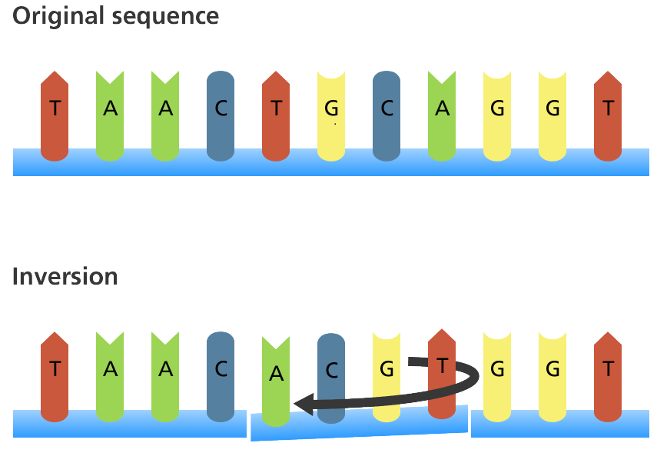

Note: When a codon changes and results in the coding of a different amino acid, this will show harmful effects to the organism because a non-functional protein may be formed.

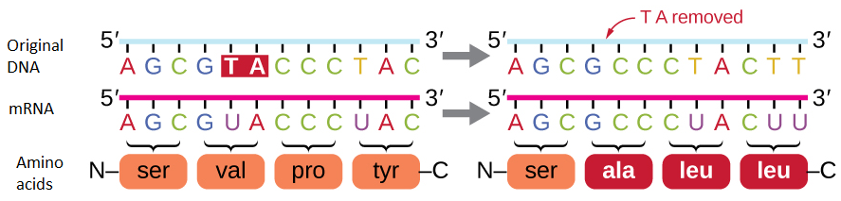
- Insertion and deletion: Adding or removing a nucleotide results in a reading frame-shift. All amino acids from the point of insertion or deletion will change.
Note: The effect of frame-shift mutations is very harmful as all codons after the point of deletion or insertion are changed. This results in the coding of totally different amino acids, rendering the protein non-functional.

SICKLE CELL DISEASE – DISORDER CAUSED BY GENE MUTATIONS
Gene mutation: Substitution in the HBB gene on chromosome 11
A single amino acid is altered in the HBB gene. This changes the shape of one of the β-chains of haemoglobin. This mutated haemoglobin is less soluble and precipitates when deprived of oxygen. As a result, red blood cells take up a sickle cell shape instead of the normal flat disc shape.

Transportation of oxygen is reduced when this happen
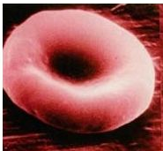
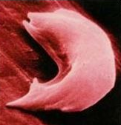
N

Normal Red Blood Cell Abnormal Red Blood Cell

Symptoms: A variety of effects is caused: Jaundice, Anaemia, Heart defects, Brain damage, Kidney defects, Skin lesions, Spleen enlargement

LESSON ACTIVITY
Question One
Define the term mutation. (L1) (Bio2.3.1.1)
_______________________________________________________________________________________________________________________________________________________________________________________________________________________________________________________________________________________________________________________________________________

Question Two
Describe one of the features of Mutation, using an example. (L2) (Bio2.3.2.1)
________________________________________________________________________________________________________________________________________________________________________________________________________________________________________________________________________________________________________________________________________________________________________________________________________________________________________________________________________________________________________________________________________________________

Question Three
Differentiate between missense codons and nonsense codons.
(L2) (Bio2.3.3.9)
___________________________________________________________________________________________________________________________________________________________________________________________________________________________________________________________________________________________________________________________________________________________________________________________________________________________________________________________________________________________________________________________________________________________________________________________________________________________

Question Four

Describe how: (L2) (Bio2.3.2.2)

- substitution mutation produces missense or nonsense codons:

_________________________________________________________________________________________________________________________________________________________________________________________________________________________________________________________________________________________________________________________________________________________________________________________________________________________________________________________________________________________________________________________________________________________________________________________________________________________________________________________________________________________________________________________________________________________________

(ii) how addition and deletion mutation results in a frameshift.

_________________________________________________________________________________________________________________________________________________________________________________________________________________________________________________________________________________________________________________________________________________________________________________________________________________________________________________________________________________________________________________________________________________________________________________________________________________________________________________________________________________________________________________________________________________________________

Question Five

Explain a cause of gene mutation. (L3) (Bio2.3.3.1)

_______________________________________________________________________________________________________________________________________________________________________________________________________________________________________________________________________________________________________________________________________________________________________________________________________________________________________________________________________________________________________________________________________________________________________________________________________________________________________________________________________________________________________________________________________________________________________________________________________________________________________________________________________________________________________________________________________________________________________________________________________________________________________________________________________________________________________________________________________________________________________________________________________________________________________________________________________________________________________________________________________________________________________________________________________________________________________________________________

Question 6
Discuss the impact of gene (point) mutations on the functioning of an affected person using named examples. (L4) (Bio2.3.4.1)
______________________________________________________________________________________________________________________________________________________________________________________________________________________________________________________________________________________________________________________________________________________________________________________________________________________________________________________________________________________________________________________________________________________________________________________________________________________________________________________________________________________________________________________________________________________________________________________________________________________________________________________________________________________________________________________________________________________________________________________________________________________________________________________________________________________________________________________________________________________________________________________________________________________________________________________

LESSON 2: Chromosomal Mutations
Key Learning Outcome:
Students are able to demonstrate understanding of mutations and ways in which these influence DNA functioning:
- chromosome (block) mutations – deletion, inversion, duplication, translocation of genes in and between chromosomes

The specific learning outcomes targeted in this lesson are provided below:
SLO # | Specific Learning Outcomes:  Students are able to | Skill level | SLO code | Achieved
27 | Define deletion, inversion, duplication, translocation of genes | 1 | Bio2.3.1.9
4 | Describe chromosome (block) mutations (deletion, inversion, duplication, translocation of genes in and between chromosomes) | 2 | Bio2.3.2.3
6 | Differentiate between chromosome mutation and gene mutation | 3 | Bio2.3.3.2
7 | Explain the causes and effects of chromosome (block) mutation. | 3 | Bio2.3.3.3
9 | Discuss the impact of chromosome (block) mutations on an affected person using named examples | 4 | Bio2.3.4.1

Key Terms: Tick once you can define the term and use it in context.
Chromosomal mutation
Translocation
Block mutation
Duplication
Chromosome nondisjunction
Recommended Readings:
Reading Text | Page(s) | Achieved
Bayley, M. (2000). Designs of Life (2nd Edition) - Biology for Year 13 students. Auckland: Pearson Education Limited. | 121 – 123
Hanson, M., & Sinclair, M. (2006). Year 13 Biology Student Guide. Auckland: ESA Publications Ltd. | 127 – 137

CHROMOSOMAL MUTATIONS
There are two types of chromosomal mutations:
- Changes in the quantity of genetic material (deletions and duplications)
- Rearrangements of genetic material (translocations, and inversions.

- Changes in the quantity of genetic material

- Deletions:
- This is when a section of chromosome becomes deleted leaving a shorter chromosome.
- Deletions are often fatal since they usually involve the loss of a substantial number of genes.

- Duplications:
- This is when a section of a chromosome is repeated.
- Duplications are generally less serious than deletions since there is no loss of genes.

- Translocations:
- This is when breaks occur in either non-homologous chromosomes or a pair of homologous chromosomes, the ends of one chromosomes may rejoin with the end of the other chromosome involved in the exchange.

- Inversions:
- This is when a chromosome is broken in two places and repaired ‘the wrong way round’.

Note: With inversions and translocations, there is no loss of genetic material but problems arise during chromosome pairing in meiosis which may result in in-viable gametes.

EXAMPLES OF CHROMOSOMAL DISORDERS

Cri Du Chat
    - Caused by the translocation of part of chromosome 5 onto its other pair.
    - Symptoms:
      - cat-like cry,
      - low weight and growth;
      - slow learning,
      - eyes are far apart;
      - abnormally shaped ears and fingers.

Translocation Downs’ Syndrome
    - Caused by the complete transfer (translocation) of one of the pairs of Chromosome 21 onto chromosome 14.
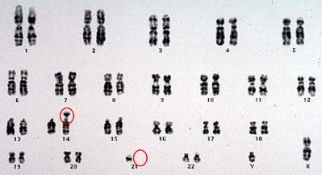

    - The person with this condition would have the normal pair of chromosomes 21 (2 copies) plus an extra chromosome 21 attached to chromosome 14. Therefore a total of 3 copies of chromosome 21. The extra genetic material from chromosome 21 causes Downs Syndrome, This cause of Downs syndrome is not as common as Downs Syndrome caused by aneuploidy (see notes on Aneuploidy).

    - Symptoms: Short in stature, small ears & mouth, mongoloid facial features, mentally slow, low muscle tone.

LESSON ACTIVITY
Question One
Define the following types of chromosomal mutation. (L1) (Bio2.3.1.9)
(i) Deletion:
____________________________________________________________________________________________________________________________________________________________________________________________________________________________________________________________________________
(ii) Inversion:
____________________________________________________________________________________________________________________________________________________________________________________________________________________________________________________________________________
(iii) Duplication:
____________________________________________________________________________________________________________________________________________________________________________________________________________________________________________________________________________
(iv)Translocation:
____________________________________________________________________________________________________________________________________________________________________________________________________________________________________________________________________________

Question Two
Describe what happens during the following types chromosomal mutations:
(L2) (Bio2.3.2.3)
(i)Translocation:

________________________________________________________________________________________________________________________________________________________________________________________________________________________________________________________________________________________________________________________________________________________________________________________________________________________________________________________________________________________________________________________________________________________

(ii) Deletion:
____________________________________________________________________________________________________________________________________________________________________________________________________________________________________________________________________________
____________________________________________________________________________________________________________________________________________________________________________________________________________________________________________________________________________
(iii) Duplication:
_______________________________________________________________________________________________________________________________________________________________________________________________________________________________________________________________________________________________________________________________________________
______________________________________________________________________________________________________________________________________
(iv) Inversion:
_______________________________________________________________________________________________________________________________________________________________________________________________________________________________________________________________________________________________________________________________________________
______________________________________________________________________________________________________________________________________

Question Three
Explain the difference between gene mutation and a chromosomal mutation.
(L3) (Bio2.3.3.2)
________________________________________________________________________________________________________________________________________________________________________________________________________________________________________________________________________________________________________________________________________________________________________________________________________________________________________________________________________________________________________________________________________________________
Question Four
Explain the cause and effect of the following genetic disorders:
(L3) (Bio2.3.3.3)
(i)Cri du chat syndrome:
Cause:______________________________________________________________________________________________________________________________________________________________________________________________________________________________________________________________________
Effect:__________________________________________________________________________________________________________________________________________________________________________________________________________________________________________________________________________________________________________________________________________
(ii)Down’s syndrome:
Cause:______________________________________________________________________________________________________________________________________________________________________________________________________________________________________________________________________
Effect:__________________________________________________________________________________________________________________________________________________________________________________________________________________________________________________________________________________________________________________________________________

Question Five
Translocation Downs Syndrome is a medical condition caused by a chromosomal mutation. Discuss the impact of this mutation on the affected person. In your discussion you should mention the following points:
- How translocation downs syndrome is caused.
- The effects of the mutation on the normal functioning of the affected person.
(L4) (Bio2.3.4.2)

_____________________________________________________________________________________________________________________________________________________________________________________________________________________________________________________________________________________________________________________________________________________________________________________________________________________________________________________________________________________
_________________________________________________________________________________________________________________________________________________________________________________________________________________________________________________________________________________________________________________________________________________________________________________________________________________
_______________________________________________________________________________________________________________________________________________________________________________________________________________________________________________________________________________________________________________________________________________

LESSON 3: Aneuploidy
Key Learning Outcome:
Students are able to demonstrate understanding of mutations and ways in which these influence DNA functioning
- aneuploidy – change in number of chromosomes within a set resulting from nondisjunction during meiosis e.g. Downs (trisomy 21), Turners, Kleinfelters syndromes

The specific learning outcomes targeted in this lesson are provided below:
SLO# | Specific Learning Outcomes:  Students are able to | Skill level |  | SLO code | Achieved
18 | Define Non-disjunction | 1 | Bio2.3.1.5
20 | Define Aneuploidy | 1 | Bio2.3.1.7
21 | Explain the effects of aneuploidy on the genome | 3 | Bio2.3.3.7
22 | Discuss the impact of aneuploidy on an affected individual using examples | 4 | Bio1.3.4.4
23 | Identify from a given representation or a karyotype if a person is suffering from Down’s Syndrome/Turner’s Syndrome/Klinefelters Syndrome. | 1 |  | Bio2.3.1.8
24 | Describe chromosomal characteristics of a person suffering from Down Syndrome/Turner’s Syndrome/Klinefelters Syndrome | 2 |  | Bio2.3.2.5
25 | Describe the common physical characteristics of a person suffering from Down’s Syndrome/Turner’s Syndrome/Klinefelters Syndrome | 2 |  | Bio2.3.2.6
26 | Compare features of Down Syndrome, Turner’s and Klinefelters Syndrome | 3 |  | Bio2.3.3.8

Key Terms: Tick once you can define the term and use it in context.
Term | Achieved |  | Term | Achieved
Aneuploidy |  |  | Klinefelters syndrome
Trisomy |  |  | Turners syndrome
Eusomy |  |  | Chromosome non-disjunction
Tetrasomy |  |  | Meiosis
Downs Syndrome

Recommended Readings:
Reading Text | Page(s) | Achieved
Bayley, M. (2000). Designs of Life (2nd Edition) - Biology for Year 13 students. Auckland: Pearson Education Limited. | 134 – 138
Hanson, M., & Sinclair, M. (2006). Year 13 Biology Student Guide. Auckland: ESA Publications Ltd. | 147 – 152

ANEUPLOIDY
This is a chromosomal abnormality whereby there is variation in the chromosome number involving only part of the chromosome set.
The type of aneuploidy is determined by the number of times a particular chromosome is represented in a diploid organism.
  - Monosomy (1 chromosome is missing from a pair; 2n-1)
  - Trisomy (1 extra chromosome in the pair; 2n + 1)
  - Tetrasomy (2 extra copies of a pair of chromosomes; 2n + 2)
Aneuploidy is caused by the failure of chromatids to separate (non-disjunction) during the process of meiosis within a parents sex cells. The result is gametes that either have both pairs of chromosomes instead of the normal one or is missing the chromosome.
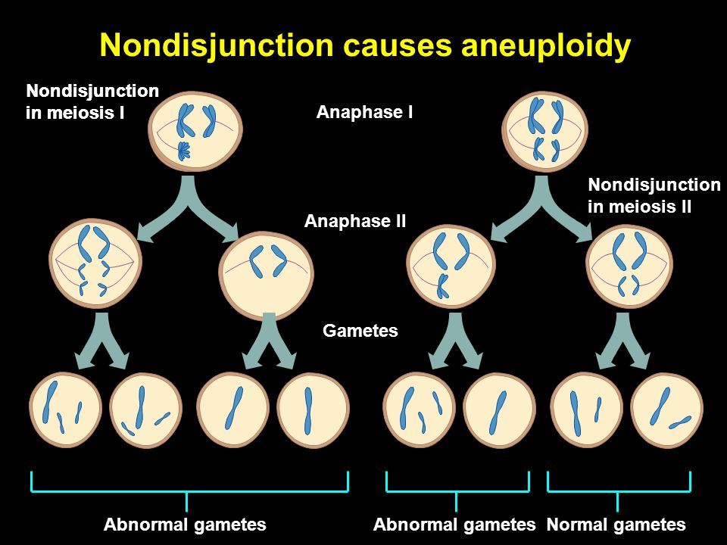
http://slideplayer.com/slide/5911585/19/images/41/Nondisjunction+causes+aneuploidy.jpg

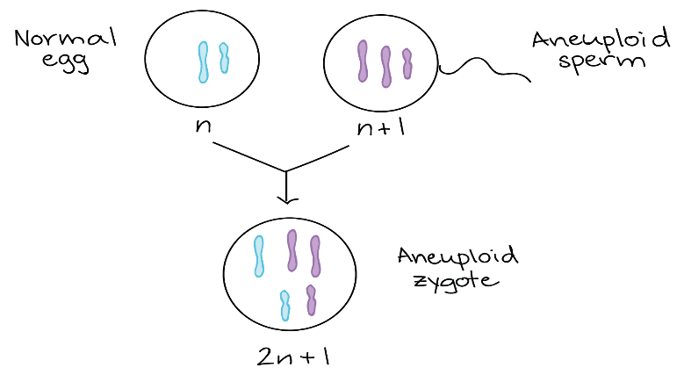
During fertilization, when this ‘abnormal’ gamete or aneuploid gamete (e.g. sperm) fuses with either a normal gamete or another ‘abnormal’ gamete, an aneuploid is formed.

In the case on the right, a triploid offspring is produced.
(Triploid)
EXAMPLES OF MEDICAL CONDITIONS CAUSED BY ANEUPLOIDY

Downs Syndrome: (three copies of chromosome 21)
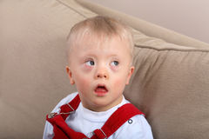
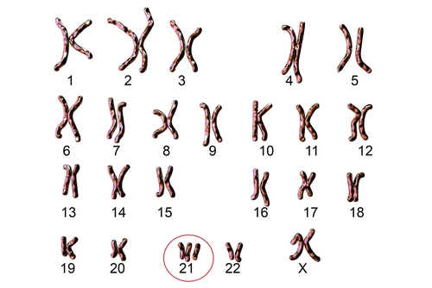
Symptoms: Short in stature, small ears & mouth, mongoloid facial features, mentally slow, low muscle tone.

- Turner’s Syndrome: (the ‘X’ chromosome is missing in the sex chromosomes)
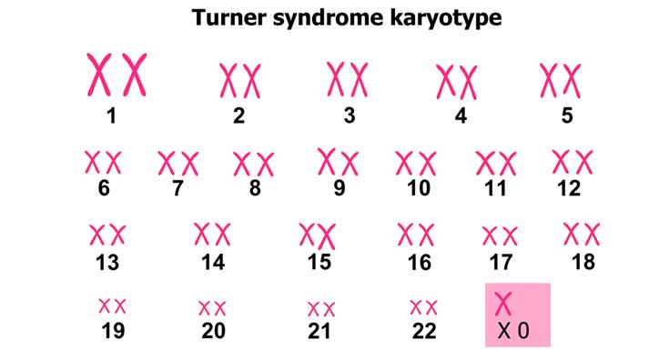
Symptoms:
- Is female but with underdeveloped sex organs; webbed neck.
- Broad chest with widely spaced nipples.

- Klinefelter’s Syndrome (an extra ‘X’ chromosome is present in the sex chromosomes)
Symptoms:
Male; underdeveloped muscles, reduced facial hair, delayed puberty, infertile, very tall with long legs and wide hips, breast development.

The following diagrams summarize how each of the above aneuploids (A, B & C) are caused.
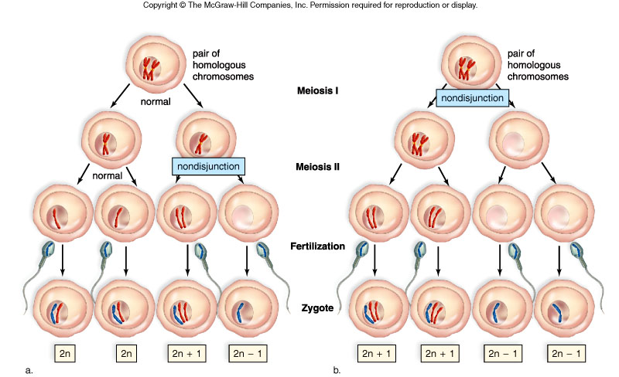
B
B
A & C
A & C
B
A & C

https://kleinfeltersdisease.files.wordpress.com/2012/11/f12-10_nondisjunction_o_c1.jpg

- Downs Syndrome is an example of an autosomal aneuploid because it is caused by non-disjunction of an autosome (chromosome 21).
- Turner’s Syndrome and Klinefelter’s Syndrome are examples of sex aneuploids because they are caused by non-disjunction of a sex chromosome;
  - A person with Turner’s syndrome has only one X chromosome and no other sex chromosome pair (either an X or a Y).
  - A person with Klinefelter’s syndrome has the normal sex chromosome pair (XY as it is male) but also has another extra X chromosome,

LESSON ACTIVITY

Question One
Define Non-disjunction. (L1) (Bio2.3.1.5)
____________________________________________________________________________________________________________________________________________________________________________________________________________________________________________________________________________

Question Two
Define Aneuploidy. (L1)(Bio2.3.1.7)
____________________________________________________________________________________________________________________________________________________________________________________________________________________________________________________________________________

Question Three
Explain the effects of aneuploidy on the genome. (L3)(Bio2.3.3.7)
________________________________________________________________________________________________________________________________________________________________________________________________________________________________________________________________________________________________________________________________________________________________________________________________________________________________________________________________________________________________________________________________________________________

Question Four
Klinefelters syndrome is a chromosomal abnormality which results in the following characteristics: underdeveloped muscles, reduced facial hair, delayed puberty, infertile, very tall with long legs and wide hips and breast development. Some of these characteristics are female oriented, however, the condition is only seen in males.

Discuss how it is possible that only males suffer from Klinefelter’s syndrome but still have very female-like characteristics. In your discussion, include the following points on how the affected individual is formed as a result of:
- Chromosomal non-disjunction and gamete formation.
- Gamete fertilization (L4) (Bio2.3.4.4)

__________________________________________________________________________________________________________________________________________________________________________________________________________________________________________________________________________________________________________________________________________________________________________________________________________________________________________________________________________________________________________________________________________________________________________________________________________________________________________________________________________________________________________________________________________________________
_______________________________________________________________________________________________________________________________________________________________________________________________________________________________________________________________________________________________________________________________________________________________________________________________________________________________________________________________________________________________________________________________

Question Five (L1) (Bio2.3.1.8)
Identify the genetic disorders represented by the following representation.
(i)
(i) 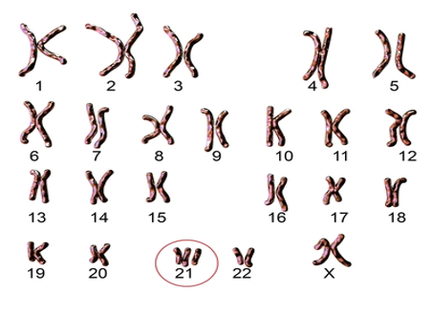
Disorder: ____________________________________________________________________

(ii) 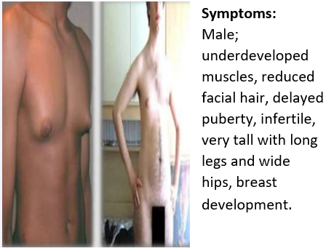
Disorder: _______________________________________________________________

Question Six
Describe the chromosomal characteristics of a person suffering from the following genetic disorders: (L2)(Bio2.3.2.3)
(i) Down’s Syndrome:
_____________________________________________________________________________________________________________________________________________________________________________________________________________________________________________________________________________________________________________________________________________________________________________________________________________________________________________________________________________________

(ii) Turner’s Syndrome:
_____________________________________________________________________________________________________________________________________________________________________________________________________________________________________________________________________________________________________________________________________________________________________________________________________________________________________________________________________________________

(iii) Klinefelter’s Syndrome:
_____________________________________________________________________________________________________________________________________________________________________________________________________________________________________________________________________________________________________________________________________________________________________________________________________________________________________________________________________________________

Question Seven
Describe the common physical characteristics of a person suffering from the following genetic disorders: (L2)(Bio2.3.2.3)
(i) Down’s Syndrome:
_____________________________________________________________________________________________________________________________________________________________________________________________________________________________________________________________________________________________________________________________________________________________________________________________________________________________________________________________________________________

(ii) Turner’s Syndrome:
_____________________________________________________________________________________________________________________________________________________________________________________________________________________________________________________________________________________________________________________________________________________________________________________________________________________________________________________________________________________

(iii) Klinefelter’s Syndrome:
_____________________________________________________________________________________________________________________________________________________________________________________________________________________________________________________________________________________________________________________________________________________________________________________________________________________________________________________________________________________

Question Eight
Individuals with Turner’s syndrome, Klinefelters and Down’s syndrome suffer from specific types of chromosomal abnormalities called aneuploidy.
Compare the features of each of the syndromes above in terms of the total number of chromosomes and gender of the people who suffer from these syndromes.
(L2) (Bio2.3.3.8)
Feature | Turner’s syndrome | Klinefelters Syndrome | Down’s syndrome
Total number of chromosomes
Monosomic or trisomic?
Gender

LESSON 4: Polyploidy
Key Learning Outcome:
Students are able to demonstrate understanding of mutations andways in which these influence DNA functioning
- polyploidy – change in numbers of (whole) sets of chromosomes resulting from complete non-disjunction during meiosis eg triploid (3n), tetraploid (4n); autopolyploidy, allopolyploidy

The learning outcomes targeted in this lesson are provided below:
SLO # | Specific Learning Outcomes: Students are able to | Skill level | SLO code | Achieved
10 | Define polyploidy | 1 | Bio2.3.1.2
11 | Define autopolyploidy/allopolyploidy | 1 | Bio2.3.1.3
12 | Describe the characteristics of polyploidy (change in numbers of whole sets of chromosomes resulting from complete non-disjunction during meiosis | 2 | Bio2.3.2.2.4
13 | Compare and contrast autopolyploidy with allopolyploidy | 3 | Bio2.3.3.4
14 | Explain the effects of polyploidy on the genome | 3 | Bio2.3.3.5
15 | Discuss the impact of polyploidy on an affected using examples | 4 | Bio2.3.4.3
16 | Define triploid(3n) | 1 | Bio2.3.1.4
17 | Compare and contrast the features of triploid with tetraploid | 3 | Bio2.3.3.6

Key Terms: Tick once you can define the term and use it in context.
Term |  |  | Term
Polyploidy |  |  | autopolyploidy
Triploid |  |  | allopolyploidy
Tetraploid |  |  | aneuploidy

Recommended Readings:
Reading Text | Page(s) | Achieved
Bayley, M. (2000). Designs of Life (2nd Edition) - Biology for Year 13 students. Auckland: Pearson Education Limited. | 121 – 123
Hanson, M., & Sinclair, M. (2006). Year 13 Biology Student Guide. Auckland: ESA Publications Ltd. | 127 – 137

POLYPLOIDY
This is a chromosomal abnormality in which all the chromosomes within a cell are duplicated three or more times. The total number of chromosomes within the cells of the organism is therefore no longer diploid (2n) but 3n or more.
A diploid organism has the normal full set of chromosomes where each chromosome has a homologous pair. However, a triploid would have 3 sets of chromosomes while a tetraploid would have 4 sets of chromosomes.

Types of Polyploidy

The cause of polyploidy
Polyploidy is caused when polyploid gametes carrying more than one set of chromosomes fuse with normal haploid gametes or with gametes that are also polyploid.

How are polyploid gametes formed?
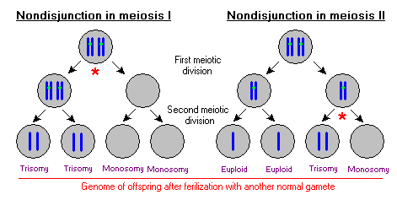

How is a polyploid individual formed?
Polyploid individuals are produced when abnormal (polyploidy) gametes fuse with either normal haploid gametes or abnormal (polyploidy) gametes.
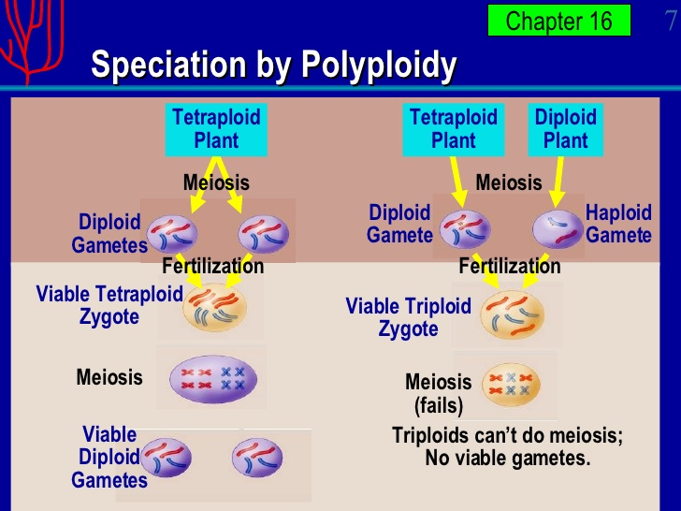

Features of Triploids and Tetraploids
Feature | Triploid | Tetraploid
Formed by | Fusion of a diploid (polyploid) gamete with a normal haploid gamete. | Fusion of two polyploid gametes (diploid sperm and diploid egg).
Fertility | Infertile; due to presence of a chromosome set with no pair. | Fertile; all chromosomes have pairs.
Number of chromosome sets | three | four
Can undergo meiosis? | No | Yes
Gametes produced | No viable gametes | viable
Size of hybrid | Smaller that tetraploid but bigger than normal diploids | Larger than triploids and diploids.

AUTOPOLYPLOIDY VERSUS ALLOPOLYPLOIDY
Autopolyploidy | Allopolyploidy
Polyploids created by chromosome duplication within the same species. (Mating occurs between members of the same species). | Polyploids are created by hybridization between different species. Different species mate to produce a polyploidy.

Note: Polyploids with an odd set of chromosomes, for example, 3n, 5n and more are considered to be infertile. This is because the odd set of chromosomes will have no matching pair to line up with during meiosis. As a result non-viable gametes produced or gamete production is impossible.
Polyploids with even sets of chromosomes, for example, 2N, 4N and more are considered to be fertile. This is because each chromosome has a matching (homologus) pair to line up with during meiosis to produce viable gametes.

AMPHIPLOIDY
This is a process whereby all the chromosomes within the sex cells of infertile hybrids undergo a doubling process (replication). Where a polyploidy has an odd set of chromosomes it is rendered infertile. This is because of the presence of unpaired chromosomes. These unpaired chromosome sets may have been received during the process of allopolyploidy (where mating occurs between parents belonging to different species) or during autopolyploidy (where mating occurs between parents belonging to the same species). When the sex cells of the polyploidy hybrid undergoes amphiploidy, all chromosomes double and now become paired. Meiosis can now be carried out successfully to produce viable gametes.
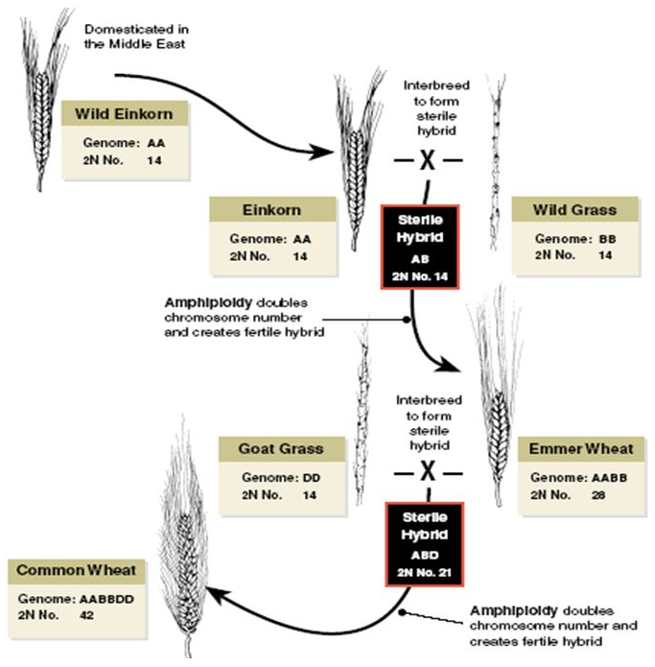
Amphiploidy in Corn
http://slideplayer.com/slide/8537583/26/images/62/Evolution+of+wheat.jpg

LESSON ACTIVITY
Question One

Define the term polyploidy. (L1) (Bio2.3.1.2)
_____________________________________________________________________________________________________________________________________________________________________________________________________________________________________________________________________________________________________________________________________________________________________________

Question Two

Define the following terms:

(ii)autopolyploidy: (L1)(Bio.2.3.1.3)
_____________________________________________________________________________________________________________________________________________________________________________________________________________________________________________________________________________________________________________________________________________________________________________

(iii)allopolyploidy:
_____________________________________________________________________________________________________________________________________________________________________________________________________________________________________________________________________________________________________________________________________________________________________________

Question Four
The following cross breeding is carried out between a horse and a donkey. 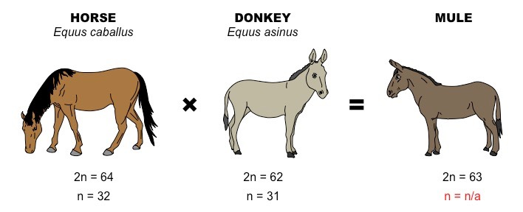
(i)Identify whether the above cross is an example of autopolyploidy or allopolyploidy and explain the difference in the two terms (Bio2.3.3.4)
________________________________________________________________________________________________________________________________________________________________________________________________________________________________________________________________________________________________________________________________

Question Five
Explain the effects of polyploidy on the genome. (L3)(Bio2.3.3.5)
_____________________________________________________________________________________________________________________________________________________________________________________________________________________________________________________________________________________________________________________________________________________________________________________________________________________________________________________________________________________

Question Six
Almost all modern cultivated varieties (cultivars) of edible bananas are hybrids and polyploids of two different wild, seeded banana species, Musa acuminate and Musa balbisiana. This is a form of allopolyploidy. Cultivated bananas are almost always seedless and hence infertile.
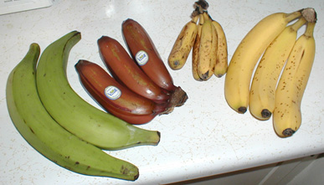

(i)The two types of polyploidy are allopolyploidy and autopolyploidy. Distinguish between these two forms of polyploidy and identify the type of polyploidy that has occurred in the example above with bananas. (L3) (Bio2.3.3.4)
__________________________________________________________________________________________________________________________________________________________________________________________________________________________________________________________________________________________________________________________________________________________________________________________________________________________________________________________________________________________________________

(ii)Discuss the impact of polyploidy on the banana cultivars that are present today in most of Pacific Island Countries. In your discussion you must mention the following:
(L4) (Bio2.3.4.2)
- Describe the process of polyploidy that has occurred to produce the different banana hybrids.
- Explain why most banana hybrids produced from polyploidy are seedless and therefore infertile.

_________________________________________________________________________________________________________________________________________________________________________________________________________________________________________________________________________________________________________________________________________________________________________________________________________________________________________________________________________________________________________________________________________________________________________________________________________________________________________________________________________________
_________________________________________________________________________________________________________________________________________________________________________________________________________________________________________________________________________________________________________________________________________________________________________________________________________________________________________________________________________________________________________________________________________________________________________________________________________________________________________________________________________________
______________________________________________________________________________________________________________________________________________________________________________________________________________________________________________________________________________________________________________________________________________________________________________________________________________________________________________________
Question Seven

Compare and contrast the features of Triploid and Tetraploid. (L3) (Bio2.3.3.3)
Feature | Triploid | Tetraploid
How are they formed?
Are they fertile? Why or why not?

