STRAND 2: GENE EXPRESSION

Sub-strand 2.2 Protein structure, function and synthesis

LESSON 1: PROTEIN SYNTHESIS

Key Learning outcome:
Students are able to demonstrate understanding of protein synthesis and how it contributes to forms and functions:
- transcription and translation; ribosomes
- revision and extension of form 6 to include role of DNA (triplets), mRNA (codons), tRNA (anticodons)
- use of codon dictionary to identify amino acids; redundant nature of the genetic code

The specific learning outcomes targeted in this lesson are provided below: Tick the last column when you have achieved each outcome.
SLO# | Specific Learning Outcomes:  Students are able to | Skill level | SLO code | √
1 | Define transcription/translation | 1 | Bio2.2.1.1
2 | Define codons/anticodons | 1 | Bio2.2.1.2
3 | State the function of mRNA/tRNA | 1 | Bio2.2.1.3
4 | Identify transcription in a given representation of protein synthesis | 1 | Bio2.2.1.4
5 | Identify translation in a given representation of protein synthesis | 1 | Bio2.2.1.5
6 | Identify codons/anticodons in a given representation of protein synthesis | 1 | Bio2.2.1.5
7 | Identify mRNA/tRNA in a given representation of protein synthesis | 1 | Bio2.2.1.7
8 | Define protein synthesis | 1 | Bio2.2.1.8
9 | Identify/State a feature of protein synthesis, within a given context | 1 | Bio2.2.1.9
10 | Describe the process of protein synthesis | 2 | Bio2.2.2.1
11 | Describe the use of codon dictionary to identify amino acids | 2 | Bio2.2.2.2
12 | Describe the redundant nature of the genetic code | 2 | Bio2.2.2.3
13 | Explain the relationships within transcription and translation including role of DNA (triplets), mRNA (codons), tRNA (anticodons), ribosomes; use of codon dictionary to identify amino acids; redundant nature of the genetic code | 3 | Bio2.2.3.1
14 | Discuss the interdependency of the different parts of the process of protein synthesis (transcription and translation including role of DNA (triplets), mRNA (codons), tRNA (anticodons), ribosomes; use of codon dictionary to identify amino acids; redundant nature of the genetic code) and the impact of a failure of one part to the whole process | 4 | Bio2.2.4.1

Key Terms: Tick if you are able to define and use the following terms correctly.
Term | Checked |  | Term | Checked
Protein synthesis |  |  | Transcription
Messenger RNA |  |  | Translation
Transfer RNA |  |  | RNA processing
Codon |  |  | RNA polymerase
Anticodon |  |  | Spliceosome
Triplet |  |  | Polypeptide chain
Ribose sugar |  |  | Exons
Sense strand |  |  | Introns
Genetic code |  |  | Terminator codon
Redundancy |  |  | Non-overlapping
Degeneracy |  |  | Amino acid
Methionine

Recommended Readings:
Reading Text | Page(s) | Achieved
Bayley, M. (2000). Designs of Life (2nd Edition) - Biology for Year 13 students. Auckland: Pearson Education Limited. | 121 – 123
Hanson, M., & Sinclair, M. (2006). Year 13 Biology Student Guide. Auckland: ESA Publications Ltd. | 127 – 146

LESSON NOTES
Comparison of DNA, tRNA and mRNA
DNA (Deoxyribose Nucleic Aicd)
- Is double stranded, helical in shape and very long since it is composed of many genes.
- One of its strands acts as a template (anti-sense, non-coding strand or template strand) which is copied by mRNA to make a protein. The other strand (sense) conserves the genetic instruction.
- Its sugar group is called deoxyribose.
- It has the bases: A (adenine), T (thymine), C (cytosine) and G (Guaninie)
- Every 3 bases along the strand is called a Triplet (1 triplet codes for 1 amino acid).
mRNA (messenger Ribonucleic Acid)
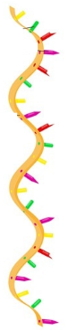
- Single-stranded, thread-like and smaller than DNA but larger than tRNA.
- It is a copy (transcript) of a gene in the DNA strand.
- It has a start codon (AUG) on one end and a stop codon (any of UAA, UAG or UGA) on its other end).
- Its sugar group is called Ribose.
- It has the bases: A, C, G and U (uracil) instead of thymine.
- Every 3 bases along it is called a codon. Each codon codes for an amino acid.
- The codon is a copy of the triplets on the anti-sense strand of DNA. Therefore, each codon should be the same as the triplets found on the DNA sense strand.
tRNA (transfer Ribonucleic Acid)
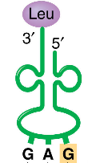
- Single-stranded; smaller than mRNA and shaped like a clover-leaf.
- It is involved in the translation of mRNA into a polypeptide chain. It does this by carrying the correct amino acid to its corresponding mRNA codon within the ribosome.
- Its sugar group is the same as mRNA.
- It has a specific 3 base sequence called a triplet which corresponds to its complementary codon on mRNA.

PROTEIN SYNTHESIS
Protein synthesis is a process in cells which involves the decoding of the instruction held within a gene, to produce a protein.
Stages of protein synthesis
There are two stages of protein synthesis: transcription and translation.
- Transcription

  - DNA unwinds at a specific gene sequence.
  - Initiation: RNA polymerase enzyme attaches to the start of the gene sequence and adds on free nucleotides along the DNA template strand. The first triplet to be transcribed on the gene sequence would be TAC. This will be transcribed as AUG on the mRNA strand. This is the start codon on mRNA.
  - Elongation: RNA polymerase starts adding on new nucleotides to the already existing chain of nucleotides. The addition of nucleotides follows the base – pairing rule A-U, C-G.
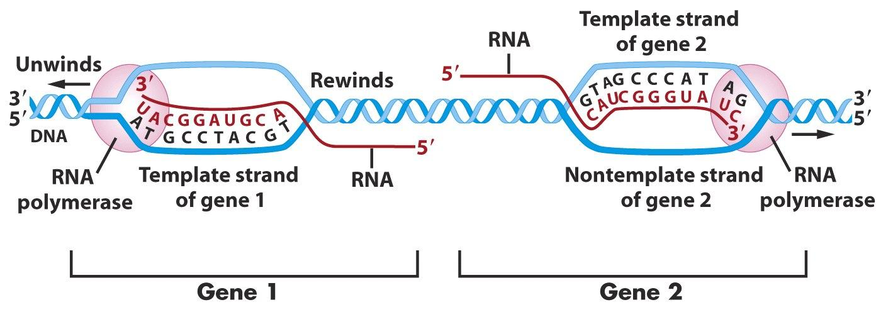
  - Termination: RNA polymerase enzyme stops adding more nucleotides to the growing mRNA strand. This is because it has reached the last triplet on the DNA template strand. This triplet should read either ATT, ATC or ACT. So the last codon on the mRNA strand should either be UAA, UAG or UGA.
mRNA
mRNA
http://1.bp.blogspot.com/-hu2juyywUxs/TYi3t74Xa6I/AAAAAAAAADM/FGBZC-p1FxU/s1600/sense-antisense.JPG

Editing or RNA Processing/Splicing:
mRNA detaches from the DNA template. The mRNA strand would have copied ALL of the bases along the specific gene sequence on DNA. Some of the base sequences (codons) do not code for amino acids and therefore must be removed before mRNA undergoes the next stage. These non-coding regions are called introns. The base sequences (codons) which do code for amino acids are called exons. The introns are removed by an enzyme called spliceosome. The exons that remain are then reconnected o form the final mRNA transcript. It should now be much shorter than the original mRNA.

  - mRNA transcript moves out of the nuclear pore and into the cytoplasm.
2. Translation
- The 5’ end of the mRNA transcript enters a ribosome complex. The ribosome moves along the mRNA a codon at a time starting from the end which has the codon AUG (the start codon) until it reaches the other end of mRNA which should have any one of the following terminator codons: UAA, UAG or UGA.
- A tRNA molecule attaches to its correct amino acid within the cytoplasm. (The type of amino acid that is collected depends upon the codon on mRNA that is complementary to the anticodon on the tRNA).
- The tRNA transports the amino acid onto the ribosome. It base-pairs temporarily to the codon within the A-site. As the codon moves to the next site, (P-site) taking tRNA with it, a peptide bond will form between its amino acid and the previously deposited amino acid within the growing amino acid chain. The codon is moved to the E-site where tRNA detaches from its amino acid and moves out of the ribosome. tRNA molecules continue this cycle from the A-site to the P-site until the last codon on mRNA has been translated. As a result, a growing chain of amino acids is produced. This is called the polypeptide chain.
- The polypeptide chain comes off from the ribosome. The ribosomal complex separates into its sub-units since translation is complete.
- The polypeptide chain folds up to form a specific protein.

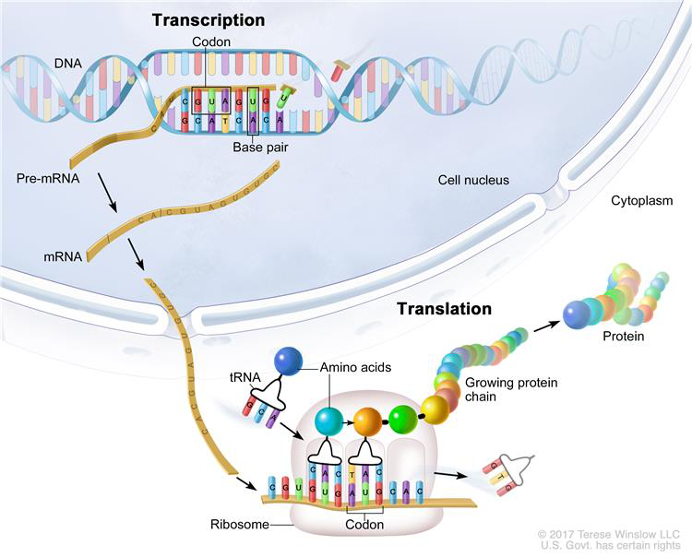
An overview of Protein Synthesis
https://www.cancer.gov/images/cdr/live/CDR761782-750.jpg
E-site
THE GENETIC CODE
The genetic code is the set of rules by which information encoded in genes within the DNA is translated into proteins. It consists of 64 different codon arrangements. Each of these codons encodes for one of the 20 amino acids used to make up proteins.
How to read the genetic code chart
For example: What amino acid is coded for by the codon CAG.
- The first letter in the codon is located on the left hand side of the chart (the base has been highlighted in green).
- The second letter is at the top of the chart (highlighted in yellow). Find where these two letters intersect.
- The third letter is on the right hand side of the chart in the box where one and two intersect. The place where all 3 letters intersect shows the name of the amino acid (In this case, Glu (glutamine acid)
- Features:
- It is a triplet code
Each codon is made up of three bases. A three-letter code ensures that all 20 known amino acids are coded for with some coded for by different codon arrangements.
Explanation:
There are only 4 different types of bases in DNA and RNA. When these bases are arranged randomly in 3s, they can provide 64 different arrangements (4 x 4 x 4 = 64). Since 1 codon arrangement codes for 1 amino acid, a triplet code therefore allows for all 20 known amino acids to be coded for with some of these amino acids coded for by more than one different codon arrangement. Singlet (4) and doublet codes (4 x 4 = 16) are not enough to code for 20 amino acids. Again in case of a quadruplet codon there will be 256 possible codons (4 x 4 x 4 x 4) which are highly excessive. Triplet codon thus is the minimum requisite having 64 possible codons.

- It is degenerate
This means that the same amino acid can be coded for by more than one codon arrangement. For example, the amino acid Valine (Val) can be coded for by the codons GUU, GUC, GUA and GUG.
Importance: Having many codon possibilities for the same amino acid, reduces the effects of mutations in DNA or mistakes that occur in the formation of mRNA during transcription.

IMPORTANT INTER-RELATIONSHIPS IN PROTEIN SYNTHESIS
The molecular structures DNA, mRNA and tRNA are interlinked in their roles. The DNA holds the template which is used to form mRNA. Since DNA cannot travel out of the nucleus (in an eukaryotic cell), the mRNA is the only medium in which this information can be accessible outside of the nucleus.

The codon sequence on mRNA provides the foundation of a protein. If the message in DNA or mRNA is incorrect, then incorrect amino acids will be delivered to the ribosomes by tRNA. As a result a protein with an incorrect shape is formed. Such a protein cannot carry out its normal function – it becomes non-functional.

The genetic code allows the identification of the types of amino acids within a polypeptide chain. The types of amino acids in the chain determines the overall shape of the protein and therefore its function.

Any changes in the information in DNA or mRNA will cause a change in the final product of protein synthesis, the protein. The protein will attain a shape different from what it should originally be. It will then cease to function correctly.
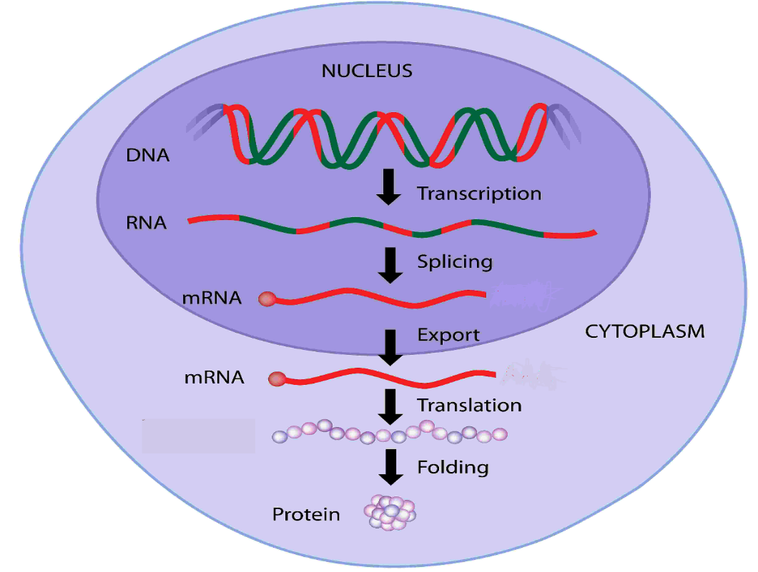

LESSON ACTIVITY
Question One
Define the following terms: (L1) (Bio2.2.1.1)
(i) Transcription: _______________________________________________________________________________________________________________________________________________________________________________________________________________________________________________________________________________________________________________________________________________

(ii)Translation: _______________________________________________________________________________________________________________________________________________________________________________________________________________________________________________________________________________________________________________________________________________

Question Two
Define the following terms: (L1) (Bio2.2.1.2)
(i)Codons: _______________________________________________________________________________________________________________________________________________________________________________________________________________________________________________________________________________________________________________________________________________

(ii)Anticodons: _______________________________________________________________________________________________________________________________________________________________________________________________________________________________________________________________________________________________________________________________________________

Question Three
State the function of the following RNA’s: (L1) (Bio2.2.1.3)
(i) mRNA: _______________________________________________________________________________________________________________________________________________________________________________________________________________________________________________________________________________________________________________________________________________

(ii) tRNA: _______________________________________________________________________________________________________________________________________________________________________________________________________________________________________________________________________________________________________________________________________________

(iii)rRNA:
_______________________________________________________________________________________________________________________________________________________________________________________________________________________________________________________________________________________________________________________________________________
Question Four
Define the term protein synthesis. (L1)(Bio2.2.1.8)
____________________________________________________________________________________________________________________________________________________________________________________________________________________________________________________________________________

Question Five
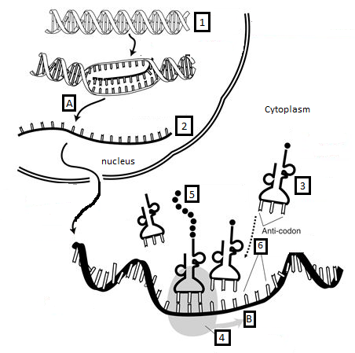
The diagram below represents the main stages in a process occurring in a cell.

(i)Name and describe the processes A and B occurring in the diagram.

Process A (L1) (Bio2.2.1.4): __________________________________________
Description (L2) (Bio2.2.2.2): ________________________________________________________________________________________________________________________________________________________________________________________________________________________________________________________________________________________

Process B (L1) (Bio2.2.1.9): __________________________________________
Description (L2) (Bio2.2.2.2):
________________________________________________________________________________________________________________________________________________________________________________________________________________________________________________________________________________________
Question Six
(i)Identify the number of the structure that represents the following:
(L1) (Bio2.2.1.7) (Bio2.2.1.6)
- mRNA: ________________________________
- tRNA: ________________________________
- DNA: ________________________________
- Anticodon: ________________________________
- Codon ________________________________

Question Seven

Describe the difference in Processes A and B. (L2) (Bio2.2.2.1)

Function
Process A | Process B

Question Eight
A section of a polypeptide chain has the sequence MET – LYS – SYR.
This sequence of molecules has been coded for in the mRNA by codons. A table of these codons and the molecules for which they code is shown below.
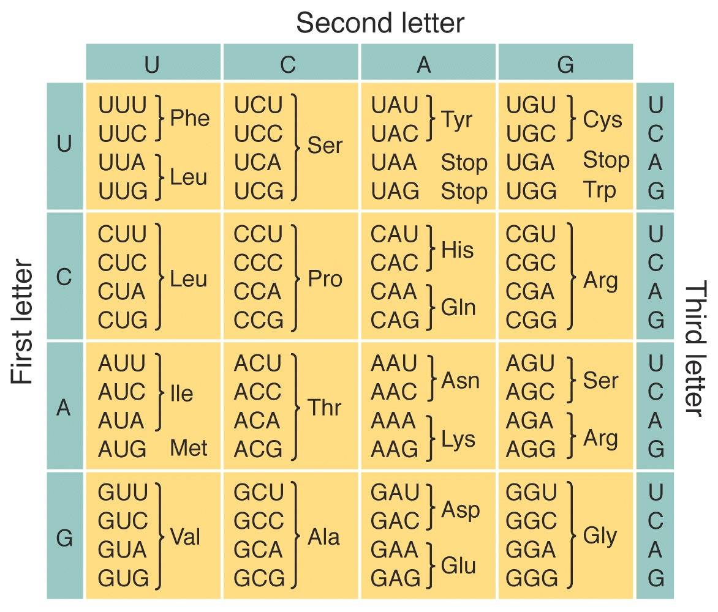

(i) List ALL the possible codon sequences for the amino acids: (L2) (Bio2.2.1.6)

1. MET ________________________________________________________
2. LYS _________________________________________________________
3. SER _________________________________________________________
(ii)Describe how to use the Genetic Code to identify an amino acid from a given codon.
(L2) (Bio2.2.2.2)
_____________________________________________________________________________________________________________________________________________________________________________________________________________________________________________________________________________________________________________________________________________________________________________

Question Nine
Describe the redundant nature of the Genetic Code. (L2) (Bio2.2.2.3)
______________________________________________________________________________________________________________________________________________________________________________________________________________________________________________________________________________________________________________________________________________________________________________________________________________________________________________________

Question Ten
Explain the relationships within transcription and translation including the role of DNA, mRNA,tRNA and ribosomes. (L3)(Bio2.2.3.1)

_______________________________________________________________________________________________________________________________________________________________________________________________________________________________________________________________________________________________________________________________________________________________________________________________________________________________________________________________________________________________________________________________

Question Eleven
The following DNA base sequence has been transcribed to form mRNA.
3’……….. A T T C A G C C T T C A G G A G T A ………….. 5’

- Identify the correct amino acids in the polypeptide chain formed after translation of the mRNA above. (Use the genetic code given in the previous page to answer this question). (L1) (Bio2.1.1.9)

___________________________________________________________________

(ii) The DNA strand above underwent some changes to its base sequence due to errors in the replication process. The third and fourth nucleotides ‘T’ and ‘C’ from the 3’ end exchanged places with each other.
Discuss how the above change in the DNA base sequence would impact upon the processes of transcription and translation. In your answer you should explain how transcription and translation are interconnected and state the changes that would come about in the codon, anticodons and amino acids coded for in the final polypeptide chain that is formed.
(L4) (Bio.2.2.4.1)
______________________________________________________________________________________________________________________________________________________________________________________________________________________________________________________________________________________________________________________________________________________________________________________________________________________________________________________________________________________________________________________________________________________________________________________________________________________________________________________________________________________________________________________________________________________________________________________________________________________________________________________________________________________________________________________________________________________________________________________________________________________________________________________________________________________________________________________________________________________________________________________________________________________________________________________________________________________________________________________________________________________________________________________________________________________________________________________________________________________________________________________________

LESSON 2: PROTEIN STRUCTURE & FUNCTION

Key Learning outcome:
Students are able to demonstrate understanding of protein structure, functions and synthesis and how these contribute to forms and functions
- protein structure (primary, secondary, tertiary) and function (structural e.g. collagen, keratin, and regulatory e.g. enzymes, hormones)

The specific learning outcomes targeted in this lesson are provided below: Tick the last column when you have achieved each outcome.
SLO# | Specific Learning Outcomes:  Students are able to | Skill level | SLO code | Achieved
15 | Describe the features of structural protein/functional protein | 2 | Bio2.2.2.4
16 | Relate protein structure to its function (structural eg collagen, keratin, and regulatory e.g. enzymes, hormones) | 3 | Bio2.2.3.2
17 | Discuss the importance of protein structure to different forms and functions in plants and/or animals | 4 | Bio2.2.4.2
Key Terms:
Term |  |  | Term
Protein |  |  | Di-sulfide bonds
Structural protein |  |  | R-groups
Regulatory protein |  |  | Hydrogen bonds
Collagen |  |  | Van-der waals forces
Keratin |  |  | Peptide bond
Hormones |  |  | Primary structure
Enzymes |  |  | Secondary structure
Quaternary structure |  |  | Tertiary structure
Hydrogen bonds
Recommended Readings:
Reading Text | Page(s) | Achieved
Bayley, M. (2000). Designs of Life (2nd Edition) - Biology for Year 13 students. Auckland: Pearson Education Limited. | 121 – 123
Hanson, M., & Sinclair, M. (2006). Year 13 Biology Student Guide. Auckland: ESA Publications Ltd. | 127 – 137

PROTEINS STRUCTURE & FUNCTION
Proteins are the end-products of the translation process of protein synthesis. After the polypeptide chain is released from the ribosome, it will twist and turn upon itself to form a specific shape.
The shape of the protein determines its overall function. A functional protein is therefore formed when its polypeptide chain undergoes different levels of folding. The nature of how a polypeptide chain folds up is determined by its primary, secondary, tertiary and quaternary structure (for some proteins):
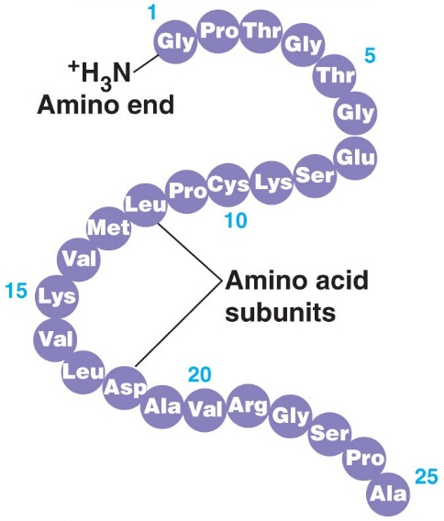
  - Primary structure

This is the order of amino acids that is found in the polypeptide chain. The amino acids possess chemical properties which vary depending upon the R-groups they have. The type of interactions between each amino acid along the chain will therefore determine how the protein folds up to form a particular shape.

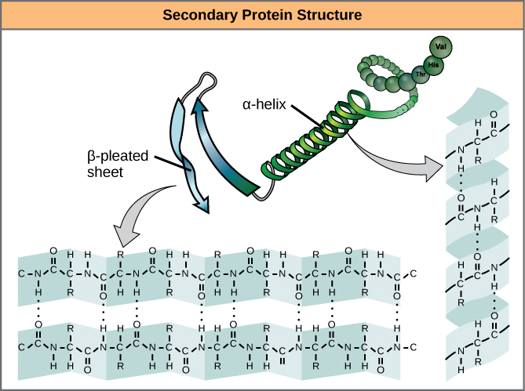
Amino acids within the polypeptide chain are held together by peptide bonds between the amine group of one amino acid and the carboxyl group of the next amino acid (Figure 1).

  - Secondary structure:

In the secondary structure, the polypeptide chain will twist or bend upon itself to form two different types of geometrical structures. The alpha helix or the beta pleated sheet. As the polypeptide bends or twists, exposed Hydrogen atoms from the amine group and Oxygen atoms from the carboxyl groups will interact further to create Hydrogen bonds which hold them together.
http://bio1510.biology.gatech.edu/wp-content/uploads/2013/11/ Figure_03_04_07.jpg

  - Tertiary Structure

This structure is created when the polypeptide chain’s exposed R’ groups interact with each other to create specific bonds. The bonds that are formed depend upon the chemical nature of the R groups. Table 1 summarizes some of the bonds that hold these R-groups together.

R-groups interacting | Type of Interaction / Chemical Bond formed
Non-polar and non-polar | Hydrophobic
Polar (neutral) and water | Hydrophilic
Polar (basic) – NH₃⁺ and polar (acidic) – COO⁻ | Salt bridges
Polar (neutral) and polar (neutral) – OH and – NH or – NH₂ | Hydrogen bonds
– SH and – SH (between cysteine amino acids) | Disulfide bonds

Where the R-group is located along the polypeptide chain will determine how the chain folds up to form the tertiary structure.
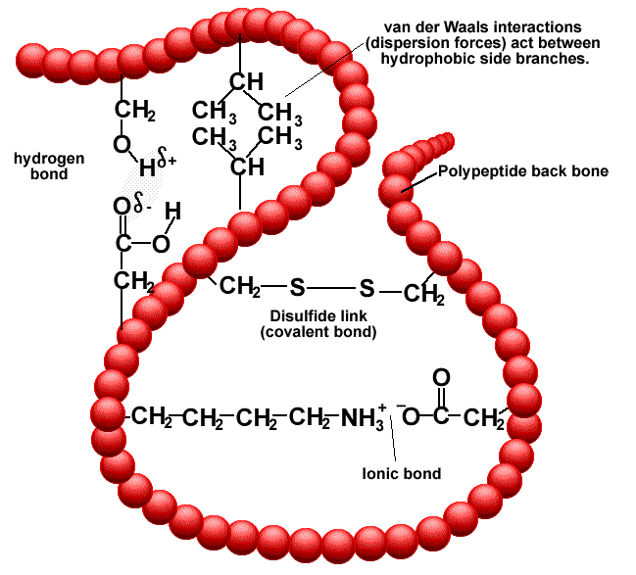

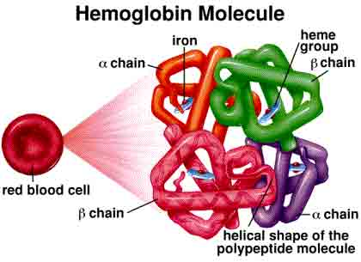
  - Quaternary Structure

This is the final structure which involves the interaction between different polypeptide chains. Some proteins can only function properly when they attain this structure. Other proteins can function properly when they have a tertiary structure. Most regulatory (globular) and structural (fibrous) proteins have a quaternary structure.

STRUCTURE & FUNCTION OF SOME REGULATORY PROTEINS
Feature | Globular (Regulatory Proteins) |  | Fibrous (Structural Proteins)
Solubility | Globular proteins are soluble in water, acids, and bases. |  | Fibrous proteins remain insoluble in water, acids, and bases.
Shape & dimension | Globular proteins have ball-like spherical shapes, which are three-dimensional (3D) in nature. |  | Fibrous proteins have rod-like, thread-like or sheet-like structure.
Intermolecular forces | Weak |  | Strong
Function | Globular proteins perform various functions including oxygen transportation in blood, glucose metabolism, oxygen storage in muscles and acting as a catalyst for hundreds of reaction taking place within the body. |  | Fibrous proteins perform dozens of functions; from providing tensile strength, rigidity, elasticity, to providing structural functions like formation of scaffold structures inside cells and membrane structures.
Example | insulin, hemoglobin, enzymes (lysozyme) |  | collagen, keratin
Structure of haemoglobin |  | Structure of Collagen  Made up of 3 polypeptide chains coiled together like a rope.  Structure of Keratin  Made up of alpha helix polypeptide chains held together by hydrogen bonds and di-sulfide bonds between cysteine amino acids.

LESSON ACTIVITY
Question One
Describe the features of structural proteins and functional proteins.
(L2) (Bio2.2.2.4)
Structural Protein | Functional Protein

Question Two
The diagram shows the formation of keratin, which is found in human hair. The protein structure of keratin helps to determine if the hair is straight or curly. Each keratin molecule consists of several polypeptide chains, each individual chain wound into a spiral or helix. The polypeptide chains include many cysteine amino acids which give keratin their characteristic strength.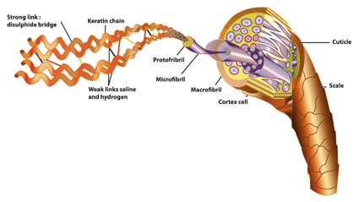
Explain how the structure of protein relates to its function, using keratin as an example.
(L3) (2.2.3.2)
____________________________________________________________________________________________________________________________________________________________________________________________________________________________________________________________________________________________________________________________________________________________________________________________________________________________________________________________________________________________________________________________________________________________________________________________________________________________________________________________________________________________________________________________

Question Three

Discuss the importance of the protein structure of keratin in its function in animals.
(L4) (Bio2.2.4.2)
____________________________________________________________________________________________________________________________________________________________________________________________________________________________________________________________________________________________________________________________________________________________________________________________________________________________________
____________________________________________________________________________________________________________________________________________________________________________________________________________________________________________________________________________________________________________________________________________________________________________________________________________________________________
____________________________________________________________________________________________________________________________________________________________________________________________________________________________________________________________________________________________________________________________________________________________________________________________________________________________________
____________________________________________________________________________________________________________________________________________________________________________________________________________________________________________________________________________________________________________________________________________________________________________________________________________________________________

