**Strand 2: Gene Expression**

***Sub-strand 2.1 DNA structure and replication***

**LESSON 1: THE GENOME**

**Key Learning outcome**:

Students are able to demonstrate understanding of the DNA structure and replication and ways in which these influence DNA functioning:

* Genome
* Structure of the gene
* Replication of DNA

The **specific learning outcomes** targeted in this lesson are provided below: Tick the last column when you have achieved each outcome.

|  |  |  |  |  |
| --- | --- | --- | --- | --- |
| **SLO#** | **Specific Learning Outcomes:**  *Students are able to* | **Skill level** | **SLO code** | **Achieved** |
| 1 | Define genome | 1 | Bio2.1.1.1 |  |
| 2 | Identify / State a feature or example of a genome in a given context | 1 | Bio2.1.1.2 |  |
| 3 | Describe the structure of a gene | 2 | Bio2.1.2.1 |  |
| 4 | Explain how the genome determines the full characteristics of an organism | 3 | Bio2.1.3.1 |  |

**Key Terms:**

|  |  |  |  |  |
| --- | --- | --- | --- | --- |
| **Term** |  |  | **Term** |  |
| Genome |  |  | Loci |  |
| Chromosome |  |  | Genotype |  |
| DNA |  |  | Phenotypic trait |  |
| Gene |  |  | Nucleotide |  |
| Protein |  |  | Sugar-phosphate backbone |  |
| Nitrogenous Base |  |  |  |  |
|  |  |  |  |  |

**Recommended Readings:**

|  |  |  |
| --- | --- | --- |
| **Reading Text** | **Page(s)** | **Achieved** |
| * Bradfield, P., Dodds, J., Dodds, J., & Taylore, N. (2001). *AS Level Biology*. Essex: Pearson Education Limited. | 119 – 126 |  |
| * Roberts, A. & Sinclair, M. (2012). ESA Study Guide Level 2 Biology, Auckland: ESA Publications Limited | 60 – 65 |  |
| * Bailey, M. (2009). *Designs of Life*. Auckland: ESA Publications Limited. | 185 – 192 |  |

**Summary Notes:**

* All the DNA found within the chromosomes of an organisms cells make up the genome of that organism.
* The DNA holds the important genetic information which is the blueprint of instructions for all the functions and biological make-up of the organism.
* The DNA is made up of two long strands of nucleotides joined together to form a double, helix structure. Since DNA is very long, it can be compressed within the nucleus of a cell because of this helix structure.
* Each nucleotide is composed of a nitrogenous base, a sugar and a phosphate group, with each phosphate of a nucleotide joining to the sugar group of another nucleotide to form the sugar-phosphate backbone of the DNA strand.
* The double strand of nucleotides in DNA are joined together by weak hydrogen bonds between their nitrogenous bases. One strand of the DNA holds the blueprint for making proteins. The other strand holds a copy of this information and is the strand that is copied during protein synthesis. This is important because the blueprint must be conserved as it is. Where the DNA base sequence is exposed possibilities of mutations can occur. However, the base-pairing rule of DNA allows for repair mechanisms to be maintained to keep the genetic information correct and intact.
* A gene is made up of a specific sequence of nucleotides along the DNA. The order in which the nucleotides are arranged along the DNA specifies what type of protein that gene will produce.
* Proteins carry out different functions and are essential to the survival of an organism. The proteins determine an organisms’ physiological, structural and behavioral characteristics.

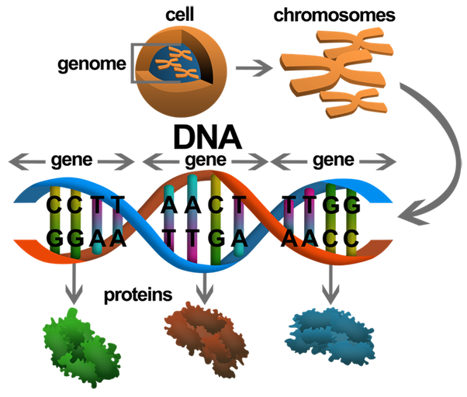

<https://qph.fs.quoracdn.net/main-qimg-7cf4370c883ff973ed497ab9fd6d917d>

**Fig. 1** *The relationship between the major components of the genome.*

**Lesson Activity**

**Question One**

Define the term **genome**. **(L1) (Bio2.1.1.1)**

_______________________________________________________________________________________________________________________________________________________________________________________________________________________________________________________________________________________________________________________________________________

**Question Two**

The structure below shows the features of a DNA molecule.



**B**

**C**

**A**

Identify the structures labelled: **(L1) (Bio2.1.1.2)**

A: ___________________________________________

B: ___________________________________________

C: ___________________________________________

**Question Three**

Describe the structure of a DNA **(L2) (Bio2.1.2.1)**

_______________________________________________________________________________________________________________________________________________________________________________________________________________________________________________________________________________________________________________________________________________

**Question Four**

Explain how the overall features of the genome determine the overall characteristics of an organism. **(L3) (Bio2.1.3.1)**

________________________________________________________________________________________________________________________________________________________________________________________________________________________________________________________________________________________________________________________________________________________________________________________________________________________________________________________________________________________________________________________________________________________________________________________________________________________________________________________________________________________________________________________________________________________________________________________________________________________________________________________________________________________________________________________________________________________________________________________________________________________________________________________________________________________________________________

**Strand 2: Gene Expression**

***Sub-strand 2.1 DNA structure and replication***

**Key Learning outcome**:

Students are able to demonstrate understanding of the DNA structure and replication and ways in which these influence DNA functioning:

* Replication of DNA

The **specific learning outcomes** targeted in this lesson are provided below: Tick the last column when you have achieved each outcome.

**LESSON 2: DNA REPLICATION**

The learning outcomes targeted in this lesson are provided below:

|  |  |  |  |  |
| --- | --- | --- | --- | --- |
| **SLO#** | **Specific Learning Outcomes:** *Students are able to* | **Skill level** | **SLO code** | **Achieved** |

|  |  |  |  |  |
| --- | --- | --- | --- | --- |
| 5 | Define semi-conservative replication | 1 | Bio2.1.1.3 |  |
| 6 | Identify semi-conservative replication, in a DNA replication representation | 1 | Bio2.1.1.4 |  |

|  |  |  |  |  |
| --- | --- | --- | --- | --- |
| 7 | Identify the leading and the lagging strand in a DNA replication representation | 1 | Bio2.1.1.5 |  |
| 8 | Describe the direction of the synthesis of the new strand[5’ to 3’ direction] | 2 | Bio2.1.2.2 |  |
| 9 | Describe the structure and replication of DNA in terms of semi-conservative replication, enzyme control, and antiparallel strand. | 2 | Bio2.1.2.3 |  |
| 10 | Explain the roles of respective enzymes in DNA Replication[Helicase/DNA Polymerase/Ligase] | 3 | Bio2.1.3.2 |  |
| 11 | Explain the process of DNA Replication in terms of the leading and the lagging strand and the okazaki fragments. | 3 | Bio2.1.3.3 |  |
| 12 | Discuss the process of DNA Replication of the lagging and leading strand and okazaki fragments, with the help of enzymes. | 4 | Bio2.1.4.1 |  |
| 13 | Describe ways in which DNA Replication problems may arise. | 2 | Bio2.1.2.4 |  |

**Key Concepts & Terms:**

|  |  |  |  |  |
| --- | --- | --- | --- | --- |
| **Concept** |  |  | **Terms** |  |
| DNA Replication |  |  | Helicase enzyme |  |
| Semi-conservative nature |  |  | Leading strand |  |
| Enzyme control |  |  | Lagging strand |  |
| Antiparallel nature |  |  | DNA polymerase enzyme |  |
| 3’ – 5’ synthesis |  |  | Ligase enzyme |  |
| RNA primer |  |  | Okazaki fragments |  |
|  |  |  |  |  |

**Recommended Readings:**

|  |  |  |
| --- | --- | --- |
| **Text** | **Pages** | **Achieved** |
| * Bradfield, P., Dodds, J., Dodds, J., & Taylore, N. (2001). *AS Level Biology*. Essex: Pearson Education Limited. | 126 – 129 |  |
| * Roberts, A. (2012). *ESA Study Guide, Level 2 Biology*. Auckland: ESA Publications Limited. | 55 – 59 |  |
| * Bailey, M. (2009). *Designs of Life*. Auckland: ESA Publications Limited. | 207 – 212 |  |

**SUMMARY NOTES:**

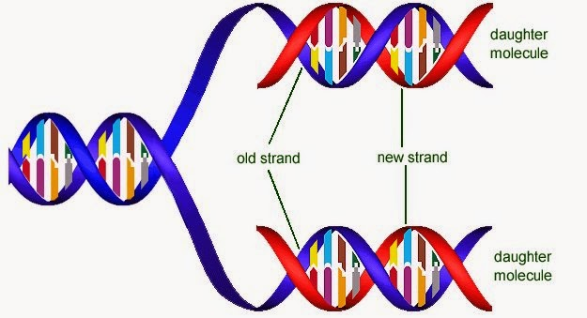***The semi-conservative nature of DNA***

During DNA replication, each original strand of DNA acts as a template for making new DNA. The strands acting as templates are also considered the ‘old’ strands (Figure 1). The DNA strands that are formed are therefore called the new strands. Having both copies of the old and the new strand makes DNA *semi-conservative*.

Fig.1: The semi-conservative nature of DNA <http://slideplayer.com/slide/5703636/18/images/32/3.4.3+State+that+DNA+replication+is+semiconservative..jpg>

***Important points to understand about the structure of DNA in relation to replication***

* 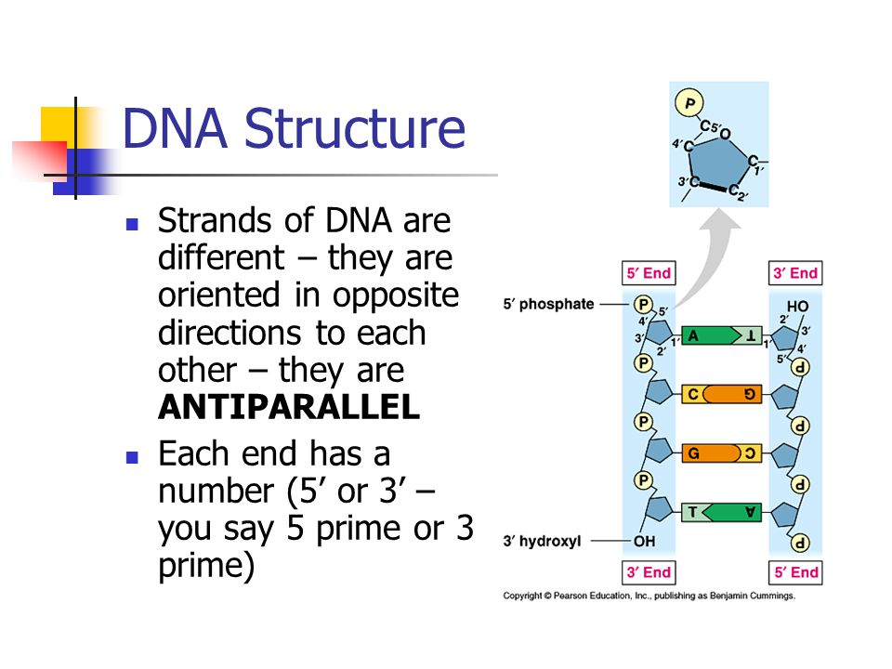A nucleotide consists of a phosphate group, a pentose-sugar group and a nitrogenous base. The pentose sugar has a hydroxyl group attached to its 3rd carbon. The phosphate group is attached to its 5th carbon.
* DNA therefore has 2 ends, one with a phosphate group exposed and the other with a hydroxyl group exposed. Where the hydroxyl group is exposed this is called the 3’ (prime) end. Where the phosphate group is exposed this is called the 5’ (prime) end.
* Both strands of DNA are therefore *anti-parallel*.

Fig. 2. *The anti-parallel nature of DNA*

Copyright © 2001 Benjamin Cummings, an imprint of Addison Wesley Longman, Inc.

This means that both strands run in opposite

directions to each other (Figure 2).

***Important points about DNA Replication***

* Both strands of DNA act as templates for replication.
* When DNA unwinds, the parental DNA with a 3’ end exposed will be copied in the direction towards the replication fork to form a new strand of DNA called the *leading strand*. The other strand with the 5’ end exposed will be copied in a direction away from the replication fork to form a new DNA strand called the *lagging strand*.
* Various important enzymes control the replication process:

|  |  |
| --- | --- |
| **Enzyme** | **Role in replication** |
| Helicase | Unwinds DNA and breaks Hydrogen bonds between base pairs. |
| DNA Polymerase III | Attaches nucleotides in a 5’ 3’ direction. |
| RNA primase | Attaches RNA primers on the template strands. |
| DNA polymerase I | Removes RNA primers. |
| DNA Ligase | Attaches Okazaki fragments together by forming covalent bonds between nucleotides. |

* RNA primers initiate the replication process on both parental DNA strands.
* The leading strand is formed in a continuous fashion (Figure 3). This is because
  + 1. DNA polymerase enzyme only recognizes the 5’ end of a nucleotide and adds new nucleotides from this end.
    2. DNA polymerase binds only to 3’ ends of template strands.

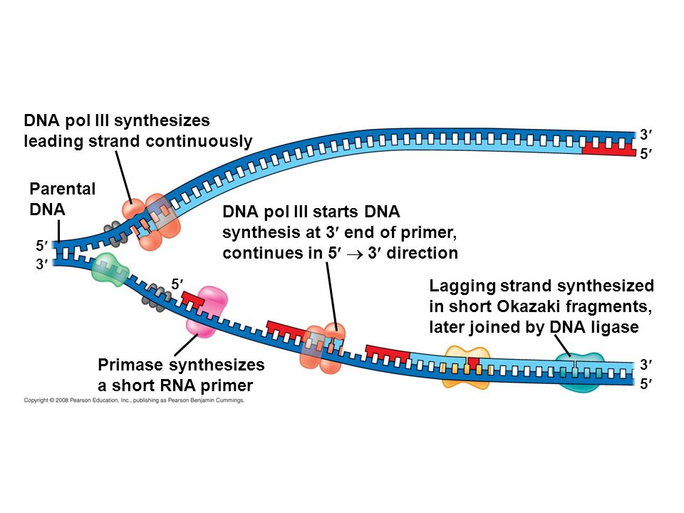

Fig. 3: *The role of enzymes in the DNA replication process. (Retrieved from* [*http://slideplayer.com/slide/4463335/14/images/2/DNA+pol+III+synthesizes+leading+strand+continuously.jpg*](http://slideplayer.com/slide/4463335/14/images/2/DNA+pol+III+synthesizes+leading+strand+continuously.jpg)

* 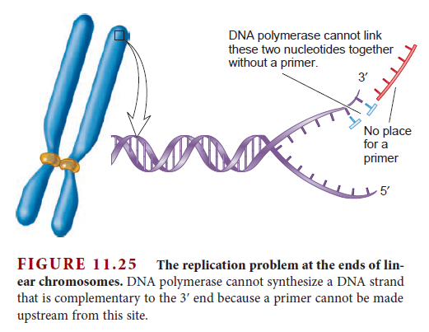The lagging strand is formed from short, discontinuous segments of 1000-2000 nucleotides called *okazaki fragments* (Figure 3).
  + RNA primers are attached at various locations along the DNA template rather than at its end. This is because, the exposed end of the template has a 5’ end. A primer attached to this end would not allow DNA polymerase to add on new nucleotides as there would be no template to read from (Figure 4).

Fig. 4: *The replication problem with the synthesis of the lagging strand.*

*(Retrieved from* <http://i68.servimg.com/u/f68/17/30/76/23/telome12.png>

* + DNA polymerase III extends each primer until it

reaches the next primer along the template. DNA

polymerase I then removes the primers and replaces

them with DNA. Ligase joins the okazaki fragments

together to form a continuous strand.

**Lesson Activity**

**Question One**

Define the term **semi-conservative replication**. **(L1) (Bio2.1.1.3)**

______________________________________________________________________________________________________________________________________________________________________________________________________________________________________________________________________________________________________________________________________________________________________________________________________________________________________________________

**Question Two**

The diagram below shows a DNA that had replicated.

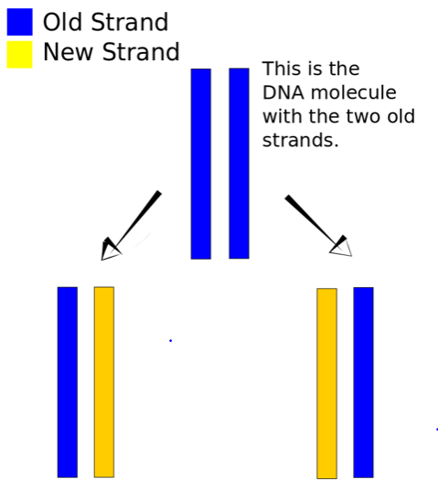

Is DNA replication described as conservative or semi-conservative? **(L1) (Bio 2.1.1.4)**

_______________________________________________________________________

**Question Three**

Refer to the diagram below on protein synthesis to answer the following questions.

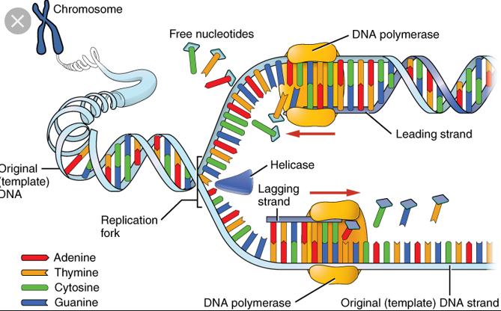

Identify the strand that is synthesized: **(L1) (Bio2.1.1.5)**

(i) In short fragments: _________________________________________________

(ii) Continuously: ________________________________________________

**Question Four**

Describe the direction of the synthesis of the new strand. **(L2) (Bio2.1.2.2)**

__________________________________________________________________________________________________________________________________________________________________________________________________________________________________________________________________________________________________________________________________________________________________________________________________________________________________________________________________________________________________________________________________________________________________________________________________________________________________________________________________________________________________________________________________________________________

**Question Five**

Describe the structure and replication of DNA in terms of semi-conservative replication, enzyme control, antiparallel 3’-5’ strand. **(L2) (Bio2.1.2.3)**

**________________________________________________________________________________________________________________________________________________________________________________________________________________________________________________________________________________________________________________________________________________________________________________________________________________________________________________________________________________________________________________________________________________________________________________________________________**

**Question Six**

Explain the roles of the following enzymes in DNA Replication. **(L2) (Bio2.1.3.2)**

(i)**Helicase:**_____________________________________________________________________________________________________________________________________________________________________________________________________________________________________________________________________________________________________________________________________________________________________________________________________________________________________________

(ii)**DNA polymerase**:____________________________________________________________________________________________________________________________________________________________________________________________________________________________________________________________________________________________________________________________________________________________________________________________________________________________________________

(iii)**Ligase**: ______________________________________________________________________________________________________________________________________________________________________________________________________________________________________________________________________________________________________________________________________________________________________________________________________________________________________________________

**Question Seven**

Explain the process of DNA Replication in terms of the leading and the lagging strand and the okazaki fragments. **(L3) (Bio2.1.3.3)**

___________________________________________________________________________________________________________________________________________________________________________________________________________________________________________________________________________________________________________________________________________________________________________________________________________________________________________________________________________________________________________________________________________________________________________________________________________________________

**Question Eight**

Discuss the process of DNA Replication in terms of the lagging and the leading strand and the okazaki fragments with the help of enzymes[helicase/DNA polymerase/ligase] **(L4) (Bio2.1.4.1)**

________________________________________________________________________________________________________________________________________________________________________________________________________________________________________________________________________________________________________________________________________________________________________________________________________________________________________________________________________________________________________________________________________________________________________________________________________________________________________________________________________________________________________________________________________________________________________________________________________________________________________________________________________________________________________________________________________________________________________________________________________________________________________________________________________________________________________________

**Question Nine**

Describe ways in which DNA replication problems may arise. **(L2) (Bio2.1.2.4)**

________________________________________________________________________________________________________________________________________________________________________________________________________________________________________________________________________________________________________________________________________________________________________________________________________________________________________________________________________________________________________________________________________________________________________________________________________