Central School
Home School Package

Year :12

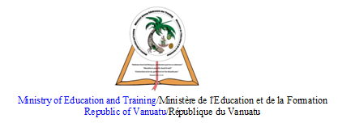

HOME SCHOOL PACKAGE CONTENT
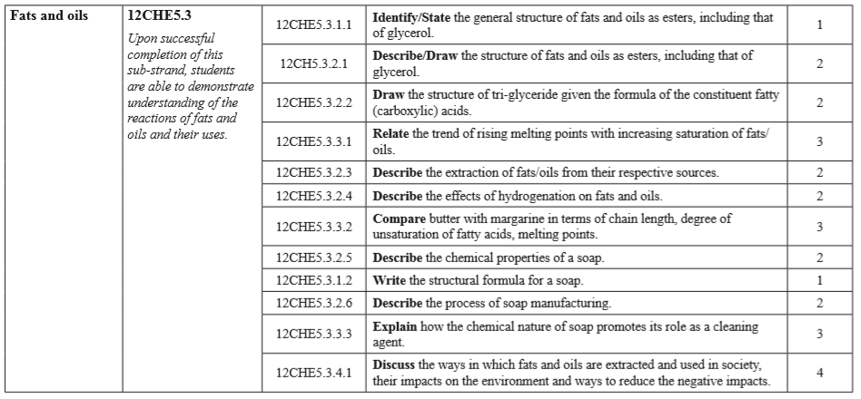

LESSON Plan

Teacher | Name :Judy W Vire  Subject :Chemistry
Date | Week 7 of term 2
Topic : Organic Chemistry
Lesson number : 3

Learning outcomes | - Write the structural formula for a soap  - Describe the process of soap manufacturing  - Explain how the chemical nature of soap promotes its role as a cleaning agent  - Discuss the ways in which fats and ils are extracted and used in society, their impacts on the environment and ways to reduce the negative impacts.
Introduction | Every year we celebrate Global Handwashing Day on 15 October with exciting, innovative activities across many countries. But why? What role should handwashing play in the global development agenda and why should we care about handwashing?
 | Catch phrase for the lesson
Learners notes | Summary  Soap is formed when sodium hydroxide is heated with triglyceride molecules for form sodium salt like sodium stearate, sodium laurate etc. The process is called saponification. Historically, this is how soap is made in the form of structural formula: 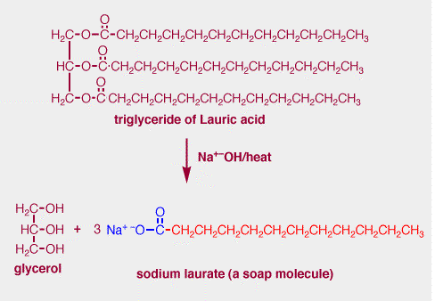  The kettle method of making soap is still used today by small soap manufacturing companies. This process takes from four to eleven days to complete, and the quality of each batch is inconsistent due to the variety of oils used. Around 1940, engineers and scientists developed a more efficient manufacturing process, called the continuous process. This procedure is employed by large soap manufacturing companies all around the world today. Exactly as the name states, in the continuous process soap is produced continuously, rather than one batch at a time. Technicians have more control of the production in the continuous process, and the steps are much quicker than in the kettle method—it takes only about six hours to complete a batch of soap. Read more: http://www.madehow.com/Volume-2/Soap.html#ixzz6LjW23oCS  The soap molecule has two different ends, one that is hydrophilic (polar head) that binds with water and the other that is hydrophobic (non-polar hydrocarbon tail) that binds with grease and oil. When greasy dirt or oil is mixed with soapy water, the soap molecules arrange themselves into tiny clusters called micelles.  Soaps are denoted by the general formula RCOO-Na+, where R is any long chain alkyl group consisting 12 to 18 carbon atoms.  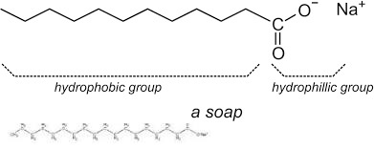  Some common examples of fatty acids that are used in soaps are stearic acid having chemical formula C17H35COOH, palmitic acid having chemical formula C15H31COOH.
- How does soap work ? by NileBlue - https://www.youtube.com/watch?v=wTuRmwSkuzQ
- Cleansing action of soaps and detergents by Fortuna Pix - https://www.youtube.com/watch?v=2CVUvr1K9nk
- Saponification :The process of making soap by Amritacreate - https://www.youtube.com/watch?v=Tu_sWoHULtY
- How to make soap by KimmieH - https://www.youtube.com/watch?v=k1rsfZ_WGm4
- Soap manufacturing business by StartupYo - https://www.youtube.com/watch?v=Xb21Ynmu8Vo

- Write the structural formula for soap
- Explain how the chemical nature of soap promotes its role as a cleaning agent.
Assignment | Describe in outlining the steps the manufacturing process of soap
Assessment | Above assignment is assessed - 5%
References | https://www.quora.com/What-is-the-structure-and-formula-of-soap  http://www.asu.edu/courses/chm233/notes/derivatives/derivativesRL2/soap.html  http://www.madehow.com/Volume-2/Soap.html

WEEKLY CHECKLIST For Parents:

Term: 2 Week number 1 Date…… to…… Month: …………

Subject | Number of lessons | Days | Tick when activity is complete | Parents comment | Signature
 | 1
 | 2
 | 3
 | 4
 | 5
 | 6

Term: 2 Week number 2 Date…… to…… Month: …………

Subject | Number of lessons | Days | Tick when activity is complete | Parents comment | Signature
 | 1
 | 2
 | 3
 | 4
 | 5
 | 6

Term: 2 Week number 3 Date…… to…… Month: …………

Subject | Number of lessons | Days | Tick when activity is complete | Parents comment | Signature
 | 1
 | 2
 | 3
 | 4
 | 5
 | 6

Term: 2 Week number 4 Date…… to…… Month: …………

Subject | Number of lessons | Days | Tick when activity is complete | Parents comment | Signature
 | 1
 | 2
 | 3
 | 4
 | 5
 | 6

Term: 2 Week number 5 Date…… to…… Month: …………

Subject | Number of lessons | Days | Tick when activity is complete | Parents comment | Signature
 | 1
 | 2
 | 3
 | 4
 | 5
 | 6

Term: 2 Week number 6 Date…… to…… Month: …………

Subject | Number of lessons | Days | Tick when activity is complete | Parents comment | Signature
 | 1
 | 2
 | 3
 | 4
 | 5
 | 6

Term: 2 Week number 7 Date…… to…… Month: …………

Subject | Number of lessons | Days | Tick when activity is complete | Parents comment | Signature
 | 1
 | 2
 | 3
 | 4
 | 5
 | 6

Term: 2 Week number 8 Date…… to…… Month: …………

Subject | Number of lessons | Days | Tick when activity is complete | Parents comment | Signature
 | 1
 | 2
 | 3
 | 4
 | 5
 | 6

Term: 2 Week number 9 Date…… to…… Month: …………

Subject | Number of lessons | Days | Tick when activity is complete | Parents comment | Signature
 | 1
 | 2
 | 3
 | 4
 | 5
 | 6

Term: 2 Week number 10 Date…… to…… Month: …………

Subject | Number of lessons | Days | Tick when activity is complete | Parents comment | Signature
 | 1
 | 2
 | 3
 | 4
 | 5
 | 6

Term: 2 Week number 11 Date…… to…… Month: …………

Subject | Number of lessons | Days | Tick when activity is complete | Parents comment | Signature
 | 1
 | 2
 | 3
 | 4
 | 5
 | 6

Term: 2 Week number 12 Date…… to…… Month: …………

Subject | Number of lessons | Days | Tick when activity is complete | Parents comment | Signature
 | 1
 | 2
 | 3
 | 4
 | 5
 | 6

Term: 2 Week number 13 Date…… to…… Month: …………

Subject | Number of lessons | Days | Tick when activity is complete | Parents comment | Signature
 | 1
 | 2
 | 3
 | 4
 | 5
 | 6

