Central School
Home School Package

Year :12

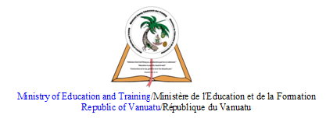

HOME SCHOOL PACKAGE CONTENT
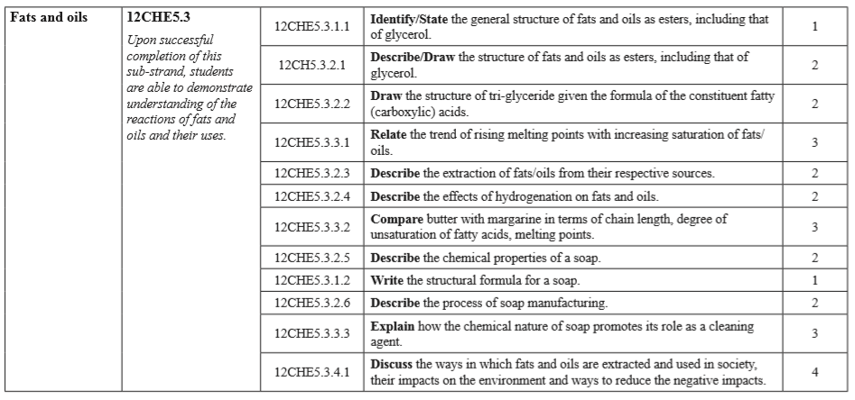

LESSON Plan

Teacher | Name :Judy W Vire  Subject :Chemistry
Date | Week 7 of Term 2
Topic :Organic Chemistry
Lesson number :2

Learning outcomes | - Describe the extraction of fats/oils from their respective sources  - Describe the effects of hydrogenation on fats and oils  - Compare butter with margarine in terms of chain length, degree of unsaturation of fatty acids, melting points  - Describe the chemical properties of a soap
Introduction | Fats and oils are esters of fatty acids. Fats are soft solid at room temperature where they are saturated and found in animals such as lard, cod and liver oil. Oils are liquid at room terperature where they are unsaturated compounds and come from plant sources such as seeds, nuts, berries and sunflower.  Fats and oils are used in our diets to provide us with energy. They play an important role in the transport of vitamins which are soluble in fats around the human body.
Catch phrase for the lesson
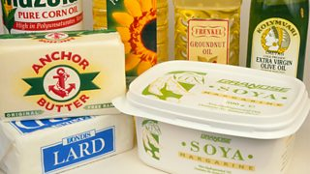
Fats and oil-based food product
Learners notes | Summary  Hydrogenation is the chemical reaction between hydrogen and other compounds in the presence of catalyst. For example, Oils (such as vegetable, olive, sunflower) are liquids at room temperature. In the food industry, hydrogen is added to oils (in a process called hydrogenation) to make them more solid, or 'spreadable like margarine and their melting point is change now at room temperature The use of hydrogenated helps to prolong the shelf-life of the food and maintain flavour stability.  Butter is a dairy product, made from milk or cream… "Light" butter contains more water, for less fat and calories. Margarine is an oil-based product. It is typically made of 80 percent vegetable oil and water and flavored to taste like butter. They both differ from one another in three ways:  1. Carbon chain length (i.e. 6 carbons, 18 carbons)  2. Saturation/unsaturation  3. Melting point  Butter is made out of short chained fatty acids in comparison to longer chained fatty acids. Margarine's melting point is only slightly higher than that of butter. The melting point of margarine is slightly higher than butter because of the presence of hydrogenated fats. It melts at 94-98 °F. Like butter, there is no set point at which it will solidify; it will usually solidify around 65-70°F. Margarine contains a higher level of unsaturated and trans-fatty acids (TFA) than butter. ... Margarine, compared to the butter, contained a higher degree of unsaturation,  Soap is formed when sodium hydroxide is heated with triglyceride molecules to form sodium salt. The reaction is known as saponification and is the resverse of esterificaiton. It is a sodium or potassium salts of higher fatty acids like stearic, palmitic and oleic acids can be either saturated or unsaturated. They contain a long hydrocarbon chain of about 10-20 carbon with one carboxylic acid group as the functional group.
- The extraction of plant oils by fuseschool - https://www.youtube.com/watch?v=ggvKSjaJ8Fw
- Fats and oils (plant oils) chemistry for all by Fuseschool - https://www.youtube.com/watch?v=rjdttw1rqt8
- Animal fats oil extraction machine by Debby Yu - https://www.youtube.com/watch?v=mIdGfyuvGJQ
- Hydrogenation of oil (HL) by Mike Sugiyama - https://www.youtube.com/watch?v=SBxejJtj2d0
- Hydrogenation : transform liquid oil into solid fat by Applied science - https://www.youtube.com/watch?v=oqdDWA9-DSY

- Describe the extraction of fats/oils from their respective sources
- Fats _____________________________
- Oils _____________________________
- Describe four effects of hydrogenation on fats and oils
- _________________________
- _________________________
- _________________________
- _________________________
- Compare butter and margarine by completing the table below
- Butter
- Chain length _____________________
- Degree of unsaturation _____________
- Melting point ____________________
- Margarine
- Chain length _____________________
- Degree of unsaturation _____________
- Melting point ____________________

- Describe the four chemical properties of soap

Assignment | Dicuss the ways in fats and oils are extratced and used in society their impacts on the environment and ways to reduced the negative impacts.  - Ways fats and oils extracted  - Fats and oils used in society  - Fats and oils impact on the environment  - Ways to reduced the negative impacts
Assessment | Above assignment is assessed – 5%
References | https://www.bbc.co.uk/bitesize/guides/zp8wwmn/revision/4  https://study.com/academy/lesson/what-are-hydrogenated-fats-definition-examples.h  https://www.giapo.com/butter-vs-margarine/  https://www.researchgate.net/publication/318079865_Comparison_of_Physicochemical_Characteristics_of_Some_Margarines_and_Butters_in_Iranian_Market_during_Storage

WEEKLY CHECKLIST For Parents:

Term: 2 Week number 1 Date…… to…… Month: …………

Subject | Number of lessons | Days | Tick when activity is complete | Parents comment | Signature
 | 1
 | 2
 | 3
 | 4
 | 5
 | 6

Term: 2 Week number 2 Date…… to…… Month: …………

Subject | Number of lessons | Days | Tick when activity is complete | Parents comment | Signature
 | 1
 | 2
 | 3
 | 4
 | 5
 | 6

Term: 2 Week number 3 Date…… to…… Month: …………

Subject | Number of lessons | Days | Tick when activity is complete | Parents comment | Signature
 | 1
 | 2
 | 3
 | 4
 | 5
 | 6

Term: 2 Week number 4 Date…… to…… Month: …………

Subject | Number of lessons | Days | Tick when activity is complete | Parents comment | Signature
 | 1
 | 2
 | 3
 | 4
 | 5
 | 6

Term: 2 Week number 5 Date…… to…… Month: …………

Subject | Number of lessons | Days | Tick when activity is complete | Parents comment | Signature
 | 1
 | 2
 | 3
 | 4
 | 5
 | 6

Term: 2 Week number 6 Date…… to…… Month: …………

Subject | Number of lessons | Days | Tick when activity is complete | Parents comment | Signature
 | 1
 | 2
 | 3
 | 4
 | 5
 | 6

Term: 2 Week number 7 Date…… to…… Month: …………

Subject | Number of lessons | Days | Tick when activity is complete | Parents comment | Signature
 | 1
Chemistry | 2
 | 3
 | 4
 | 5
 | 6

Term: 2 Week number 8 Date…… to…… Month: …………

Subject | Number of lessons | Days | Tick when activity is complete | Parents comment | Signature
 | 1
 | 2
 | 3
 | 4
 | 5
 | 6

Term: 2 Week number 9 Date…… to…… Month: …………

Subject | Number of lessons | Days | Tick when activity is complete | Parents comment | Signature
 | 1
 | 2
 | 3
 | 4
 | 5
 | 6

Term: 2 Week number 10 Date…… to…… Month: …………

Subject | Number of lessons | Days | Tick when activity is complete | Parents comment | Signature
 | 1
 | 2
 | 3
 | 4
 | 5
 | 6

Term: 2 Week number 11 Date…… to…… Month: …………

Subject | Number of lessons | Days | Tick when activity is complete | Parents comment | Signature
 | 1
 | 2
 | 3
 | 4
 | 5
 | 6

Term: 2 Week number 12 Date…… to…… Month: …………

Subject | Number of lessons | Days | Tick when activity is complete | Parents comment | Signature
 | 1
 | 2
 | 3
 | 4
 | 5
 | 6

Term: 2 Week number 13 Date…… to…… Month: …………

Subject | Number of lessons | Days | Tick when activity is complete | Parents comment | Signature
 | 1
 | 2
 | 3
 | 4
 | 5
 | 6

