Central School
Home School Package

Year :12

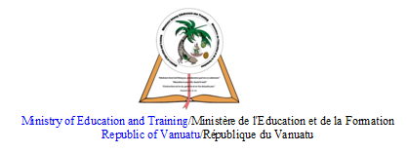

HOME SCHOOL PACKAGE CONTENT
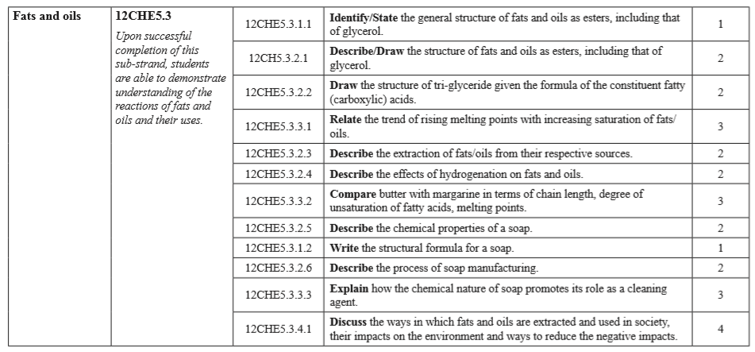

LESSON Plan

Teacher | Name : Judy Vire  Subject :Chemisty
Date | Week 7 of term 2
Topic :Organic Chemistry
Lesson number : 7 of Term 2

Learning outcomes | - Identify/state the general structure of fats and oils as esters including that of glycerol  - Describe/draw the structure of fats and oils as esters, including that of glycerol  - Draw the structure of tri-glyceride given the formula of the constituent fatty (carboxylic) acids  - Relate the trend of rising melting points with increasing saturation of fats/Oils
Introduction | Many esters occur naturally. They often have pleasant fruity smells and are found in flowers and fruit. For example, ethyl methanoate(an esters) is found in raspberries, ethyl butanoate is found in pineapples, methyl butanoate is found in apples.  Synthetic esters are used as flavourings, fragrances and in the biological control of insect pests.  Tri-glycerides are naturally occurring esters found in fats and oils. Some insects produce esters as sex attractants.  Learners Notes  Esters are derived from carboxylic acids. A carboxylic acid contains the -COOH group, and in an ester the hydrogen in this group is replaced by a hydrocarbon group of some kind. This could be an alkyl group like methyl or ethyl, or one containing a benzene ring like phenyl.
Catch phrase for the lesson

Perfume of the day…..sweet smelling
Learners notes | Summary  Esters are derived from carboxylic acids. A carboxylic acid contains the -COOH group, and in an ester the hydrogen in this group is replaced by a hydrocarbon group of some kind. This could be an alkyl group like methyl or ethyl, or one containing a benzene ring like phenyl.  Differences between fats and oils  Animal and vegetable fats and oils are just big complicated esters. The difference between a fat (like butter) and an oil (like sunflower oil) is simply in the melting points of the mixture of esters they contain.  If the melting points are below room temperature, it will be a liquid - an oil. If the melting points are above room temperature, it will be a solid - a fat.  The causes of the differences in melting points will be discussed further down the page under physical properties.  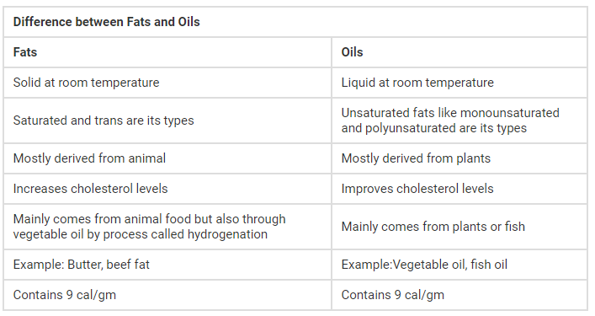  Structures of Fats and Oils  Fats and oils are called triglycerides (or triacylcylgerols) because they are esters composed of three fatty acid units joined to glycerol, a trihydroxy alcohol:  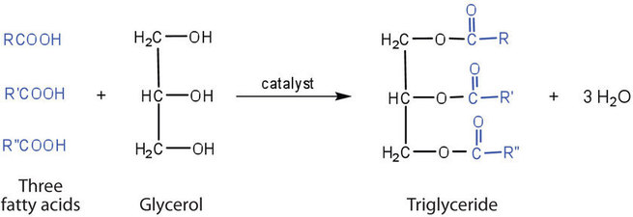  If all three OH groups on the glycerol molecule are esterified with the same fatty acid, the resulting ester is called a simple triglyceride. Although simple triglycerides have been synthesized in the laboratory, they rarely occur in nature. Instead, a typical triglyceride obtained from naturally occurring fats and oils contains two or three different fatty acid components and is thus termed a mixed triglyceride.  Fats and oils share a common molecular structure, which is represented by the formula below.  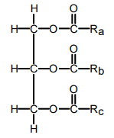  The most common fatty acids are listed. Note that there are two groups of fatty acids--saturated and unsaturated. Recall that the term unsaturated refers to the presence of one or more double bonds between carbons as in alkenes. A saturated fatty acid has all bonding positions between carbons occupied by hydrogens.  The melting points for the saturated fatty acids follow the boiling point principle observed previously. Melting point principle: as the molecular weight increases, the melting point increases. This observed in the series lauric (C12), palmitic (C16), stearic (C18). Room temperature is 25ºC, Lauric acid which melts at 44º is still a solid, while arachidonic acid has long since melted at -50º, so it is a liquid at room temperature.  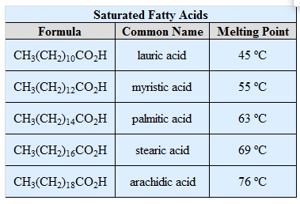  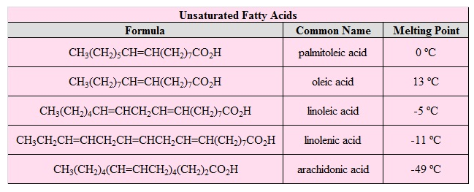  Note that as a group, the unsaturated fatty acids have lower melting points than the saturated fatty acids. The reason for this phenomenon can be found by a careful consideration of molecular geometries. The tetrahedral bond angles on carbon results in a molecular geometry for saturated fatty acids that is relatively linear although with zigzags.  Stearic acid Oleic aci  This molecular structure allows many fatty acid molecules to be rather closely "stacked" together. As a result, close intermolecular interactions result in relatively high melting points.
Molecular structure of triglycerides (fats) by Khan Academy - https://www.khanacademy.org/science/biology/macromolecules/lipids/v/molecular-structure-of-triglycerides-fats
Esters 3. Structure of fats and oils by Frankly Chemistry - https://www.youtube.com/watch?v=hXNMWj7uPXs

- State the general structure of fats and oils as esters including that of glycerol
- Draw and describe the structure of fats and oils as esters including that of glycerol
- Draw the structure of tri-glyceride given the formula of the constituent fatty (carboxylic) acids
- Relate the trend of rising melting points with increasing saturation of fats/Oils
Assignment | List ten fats & oils foods/products commonly used traditionly or eaten in the pacific.
Assessment | Written test on week 9 at Central School, Port Vila
References | https://chem.libretexts.org/Bookshelves/Introductory_Chemistry/Book%3A_The_Basics_of_GOB_Chemistry_(Ball_et_al.)/17%3A_Lipids/17.2%3A_Fats_and_Oils  https://www.chemguide.co.uk/organicprops/esters/background.html  http://www.scifun.org/CHEMWEEK/FatsOils2017.pd  https://chem.libretexts.org/Courses/University_of_Illinois%2C_Springfield/UIS%3A_CHE_267_-_Organic_Chemistry_I_(Morsch)/Chapters/Chapter_10%3A_Alkenes/10.17%3A_Lipids%E2%80%94Part_2

WEEKLY CHECKLIST For Parents:

Term: 2 Week number 1 Date…… to…… Month: …………

Subject | Number of lessons | Days | Tick when activity is complete | Parents comment | Signature
 | 1
 | 2
 | 3
 | 4
 | 5
 | 6

Term: 2 Week number 2 Date…… to…… Month: …………

Subject | Number of lessons | Days | Tick when activity is complete | Parents comment | Signature
 | 1
 | 2
 | 3
 | 4
 | 5
 | 6

Term: 2 Week number 3 Date…… to…… Month: …………

Subject | Number of lessons | Days | Tick when activity is complete | Parents comment | Signature
 | 1
 | 2
 | 3
 | 4
 | 5
 | 6

Term: 2 Week number 4 Date…… to…… Month: …………

Subject | Number of lessons | Days | Tick when activity is complete | Parents comment | Signature
 | 1
 | 2
 | 3
 | 4
 | 5
 | 6

Term: 2 Week number 5 Date…… to…… Month: …………

Subject | Number of lessons | Days | Tick when activity is complete | Parents comment | Signature
 | 1
 | 2
 | 3
 | 4
 | 5
 | 6

Term: 2 Week number 6 Date…… to…… Month: …………

Subject | Number of lessons | Days | Tick when activity is complete | Parents comment | Signature
 | 1
 | 2
 | 3
 | 4
 | 5
 | 6

Term: 2 Week number 7 Date…… to…… Month: …………

Subject | Number of lessons | Days | Tick when activity is complete | Parents comment | Signature
 | 1
 | 2
 | 3
 | 4
 | 5
 | 6

Term: 2 Week number 8 Date…… to…… Month: …………

Subject | Number of lessons | Days | Tick when activity is complete | Parents comment | Signature
 | 1
 | 2
 | 3
 | 4
 | 5
 | 6

Term: 2 Week number 9 Date…… to…… Month: …………

Subject | Number of lessons | Days | Tick when activity is complete | Parents comment | Signature
 | 1
 | 2
 | 3
 | 4
 | 5
 | 6

Term: 2 Week number 10 Date…… to…… Month: …………

Subject | Number of lessons | Days | Tick when activity is complete | Parents comment | Signature
 | 1
 | 2
 | 3
 | 4
 | 5
 | 6

Term: 2 Week number 11 Date…… to…… Month: …………

Subject | Number of lessons | Days | Tick when activity is complete | Parents comment | Signature
 | 1
 | 2
 | 3
 | 4
 | 5
 | 6

Term: 2 Week number 12 Date…… to…… Month: …………

Subject | Number of lessons | Days | Tick when activity is complete | Parents comment | Signature
 | 1
 | 2
 | 3
 | 4
 | 5
 | 6

Term: 2 Week number 13 Date…… to…… Month: …………

Subject | Number of lessons | Days | Tick when activity is complete | Parents comment | Signature
 | 1
 | 2
 | 3
 | 4
 | 5
 | 6

