DAY 4
TOPIC: ELEMENTS AND COMPOUNDS- NAMES, SYMBOLS AND FORMULAE.
Aims :
- identify correct chemical symbols for certain elements (as prescribed)
- identify correct chemical formulae for certain compounds (as prescribed)
Elements’ names and symbols
Notes:
Every substance on earth is made from an element or a combination of elements (compound). There are about 116 known elements, and each element has its own symbol. The symbol is a letter (or letters) that is used and understood by all scientists all over the world, no matter what language they speak, and what they call the elements.
For year 9 you don’t need to know all 116 elements and their symbols. The table below shows the elements, that you should be familiar with in year 9. You are to learn the names and the symbols of the elements
Element | Symbol |  | Element | Symbol
Hydrogen | H |  | Carbon | C
Nitrogen | N |  | Oxygen | O
Sodium | Na |  | Magnesium | Mg
Sulphur | S |  | Chlorine | Cl
Calcium | C |  | Copper | Cu
Iron | Fe

Compounds’ Names and Formulae
When the atoms of different elements bond, they form a completely new substance called a compound. Eg. Water is a compound that is formed by chemically joining the two different elements, Hydrogen and Oxygen.
The formula of a compound tells you what elements were chemically joined together to form the compound.
For example Sodium Chloride has the formula NaCl, this shows that it is formed by chemically joining 1 atom of Sodium (Na) and 1 atom of Chlorine (Cl).
Water has the formula H₂0. This shows that water is formed by chemically joining 2 atoms of Hydrogen (H₂) with 1 atom of Oxygen (O).

Activity 1
Complete the table below by writing down which elements the compound is made of, then choose the correct chemical formulae, for the compound from the list below, and write it into your table. (The first one is already done for you)
CO₂ , NaCl, H₂O, FeS, CuSo₄, CuCl₂

Compound Name | Elements in the compound | Chemical formulae
Water (dihydrogen oxide) | 2 Hydrogen atoms + 1 Oxygen atom | H₂0
Carbon Dioxide | 1 Carbon atom + 2 Oxygen atoms | CO₂
Iron Sulfide | 1 iron atom + 1 Sulphur atom | FeS
Sodium Chloride | 1 Sodium atom + 1 Chlorine atom | NaCl
Copper Chloride | 1 Copper atom + 2 Chlorine atoms | CuCl₂
Copper sulphate | 1 Copper atom + 4 Sulphur atoms + 1 Oxygen atom | CuSO₄

Activity 2
Read Hand out pages 44-47 below then answer questions on particles 7 and 8.

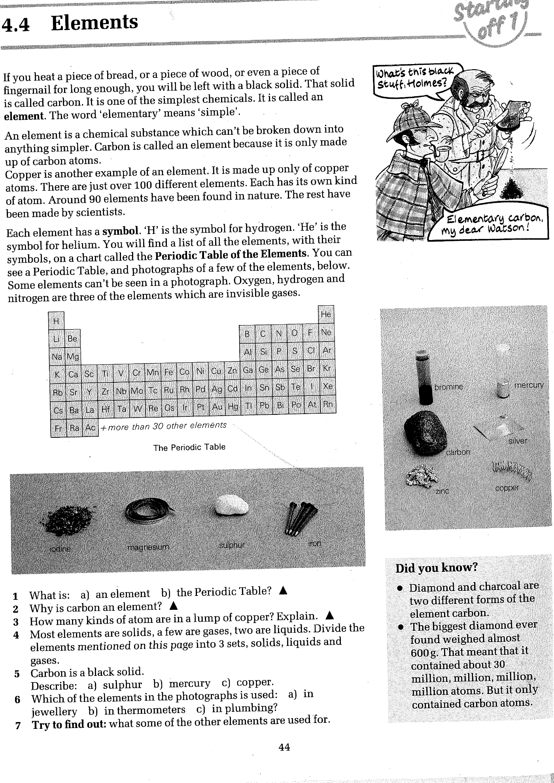
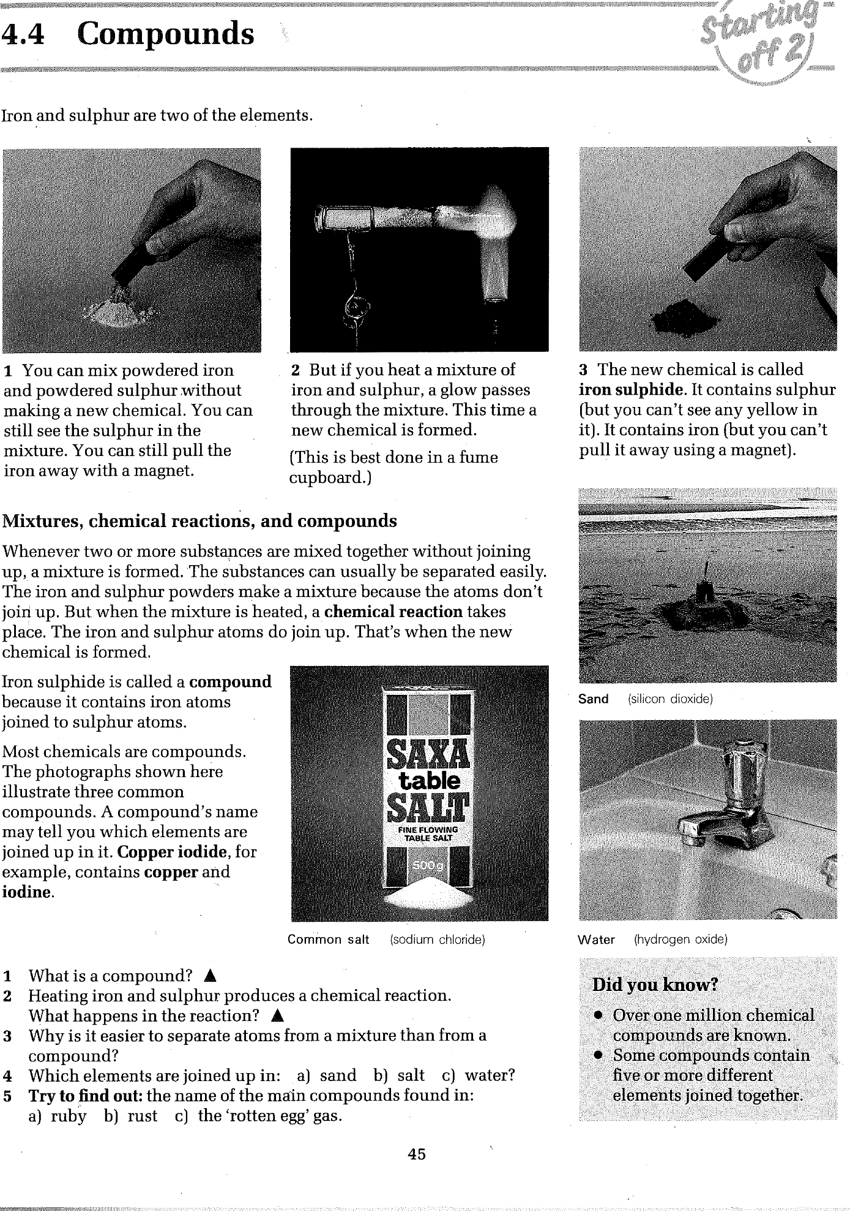
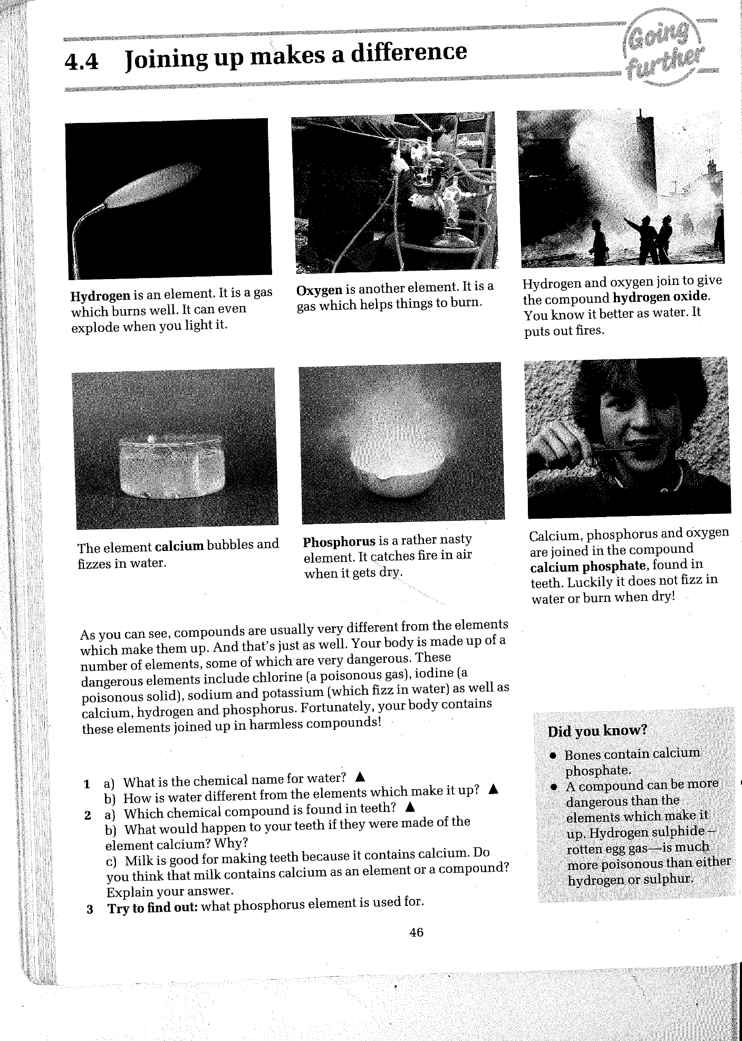
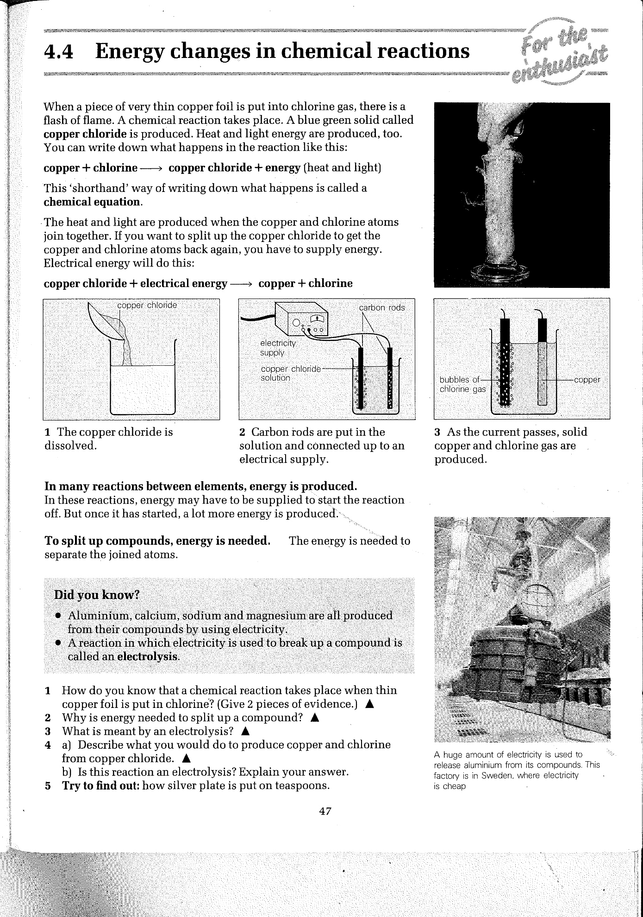
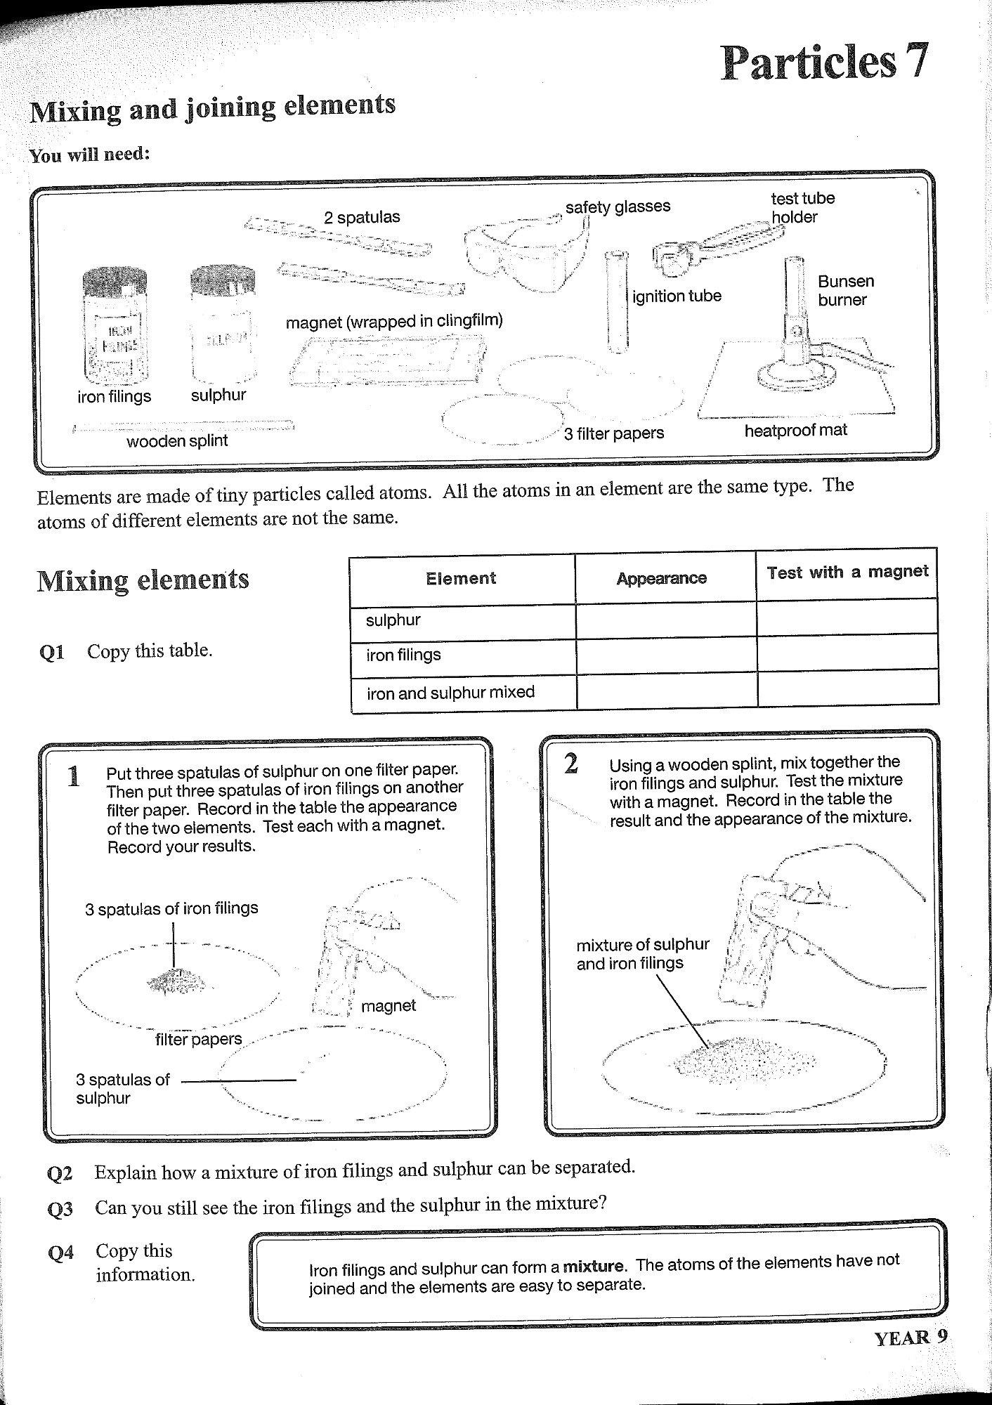\
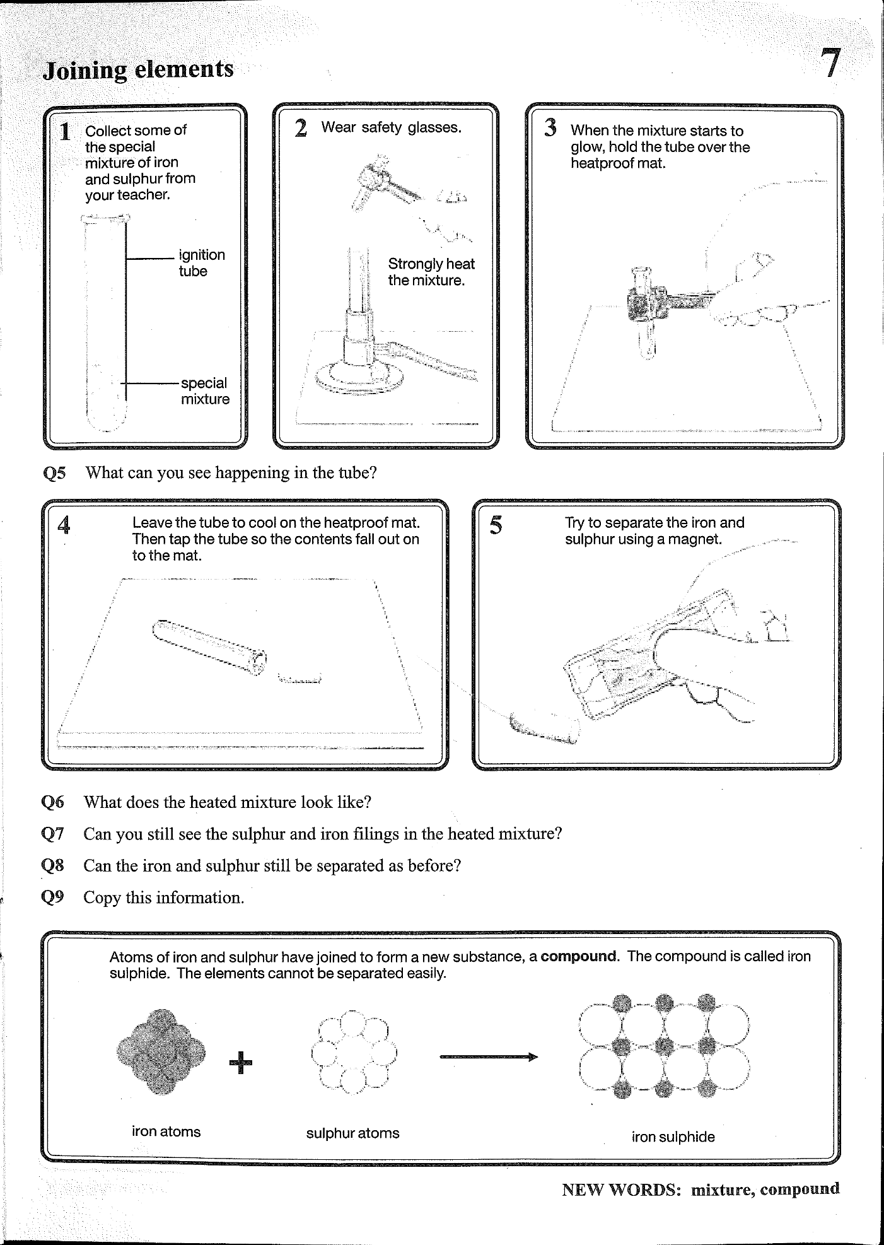
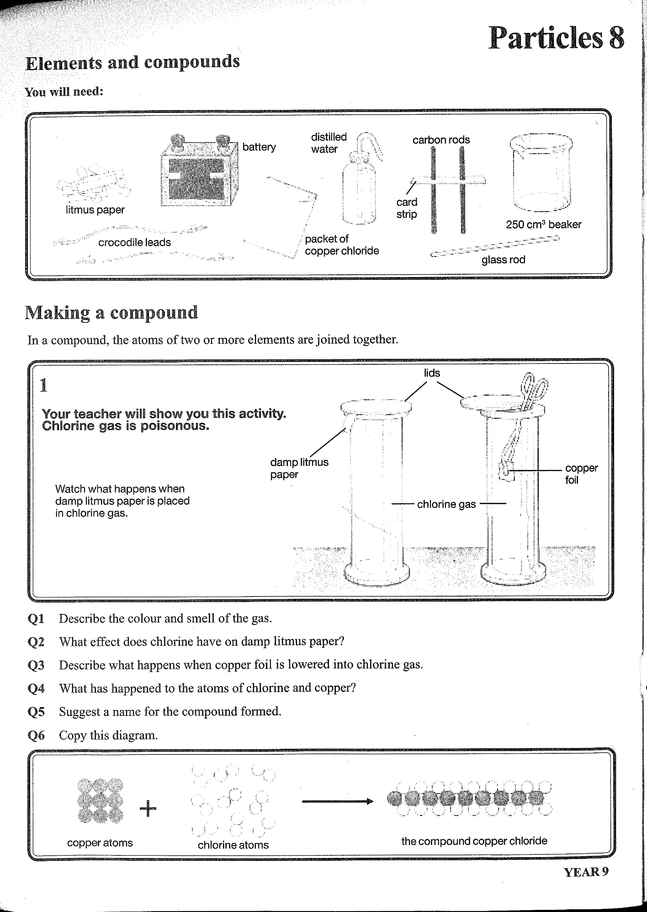
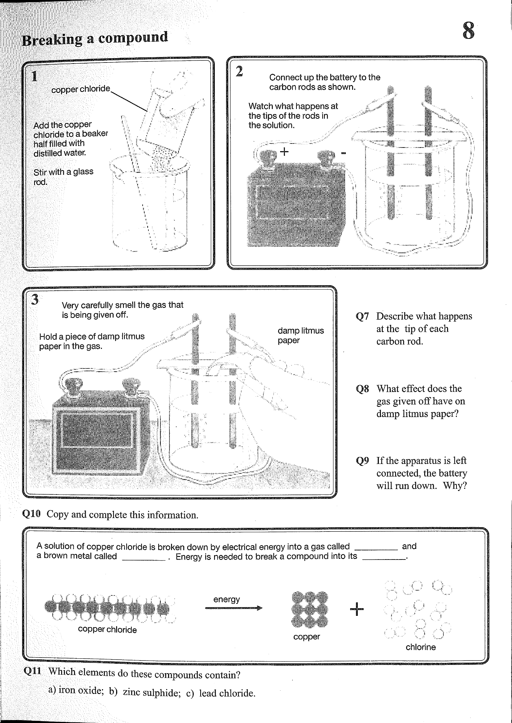
PARTICLES 7

Q.1.
element | appearance | Test with a magnet
Sulphur | Yellow powder | Not attracted by magnet
Iron fillings | Gray metal | Attracted by magnet
iron and sulphur mixed | Yellow powder with gray metals mixed with it | Only the iron is attracted by the magnet.

Q.2. By using a magnet to remove the iron fillings from the mixture, leaving only the sulphur.
Q.3. Yes
Q.5. I should see the mixture glowing, and there should be a change in appearance.
Q.6. Black solid
Q.7. No I can no longer see the iron and the sulphur in the mixture.
Q.8. No they cannot be separated as before.

PARTICLES 8

Q.1. Green- yellow gas and smells like bleach.
Q.2. Chlorine turns litmus paper white.
Q.3. you should see a flash of flame.
Q.4. The copper and chlorine atoms have joined together to form a compound.
Q.5. Copper Chloride.
Q.7. Brown solids are forming on the surface of one rod and bubbles of a gas are seen on the surface of the other rod.
Q.8. The gas turns litmus paper, white.
Q.9. The energy from the battery is used up to split the compound.
Q.10. a) iron and oxygen b) zinc and sulphur c) lead and chlorine.

